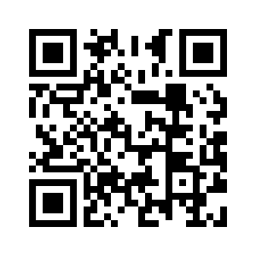**JAMES LE**

le.toanjames@gmail.com

Houston, TX 77083 • (832) 659-4754 • www.linkedin.com/in/james-le1

**EDUCATION**

**University of Houston Main Campus** Bachelor of Computer Science May 2021

Current GPA: 3.69

**PROJECTS**

**Database Systems Project – Theme Park Management Database** January 2019 - Present

* Cooperated with group members to design schema for an Amusement Park Concept
* Implementing Microsoft SQL Server to create and maintain database
* Utilizing .NET Framework to create front-end applications

**CodeRed Hackathon - github.com/JamzJamzJamz/fly_cheap** November 2018

* Worked with team through GitHub to develop a web-app that finds cheapest flights between two locations
* Implemented Python’s JSON and requests library to retrieve and organize flight data from the Amadeus API
* Applied Flask web framework to display data from Python program onto an HTML webpage

**RELEVANT COURSEWORK**

Programming Languages and Paradigms*

Operating Systems*

Database Systems *

Algorithms and Complexities;

Computer Organization and Architecture;

Data Structures (C++/Java);

*in progress

**LEADERSHIP EXPERIENCE AND ACTIVITIES**

**CSS Youth South** – *Youth Group Treasurer;* Houston, TX November 2017 - Present

* Organized classes, volunteer events, spiritual enrichment and youth camps for Houston based members
* Maintained and accounted for funds for fundraising events
* Designed and created website

**University of Texas Austin College Radio Station** – *Radio DJ;* Austin, TXAugust 2016 - May 2017

• Performed shows on a weekly basis

* Organized and compiled varieties of new music lists for shows
* Catalogued and reviewed new music releases

**WORK EXPERIENCE**

**Piano Tutor –** Houston, TXJune-July 2016

* Worked alongside students to develop a personalized training routine
* Adapted to students’ needs and created exercises based on their strengths and weaknesses
* Maintained teaching materials and schedule

**ADDITIONAL INFORMATION**

**Computer Skills:** C++, Java, Python, HTML, CSS, Git

**Languages:** Fluent in Vietnamese, Conversational in French

**Interests:** Electric and Bass Guitar, Piano, Software Development, Computer Hardware

**Work Eligibility:** US Citizen