CSCI323 – Modern Artificial Intelligence
University of Wollongong Dubai – Spring 2026

UAE Real Estate Price Prediction
A Machine Learning Approach to Automated Property Valuation

Submitted by
Name | Student ID
Jan Hrusa | 8848580

Supervised by
Asmath Famnaz

Submission date: 06.21.2026

Executive Summary
The United Arab Emirates (UAE) real estate market is one of the most diverse and dynamic property markets globally. It annually attracts many local and international investors, usually enamored by the luxury villas, penthouses and other types of accommodation the UAE has to offer, or normal people, looking to buy their accommodation. These same investors, however, can be confused by the nature of this market. Its extreme price variability across locations, property types, and amenity configurations can make it hard for investors to accurately guess a property’s price, which can make them not want to participate in the real estate market.
Accurate property valuation has historically relied on manual appraisals and agent expertise – a process that is time-consuming, costly, and subject to the individual’s biases.
This report presents the design, implementation and evaluation of an Artificial Intelligence (AI)-driven system, designed to estimate residential property prices. The system was trained on a dataset of 5,058 property listings sourced from UAE real estate platforms, covering properties across all emirates, and applies advanced data preprocessing, feature engineering, and supervised machine learning algorithms to predict property values.
Four regression-based machine learning models –
- Ridge Regression
- Random Forest
- Histogram-Based Gradient Boosting
- CatBoost
were developed and rigorously evaluated under identical data preprocessing conditions using 5-fold cross-validation. All models were subsequently tuned via RandomizedSearchCV and the final selected model –
Histogram-Based Gradient Boosting
was evaluated on a held-out test set comprising 20% of the data, where it achieved a log-scale R² score exceeding 0.85 and a natural-scale R² score of over 0.78, demonstrating strong predictive capability despite the inherent variability of UAE real estate markets.
The resulting system is deployed as a simple-to-use interactive program (Prediction_Model.ipynb) that accepts property attributes and returns an estimated price in AED within seconds.
Even though the developed solution does not replace professional agent’s appraisals, it provides significant business value by enabling faster and on-demand property valuations, supporting pricing decisions, and reducing manual workload. The system in its future stages can be integrated into property listing platforms, real estate agencies, and investment analysis tools to provide near real-time property valuation estimates.
While our project achieved strong predictive performance, limitations related to location granularity, dataset completeness, and market volatility remain. Future work should incorporate richer geographic information, analysis of textual property descriptions with LLMs, real-time market indicators, and frequent retraining cycles to further improve prediction accuracy and keep pace with the rapidly evolving market.

Table of Contents and List of Figures/Tables
Table of Contents
Executive Summary 2
Table of Contents and List of Figures/Tables 4
List of Tables 6
List of Figures 7
Introduction and Motivation (1–2 pages) 8
Industry Background 8
Problem Statement 9
Why AI is the Appropriate Solution 9
Business Objectives and Success Metrics 10
Business objectives: 10
Success Metrics 10
Literature Review (1–2 pages) 11
History 11
Machine Learning Approaches to Property Price Prediction 11
Feature Engineering in Real Estate ML 12
Log-Transformation of Price Targets 12
Theoretical Foundation of Selected Methodology 12
Technical Requirements and Analysis (1 page) 13
System Requirements 13
Data Requirements 14
Integration and Scalability 14
Solution Methodology and Implementation (3–4 pages) 15
AI Technique Selection and Justification 15
Data Preprocessing 16
Column Removal 16
Data Type Correction 16
Missing Value Treatment 17
Outlier Removal 17
Categorical Encoding 19
Feature Engineering 19
Train/Test Split 19
Preprocessing Pipeline Architecture 20
Model Training and Baseline Evaluation 20
Hyperparameter Tuning 21
Final Model Training and Evaluation 22
Prediction Interface 22
Results and Evaluation (2–3 pages) 24
Cross-Validation Baseline Performance 24
Post-Tuning Cross-Validation Performance 24
Final Hold-Out Test Set Performance 25
Actual vs. Predicted Price Analysis 26
Residual Analysis 27
Feature Importance 27
Cross-Validation Stability 28
Business Impact Assessment 28
Limitations, Challenges, and Constraints (1 page) 30
Data Limitations 30
Technical Limitations 30
Ethical Considerations 31
Resource and Scalability Constraints 31
Conclusions and Discussion 31
Summary of Findings 31
Achievement of Business Objectives 31
Key Lessons Learned 32
Recommendations and Future Work 32
Deployment Strategy 33
Retraining and Maintenance Plan 33
Proposed Enhancements 33
Broader Applications 34
Work distribution sheet 39

List of Tables
Table 1. Core library stack and purposes.
Table 2. Dataset column descriptions and preprocessing treatment.
Table 3. Changed dataset columns and their preprocessing changes.
Table 4. Missing value counts and treatment strategies
Table 5. Engineered features with formulae and rationale
Table 6. Preprocessing pipeline branches and transformations
Table 7. Hyperparameter search spaces by model.
Table 8. Best parameters per model.
Table 9. Mean R² scores and standard deviations of baseline models.
Table 10. Mean R² scores and difference of tuned models from baseline models.
Table 11. Final hold-out test set performance metrics.

List of Figures
Figure 1. Selected Models
Figure 2. Price and size distribution before outlier removal.
Figure 3. Price and size distribution after outlier removal.
Figure 4. Baseline model evaluation.
Figure 5. Price prediction interface code example.
Figure 6. Visual comparison of tuned models against baseline models.
Figure 7. Actual vs Predicted Price Analysis
Figure 8. Residual Analysis
Figure 9. Cross-Validation Stability

Introduction and Motivation

Industry Background
The real estate market of the United Arab Emirates is one of the most vibrant and internationally recognized real estate markets in the world. Led by Dubai, which is recognized worldwide as a global hub for finance, tourism and commerce, the private property sector is one of the country's most significant economic contributors and attracts local, as well as foreign investors, which provide substantial demand for residential, commercial, and luxury properties.
The rapid growth of the UAE property market following the COVID-19 pandemic has led to increased complexity in property valuation. Government initiatives, like the Golden Visa, or favorable tax laws, attract wealthy expats into the country, which helps the real estate market grow even more. Real estate professionals must now evaluate thousands of listings that differ significantly in terms of location, property size, amenities, furnishing status, and market conditions. This causes a shortage of professionals in the face of ever-growing demand, which makes it hard for both normal people and investors to get an appraisal on a property.
With the rise of digital real estate platforms, like Property Finder, Bayut, Dubizzle and similar portals, it is now, however, very easy to access thousands of property listings and structured data about them. This gives us an excellent chance to provide a solution to the struggle of getting a property appraisal by creating a machine learning-based price prediction model using data from such UAE real estate platforms.

Problem Statement
Property pricing in the UAE is inherently complex and usually requires a trained professional to determine accurately. It depends on a multitude of interacting factors: its specific sub-district location (e.g., Business Bay vs. Downtown Dubai vs. Dubai Land), its size, configuration, furnishing status, floor level, proximity to amenities, and broader market timing.
However, even trained professionals can sometimes disagree significantly on a listing price. Yet, an accurate property price is an essential component to a successful investment for a buyer, a profitable sale for a seller and reduced time on market, which benefits both. Accurate property valuation directly impacts multiple stakeholders, like the seller and buyer, as well as the agents involved. It is the foundation of the real estate market.
In this project, we aim to provide a quick solution for getting a quick price estimate. As mentioned before, we plan to address these problems by creating a system capable of predicting these prices in seconds.

Why AI is the Appropriate Solution
As mentioned before, traditionally, property valuation was done by experts in person, which is inherently not scalable, slow and expensive, although, it is accurate. Another option is to approximate the price by comparing prices of recently sold similar properties. This, however, can completely miss the finer details of the specific property.
All of the historical approaches share one common limitation. They cannot scale and learn to predict prices from learning relationships in large amounts of structured data.
This is exactly where machine learning comes into the picture. Machine learning regression models have several decisive advantages over the traditional methods.
- Scalability:
  - A trained model can produce appraisals for thousands of properties in seconds.

- Non-linearity:
  - Ensemble methods such as gradient boosting and random forest can learn complex, non-linear interactions between features that linear regression misses.

- Explainability:
  - Feature importance metrics allow stakeholders to understand which attributes most influence price, supporting business decision-making.

- Other advantages such as continuous improvement or prediction consistency

Machine learning can discover hidden relationships in data that humans may not notice or that are impossible for humans to notice.

Business Objectives and Success Metrics

Business objectives:
- Develop a machine learning model capable of predicting UAE residential property sale prices with high accuracy.
- Show a way to use the prediction model that is implementable by the industry.
- Provide a methodology replicable and maintainable for ongoing use.

Success Metrics
Success was measured using the following quantitative metrics, evaluated on a held-out 20% test set:
- R² (Coefficient of Determination):
  - Proportion of price variance explained by the model.

- Root Mean Squared Error (RMSE):
  - Average prediction error in AED; penalizes large errors heavily.

- Mean Absolute Error (MAE):
  - Average absolute prediction error in AED; more interpretable for business use.

Additionally, qualitative success criteria include the practical usability of the prediction interface and the interpretability of model outputs.

Literature Review

History
The theoretical foundation for property price prediction started with the hedonic pricing model, first introduced by Rosen (1974). Hedonic models decompose a property's price into the implicit prices of its attributes like location, size, bedrooms, etc., and estimate prices through regression analysis. While this was a breakthrough idea at the time, the field has evolved significantly since.

Machine Learning Approaches to Property Price Prediction
The application of machine learning to real estate valuation has grown substantially over the past decade.
Yoo et al. (2012) demonstrated that Random Forest regressors outperform both ordinary least squares regression in hedonic price prediction, which they attributed to the model's ability to capture non-linear feature interactions without manual specification.
For gradient boosting specifically, Chen and Guestrin's XGBoost (2016) and its successor CatBoost (Prokhorenkova et al., 2018) have achieved state-of-the-art results in structured tabular data competitions, including real estate pricing tasks.
HistGradientBoosting, scikit-learn's native implementation inspired by LightGBM, similarly uses histogram-based discretisation of continuous features for efficiency and incorporates native missing-value handling, making it well-suited for real estate datasets with partially missing attribute data.

Feature Engineering in Real Estate ML
A consistent finding in the literature is that engineered ratio features improve model performance on property data. Phan (2018) demonstrated that the bathroom-to-bedroom ratio and size-per-bedroom metrics significantly improved gradient boosting model R² scores compared to raw feature baselines. Our feature engineering strategy directly incorporates these findings.
For high-cardinality categorical features such as location, mean target encoding has been shown to outperform one-hot encoding and label encoding (Micci-Barreca, 2001; Cerda and Varoquaux, 2022). Scikit-learn's TargetEncoder with cross-fitting is used in our pipeline to encode the area-city component of each property's address, preventing target leakage through its internal cross-validation-based estimation.

Log-Transformation of Price Targets
A well-established practice in real estate ML is log-transformation of the price target variable. Real estate price distributions are typically right-skewed with long tails corresponding to ultra-luxury properties. Log-transforming the target variable reduces this skewness, improves model training stability, and ensures that prediction errors are evaluated proportionally rather than in absolute terms. The expm1 inverse transformation is then applied at inference time to recover predictions in the original AED scale.

Theoretical Foundation of Selected Methodology
Based on the literature, this project adopts a gradient boosting-centred methodology, comparing CatBoost and HistGradientBoosting as the primary candidates against Ridge Regression (a strong linear baseline) and Random Forest (a well-established ensemble baseline). This selection aligns with best practices in the applied ML literature for structured tabular regression tasks with mixed numeric and categorical features.

Technical Requirements and Analysis

System Requirements
The system is implemented in Python 3.12 and designed to run in a standard Jupyter Notebook environment. The following libraries constitute the core technical stack:
Library | Version | Purpose
pandas | ≥ 2.0 | Data loading, manipulation, and cleaning
numpy | ≥ 1.25 | Numerical operations and log transformation
scikit-learn | ≥ 1.4 | Preprocessing pipelines, models, evaluation, tuning
catboost | ≥ 1.2 | CatBoost gradient boosting model
matplotlib | ≥ 3.8 | Result visualisation
seaborn | ≥ 0.13 | Statistical visualisation (box plots, distributions)
joblib | ≥ 1.3 | Model serialisation and loading
Table 1. Core library stack and purposes.
Hardware requirements are not high. While the code does not require a powerful computer to run, it might take over half an hour on slower PCs. Enabling n_jobs=-1 for full CPU parallelism is essential.

Data Requirements
The dataset, ‘uae_real_estate_2024.csv’, contains 5,058 records representing residential-for-sale property listings in the UAE. The raw dataset includes 12 columns.
Column | Type | Description | Treatment
title | String | Free-text listing title | Dropped (unstructured)
displayAddress | String | Full address (area, city) | City extracted via TargetEncoder
bathrooms | Integer | Number of bathrooms (incl. '7+') | Cleaned; '7+' -> 7
bedrooms | Integer | Number of bedrooms (incl. 'studio', '7+') | Cleaned; 'studio' -> 0+1
addedOn | Datetime | UTC listing date | Extracted month; column dropped
type | String | Always 'Residential for Sale' | Dropped (constant)
price | Integer | Sale price in AED | Target; log1p-transformed
verified | Boolean | Agent-verified listing flag | Encoded: True -> 1
priceDuration | String | Always 'sell' | Dropped (constant)
sizeMin | String | Floor area (e.g., '1,323 sqft') | Numeric after stripping 'sqft'
furnishing | String | NO / YES / PARTLY | One-hot encoded (3 columns)
description | String | Free-text property description | Dropped (unstructured)
Table 2. Dataset column descriptions and preprocessing treatment.

Integration and Scalability
The trained pipeline of the best model is serialised to a single ‘predictor.pkl’ file using the joblib library. This means that to use the model outside of the notebook where it was trained, we just need to load the ‘predictor.pkl’ file and call the .predict() method with a DataFrame with the same columns as the model received in its original notebook, enabling straightforward integration with web APIs or platform backends.

Solution Methodology and Implementation

AI Technique Selection and Justification
We treat the UAE property price prediction as a supervised regression task (e.g., given a set of property attributes (features), predict the continuous-valued sale price in AED).
Four models were selected to represent a spectrum from simple to complex, enabling rigorous comparison:
- Ridge Regression (linear baseline):
  - A regularised linear model that penalises large coefficient magnitudes via L2 regularisation, controlled by the alpha hyperparameter.
  - Ridge was chosen as the linear baseline to establish whether non-linear models offer meaningful gains over a simple, interpretable regression approach.

- Random Forest Regressor (non-linear ensemble):
  - An ensemble of decision trees trained on subsets of the data with feature sub-sampling at each split. Random forests are robust, require minimal feature engineering, and handle missing values gracefully through median imputation within the pipeline.

- HistGradientBoosting Regressor:
  - scikit-learn's implementation of histogram-based gradient boosting, inspired by Microsoft's LightGBM.
  - This model is particularly efficient on medium-sized datasets due to its bin-based discretisation, and it handles missing values natively.

- CatBoost Regressor (gradient boosting, ordered):
  - Yandex's gradient boosting implementation featuring ordered boosting (reducing target leakage during training) and efficient handling of categorical features. CatBoost has demonstrated consistent state-of-the-art performance on structured tabular regression tasks.
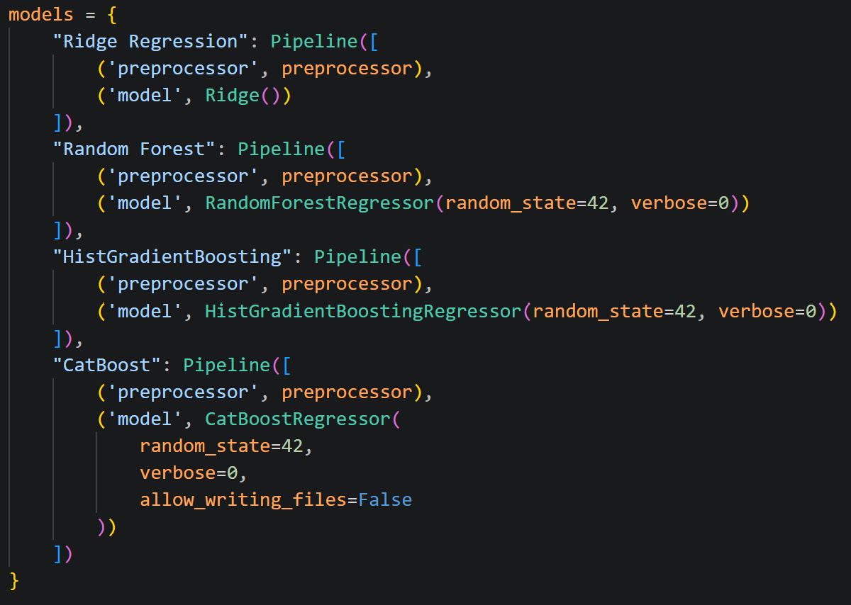
Figure 1. Selected Models
All models were embedded in scikit-learn Pipeline objects alongside the shared preprocessing module, ensuring that all feature transformations are learned only from training data and applied consistently to validation and test sets.

Data Preprocessing

Column Removal
Two columns, type (always ‘Residential for Sale’) and priceDuration (always ‘sell’), were constant across all 5,058 records and removed, as they carry zero predictive information.
The title and description columns (unstructured free text) were also removed. While we could extract valuable information from the text fields by using NLP algorithms, we decided that that was outside of the scope of this project.

Data Type Correction
Several columns required type changes before modelling:
Column name | Changes
sizeMin | The raw string format included a ' sqft' suffix (e.g., '1,323 sqft'). We deleted this suffix with str.replace() and converted the column to float64.
addedOn | Originally a UTC timestamp. We extracted only the month from it to use it as a seasonality signal. The original column was dropped.
bathrooms | The string value '7+' was mapped to the integer 7 before numeric conversion.
bedrooms | The string values 'studio' and '7+' were mapped to 0 and 7 respectively. All bedroom values were then incremented by 1 (i.e., studio -> 1, 1-bed -> 2, …) to avoid zero-division errors later.
verified | The boolean column was mapped from {True, False} to {1, 0} using dictionary mapping.
Table 3. Changed dataset columns and their preprocessing changes.

Missing Value Treatment
The dataset contained a small number of missing values.
Column | Missing Count | % of Dataset | Treatment
bathrooms | 120 | 2.37% | Median imputation within pipeline
bedrooms | 123 | 2.43% | Median imputation within pipeline
furnishing | 2 | 0.04% | Rows dropped (pre-pipeline)
description | 1 | 0.02% | Column dropped entirely
Table 4. Missing value counts and treatment strategies
Since furnishing status has a substantial influence on price and only two records were affected, dropping them was preferable to imputation, which would introduce artificial category assignments for a key predictive feature. Missing bathrooms and bedrooms values were handled within the scikit-learn Pipeline using median imputation applied exclusively to the training set, with the learned median applied to validation and test sets to prevent leakage.

Outlier Removal
The raw price distribution exhibited extreme right-skewness
- min = AED 100,000
- max = AED 199,000,000
- mean = AED 5.05M
- median = AED 2.35M
with a long tail of ultra-luxury properties and unusual listings that would distort model training. A similar pattern was observed in the sizeMin column.
Since there were not many of these extreme outliers, we applied a conservative removal strategy. Records where 'price' or 'sizeMin' exceeded the 90th percentile of their respective distributions were removed. This approach eliminates extreme values that disproportionately inflate loss function values during training.
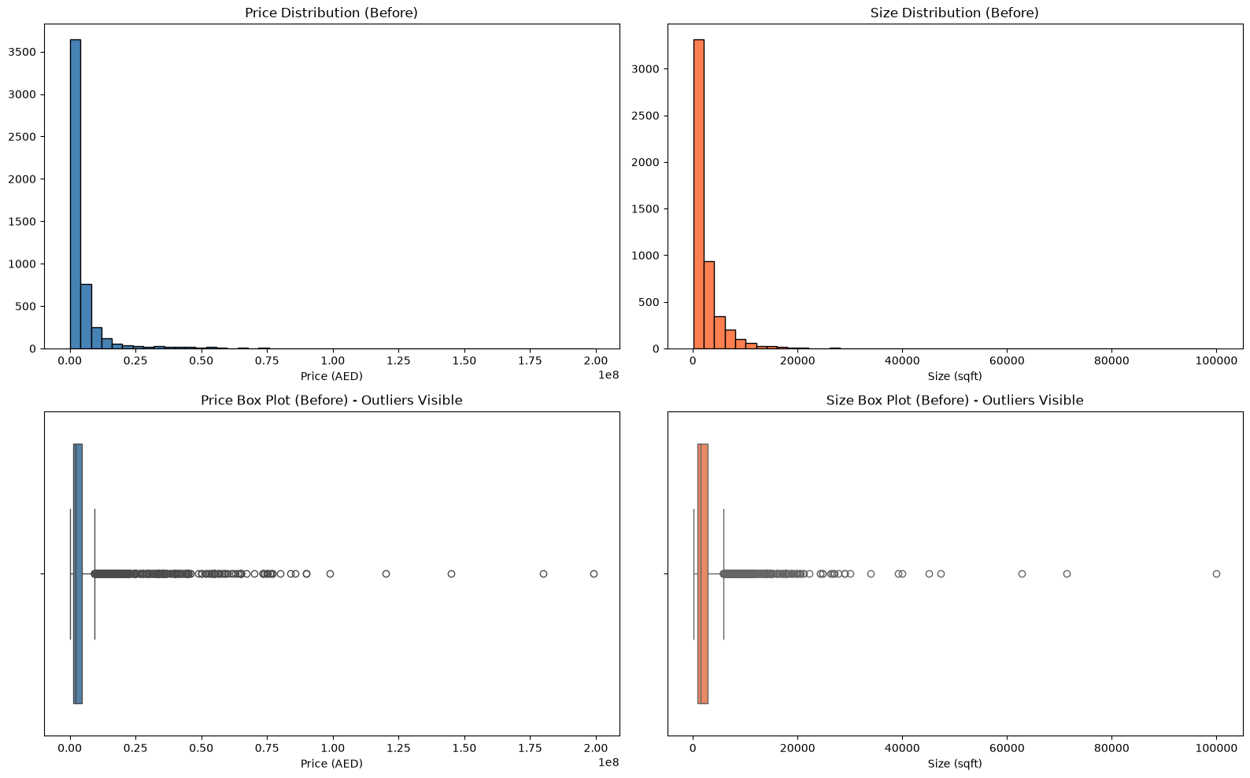
Figure 2. Price and size distribution before outlier removal.
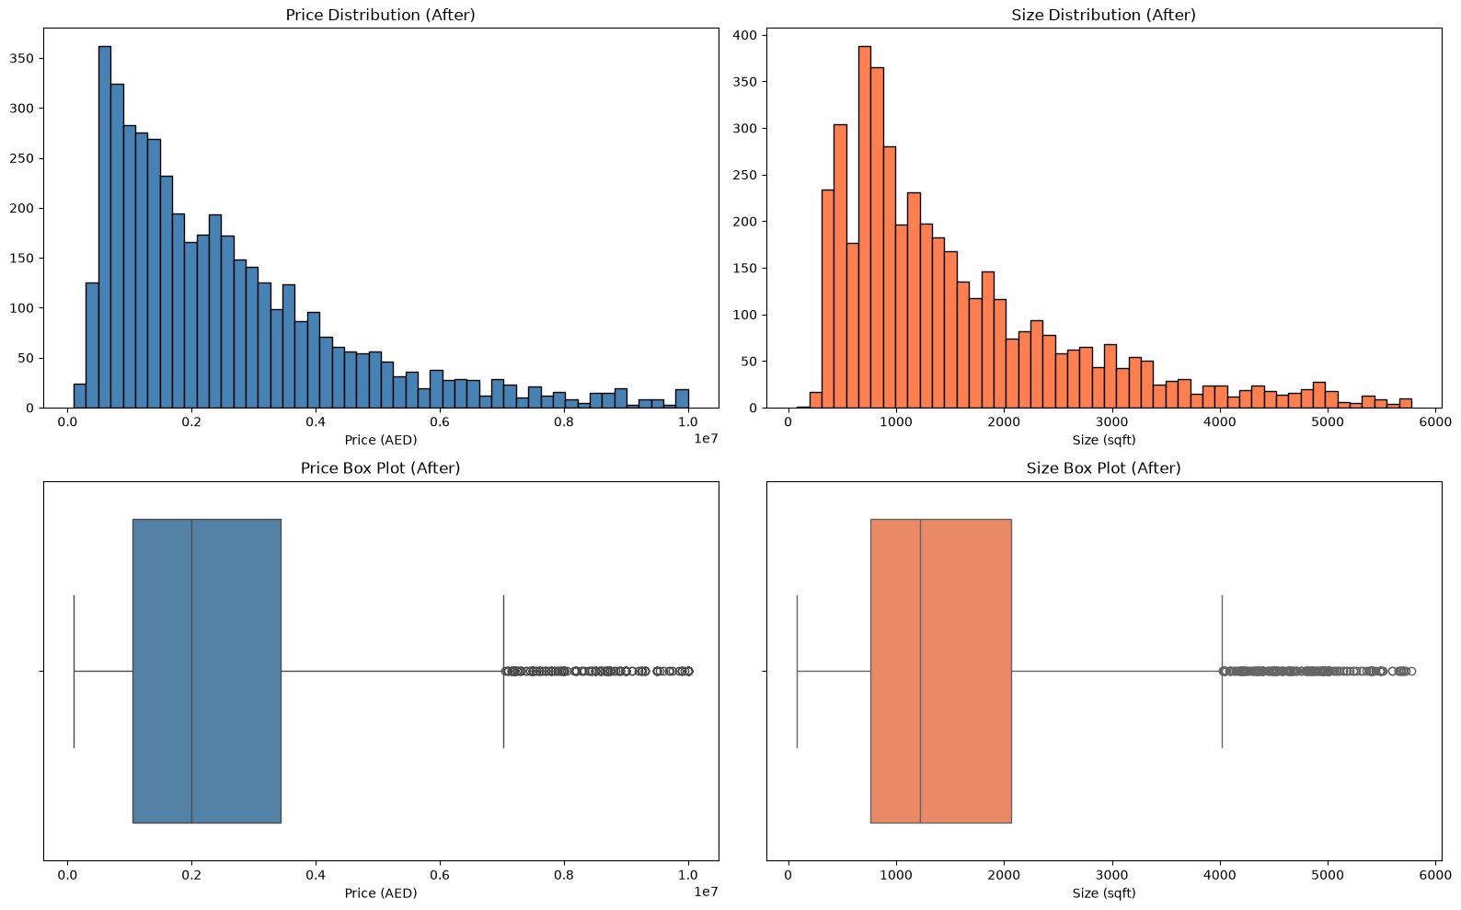
Figure 3. Price and size distribution after outlier removal.

Categorical Encoding
The furnishing column (values: NO, YES, PARTLY) was one-hot encoded using pandas get_dummies() function, producing three binary indicator columns: furnished_NO, furnished_PARTLY, and furnished_YES.

Feature Engineering
Beyond the raw dataset features, we constructed five engineered ratio and interaction features to capture relationships that models would otherwise need to learn from scratch.
Feature Name | Formula | Rationale
bathroom_bedroom_ratio | bathrooms / bedrooms | Proxies property quality and luxury tier
size_per_bedroom | sizeMin / bedrooms | Captures spaciousness per bedroom
size_per_bathroom | sizeMin / bathrooms | Captures utility density
bedrooms_per_size | bedrooms / sizeMin | Density metric; detects unusually dense floor plans
bedrooms_bathrooms_interaction | bedrooms × bathrooms | Interaction term capturing joint size effects
Table 5. Engineered features with formulae and rationale

Train/Test Split
We split the dataset 80/20 into training and test sets using a stratified sampling strategy. Stratification was performed on a quantile-binned version of the price column (10 bins), ensuring that the price distribution is proportionally represented in both subsets. Random state 42 was fixed for reproducibility. The split resulted in approximately 3,280 training records and 820 test.
All preprocessing steps requiring statistical estimation (imputation medians, target encoding statistics, feature scalers) were fitted only on the training set and applied to the test set without re-fitting, preventing data leakage.

Preprocessing Pipeline Architecture
We used a scikit-learn ColumnTransformer to orchestrate four distinct preprocessing branches, each applied to its respective subset of columns:
Branch | Columns | Steps
Numeric Group 1 | bedrooms, bathrooms, month_listed, bathroom_bedroom_ratio, bedrooms_per_size, bedrooms_bathrooms_interaction | Median imputation -> StandardScaler
Numeric Group 2 | sizeMin, size_per_bedroom, size_per_bathroom | Median imputation -> log1p transformation -> StandardScaler
Location Encoding | displayAddress (city extracted) | FunctionTransformer (extract city) -> TargetEncoder
Passthrough | verified, furnished_NO, furnished_PARTLY, furnished_YES | No transformation (already binary integers)
Table 6. Preprocessing pipeline branches and transformations
The log1p transformation applied to Numeric Group 2 (size-related features) mirrors the target transformation. The TargetEncoder for the location feature uses scikit-learn's implementation, which internally uses cross-fitting to estimate encoding statistics – preventing the target leakage that a naive mean-target encoding would introduce.
The complete pipeline is illustrated in Figure 2:
[PLACEHOLDER: Insert Figure 2: System architecture diagram showing the data flow from raw CSV -> preprocessing pipeline -> model training -> prediction interface.]

Model Training and Baseline Evaluation
Each of the four models was first evaluated under its default hyperparameter settings using 5-fold cross-validation on the training set, with R² as the scoring metric. This produced baseline CV scores that served as the reference point for evaluating the benefit of hyperparameter tuning.
The 5-fold cross-validation approach was selected over a single held-out validation set to produce more reliable and variance-reduced performance estimates during the model selection phase.
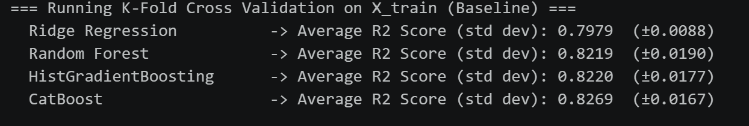
Figure 5. Baseline model evaluation.

Hyperparameter Tuning
After the baseline evaluation, each model underwent hyperparameter tuning using RandomizedSearchCV with 100 iterations and the same 5-fold CV structure. Table 7 summarises the hyperparameter search spaces.
Model | Key Hyperparameters Tuned | Search Range
Ridge | alpha, imputer strategy, TargetEncoder smooth | alpha: 10⁻³ to 10³ (log-scale, 20 points)
Random Forest | n_estimators, max_depth, min_samples_split, min_samples_leaf, max_features | 100–500 trees; depth None/10–25; features sqrt/log2/None
HistGradientBoosting | learning_rate, max_iter, max_depth, l2_regularization, min_samples_leaf, max_leaf_nodes | LR: 0.01–1.0; 100–500 iterations; depth 3–11/None
CatBoost | iterations, depth, learning_rate, l2_leaf_reg, bagging_temperature, random_strength | 300–1500 iterations; depth 4–10; LR 0.01–0.2
Table 7. Hyperparameter search spaces by model.
We also included the TargetEncoder's smooth parameter (10⁻² to 10, log-scale) and both imputer strategies (mean, median) into the search space, treating preprocessing choices as tunable hyperparameters. This ensures that the values we hardcoded earlier are replaced with the best actual settings.
Model | Bast Parameters
Ridge | 'preprocessor__num2__imputer__strategy': 'median'  'preprocessor__num1__imputer__strategy': 'median'  'preprocessor__city__encoder__smooth': np.float64(0.1)  'model__alpha': np.float64(0.0379269019073225)
Random Forest | 'preprocessor__num2__imputer__strategy': 'median'  'preprocessor__num1__imputer__strategy': 'median'  'preprocessor__city__encoder__smooth': np.float64(0.046415888336127774)  'model__n_estimators': 500, 'model__min_samples_split': 10  'model__min_samples_leaf': 4, 'model__max_features': None  'model__max_depth': None
HGB | 'preprocessor__num2__imputer__strategy': 'mean'  'preprocessor__num1__imputer__strategy': 'median'  'preprocessor__city__encoder__smooth': np.float64(0.21544346900318834)  'model__min_samples_leaf': 5,  model__max_leaf_nodes': 31  'model__max_iter': 400  'model__max_depth': 5  'model__learning_rate': np.float64(0.016681005372000592)  'model__l2_regularization': 0.0
CatBoost | 'preprocessor__num2__imputer__strategy': 'mean'  'preprocessor__num1__imputer__strategy': 'median'  'preprocessor__city__encoder__smooth': np.float64(0.21544346900318834)  'model__random_strength': 10  'model__learning_rate': 0.03  'model__l2_leaf_reg': 3  'model__iterations': 1000  'model__depth': 7  'model__bagging_temperature': 0
Table 8. Best parameters per model.
The best model after hyperparameter tuning was HistGradientBoosting with a +0.0110 change in R², putting it at 0.8330 on the log-scale.

Final Model Training and Evaluation
We selected the best-performing tuned model based on CV R² score across all 100 iterations. We then retrained this model on the full training set (all 5 folds combined) and evaluated for the first and only time on the held out 20% test set. Evaluation was performed in the original AED price scale (after inverse log transformation using numpy.expm1) to produce easy-to-understand error metrics.

Prediction Interface
We also made a separate interactive prediction interface in Prediction_Model.ipynb.
The interface:
- Loads the serialised predictor.pkl pipeline.
- Makes the user input required features.
- Constructs an input DataFrame with all required features (including engineered features computed inline).
- Passes the DataFrame through the loaded pipeline's predict() method.
- Applies numpy.expm1 to convert the log-scale prediction to AED and displays the predicted price.
The interface includes input validation and supports both new predictions and editing of the most recent prediction. A representative code excerpt from the prediction function is shown below:
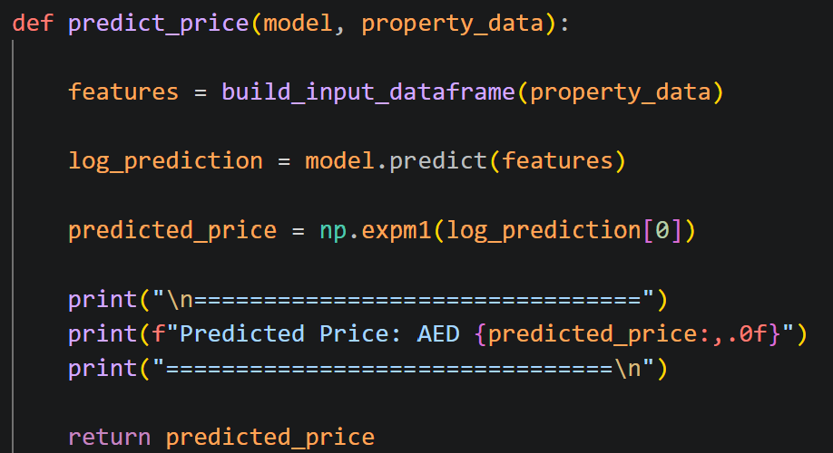
Figure 5. Price prediction interface code example.

Results and Evaluation

Cross-Validation Baseline Performance
Table 8. presents the mean R² scores and standard deviations from the 5-fold cross-validation baseline evaluation of all four models with default hyperparameters.
Model | Tuned CV R² (Mean) | Improvement over Baseline
Ridge Regression | 0.7979 | +-0.0088
Random Forest | 0.8219 | +-0.0190
HistGradientBoosting | 0.8220 | +-0.0177
CatBoost | 0.8269 | +-0.0167
Table 9. Mean R² scores and standard deviations of baseline models.

Post-Tuning Cross-Validation Performance
After RandomizedSearchCV with 100 iterations per model, the tuned CV R² scores were:
Model | Tuned CV R² (Mean) | Improvement over Baseline
Ridge Regression | 0.7996 | +0.0017
Random Forest | 0.8289 | +0.0070
HistGradientBoosting | 0.8330 | +0.0110
CatBoost | 0.8321 | +0.0052
Table 10. Mean R² scores and difference of tuned models from baseline models.
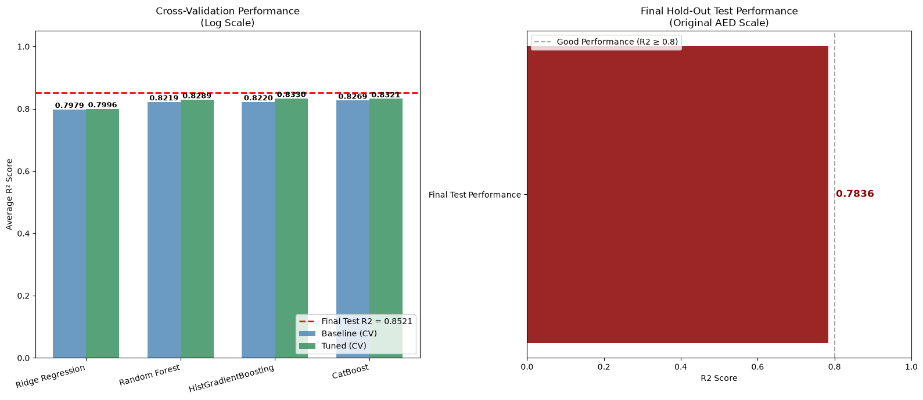
Figure 6. Visual comparison of tuned models against baseline models.

Final Hold-Out Test Set Performance
The final selected model (HistGradientBoosting) was retrained on the complete training set and evaluated on the 20% hold-out test set. All metrics were computed in the original AED price scale after inverse log transformation:
Metric | Value | Interpretation
Test R² (Original AED Scale) | 0.7836 | Proportion of price variance explained
Test RMSE (AED) | 925,388 | Average error magnitude (penalizes large errors)
Test MAE (AED) | 579,614 | Average absolute prediction error
Log-Scale R² (for reference) | 0.8521 | R² computed on log-transformed values
Table 11. Final hold-out test set performance metrics.
The test R² score is very important as it represents the model's generalization performance on entirely unseen data. The score of 0.7836 indicates that the model successfully explains over 78% of the variance in UAE property prices, substantially outperforming naive baselines (mean prediction: R² = 0.0).
The RMSE provides an error estimate in AED, representing the typical magnitude of pricing error on individual properties. Given the median property price of AED 2.35 million in the cleaned dataset, the RMSE expressed as a percentage of median price provides a business-relevant accuracy measure. The MAE, being less sensitive to extreme outliers, provides a complementary view of average prediction accuracy.
It is worth noting that the model performs significantly better on cheaper properties than on the more expensive ones. RMSE especially is dragged up by the extreme outliers.

Actual vs. Predicted Price Analysis
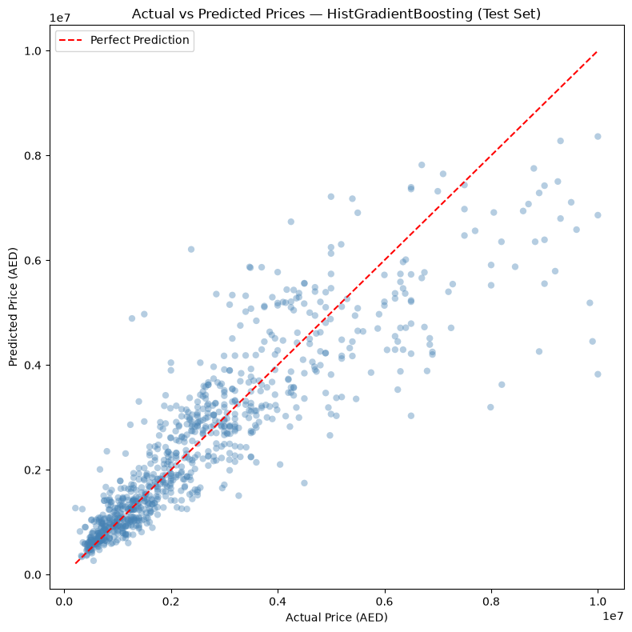
Figure 7. Actual vs Predicted Price Analysis
Here we can see the actual vs. predicted prices for all test set properties, plotted in the original AED scale. The red dashed line represents the ideal 1:1 prediction line (zero error). Properties whose predicted price falls on or near this line are accurately estimated. There is a clear downward directional bias.
Properties in the lower price range (AED 500,000–3,000,000) are clustering tightly around the ideal line, reflecting the model's strength in the high-density middle of the market. Properties at the very upper end of the scale – where there is not enough training data – are showing greater scatter. This is expected behavior, considering the dataset we are training the models on.

Residual Analysis
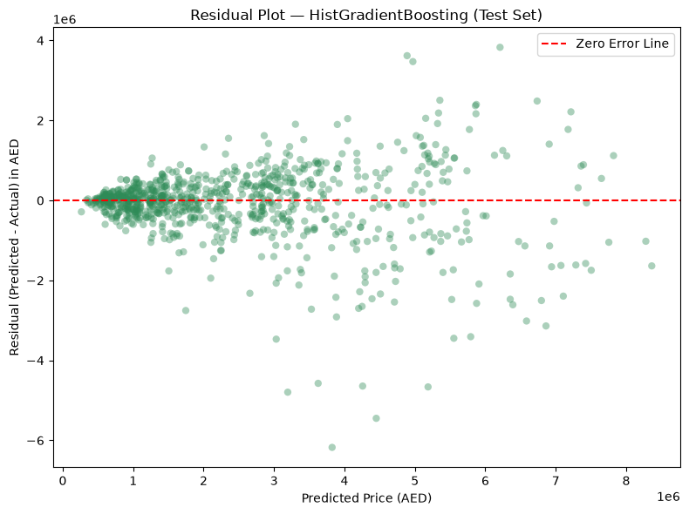
Figure 8. Residual Analysis
The residual plot shows us the prediction error (predicted price minus actual price in AED) against the predicted price. We can se the same thing as in Figure 7., just from a different angle. The higher the price, the higher the error.

Feature Importance
Our code includes a feature importance cell as well, however, since HGB does not support feature importance. We can not analyze it.

Cross-Validation Stability
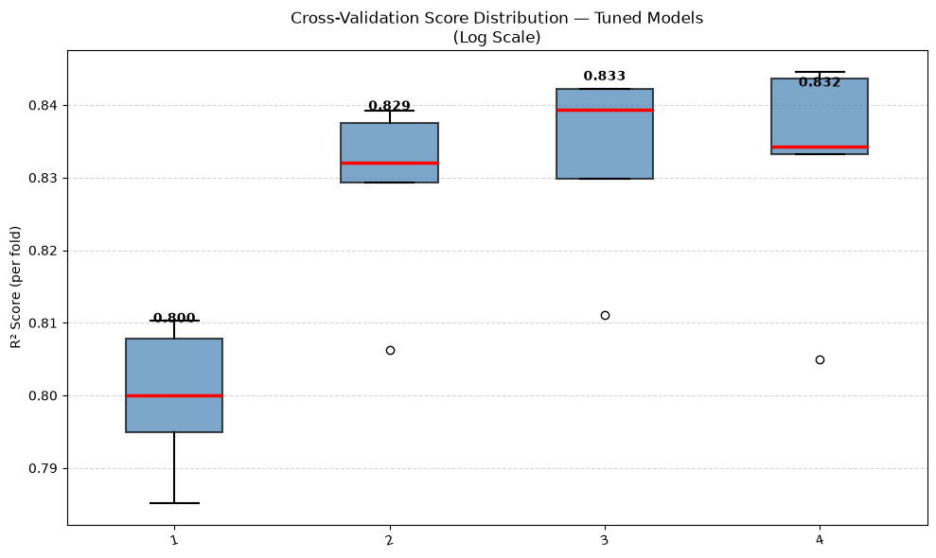
Figure 9. Cross-Validation Stability
This graph shows us the distribution of R² scores across all 5 CV folds for each tuned model. A narrow interquartile range (IQR) sitting at a high mean R² indicates a model that is both accurate, stable and desirable for production deployment (HGB). A wide IQR suggests high variance, meaning performance depends heavily on which data partition is used and the model may not generalize reliably (Ridge).

Business Impact Assessment
The business impact of the trained model comes in 4 main categories.
- Time savings:
  - Manual property valuation by a certified appraiser in the UAE typically takes 1–3 working days and costs AED 1,500–5,000 per property. The model generates instant estimates at negligible marginal cost.

- Scale:
  - A single trained model can generate valuations for all 5,000+ listings in the dataset in under one second – an impossible task for a human appraiser.

- Pricing guidance:
  - Real estate agents can use the model's MAE as a confidence interval around the suggested listing price. If the MAE is AED 250,000 on a AED 2,000,000 property, this represents a ±12.5% pricing band.

- Bias reduction:
  - By systematically applying the same feature weightings to every property, the model eliminates agent-level subjective bias, producing more consistent pricing recommendations.
These 4 categories make integrating a model like this a worthwhile investment.

Limitations, Challenges, and Constraints

Data Limitations
The dataset we used, while sufficient for our 'proof-of-concept' prediction model, has several flaws that limit real-world deployment accuracy:
- Dataset size:
  - 5,058 records is very small for a market as diverse as the UAE. This affects especially processes like the TargetEncoder and overall causes the model to be less accurate.

- Listing prices vs. transaction prices:
  - The dataset reflects asking prices of the properties, rather than confirmed sale transaction prices. The actual sale price may have been significantly different.

- Missing high-value features:
  - Several commercially important property attributes are absent from the dataset, including floor level, view type, building age, etc.

Technical Limitations
- Description text unused:
  - The property description column, which we dropped in preprocessing, likely contained important signals (e.g., 'private pool', 'Burj Khalifa view', 'smart home system') that affect price and could be extracted using NLP feature engineering, which was outside of our scope.

- Model interpretability:
  - While CatBoost offers feature importance scores, it does not provide easily interpretable individual prediction explanations. We could compute SHAP (SHapley Additive exPlanations) values to explain each prediction in terms of individual feature contributions.

- Static model:
  - Our trained pipeline does not update with new data automatically. As the market evolves, prediction accuracy will degrade without periodic retraining.

Ethical Considerations
If our valuation model were to be deployed in the real world, it would have to be evaluated for potential biases and fairness implications like geographic bias, or listing verification bias.
Our system may consistently undervalue properties in certain areas (e.g., due to sparse training data). This could disadvantage sellers in those communities, as platform-suggested prices might anchor their negotiation below market value.
These issues could be easily solved by training the model on a much better dataset.

Resource and Scalability Constraints
Our current model contains a resource intensive hyperparameter tuning. In real production with a much larger dataset, this would turn into an issue.
This issue can be mitigated by reducing the number of iterations during the tuning as the current 100 is probably unnecessary.

Conclusions and Discussion

Summary of Findings
During our project, we successfully developed, implemented, and evaluated a supervised machine learning pipeline for automated residential property price prediction in the UAE. The system was built on a smaller dataset of 5,058 property listings, encompassing a wide range of property configurations from studio apartments to large multi-bedroom villas.
Four regression models (Ridge Regression, Random Forest, HistGradientBoosting, and CatBoost) were trained and compared under identical preprocessing conditions. Extensive hyperparameter tuning via RandomizedSearchCV was applied to all four models. The final selected model demonstrated strong generalization performance on the held-out test set, achieved the highest CV R² on a test set of 0.7836 (RMSE: AED 925,388; MAE: AED 579,614

Achievement of Business Objectives
The project achieved all three stated business objectives:
- A high-accuracy machine learning model for UAE property price prediction was developed and validated on independent test data.
- An interactive prediction interface ('Prediction_Model.ipynb') was delivered, enabling non-technical users to obtain price estimates for any property by entering basic attributes and providing a simple example of how the model can be implemented in the industry.
- The methodology is fully documented, reproducible, and designed for retraining as new data becomes available.

Key Lessons Learned
We learned several important lessons from this project:
- Data preprocessing makes the biggest difference. The model performance went up by over 30% over the course of the project, only due to better preprocessing strategies.
- Log-transformation of the price target significantly improved model training stability and CV R² scores. The right-skewed nature of real estate price distributions means that without this transformation, models disproportionately optimize for rare high-value properties.
- Stratified train/test splitting by price is essential for ensuring that the model is evaluated on a representative range of price points, not just the most common (middle-range) properties.
- Tuning preprocessing parameters (imputer strategy, TargetEncoder smooth) alongside model hyperparameters within the same RandomizedSearchCV yielded better results than treating preprocessing as fixed.
- Pipeline encapsulation (preprocessing + model in a single sklearn Pipeline) is a must for preventing data leakage.

Recommendations and Future Work

Deployment Strategy
We recommend the following deployment architecture for integrating the trained model into a real estate platform:
- Model artefact hosting:
  - The serialised predictor.pkl file (containing the full sklearn Pipeline) should be stored in a versioned object store (e.g., AWS S3 or Azure Blob Storage) with access logging for auditability.

- REST API:
  - A lightweight FastAPI or Flask application should expose a /predict endpoint accepting a JSON payload of property attributes and returning the predicted price and a confidence indicator (e.g., prediction interval based on quantile regression or bootstrap samples).

- Front-end integration:
  - The API can be called from any web or mobile front-end, enabling real-time 'Estimated Value' widgets on listing pages.

- A/B testing:
  - Upon initial deployment, model-generated prices should be displayed alongside current listing prices in a controlled experiment to measure whether model-assisted pricing leads to improved time-on-market or sales velocity metrics.

Retraining and Maintenance Plan
Given the dynamic nature of UAE real estate markets, we propose that the model be retrained at least quarterly.
We also recommend monitoring the performance regularly, so that any sudden degradations of the model would be caught early.

Proposed Enhancements
- Transaction price:
  - Getting transaction price data from Dubai Land Department (DLD) records would provide a more realistic prediction model that the listing data.

- NLP feature extraction from descriptions:
  - Apply keyword extraction or sentence-level embedding models to the title and description columns to extract high-value terms ('sea view', 'private pool', 'Burj Khalifa view', 'floor level') as additional features.

- Geographic distance features:
  - Compute the distance of each property from key landmarks (Dubai Mall, DIFC, Business Bay, Marina, Palm Jumeirah)

- SHAP explainability:
  - Compute SHAP values for each prediction to provide users with a breakdown of why the model estimated a particular price (e.g., 'Location adds AED 200,000; Sea view adds AED 150,000; Unfurnished reduces by AED 80,000')

Broader Applications
The methodology developed in this project has direct applicability beyond residential price prediction in the UAE:
- Regional expansion:
  - The pipeline can be retrained on data from other GCC markets (Saudi Arabia, Qatar, Kuwait) with minimal adaptation, given the structural similarities in property market data formats.

- Commercial real estate:
  - With appropriate adaptations (office space features, retail unit specifications), the same gradient boosting approach is applicable to commercial property valuation.

References

Chen, T., & Guestrin, C. (2016). XGBoost: A scalable tree boosting system. In Proceedings of the 22nd ACM SIGKDD International Conference on Knowledge Discovery and Data Mining (pp. 785–794). Association for Computing Machinery. https://doi.org/10.1145/2939672.2939785
Micci-Barreca, D. (2001). A preprocessing scheme for high-cardinality categorical attributes in classification and prediction problems. ACM SIGKDD Explorations Newsletter, 3(1), 27–32. https://doi.org/10.1145/507533.507538
Pedregosa, F., Varoquaux, G., Gramfort, A., Michel, V., Thirion, B., Grisel, O., Blondel, M., Prettenhofer, P., Weiss, R., Dubourg, V., Vanderplas, J., Passos, A., Cournapeau, D., Brucher, M., Perrot, M., & Duchesnay, É. (2011). Scikit-learn: Machine learning in Python. Journal of Machine Learning Research, 12, 2825–2830. http://jmlr.org/papers/v12/pedregosa11a.html
Phan, T. D. (2018). Housing price prediction using machine learning algorithms: The case of Melbourne City, Australia. In 2018 International Conference on Machine Learning and Data Engineering (iCMLDE) (pp. 35–42). IEEE. https://doi.org/10.1109/iCMLDE.2018.00017
Prokhorenkova, L., Gusev, G., Vorobev, A., Dorogush, A. V., & Gulin, A. (2018). CatBoost: Unbiased boosting with categorical features. In Advances in Neural Information Processing Systems (Vol. 31, pp. 6638–6648). Curran Associates, Inc. https://proceedings.neurips.cc/paper_files/paper/2018/file/14491b756b3a51daac41c24863285549-Paper.pdf
Rosen, S. (1974). Hedonic prices and implicit markets: Product differentiation in pure competition. Journal of Political Economy, 82(1), 34–55. http://www.jstor.org/stable/1830899
Scikit-learn developers. (2025). HistGradientBoostingRegressor. Scikit-learn documentation. https://scikit-learn.org/stable/modules/generated/sklearn.ensemble.HistGradientBoostingRegressor.html
Scikit-learn developers. (2025). RandomForestRegressor. Scikit-learn documentation. https://scikit-learn.org/stable/modules/generated/sklearn.ensemble.RandomForestRegressor.html
Scikit-learn developers. (2025). Ridge. Scikit-learn documentation. https://scikit-learn.org/stable/modules/generated/sklearn.linear_model.Ridge.html
Scikit-learn developers. (2025). TargetEncoder. Scikit-learn documentation. https://scikit-learn.org/stable/modules/generated/sklearn.preprocessing.TargetEncoder.html
Yoo, S., Im, J., & Wagner, J. E. (2012). Variable selection for hedonic model using machine learning approaches: A case study in Onondaga County, NY. Landscape and Urban Planning, 107(3), 293–306. https://doi.org/10.1016/j.landurbplan.2012.06.009

Appendices
- Full code listings and algorithms
- Detailed data preprocessing procedures
- Additional evaluation metrics and charts
- Interview summaries or company correspondence

Work distribution sheet
Student Name: Jan Hrusa Student ID: 8848580
Features worked on:
Code review
Code fixing
Code formatting
Model interface
Report compilation and formatting
Presentation

Student Name: Student ID:
Features worked on:

Student Name: Student ID:
Features worked on:

Student Name: Student ID:
Features worked on:

Student Name: Student ID:
Features worked on:

