Project documentation

# Databases

## Database

This database contains information on tickers in the C25 market. For specify you will find

# Functions

## MACD_strategy

The function is applying the Moving Average Convergence Divergence (MACD) strategy. To apply the strategy, we must first compute the MACD line. This line is computed by applying the following formula:

$$MACD=12 period EMA-26 period EMA$$

After we have done this, we can compute the signal line. This is the 9 period EMA of the MACD. This leads to the following buy/sell rules (see picture for visualization):

* Buy: We buy when the MACD crosses above the signal line.
* Sell: We sell when the MACD crosses below the signal line.

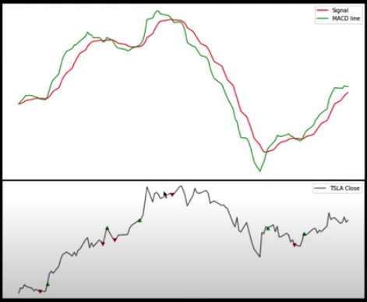

References:

* <https://www.youtube.com/watch?v=JzdVPnCSSuo&list=WL&index=5&t=931s>

## MACD_to_sql

The function will apply the MACD trading strategy to a list of tickers. After this, the buying and selling dates will be stored in to separate databases. The function takes the following inputs:

* ticker_list: The list of tickers to be considered for the MACD trading strategy.
* Buy: Boolean variable indicating if we want the buy dates or the selling dates. If Buy == True, the buying dates will be reported. The default is that the selling dates are stored in a database.

## Select_components_historical

This function will download ticker data for a given ticker (list). The function works in connection with the exchange_components() function. **Import prerequisite** for the function is that a database, to store the data in, is set up with a name before applying the actual function.

### Example of usage

The function can be used to download Tesla stock data in the following way:

Select_components_historical(ticker_list = ['TSLA'])