SOFTWARE AND AI DESIGN SPECIFICATION
GeoVision
AI-Powered Construction Monitoring Using Geotagged Image Classification

Course | Computer Engineering Practice and Design 1 — Software Design Laboratory and Practice & Design
Activity | Capstone Design Activity: Software and AI Design Elements
Thesis Title | GeoVision: Smart Construction Monitoring Using AI and Geotagging
Document Version | 1.0
Date | August 15, 2026

Table of Contents
Table of Contents 2
1. Introduction and System Summary 5
1.1 Scope of this document 5
1.2 Objectives and constraints 5
2.1 High-Level Architecture 7
2.1.1 System Overview Diagram 7
2.1.2 Module Descriptions and Data Flow 7
Data flow narrative 8
Security and reliability at each hop 9
2.2 Detailed Software Architecture 10
2.2.1 UML Diagrams 10
Class diagram 10
Sequence diagram 11
Use case diagram 12
2.2.2 Database Design 14
Entity-Relationship Diagram 14
Schema — key tables 14
Normalization and deliberate denormalization 16
Indexing strategy 16
SQL vs. NoSQL — the chosen trade-off 16
2.2.3 System APIs and Protocols 18
Representative endpoints 18
Sample contract — device ingest 18
Sample contract — progress read 19
WebSocket event catalogue (selected) 19
Protocol choices and justification 19
Communication security, end to end 20
2.3 Algorithms and Data Structures 21
2.3.1 Core Algorithms 21
A. Temporal progress aggregation — the flagship algorithm 21
B. Perspective rectification (homography transform) 22
C. CNN inference — ResNet18 forward pass 22
D. Object detection — YOLOv8 single-shot grid 22
E. HMAC signature verification and replay protection 22
F. Race-free daily sequence allocation 22
G. Grouped stratified dataset split 23
2.3.2 Data Structures and Complexity Analysis 24
Complexity summary — the algorithm the thesis is graded on 25
2.3.3 Design Patterns and Maintainability 26
2.4 AI System Design 28
2.4.1 Training Data and Engineering 28
Data sources and volume 28
Cleaning and preprocessing pipeline 28
Preventing data leakage 28
Augmentation (Albumentations 2.x, train split only) 28
Bias mitigation 29
Data privacy and ethical stewardship 29
2.4.2 Model Architecture Selection 31
Primary classifier — ResNet18, ImageNet-pretrained transfer learning 31
Corroborating detector — YOLOv8n / YOLOv8s 31
Framework constraint and its justification 31
2.4.3 Performance Metrics and Verification 32
Classifier (ResNet18) — acceptance targets 32
Backbone comparison table (structure) 32
Detector (YOLOv8) 32
Progress algorithm evaluation (Section 2.3.1's algorithm, evaluated end to end) 32
System-level performance 33
Usability (low-cost, high-value addition) 33
Verification and reproducibility discipline 33
2.4.4 Deployment Plan and Sustainability 34
Hosting strategy — server-side inference, edge capture 34
Frameworks and runtime 34
Scalability path 34
Operational and environmental sustainability 35
Closing: Honest Limitations 36

1. Introduction and System Summary
GeoVision is an AI-powered construction-monitoring system developed as an undergraduate Computer Engineering capstone. A fixed-mount ESP32-CAM node captures geotagged photographs of a construction site on a schedule, uploads them to a cloud backend, and the backend runs a computer-vision pipeline — OpenCV preprocessing, a ResNet18 construction-stage classifier, and a YOLOv8 object detector used for corroboration — to estimate how far the building has progressed. The estimate is smoothed over time, capped at an 80% machine ceiling, and presented on a React dashboard with a public face (anyone may browse public projects) and an authenticated owner face (create projects, pair cameras, collaborate, approve the final 20%, and export reports). The system was designed to satisfy four constraints simultaneously: it must be technically defensible as a thesis contribution, safe to deploy on a real, physical structure, operable on inexpensive edge hardware, and buildable by a small team on an undergraduate timeline.
This document is the Software and AI Design Specification requested for the Capstone Design Activity. It is written from, and stays consistent with, the project's living design authority — an Obsidian vault of canonical architecture, domain, API, hardware, and dataset notes that every implementation change is checked against — and from the codebase that has already been built against it. As of this writing, 12 of 16 build modules are complete and merged, backed by over 800 automated tests, so the designs described below are not merely proposed: they are implemented, running, and verified end to end (device simulator → ingest → inference → progress → dashboard). Where a design choice was revised after it met reality — for example, correcting how a device secret is stored so HMAC verification is actually possible — that revision and its reasoning are presented as an Architecture Decision Record (ADR) rather than smoothed over, because the reasoning is itself part of the engineering contribution.

1.1 Scope of this document
Section 2.1 gives the macro system architecture and data flow. Section 2.2 gives the detailed software design — UML models, the relational schema, and the API/protocol contracts. Section 2.3 analyzes the algorithms and data structures at the core of the system and the design patterns that keep the codebase maintainable. Section 2.4 covers the AI system end to end: data engineering and bias mitigation, model selection, evaluation methodology, and the deployment and sustainability plan.

1.2 Objectives and constraints
- Functional. Classify the visible construction stage of a fixed-camera site photograph, corroborate with object detection, and derive a trustworthy, monotonic-by-default progress percentage that a homeowner, engineer, or examiner can read at a glance.
- Safety / accountability. The model is advisory. It can carry a project to an 80% machine ceiling; only an authenticated human, on record with inspection notes, can certify the final 20% and mark a physical structure complete (ADR-007).
- Hard technology constraints. PyTorch only — TensorFlow/Keras is forbidden, including transitive dependencies; PostgreSQL only for durable state; image binaries never enter the database; no secret is ever committed to source control.
- Resource constraints. The edge node is a battery-powered ESP32-CAM with ~200 KB usable heap; inference must run acceptably on CPU because the thesis cannot assume a GPU server is available.
- Academic constraint. Every design decision must be defensible in an oral defense — which is why trade-offs are recorded as ADRs with context, decision, consequences, and rejected alternatives, not just a final answer.

2.1 High-Level Architecture
GeoVision is organized into five planes, each with one clear responsibility. The boundary between planes is not just conceptual — it is enforced in the repository layout and, for the backend, by an automated import-linter check that fails the build if a boundary is crossed (for example, if domain code were to import the web framework, or the API process were to import PyTorch).

2.1.1 System Overview Diagram
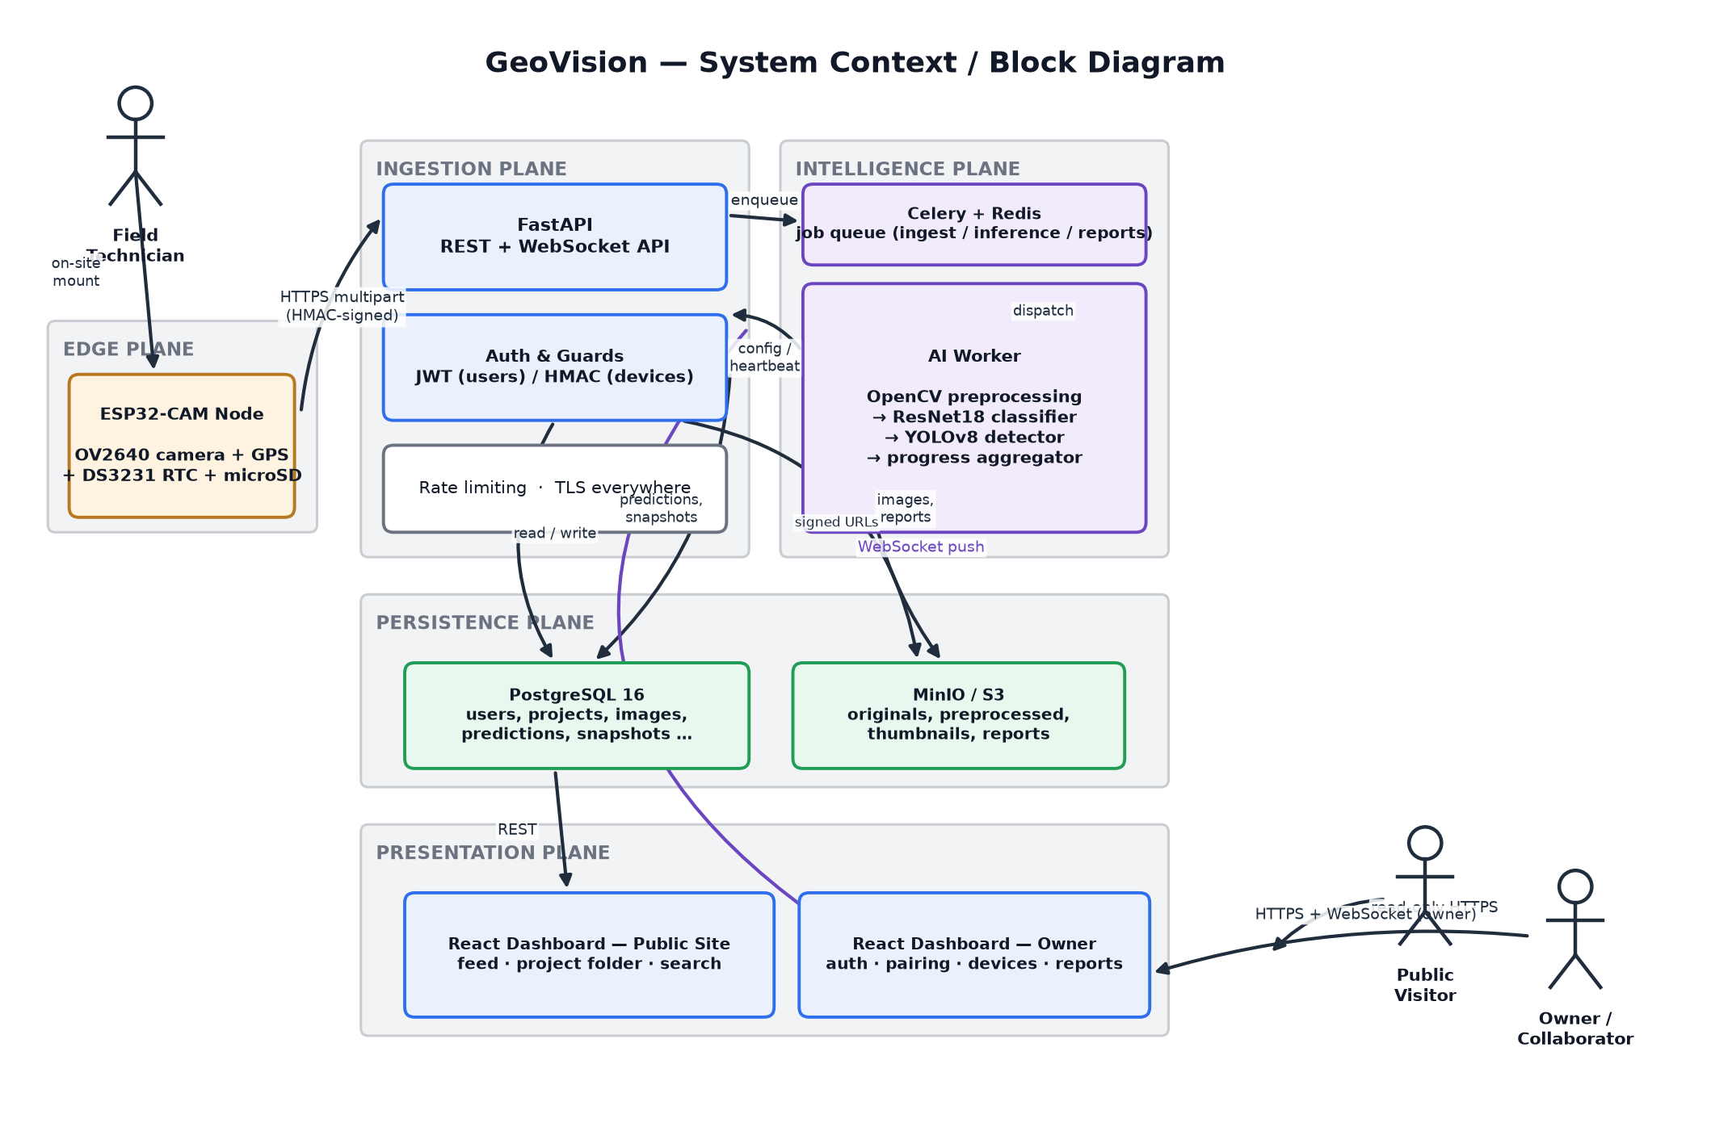
Figure 1. System context / block diagram — the five architectural planes, their technologies, and the data flows that cross plane boundaries.

2.1.2 Module Descriptions and Data Flow
Plane | Responsibility | Technology | Primary data in / out
Edge | Capture, geotag, buffer, and upload a photograph on a fixed schedule without losing data to a network outage. | ESP32-CAM (OV2640) + GPS + DS3231 RTC + microSD | In: capture schedule (pulled). Out: JPEG + GPS/timestamp metadata, HMAC-signed.
Ingestion | Authenticate every caller (human JWT or device HMAC), resolve which project a device belongs to, assign the canonical filename, store the original, and enqueue AI work. | FastAPI (REST + WebSocket), rate limiting, TLS | In: multipart upload / REST calls. Out: 201 + image_id; enqueued Celery task.
Intelligence | Rectify and normalize the frame, classify the construction stage, corroborate with object detection, and fold per-image results into a smoothed, trustworthy project-level progress percentage. | Celery + Redis, OpenCV, PyTorch (ResNet18), Ultralytics (YOLOv8) | In: image bytes + device weight. Out: prediction row, detection rows, progress snapshot.
Persistence | Durable system of record for structured data and binary assets, queried by every other plane. | PostgreSQL 16, MinIO / S3-compatible object storage | In: writes from ingestion & intelligence. Out: reads for API responses & reports.
Presentation | Render public and authenticated views; receive live push updates so an owner never has to refresh to see new data. | React 18 + TypeScript, TanStack Query, WebSocket client | In: REST responses + WS events. Out: user actions (create project, pair device, approve, etc.).

The end-to-end path from a single capture to a dashboard update is shown as a sequence diagram in Section 2.2.1 (Figure 3); Figure 2 below shows the same journey compressed into a pipeline view alongside the offline training loop that produces the model weights the pipeline serves.
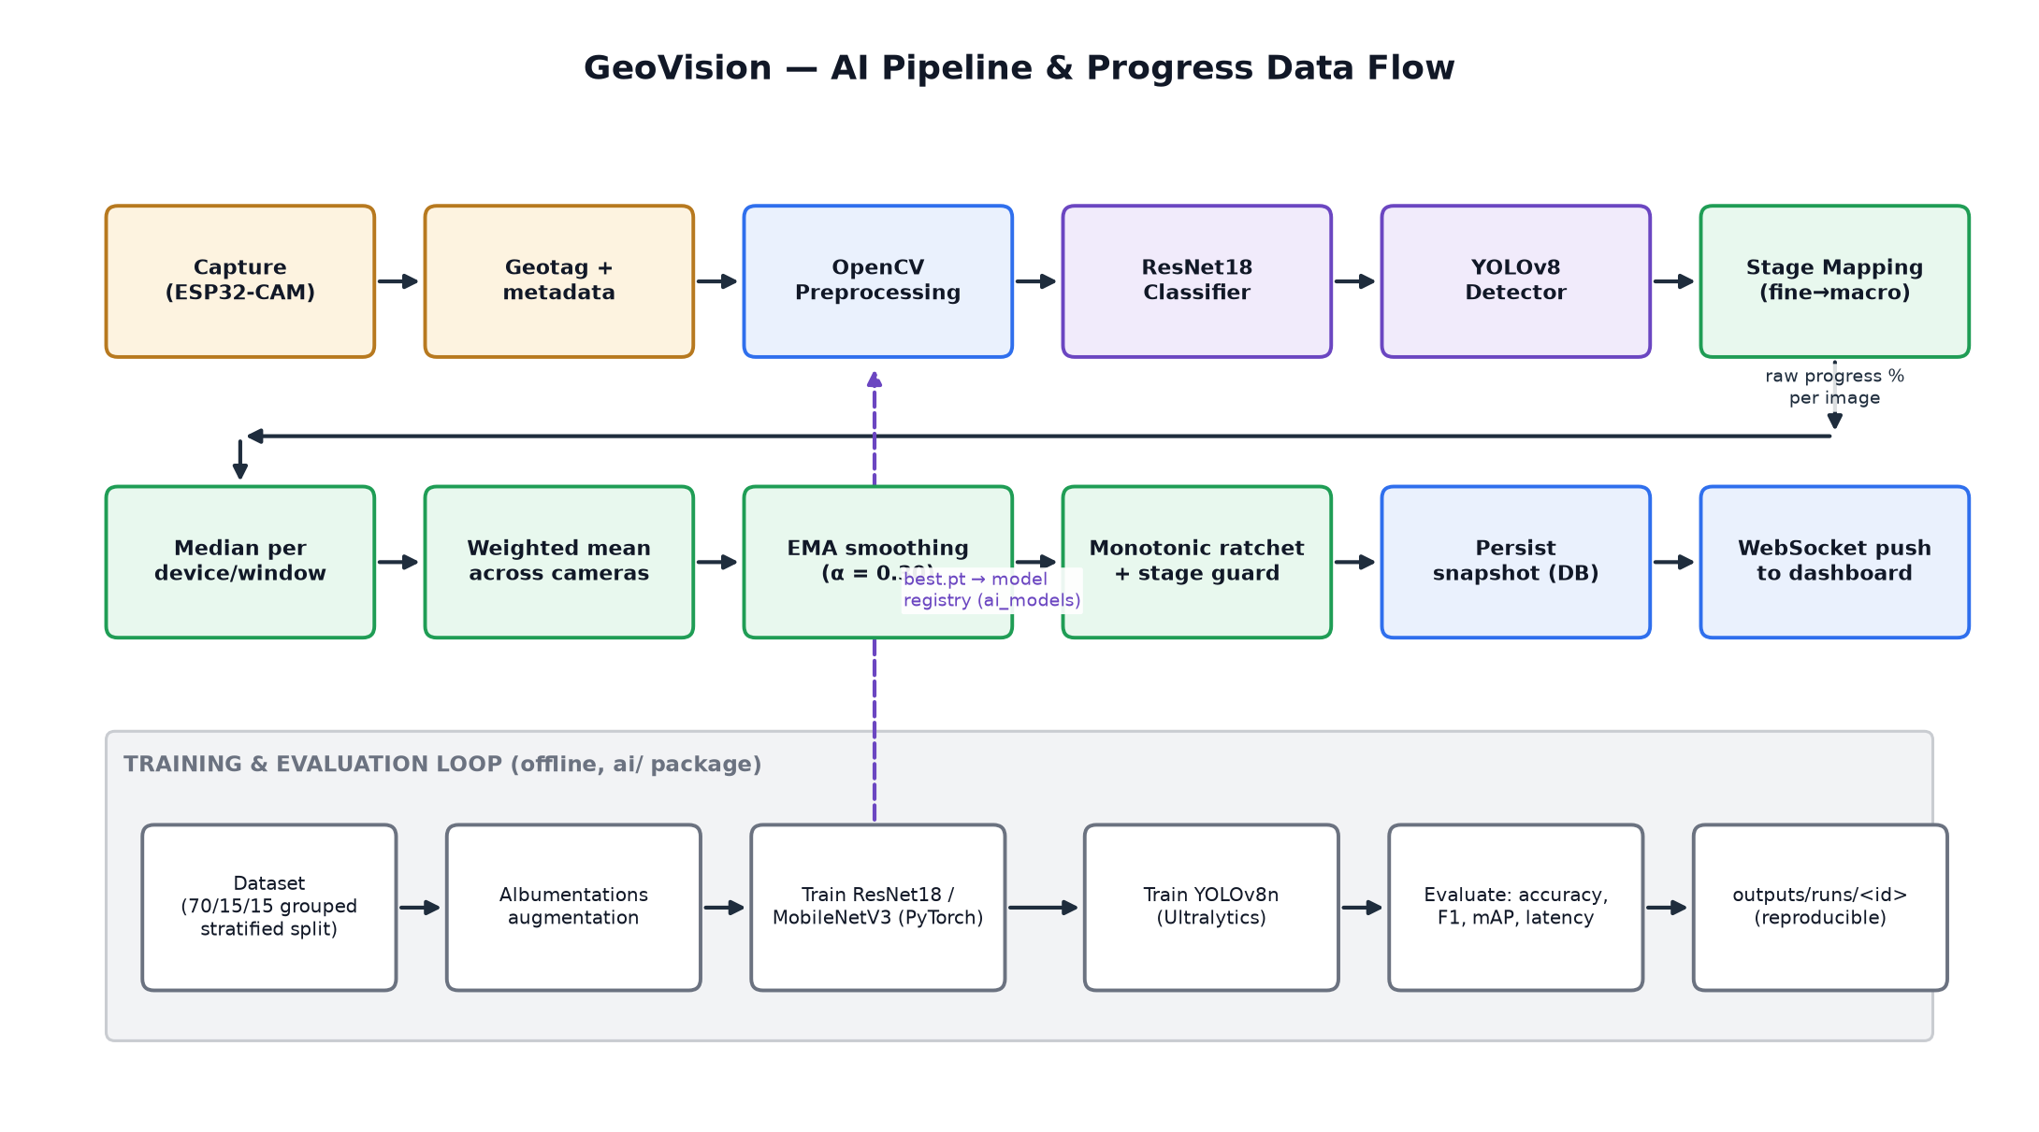
Figure 2. Online inference / progress data flow (top two rows) and the offline training-and-evaluation loop that feeds it a versioned model (bottom band).

Data flow narrative
1. The device wakes on a DS3231 RTC alarm, captures a frame, acquires a GPS fix (or falls back to the RTC-stamped last known fix), and writes both the image and a metadata sidecar to microSD before attempting any network activity — the capture can never be lost to a Wi-Fi outage.
2. The device uploads over HTTPS multipart POST, signed with HMAC-SHA256 over a canonical string that includes a nonce and timestamp. FastAPI verifies the signature, resolves the device's paired project, assigns the server-side filename, and stores the original in object storage.
3. The image row is inserted as status = pending and a Celery task is enqueued on the inference queue; the API responds 201 immediately — ingestion never blocks on inference.
4. The AI worker preprocesses the frame (perspective rectification against the camera's stored homography, resize, CLAHE brightness/white-balance normalization, bilateral denoise), classifies it with ResNet18, and runs YOLOv8 for corroborating object counts.
5. The fine-grained class is mapped to a macro stage and a nominal raw progress percentage; this value is aggregated with other eligible images from the same device and window (median), across devices (weighted mean), and across windows (EMA + monotonic ratchet — Section 2.3.1) into one trustworthy, persisted snapshot.
6. The API publishes the result over Redis pub/sub, which every FastAPI worker process forwards to the WebSocket connections subscribed to that project, so the dashboard updates with no polling and no manual refresh.

Security and reliability at each hop
- Edge → Ingestion. TLS in transit; HMAC-SHA256 device authentication with a ±5-minute replay window and a per-device nonce cache — never JWT, never a bare API key (Section 2.2.3, ADR-006).
- Ingestion → Persistence. Image binaries never touch PostgreSQL (ADR-005); the database holds only object-storage keys, and the API re-signs or re-checks permission on every read of a private resource.
- Intelligence → Persistence. Every recomputation is fully replayable from stored predictions — snapshots are rebuilt, never patched — so an algorithm-version change can be applied to history honestly and audited.
- Persistence → Presentation. Anonymous callers are served from a dedicated public response model that has no field to leak into (ADR-019), and visibility is enforced as a SQL predicate in the repository layer, not filtered after the fact in application code.
- Ingestion/Intelligence → Presentation. Server → browser push travels over a authenticated, per-project-authorized WebSocket channel; if the socket drops, the dashboard falls back to periodic polling, so WebSocket is an optimization and never the only path to a correct read (Section 2.2.3).

2.2 Detailed Software Architecture
The backend follows Clean Architecture (Ports & Adapters): dependencies point strictly inward, from infrastructure and API code toward a torch-free, framework-free domain core. This is not aspirational — it is enforced by four contracts in an import-linter configuration and by an architecture test that asserts importing the FastAPI application never pulls PyTorch into memory. The UML models below describe the structure and behavior that boundary protects.

2.2.1 UML Diagrams

Class diagram
Figure 3 models the core persistent entities as they are actually implemented in backend/app/domain/entities/ — immutable dataclasses with explicit invariants (for example, Project.__post_init__ rejects a deadline before its start date) rather than anemic records. Relationships are aggregation (a Project has Devices, Images, Remarks, Reports, and Snapshots, all of which are deleted with it) except ProjectMember, which is deliberately modeled as an association class: it is what turns the User↔Project many-to-many relationship into something that itself carries state (a membership_role and a membership_status). StageBreakdown is a derived value object — it is never stored, only computed on read from a Project's progress_pct — which is why it is drawn with a dependency rather than an association.
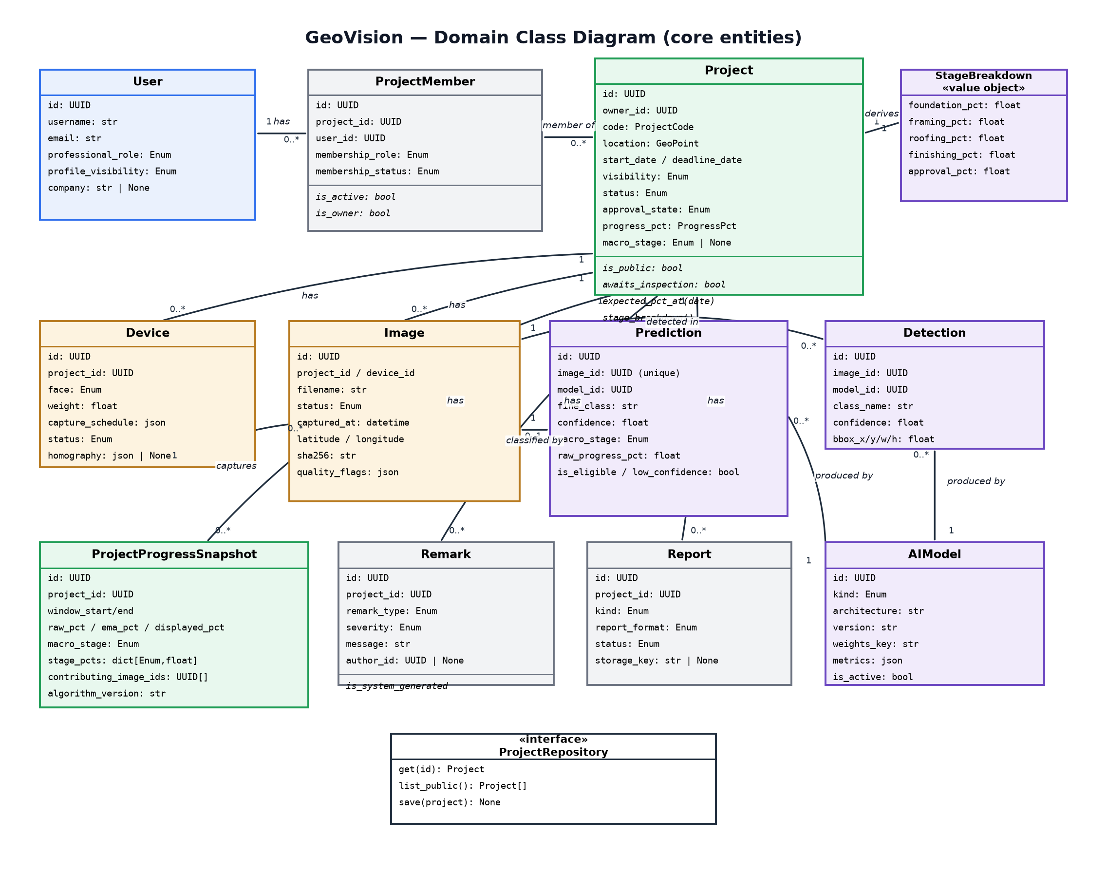
Figure 3. Domain class diagram — core entities, key attributes/methods, and their cardinalities. ProjectRepository illustrates the repository-interface pattern discussed in Section 2.3.3.

Sequence diagram
Figure 4 traces one capture from the ESP32-CAM through inference to the dashboard, matching the implementation across Modules 05 (ingestion), 06/09 (AI pipeline), and 14 (realtime). Self-messages (short loops back to the same lifeline) mark work a component does internally — signature verification, OpenCV preprocessing, model inference — as opposed to a call to another component. The failure branches noted under the diagram are implemented, not aspirational: they are covered by the ingestion and inference test suites.
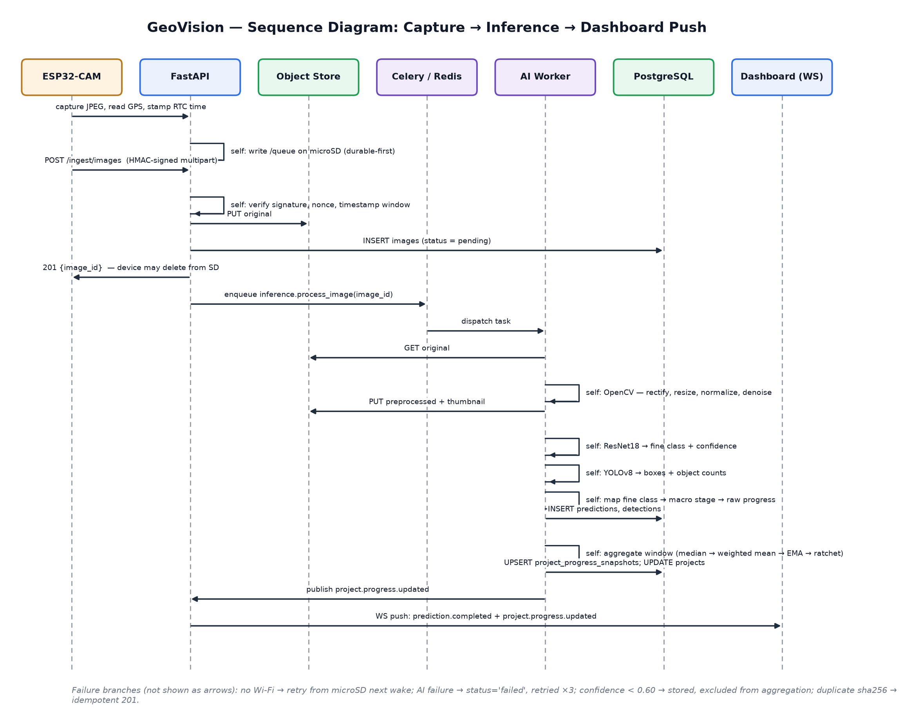
Figure 4. Sequence diagram for the primary workflow: device capture → HMAC-authenticated ingest → asynchronous AI inference → progress aggregation → WebSocket push.

Use case diagram
Figure 5 separates six actors by the authority they actually hold, matching the permission matrix in Section 2.2.2 rather than a generic “user” actor: an anonymous visitor, a registered user with no project relationship, a project member (whose exact rights depend on a membership role between viewer and editor), a manager/owner (the only roles that can pair hardware, approve the final stage, or change visibility), and two system actors — the ESP32 device (HMAC-authenticated, restricted to ingestion endpoints only) and the Celery worker. «include» relationships mark mandatory sub-behavior (ingesting an image always runs the AI pipeline, which always runs the aggregator); the single «extend» relationship marks optional behavior — approving the final stage may trigger a recomputation, but does not have to.
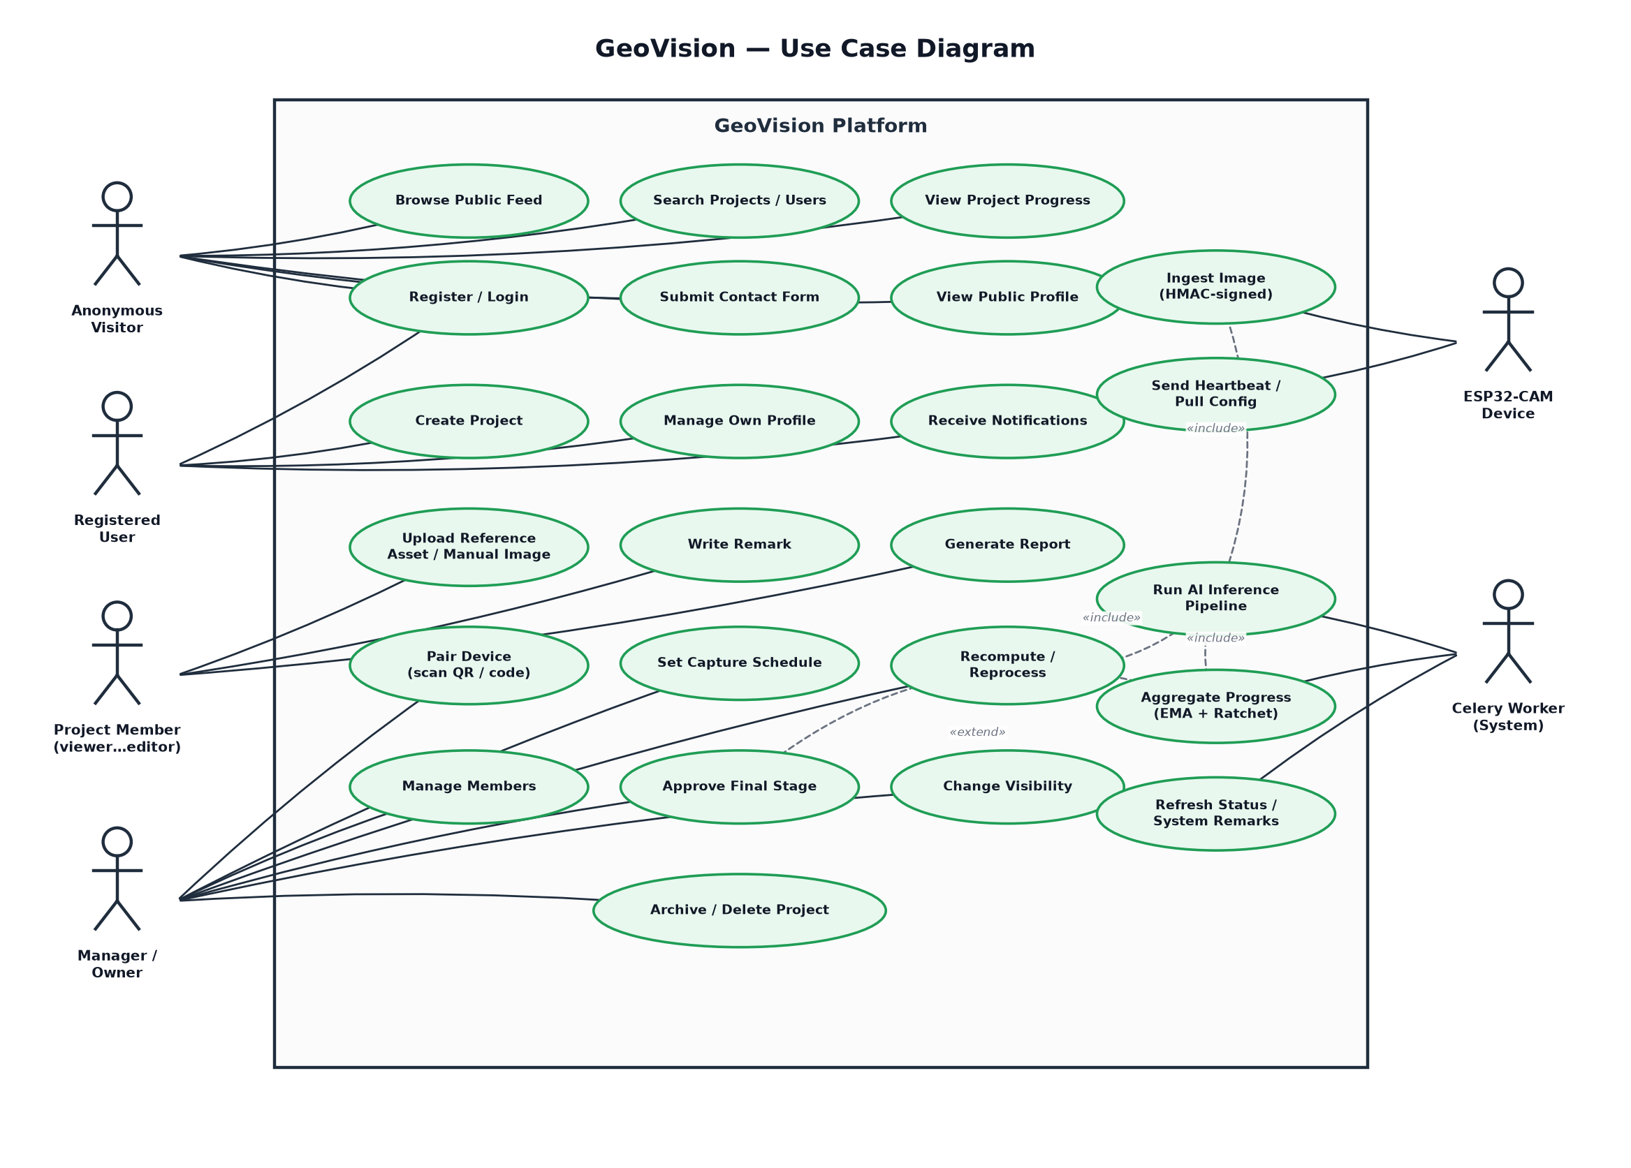
Figure 5. Use case diagram — actors, system boundary, and their use cases, with include and extend relationships for the AI pipeline.

2.2.2 Database Design

Entity-Relationship Diagram
The schema is normalized to third normal form with two deliberate, documented exceptions described below. Every primary key is a UUIDv4; every timestamp is TIMESTAMPTZ stored in UTC; every enumerated value is a native PostgreSQL enum, mirrored once in backend/app/domain/enums.py so the database and the application code cannot silently drift apart.
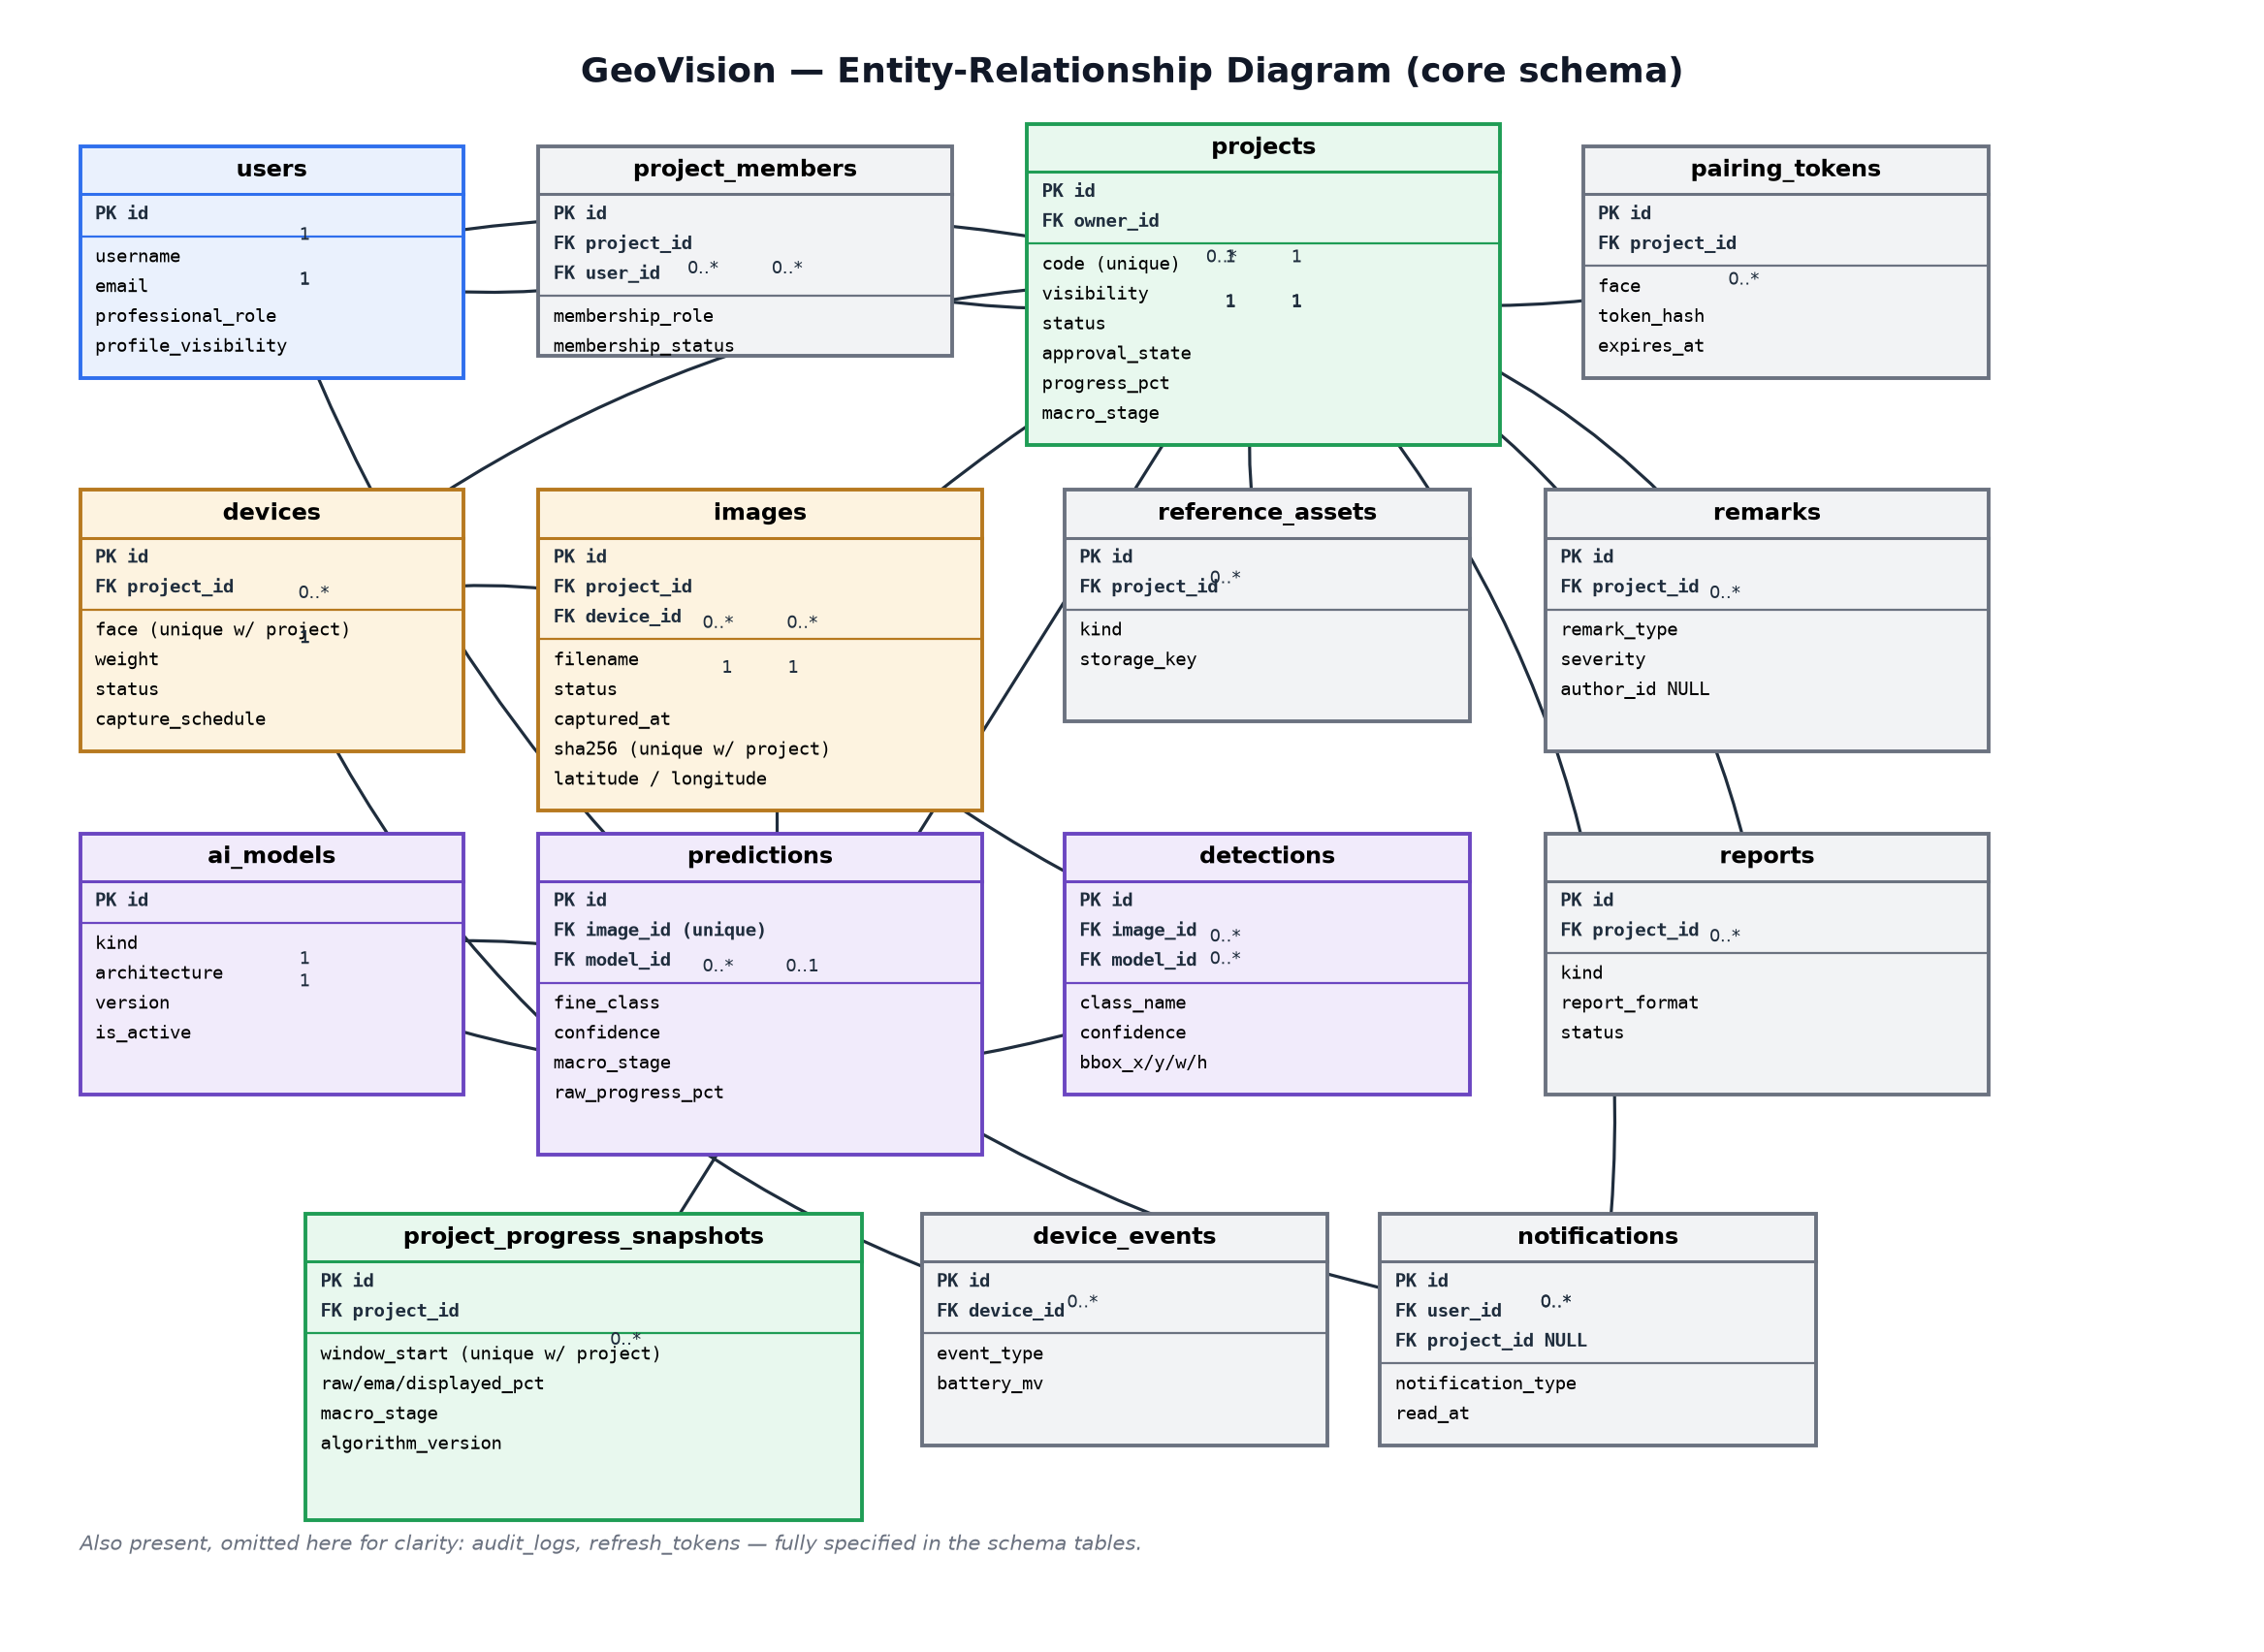
Figure 6. Entity-relationship diagram for the core schema (14 of 18 tables shown; audit_logs and refresh_tokens are omitted from the picture for legibility and described in the schema tables below).

Schema — key tables
The full column-level schema lives in the project's canonical Domain-Model note; the tables most load-bearing for the design are reproduced here.

users
Column | Type | Notes
id | uuid pk
username / email | citext unique | case-insensitive uniqueness
password_hash | text | Argon2id
professional_role | enum | descriptive only — never affects permissions
profile_visibility | enum | public | private, default public

projects
Column | Type | Notes
id | uuid pk
owner_id | uuid fk → users | creator; also gets an owner project_members row
project_code | text unique | immutable; baked into filenames and device names
visibility | enum | public | private
status | enum | active | inactive | delayed | completed | archived — derived, never hand-set
approval_state | enum | not_ready | awaiting_inspection | approved
progress_pct | numeric(5,2) | denormalized copy of the latest snapshot (see below)
macro_stage | enum | denormalized copy of the latest snapshot

images
Column | Type | Notes
id | uuid pk
project_id / device_id | uuid fk | device nullable for manual uploads
filename | text | server-assigned; see Naming Conventions, Section 2.1
captured_at | timestamptz | device (RTC) time — drives the aggregation window
sha256 | text | unique with project_id; the idempotency key for re-uploads
quality_flags | jsonb | blur / darkness / occlusion scores from the quality gate

predictions / project_progress_snapshots
Column | Type | Notes
predictions.image_id | uuid fk, unique | one prediction per image
predictions.confidence | numeric(4,3) | 0.000–1.000; gates aggregation eligibility at 0.60
snapshots.window_start | timestamptz | unique with project_id
snapshots.raw/ema/displayed_pct | numeric(5,2) ×3 | the three stages of smoothing — Section 2.3.1
snapshots.algorithm_version | text | so a re-run is attributable to the version that produced it

Normalization and deliberate denormalization
The schema is 3NF: every non-key column depends on the whole primary key and nothing but the key (there is no repeating group and no transitive dependency — professional_role lives once on users, not copied onto every project_members row, for example). Two columns break strict normal form on purpose, and both are documented as such rather than accidental:
- projects.progress_pct and projects.macro_stage are denormalized copies of the latest project_progress_snapshots row. Without them, rendering a list of a hundred projects on the homepage feed would require a correlated subquery per row to find each project's latest snapshot; with them, the feed query is a single indexed scan. The authoritative value always lives in the snapshot table — the projects columns are a read-optimization, refreshed on every recomputation, never written independently.
- ai/progress/constants.py duplicated in backend/app/domain/value_objects.py — not a database denormalization, but the same trade-off in code: the handful of threshold constants the API genuinely needs (the 80% machine ceiling, the 0.60 confidence gate) are restated rather than imported, because importing the ai package would drag PyTorch into the API container. A CI script parses both files with Python's ast module and fails the build if they disagree, so the duplication is checked, not merely hoped for.

Indexing strategy
- B-tree composite index on images(project_id, captured_at DESC) — the access pattern behind every history/timeline query.
- Partial unique index on ai_models(kind) WHERE is_active — guarantees exactly one active classifier and one active detector without a separate singleton table.
- Trigram (pg_trgm) GIN indexes on projects.name and projects.location_label — backs the fuzzy public search endpoint without a separate search engine.
- Unique composite indexes double as domain constraints, not just performance: (project_id, face) on devices enforces “one camera per face”; (project_id, sha256) on images enforces upload idempotency directly in the database rather than in race-prone application code.

SQL vs. NoSQL — the chosen trade-off
GeoVision is a relational-first system with a purpose-scoped NoSQL component, not a single database serving every role. The justification for each half:

Why PostgreSQL is the system of record
- Referential integrity across a genuinely relational domain. A prediction is meaningless without its image; an image is meaningless without its project; a progress snapshot must reconcile against real foreign keys or the number on the dashboard cannot be trusted. Foreign keys, unique constraints, and transactions are the mechanism, not a convention the application layer has to remember.
- Multi-row transactional consistency. Approving the final 20% (POST /projects/{id}/approve) updates progress_pct, approval_state, status, and completed_at together, atomically, with an audit row. A document store's single-document atomicity does not cover an update that spans several logical records without denormalizing them into one document — which would then have to be kept in sync with the very tables (predictions, snapshots) that a normalized design keeps independently queryable.
- Rich, ad-hoc query needs. Reports aggregate a date range across images, predictions, detections, and remarks in one query; SQL's JOIN and window functions are the right tool. A NoSQL store would need either broad denormalization (write amplification and drift risk) or application-side joins (N+1 query risk — the exact bug class the project already had to correct once, in the homepage feed's owner/latest-image lookup).
- Schema-enforced correctness for a thesis-grade system. Native enums reject an invalid membership_role at the database layer, independent of whichever application code path writes the row — a genuine safety property when the system's job is to inform decisions about a physical structure.

Where a NoSQL-shaped store is used, and why it is scoped narrowly
- Redis — key-value / pub-sub, not a system of record. Three roles, all transient by design: the Celery broker/result backend (durable enough for a queued job, not meant to survive a full data-center loss), the replay-protection nonce cache (SET … NX EX — an atomic “claim once” that a relational table could only offer with a row-level lock and a sweep job for data that is worthless after five minutes), and the pub/sub fan-out that lets every FastAPI worker process forward the same WebSocket event without the workers knowing about each other.
- Object storage (MinIO / S3) — blob storage, not queried. Images, thumbnails, and generated reports are opaque bytes addressed by key. PostgreSQL holds the key and every queryable fact about the image; the object store holds the bytes. This is ADR-005: BYTEA columns were rejected because they bloat backups and add memory pressure with no compensating query benefit — nothing ever needs to SELECT WHERE image_bytes = ….
Both halves are visible in Figure 1: PostgreSQL and the object store sit together in the Persistence plane because they answer different questions — “what is true” versus “where are the bytes” — and Redis sits in the Intelligence plane because it is infrastructure for the queue and the push channel, never a place application state is expected to survive.

2.2.3 System APIs and Protocols
All endpoints live under /api/v1, use snake_case JSON, UTC ISO-8601 timestamps, and cursor-based pagination. Errors share one envelope — {"error":{"code":"...","message":"...","details":{...}}} — so a client never has to special-case a status code's body shape.

Representative endpoints
Method / Path | Auth | Purpose
GET /public/feed | none | Homepage feed of public projects — thumbnail, GPS, progress, status; filterable by proximity, stage, and text query.
POST /auth/register, /auth/login | none | Account creation and session start; returns a short-lived access token and a rotating refresh token.
POST /projects | JWT | Create Project form; 409 PROJECT_CODE_TAKEN with three suggested alternatives on collision.
POST /projects/{id}/pairing-tokens | JWT, device:manage | Issues a 15-minute, single-use pairing code and QR payload for a camera face.
POST /pair/claim | possession of code | Device-side pairing claim; returns the device secret exactly once.
POST /ingest/images | HMAC | Device image upload; idempotent on (project_id, sha256); always 201, with duplicate: true on a repeat.
GET /projects/{id}/progress | JWT, member | Current displayed_pct, macro_stage, and the five stage percentages, read from the latest stored snapshot — never recomputed on the way out.
POST /projects/{id}/approve | JWT, project:approve | The final 20% — requires inspection_notes; 409 unless the project is awaiting_inspection.
POST /predict | JWT, rate-limited | Synchronous demo inference on an uploaded image, not persisted; 503 if no worker is reachable.
GET /model/status | JWT | Reconciles what PostgreSQL knows was trained against what the live worker has loaded; always 200, even when the worker is unreachable.
WSS /ws?token= | JWT (query string) | Per-project-authorized live push — prediction.completed, project.progress.updated, device.paired, and 10 other event types (Section, below).

Sample contract — device ingest
Request (multipart/form-data, HMAC-signed headers):
POST /api/v1/ingest/images
X-Device-Id: 3fa1... X-Nonce: 9c1a2b7e6f0d1a3c
X-Timestamp: 1786550400 X-Signature: <hex HMAC-SHA256>
file: <binary JPEG>
meta: {"captured_at":"2026-08-12T07:00:00Z","latitude":13.628,
"longitude":123.185,"gps_accuracy_m":4.2,"seq_hint":1,
"sha256":"…","battery_mv":3980,"rssi_dbm":-61}
Response — 201 Created:
{
"image_id": "b7e2...", "filename": "NG_00_20260812T070000Z_001.jpg",
"accepted": true, "duplicate": false,
"server_time": "2026-08-12T07:00:03Z"
}

Sample contract — progress read
GET /api/v1/projects/{id}/progress 200 OK
{
"displayed_pct": 33.5, "macro_stage": "framing",
"stages": {"foundation_pct": 100.0, "framing_pct": 67.5,
"roofing_pct": 0.0, "finishing_pct": 0.0, "approval_pct": 0.0},
"updated_at": "2026-08-17T00:00:00Z", "algorithm_version": "progress-v1",
"eligible_image_count": 2, "devices_reporting": 2, "has_data": true
}
has_data is deliberate: a brand-new project and a project genuinely stuck at 0% both report displayed_pct: 0.0, and only this flag lets the dashboard tell “nothing measured yet” apart from “measured, and it is zero.”

WebSocket event catalogue (selected)
Event | Fires when
image.received | ingest accepted the upload, before AI processing starts
prediction.completed | classification + detection finished for one image
project.progress.updated | a window aggregation produced a new snapshot
project.approval.required | the machine ceiling (80%) was reached
device.paired | a pairing token was claimed — closes the pairing modal
remark.created | a system or user remark was written
report.ready | an asynchronous PDF/CSV report finished

Protocol choices and justification
The rubric asks specifically to justify REST vs. GraphQL vs. gRPC vs. MQTT. GeoVision uses three protocols, each chosen for a different edge of the system, and rejects the other three explicitly:
- REST over HTTPS — the default for every resource-oriented interaction. Projects, users, images, and reports are naturally addressable resources; REST's uniform interface (GET/POST/PATCH/DELETE) maps directly onto CRUD-shaped use cases, is cacheable, is trivially testable with httpx/Postman, and needs no special client tooling — important because the client population includes a resource-constrained ESP32.
- WebSocket — for exactly one job: server-initiated push to the dashboard. REST is pull-only; without WebSocket, “the owner shouldn't have to refresh” would require client polling. A single long-lived, authenticated, per-project-authorized socket is the narrowest addition that satisfies that requirement (ADR-003 — see Realtime-Events).
- HMAC-SHA256 over HTTPS — for device authentication, deliberately not mTLS, JWT, or MQTT. mTLS is correct but needs a CA, per-device certificates, and rotation infrastructure disproportionate to a single-operator thesis deployment. JWT needs refresh flows and asymmetric verification that are awkward on a device that sleeps for hours between wakes. MQTT would add a broker to run and defend for no material gain at this scale, and still would not remove the need for an application-level signature. HMAC with a replay window is small enough for ~200 KB of ESP32 heap and gives per-device, instantly revocable authentication (ADR-006).
- Rejected outright: GraphQL. The client population is one purpose-built dashboard, not many third-party consumers with divergent field needs — GraphQL's main advantage, client-specified queries, has no one to benefit from it here, and it would complicate the server-push requirement that WebSocket already solves cleanly.
- Rejected outright: gRPC. No service-to-service boundary in this system needs binary-protocol performance; the API's clients are a browser and a microcontroller, neither of which benefits from HTTP/2 binary framing the way REST/JSON already fails to bottleneck this workload.

Communication security, end to end
- TLS everywhere — no endpoint accepts plaintext HTTP in a deployed environment.
- HMAC-SHA256 device signatures over a canonical string (method, path, timestamp, nonce, body hash), verified with hmac.compare_digest to avoid timing side-channels; a ±5-minute replay window backed by a Redis nonce cache set with SET … NX EX.
- JWT access tokens (15 min) + rotating refresh tokens (7 days, stored hashed); a typ claim prevents a stolen refresh token from being replayed as an access token (ADR-015).
- Two independent throttles on login — per-IP and per-account-on-failure — so credential stuffing from many source addresses is still bounded (ADR-016).
- Pairing codes are single-use, 15-minute TTL, and stored only as a hash; the derived device secret is stored encrypted at rest (Fernet/AES-128-CBC), not hashed, because the server must be able to recompute the HMAC on every subsequent request (ADR-020).

2.3 Algorithms and Data Structures

2.3.1 Core Algorithms

A. Temporal progress aggregation — the flagship algorithm
This is the project's central engineering contribution, implemented as pure functions in ai/progress/aggregator.py with no I/O, no ORM, and no PyTorch import, specifically so it can be walked through line by line in a defense and unit-tested without a database. A single frame classification is noisy — a parked truck, a rain shower, a low sun angle, or scaffolding can each flip the predicted class — so the raw model output is never shown directly. It passes through four stages:
1. Per image: nominal progress percentage for the predicted fine class, gated by a confidence threshold (MIN_CONFIDENCE = 0.60); below it, the prediction is stored and shown in the image feed but excluded from aggregation.
2. Per device, per window (default: 1 day): the median of that device's eligible images. Median, not mean, so one misclassified frame in five cannot drag the reading; a device with zero eligible images in a window contributes nothing rather than a false zero.
3. Per project, per window: a weighted mean across camera faces — Σ(weight·value) / Σ(weight) — generalizing the original two-camera average so a front_diagonal camera that sees two façades can count for more (default weight 1.5) than a single-face view (1.0).
4. Across windows: exponential moving average smoothing (α = 0.30), a stage-advancement guard requiring two consecutive confirming windows before the macro stage label moves up, and a monotonic ratchet — displayed(w) = max(displayed(w−1), ema(w)) — that holds the number steady through a one-window dip and releases only after three consecutive declining windows, at which point it writes a system remark rather than silently sliding backward.
Simplified pseudocode (the real implementation additionally tracks contributing image IDs and per-stage percentages for the persisted snapshot):
def aggregate_window(window, previous, history, alpha=0.30):
readings = [ (device_id, median(eligible_raw_pct_of(device_id)), weight)
for device_id in devices_seen(window) ]
raw = weighted_mean(readings) # Stage 3
if raw is None: # no eligible evidence
raw, ema = previous.raw_pct, previous.ema_pct
else:
ema = raw if previous is None else alpha*raw + (1-alpha)*previous.ema_pct
ema = min(ema, MACHINE_CEILING_PCT) # 80%
run = consecutive_declining_windows(ema, previous, history)
if run >= REGRESS_CONFIRMATIONS: # 3
displayed, regressed = ema, (run == REGRESS_CONFIRMATIONS)
else:
displayed, regressed = max(previous.displayed_pct, ema), False
stage = guarded_macro_stage(displayed, previous, history, ADVANCE_CONFIRMATIONS) # 2
return WindowResult(raw, ema, displayed, stage, regressed, ...)
Correctness properties enforced by unit tests: the ratchet holds on a single-window dip and releases only after three; the stage advances only after two confirmations; a single-camera project reduces exactly to plain EMA of that camera; equal device weights reduce exactly to the original two-camera average; the ceiling never exceeds 80% without an explicit human approval; and an empty window carries the previous value forward rather than zeroing it.

B. Perspective rectification (homography transform)
Because the camera is rigidly fixed but not perfectly perpendicular to the façade, each device stores a 3×3 homography matrix H, computed once from four operator-clicked correspondence points, mapping the raw sensor frame onto a canonical rectified view before any measurement is taken. Applying H is a per-pixel projective transform, O(W×H) in the image's pixel count, implemented with OpenCV's warpPerspective (a hardware-accelerated, vectorized inner loop rather than a naive Python double loop).

C. CNN inference — ResNet18 forward pass
Classification is a single forward pass through an 11.7M-parameter residual network. Time complexity is dominated by convolution: for a layer with input channels Cin, output channels Cout, kernel size k, and output spatial size H×W, one layer costs O(Cin·Cout·k²·H·W); summed over the network this is the standard O(FLOPs) bound. In practice this executes as batched matrix multiplication on optimized BLAS/cuDNN kernels, not scalar loops — average inference measured at ~88 ms/image end-to-end preprocessing + inference on the target CPU (Module 06 benchmark), comfortably inside the ≤1.5 s CPU budget in Section 2.4.3.

D. Object detection — YOLOv8 single-shot grid
YOLOv8 is a single-stage detector: one forward pass produces a fixed grid of candidate boxes with class scores, followed by non-maximum suppression (NMS) to remove duplicates — O(n log n) in the number of candidate boxes n for the sort inside NMS, versus the two-stage propose-then-classify pipeline of a Faster R-CNN, which is markedly slower for the same accuracy class. This is why YOLOv8n/s, not a two-stage detector, was chosen for a role that exists only to corroborate the classifier (Section 2.4.2).

E. HMAC signature verification and replay protection
Each ingest request is checked in a specific, cost-ordered sequence: device status, then clock skew (|now − timestamp| ≤ 300 s, the cheapest check, rejecting the most common firmware fault first), then nonce uniqueness (an O(1) Redis SET … NX EX atomic claim, keyed nonce:{device_id}:{nonce}), then the HMAC-SHA256 comparison itself, done in constant time with hmac.compare_digest so a forger cannot use response-timing to guess the signature byte by byte. The 300-second nonce TTL is chosen to equal the replay window on purpose: a replay that arrives after its nonce entry expires necessarily also fails the timestamp check, so the two checks cover each other's edge case.

F. Race-free daily sequence allocation
Filenames carry a per-project, per-day sequence number (…_001.jpg, …_002.jpg, …). Two cameras uploading in the same second must never be handed the same number, so allocation takes a PostgreSQL advisory lock keyed by a BLAKE2b digest of {project_id}:{day}, masked to 63 bits — not Python's built-in hash(), which is randomized per interpreter process (PYTHONHASHSEED) and would let two API workers compute two different lock keys for the same logical resource, silently defeating the lock (ADR-022). This is an O(1) hash computation guarding what is otherwise a classic critical-section problem.

G. Grouped stratified dataset split
Splitting 70/15/15 by image would leak: a fixed-angle camera produces many near-identical frames of the same building, so a naive random split places frames of one site in both train and test, inflating reported accuracy. The split instead uses scikit-learn's StratifiedGroupKFold with group = project/site id, which is a constrained-partitioning algorithm — it must simultaneously balance class proportions per split and keep every group (site) entirely on one side. This is a strictly harder combinatorial problem than either constraint alone, solved approximately by the library in polynomial time.

2.3.2 Data Structures and Complexity Analysis
Data structure choices in GeoVision are deliberately unglamorous — hash maps, arrays, an ordered enum, and B-tree/GIN indexes cover essentially every hot path — because the performance-critical work (convolution, matrix warps) already happens inside optimized library kernels, and the system's own code only needs to move small, well-typed collections correctly and cheaply.
Structure | Where used | Complexity | Why this and not an alternative
dict[device_id → readings] | aggregator.readings_for(): groups a window's images by device before computing each device's median. | O(n) build, O(1) avg. lookup, n = images in the window | A window holds at most a handful of devices; a hash map turns grouping into one linear pass instead of an O(n²) nested scan.
statistics.median (sorting-based) | per-device robust aggregation. | O(k log k), k = eligible images for one device in one window (typically ≤ 4) | k is tiny by construction (≤ captures/day), so the simplicity of a sort dominates any theoretical gain from a selection algorithm (O(k) median-of-medians) that would only pay off at far larger k.
Ordered enum (MacroStage, list order = domain order) | stage-advance guard and the monotonic ratchet's stage comparison. | O(1) ordinal comparison via list index | Construction stages have a real total order (Foundation < Framing < … < Approval); encoding that order once in the enum turns “did the stage regress” into an index comparison instead of a lookup table maintained separately.
EMA (streaming scalar, not a sliding window) | temporal smoothing across windows. | O(1) time and O(1) space per update | A naive trailing moving average needs to retain the last k raw values (O(k) space) and re-sum on every update; the EMA folds all history into one carried scalar, at the cost of the smoothing needing to be replayed from the start after an algorithm-version change — an accepted trade, since replay is already how recomputation works (Section 2.3.1).
tuple[image_id, …] (immutable, frozen dataclasses) | WindowResult.contributing_image_ids and every aggregator value object. | O(1) construction amortized; hashable, safe to share | Immutability makes a WindowResult safe to reuse as previous input to the next window's computation without defensive copying — the aggregator's core safety property (Section 2.3.1) depends on it.
PostgreSQL B-tree index (project_id, captured_at DESC) | every history/timeline query. | O(log n + m) — n = total images, m = rows returned | The alternative, a sequential scan filtered in application code, is O(n) per query regardless of m; at thousands of images per project over a multi-month deployment the gap is the difference between an instant response and a slow one.
PostgreSQL GIN + pg_trgm index | fuzzy public search over project name / location. | O(log n) trigram lookup vs. O(n) LIKE '%…%' scan | A trigram index turns substring search into an index-backed operation; a plain B-tree cannot support a leading-wildcard LIKE at all.
dict[project_id → set[WebSocket]] | infrastructure/realtime/hub.py connection hub. | O(1) amortized subscribe/unsubscribe; O(k) broadcast, k = subscribers to one project | A list would make unsubscribe O(k); a set gives O(1) removal, which matters because sockets connect and disconnect far more often than a project receives an update.
Redis SET key NX EX (atomic key claim) | device-request nonce cache. | O(1) claim-if-absent | The alternative — a database row plus a uniqueness constraint plus a periodic sweep job — spends a durable write on data that is worthless after 300 seconds; Redis's native TTL expiry does the sweep for free.

Complexity summary — the algorithm the thesis is graded on
Operation | Time | Space
Per-device median (one window) | O(k log k), k ≤ ~4 | O(k)
Weighted mean across devices | O(d), d ≤ 4 (camera faces) | O(d)
EMA update (one window) | O(1) | O(1)
Ratchet / regression-run check | O(r), r = REGRESS_CONFIRMATIONS = 3 (bounded lookback) | O(1) beyond the bounded history slice
Stage-advance guard | O(a), a = ADVANCE_CONFIRMATIONS = 2 (bounded lookback) | O(1)
Full-series recomputation (replay) | O(W) windows, each O(k+d) as above → O(W) overall | O(W) to hold the result series

Every bound above is small-constant — none of the aggregator's own logic is where the system's cost lives; that is squarely the CNN forward pass and image I/O, both delegated to optimized libraries as discussed in Section 2.3.1.

2.3.3 Design Patterns and Maintainability
Every pattern below is present in the shipped codebase, not aspirational; several were adopted specifically because the boundary they draw is mechanically enforced (an import-linter contract or an architecture test), which is what keeps “maintainable” from being a slogan.
Pattern | Category | Where | Maintainability payoff
Layered / Clean Architecture (Ports & Adapters) | Architectural | domain ← application ← infrastructure ← api, enforced by backend/.importlinter | The progress algorithm and every domain rule are testable with no database and no PyTorch; a future storage or ML-framework swap cannot leak into business logic because the dependency direction is checked automatically, not by code-review vigilance.
Repository | Structural | domain/repositories/ (interfaces) + infrastructure/repositories/ (SQLAlchemy implementations) | Use cases depend on ProjectRepository, an abstraction, never on SQLAlchemy directly; tests inject an in-memory fake, and a future migration off SQLAlchemy touches one layer, not every use case.
Dependency Injection | Structural | FastAPI Depends() providers in api/deps.py | Swapping a real repository for a test double, or a Redis-backed nonce cache for an in-memory one, is a constructor-time decision, never a code change inside the component being tested.
Strategy | Behavioral | StageClassifier / ObjectDetector protocols (ai/models/base.py); ObjectStorage port with Local/S3 backends (ADR-018); NonceCache port with Memory/Redis backends (ADR-021) | ResNet18 can be swapped for MobileNetV3 — or a future architecture — without touching any caller, because callers depend on the protocol, not the concrete network. The same shape lets the full ingest test suite run with zero infrastructure while production runs against MinIO and Redis.
Factory | Creational | Report builder producing PDF and CSV output from one ReportData aggregate (ADR-030); device provisioning at pairing-claim time | Adding a third report format is a new renderer function against the existing ReportData contract — the query and aggregation logic that must not disagree with the dashboard's own numbers is written exactly once.
Observer / Publish–Subscribe | Behavioral | Redis pub/sub fan-out → per-process WebSocket connection hub (infrastructure/realtime/hub.py) | A Celery worker publishes one event with no knowledge of how many API processes or dashboard sockets exist; the hub pattern is what lets the API scale to multiple Uvicorn workers without owners missing updates.
Adapter | Structural | infrastructure/ai/ wraps ai.inference for the backend; S3ObjectStorage adapts boto3 to the ObjectStorage port; InferenceGateway adapts a Celery round-trip to a synchronous-looking call for POST /predict (ADR-026) | The API package can call inference without ever importing PyTorch — the one constraint (Rule 2) that shapes the entire backend/ai package boundary.
Value Object | Domain-Driven Design | ProgressPct, GeoPoint, ProjectCode, StageBreakdown — small, immutable, self-validating types in domain/value_objects.py | A ProgressPct cannot silently hold 150 or −4; validation happens once at construction instead of being re-checked (or forgotten) at every call site that handles a raw float.
Composition root / explicit lifetime management | Architectural | Two SQLAlchemy engines — pooled for the API, NullPool for the Celery worker — because an asyncpg connection is bound to the event loop that opened it, and each Celery task runs its own short-lived loop (ADR-029) | Rather than reaching for a naive singleton engine, connection lifetime is scoped to match the process model that actually owns it — the fix for a real production bug where the second task in a worker process failed with a closed-event-loop error.
Container/Presenter (server-state hook) | Frontend structural | TanStack Query hooks per feature (features/*/hooks.ts) separate data-fetching/caching from React components, which only render | A WebSocket event patches the query cache directly (setQueryData) instead of forcing a refetch storm; components stay unaware of whether their data arrived via REST or a push event.

Two of these are worth calling out because they were corrected after an automated check caught a violation, which is itself evidence the boundaries are real rather than decorative: the DomainError hierarchy briefly imported FastAPI transitively through its own exception handlers (ADR-017), and a report-data aggregate was initially placed in the application layer, which would have let infrastructure-only libraries (ReportLab, matplotlib) leak across a layer boundary the import-linter contract exists to prevent (ADR-030). Both were moved, and a regression test now pins the corrected boundary.

2.4 AI System Design

2.4.1 Training Data and Engineering

Data sources and volume
A single fixed-angle camera capturing twice a day yields roughly 60 images a month — nowhere near enough on its own. The dataset plan therefore blends four sources, all logged with provenance in dataset/metadata/metadata.csv: the project's own ESP32 deployments (the authentic, defensible core of the dataset); public construction-progress datasets and image sets (with licences cited); manually curated web/stock construction imagery (licences checked and documented); and frames extracted from construction time-lapse videos on YouTube, the highest-yield source per hour of annotation effort, with source URL and licence recorded per frame. Target volume is a minimum of 150 images per fine class (1,500 total) with 400+ per class (4,000+ total) as the comfortable target, since site-clearing and completed frames are naturally the rarest.

Cleaning and preprocessing pipeline
- Perceptual-hash deduplication before splitting — time-lapse frames a few seconds apart are near-identical and would otherwise inflate an already-scarce class.
- Frames where the building occupies under 20% of the image are dropped.
- Quality gate shared with the production pipeline: images are rejected for blur (Laplacian variance < 60), darkness (mean L-channel < 25), or >40% occlusion of the reference façade region — the same thresholds the live system uses, so the training distribution matches what the model will actually be asked to score.
- Class-imbalance handling: class-weighted cross-entropy loss plus a WeightedRandomSampler, and per-class recall reported alongside top-1 accuracy so a rare class cannot hide behind a high overall number.

Preventing data leakage
Splits are 70/15/15 train/validation/test, stratified by class and grouped by project/site using scikit-learn's StratifiedGroupKFold — every image of a given building lands entirely on one side of the split, with a fixed seed (42) and a committed split_manifest.csv for reproducibility. Without site-grouping, a random split would let the model memorize a specific building's lighting and background rather than learn the construction stage, and the reported accuracy would not reflect real-world generalization to an unseen site — precisely the deployment condition the system will face (ADR-009).

Augmentation (Albumentations 2.x, train split only)
A.Compose([
A.LongestMaxSize(max_size=256), A.PadIfNeeded(min_height=256, min_width=256),
A.RandomResizedCrop(size=(224, 224), scale=(0.75, 1.0)),
A.HorizontalFlip(p=0.5),
A.RandomBrightnessContrast(0.25, 0.25, p=0.7), # time-of-day variation
A.HueSaturationValue(10, 20, 10, p=0.3), # white-balance variation
A.RandomShadow(p=0.2), A.RandomSunFlare(p=0.05),
A.RandomRain(p=0.1), A.RandomFog(p=0.1), # tropical weather robustness
A.MotionBlur(blur_limit=5, p=0.2), A.GaussNoise(p=0.2),
A.ShiftScaleRotate(0.05, 0.1, 7, p=0.5), # slight mount shift tolerance
A.CoarseDropout(max_holes=4, p=0.2), # partial occlusion (trucks, workers)
A.Normalize(IMAGENET_MEAN, IMAGENET_STD), ToTensorV2(),
])
Deliberately excluded: VerticalFlip and large rotations (a building has a canonical orientation; an upside-down façade is not a real input the deployed camera will ever produce), and aggressive RandomCrop that could crop the building out of frame entirely. Validation and test transforms are resize + center-crop + normalize only — augmentation never touches evaluation data.

Bias mitigation
- Ordinal-aware error reporting, not just accuracy. The ten fine classes form a real construction sequence; confusing Columns with Slab is a materially smaller error than confusing Excavation with Roof. Mean absolute ordinal error is reported alongside accuracy specifically so the evaluation cannot look strong by averaging over qualitatively different mistakes.
- Per-class recall as a gate, not a footnote. The acceptance target requires no class with recall below 0.60 — a model that is 85% accurate purely by nailing the common middle classes while failing the rare Site Clearing / Completed classes does not meet the bar.
- Label reliability is measured, not assumed. 10% of images are double-annotated and scored with Cohen's κ (target ≥ 0.75); every resolved disagreement is added back into the annotation guide's boundary table, so the ground truth itself improves over the annotation period instead of freezing early mistakes into every subsequent model.
- Domain-expert review of the stage-percentage reference table. The nominal progress percentages assigned to each fine class are civil-engineering judgment calls, not learned quantities; the design commits to having them reviewed by a civil engineer or project manager and citing that review, rather than presenting arbitrary numbers as ground truth (tracked openly as Q1 in the project's open-questions log rather than silently assumed).

Data privacy and ethical stewardship
- Site access and consent. Real deployments require the site owner's written permission before capture, tracked explicitly as an open item before any site's images are published or included in the thesis.
- Incidental capture of people. Fixed site cameras will incidentally capture workers; the YOLO detection vocabulary includes a worker class for corroboration only — the system performs no facial recognition or identity inference, and worker detections are used solely as an aggregate count, never linked to an identity.
- Visibility is a first-class privacy control, not a UI convenience. A project or profile marked private is filtered as a hard SQL predicate in the repository layer (WHERE visibility = 'public' …), and a private profile that is searched returns only {username, "This account is private"} — confirmed by an integration test that a private project's images return 404, not 403, to an anonymous caller, so the system does not even confirm the resource exists.
- Credential and secret handling. Device secrets are encrypted at rest, never stored in plaintext; password hashes use Argon2id; no secret is ever committed to source control — all of it configured through environment variables.
- Data retention as an ethics practice. Original images are retained for the project's lifetime plus one year, a deliberate, stated retention policy rather than an indefinite, unexamined one.
- Honest scope statement. Progress is estimated from exterior appearance only — a building can be well advanced internally while looking unchanged externally. This limitation is stated plainly rather than implied away, because a system that informs decisions about a physical structure should not overstate its own certainty.

2.4.2 Model Architecture Selection

Primary classifier — ResNet18, ImageNet-pretrained transfer learning
ResNet18 (11.7M parameters) with an ImageNet-pretrained backbone and a replaced classification head is the serving model. The justification is comparative, not asserted:
- Vs. training from scratch. With a dataset in the low thousands of images, a from-scratch ResNet18 is expected to overfit and underperform the pretrained variant; this is not assumed but designed as one of the ablation comparisons in Section 2.4.3, specifically to produce quantitative evidence that transfer learning is earning its place.
- Vs. a deeper network (ResNet50/101). A deeper residual network has more capacity than a dataset of a few thousand images can safely fit; the accuracy ceiling for this problem is set by data volume and label reliability, not by backbone depth, and a deeper network would add inference latency and model size for no expected accuracy gain at this dataset scale.
- Vs. a Vision Transformer. ViT-family models are data-hungry and typically need substantially larger pretraining/fine-tuning corpora to outperform a well-tuned CNN on a small, domain-specific dataset — the wrong trade for a corpus in the low thousands.
- Vs. MobileNetV3 (the comparison backbone). MobileNetV3-Small/Large is trained under identical data, split, seed, and schedule specifically to produce an accuracy-vs-latency-vs-size comparison table (Section 2.4.3) — the quantitative case for choosing ResNet18 over a lighter model, or vice versa, if the comparison shows otherwise. This is the "comparison model" the rubric and the thesis evaluation plan both call for.

Corroborating detector — YOLOv8n / YOLOv8s
YOLOv8 (Ultralytics) is used for object detection — columns, walls, roofs, exposed steel bars, scaffolding, workers, and equipment — as corroboration for the classifier, not as the primary progress signal. A single-stage, grid-based detector was chosen over a two-stage detector (e.g., Faster R-CNN) because corroboration must run inside the same latency budget as the classifier without becoming the pipeline's bottleneck (Section 2.3.1-D). Corroboration is a genuine second experiment, not decoration: a rule-based stage is inferred purely from YOLO's object counts (roof boxes present ⇒ at least Roofing; scaffolding present with no roof ⇒ at most Framing) and compared against the classifier's stage on the same test images, reporting an agreement rate and a two-way confusion table (Section 2.4.3).

Framework constraint and its justification
TensorFlow and Keras are excluded project-wide, including transitive dependencies — a hard constraint stated in the project's technical rules, not merely a preference. PyTorch is used exclusively for both the classifier and, via Ultralytics, the detector. This is justified on ecosystem fit rather than asserted by fiat: torchvision ships the pretrained ResNet18/MobileNetV3 weights used directly; Ultralytics' YOLOv8 is PyTorch-native; and PyTorch's eager-mode execution and CPU-first wheel distribution (Section 2.4.4) matter concretely for a thesis whose training and evaluation environment cannot assume GPU availability. A single framework across both models also means one dependency surface, one device-selection code path (cuda if available else cpu), and one export story (ONNX) if future edge deployment is pursued.

2.4.3 Performance Metrics and Verification
Every metric below is produced by the ai/evaluation/ package into a versioned outputs/evaluation/<run_id>/ folder as both a machine-readable table and a print-ready figure — no number is hand-copied into the thesis, and every run additionally records its resolved config, git commit hash, seed, and library/environment versions, so any reported figure is reproducible on demand.

Classifier (ResNet18) — acceptance targets
Metric | Target | Why it is measured
Top-1 accuracy | ≥ 85% | headline comparability figure
Macro-F1 | ≥ 0.80 | the honest single number under class imbalance
Per-class recall | no class < 0.60 | prevents a strong headline hiding a failed rare class
Mean absolute ordinal error | reported, minimized | stages are ordered — a 1-stage miss is not equivalent to a 5-stage miss (Section 2.3.1)
Top-2 accuracy | reported | adjacent-stage confusion is often operationally acceptable
Calibration (reliability diagram, ECE) | reported | the empirical justification for the 0.60 confidence eligibility gate

Backbone comparison table (structure)
Model | Params | Size (MB) | CPU ms/img | GPU ms/img
ResNet18 (ImageNet pretrained) | 11.7 M | ~45 | measured | measured
ResNet18 (trained from scratch) | 11.7 M | ~45 | measured | measured
MobileNetV3-Small | 2.5 M | ~10 | measured | measured
MobileNetV3-Large | 5.5 M | ~21 | measured | measured

Identical data, split, seed, augmentation, and training schedule across all four rows — only the backbone (and pretraining) varies — so the resulting accuracy-vs-latency scatter plot is a controlled comparison, not four independently-tuned results.

Detector (YOLOv8)
mAP@0.5, mAP@0.5:0.95, per-class AP, precision/recall curves, inference time, and model size, plus the cross-model agreement experiment described in Section 2.4.2 (classifier stage vs. rule-based stage from object counts), reported as an agreement rate and a two-way confusion table.

Progress algorithm evaluation (Section 2.3.1's algorithm, evaluated end to end)
Metric | Definition / target
MAE of displayed progress | mean |predicted − ground truth| in percentage points, target ≤ 8 pp, against a manually labelled per-day progress curve for 1–2 real sites
Stage transition lag | days between the true stage change and the system's confirmed label, target ≤ 3 days
Monotonicity violations | count of unjustified backward moves, target 0
Jitter reduction | standard deviation of the raw series vs. the smoothed series
Multi-camera gain | single-camera MAE vs. two-camera MAE

The jitter-reduction and zero-unjustified-monotonicity-violations results are the direct empirical justification for the EMA-plus-ratchet design (Section 2.3.1) — presented as a before/after plot of the raw vs. smoothed series over the same window sequence.

System-level performance
Metric | Method
End-to-end latency (capture → dashboard) | timestamped log spans, n ≥ 50 captures; target < 10 s
Ingest throughput | load test (locust/k6) against /ingest/images
API p50 / p95 latency | middleware timing
Inference latency | target < 1.5 s/image CPU, < 300 ms/image GPU (ResNet18 + YOLOv8n)
Device uptime & battery curve | device_events battery series over the deployment period
Upload success rate in the field | device_events over the deployment period

Usability (low-cost, high-value addition)
A 10-item System Usability Scale (SUS) questionnaire, n ≥ 10 across engineers, students, and homeowners, alongside a task-success table (register → create project → pair camera → read progress → export report). A SUS score plus task-completion rates gives the results chapter a human-factors dimension at minimal additional cost.

Verification and reproducibility discipline
Every run writes a self-contained artifact directory containing the resolved configuration, the exact git commit, the random seed, resolved library versions, the class distribution actually used, a per-epoch CSV log, training curves, both the best- and last-epoch checkpoints, and a record of the execution environment (CPU/GPU model, CUDA version where applicable). This is the mechanism, not merely the policy, that lets every figure in the thesis be traced back to the run that produced it.

2.4.4 Deployment Plan and Sustainability

Hosting strategy — server-side inference, edge capture
Inference runs server-side, not on the ESP32. This is a deliberate edge/cloud split, not an oversight: the ESP32-CAM has roughly 200 KB of usable heap and no meaningful floating-point acceleration, making on-device CNN inference infeasible; the edge node's job is narrowly capture, geotag, buffer, and upload, and the server's job is everything computationally heavy. The full stack — FastAPI, the Celery worker, PostgreSQL, Redis, and MinIO — deploys as a single-node Docker Compose stack (postgres, redis, minio, backend, worker, dashboard, optional nginx reverse proxy), which is sufficient for thesis-scale defense and demonstration load, with a documented horizontal-scaling path (below) rather than a rewrite required to get there. For a live field deployment where the server is not on the same network as the camera, a reverse tunnel (e.g., Cloudflare Tunnel) gives the ESP32 a stable HTTPS endpoint without exposing a home/lab network directly.

Frameworks and runtime
Layer | Framework | Notes
Deep learning | PyTorch + torchvision | CPU wheels by default; CUDA is a one-line opt-out for a local GPU, not a hidden requirement (Section 2.4.4, below).
Detection | Ultralytics YOLOv8 | PyTorch-native; installed as an optional worker dependency, never in the API's base dependency group.
Classical CV | OpenCV (opencv-python-headless on the server) | preprocessing, quality gate, homography rectification.
Evaluation | scikit-learn, torchmetrics | metrics, calibration, ablation analysis.
Model interchange | ONNX export path | documented as the future step for genuine edge/embedded inference; not required for the current server-side deployment.

Scalability path
- The Celery worker is horizontally scalable behind the Redis broker — adding worker replicas increases inference throughput with no code change.
- The API is stateless behind multiple Uvicorn/Gunicorn worker processes; WebSocket coherence across processes is already solved by the Redis pub/sub fan-out (Section 2.2.1), not something horizontal scaling would newly break.
- PostgreSQL is vertically sufficient at thesis scale; a read-replica path is documented for future multi-project, multi-tenant growth rather than built prematurely.
- Object storage (MinIO/S3-compatible) scales independently of both the database and the application tier by design (ADR-005).

Operational and environmental sustainability
- CPU-first by default. PyTorch installs from the CPU wheel index by default (a ~200 MB install versus a ~2.5 GB CUDA build that is useless without an NVIDIA GPU); every entrypoint already selects cuda if torch.cuda.is_available() else cpu, so enabling a local GPU is a one-line dependency change, not a code change. This keeps the default developer and CI footprint small and avoids downloading multi-gigabyte artifacts nobody's machine can use.
- Smallest model that clears the accuracy bar. The MobileNetV3 comparison exists specifically to ask whether a 2.5–5.5M-parameter model can match ResNet18's accuracy at a fraction of the compute — since the model serves every future prediction for the system's operational life, the per-inference energy cost compounds, and the deployment choice is made from the measured comparison table (Section 2.4.3), not assumed.
- Edge power budget. The ESP32-CAM node is designed around a 2-captures/day schedule at roughly 1.75 mAh per wake, meeting the ≥14-day battery-life requirement on a 10,000 mAh bank with comfortable margin even without hardware modification (removing the onboard power LED and low-Iq regulator swaps extend this to months) — fewer site visits for battery service is a direct, measurable maintenance-cost and carbon-cost reduction over the deployment's life.
- Solar extension documented, not overbuilt. A solar-charging path is documented as future work rather than built into v1, since the measured battery budget already clears the requirement — avoiding unnecessary hardware, weight, and material cost for a requirement that is already met.

Closing: Honest Limitations
A design specification that only lists what a system does is incomplete; the assumptions and deferred scope below are tracked openly in the project's living design record and are restated here because an examiner trusts a team that names its own weaknesses first.
- Progress is estimated from exterior appearance only — a building can be substantially advanced internally while looking unchanged externally.
- The camera is assumed rigidly fixed; a bumped mount invalidates the stored homography and requires re-calibration, currently a manual step.
- Construction is assumed to proceed in the canonical stage order; renovations and phased/multi-tower builds are explicitly out of scope for v1.
- The uploaded blueprint/3D-render reference assets are stored and displayed for humans but not consumed by the model in v1 — comparing a photograph against a plan is a research problem of its own scope, stated as future work rather than implied capability (ADR-010).
- Automatic weather-based delay justification is deferred; v1 uses a manually written remark.
- The nominal stage-percentage reference table awaits a formal civil-engineering review before the numbers are presented as validated rather than reasoned estimates.

