


VMC ASIAN COLLEGE FOUNDATION, INC.

College of Computer Studies

WEB-BASED SCHOOL MANAGEMENT AND QUEUING SYSTEM OF VMCACFI WITH SMS NOTIFICATION

2025



ADMIN USER’S MANUAL

NAME OF RESEARCHERS:
PLARIDEL CEDRIK GUERRERO
IVAN KLAINE CANDELARIO
JANELA CHALICE BELALO
ULYSSES BRYAN AGDUMA
JEANNE ARANDILLA JR.

1
TABLE OF CONTENTS

Title Page 1
Table of Contents 2
Figure 1. Login Page 3
Figure 2. Administrator’s Interface 4
Dashboard 4
User Management 5
Registrar’s Monitoring 6
Register Student 7
Cashier’s Monitoring 8
Payments 9
Statistical Reports 10
Student Lists 11
Announcements 12
User Request 13

2
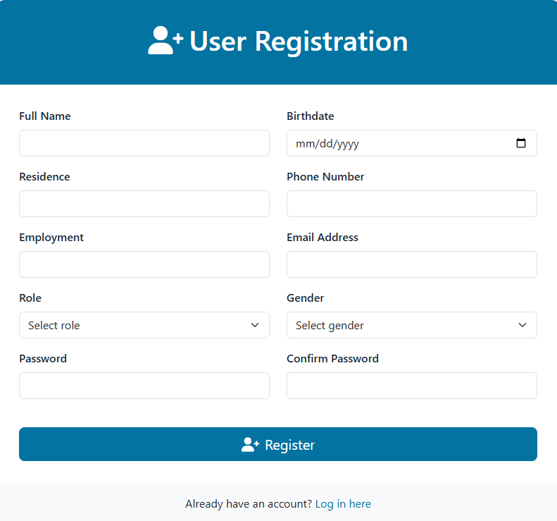
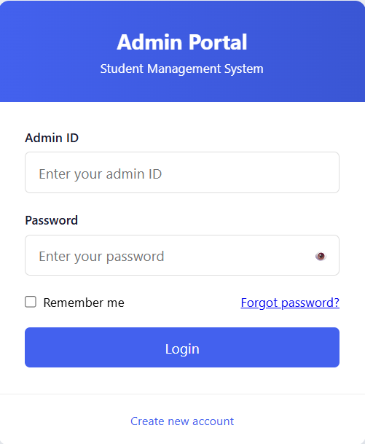

Figure 1. Login Page.
Before accessing the system, users must sign up to receive an
ID and password. Follow the steps below:

- Click on “Create New Account” (see Figure 1).
- Fill out all the required fields in the registration form.
- Click “Register” to create your account.
- Go to the “Admin Portal” to log in.
- Enter your ID and Password.
- Click the “Login” button to access the system.
- If the login is successful and the account has admin privileges, you will be directed to the admin interface (see Figure 2).
- If the login fails, an error message will appear. Re-enter your ID and password to try again.

3
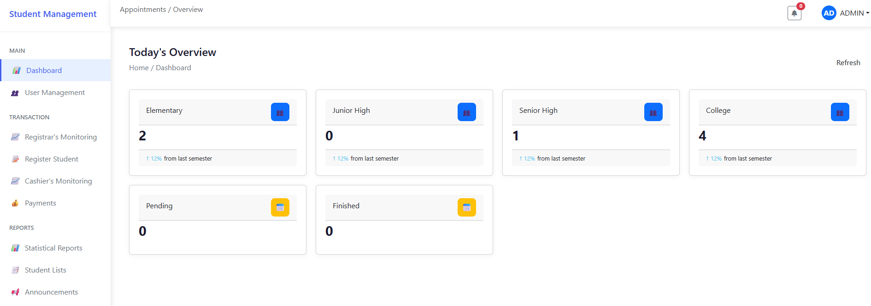

Figure 2. Administrator’s Interface.
Once logged in as an administrator, you will be directed to the Administrator’s Homepage. This interface features a sidebar with various navigation options.

Dashboard
The Dashboard provides key information about the school. It shows the enrollment progress across different educational stages and displays the status of daily tasks (both pending and completed).

- Click “Dashboard” on the sidebar.
- The system will display an overview of enrollment progress and daily task updates.

4
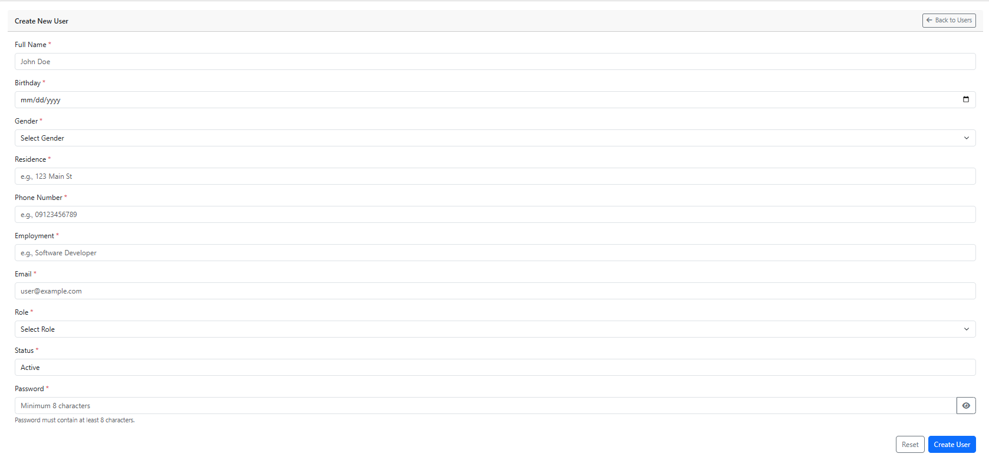
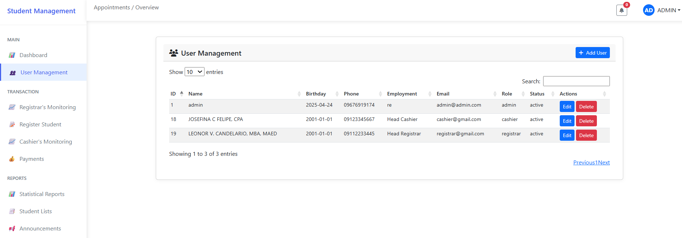

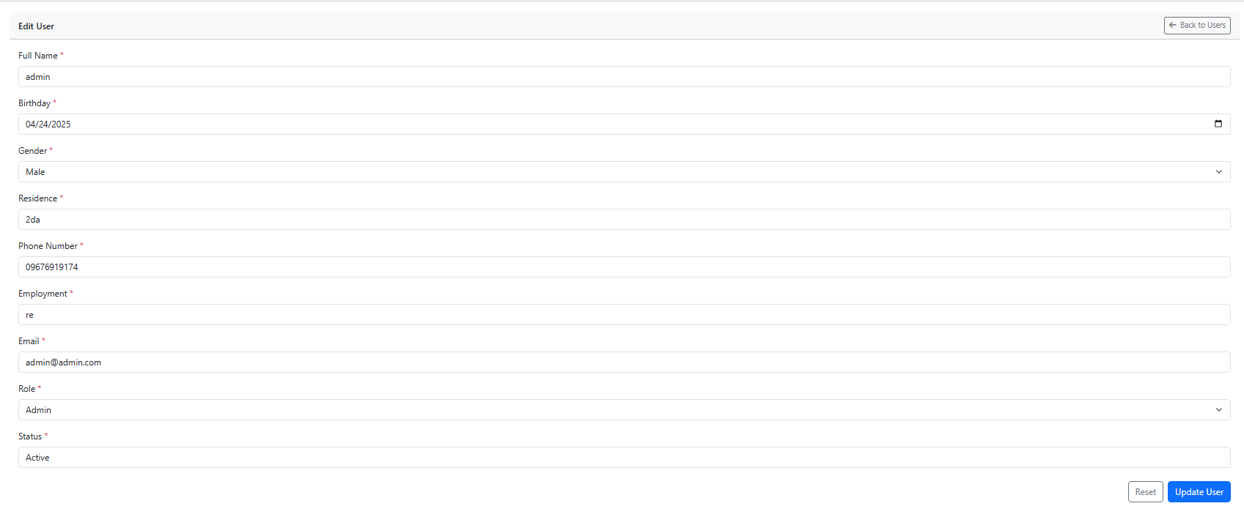

User Management
The User Management feature allows the administrator to create, view, update, and delete user accounts.

- Click “User Management” on the sidebar to view the list of users.
- To add a new user, click “Add User”, fill out all required fields, and then click “Create User” to complete the registration.
- To update a user’s information, click “Edit”, make the necessary changes, and then click “Update User” to save them.
- To remove a user, click “Delete” next to the corresponding account.

5
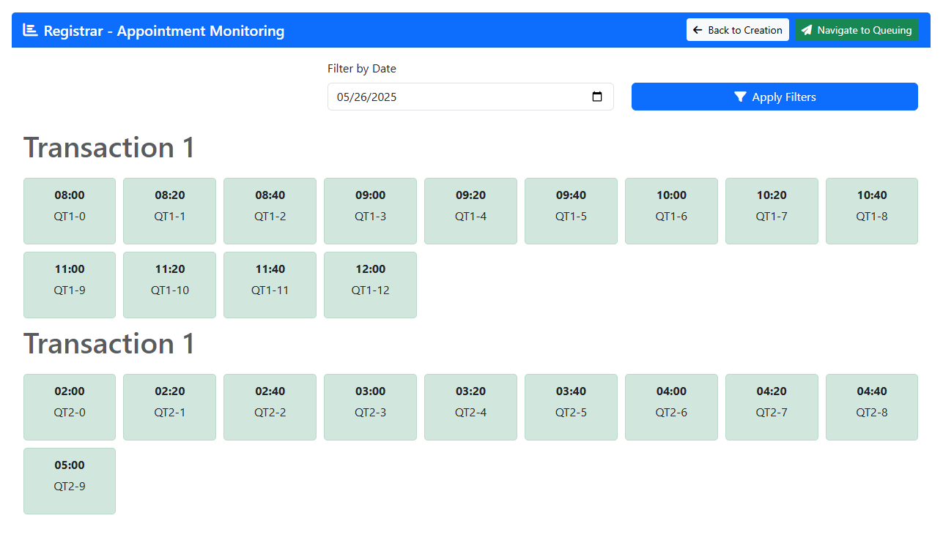
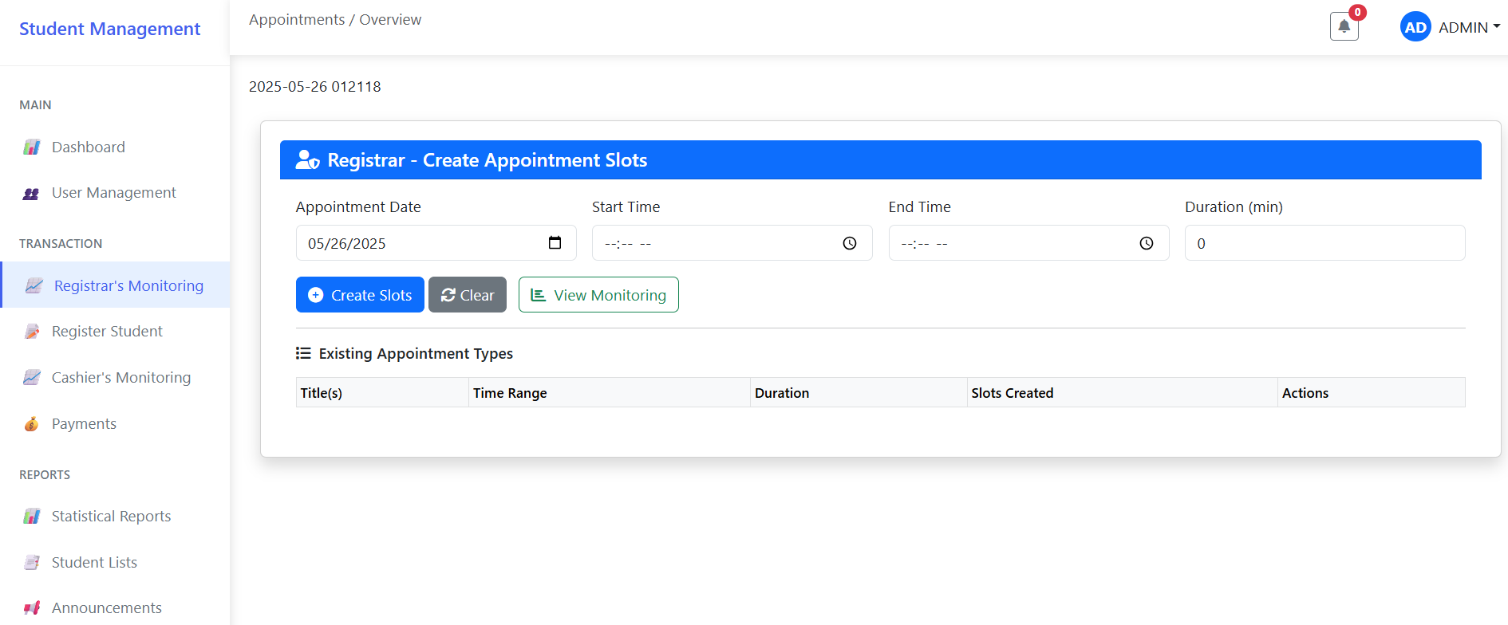

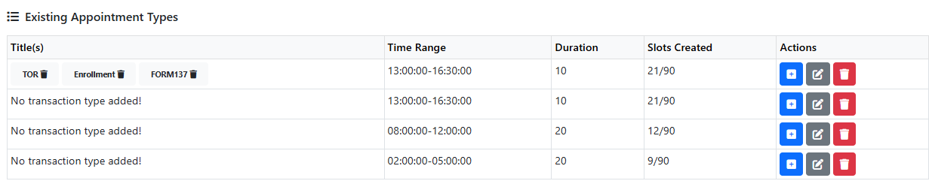

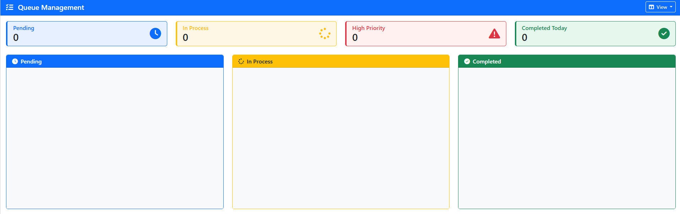

Registrar’s Monitoring
The Registrar’s Monitoring page allows the admin to monitor appointment types and availability slots created by the registrar’s staff. It also shows the current queue status of transactions in the registrar’s office. This page is strictly for viewing and monitoring purposes—admins are not allowed to entertain transactions here, even though they can perform CRUD (Create, Read, Update, Delete) operations on the data.

- Click “Registrar’s Monitoring” to view the list of appointment types created by the registrar’s staff.
- Click “View Monitoring” to see the availability slots that have been scheduled.
- Click “Navigate to Queuing” to check the current queue status of transactions for the registrar’s office.

6
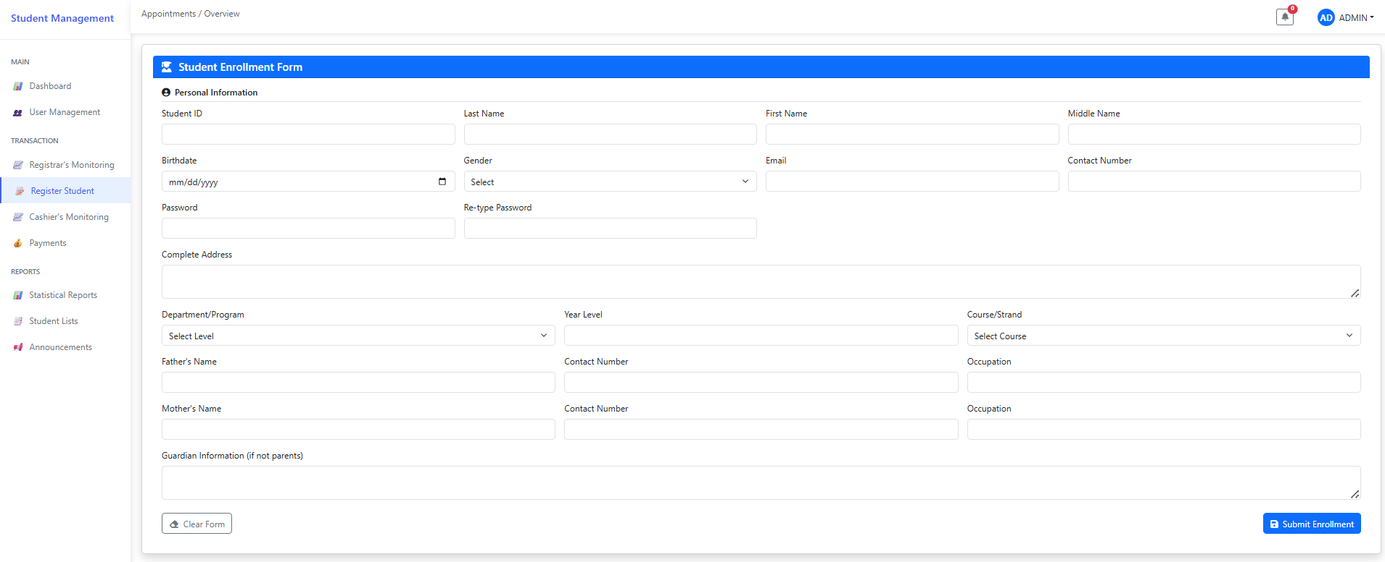

Register Student
The admin can register a student’s account through the
Register Student feature.

- Click “Register Student” to open the student registration form.
- Fill out all the required fields in the form.
- Click “Submit Enrollment” to successfully create the student’s account.

7
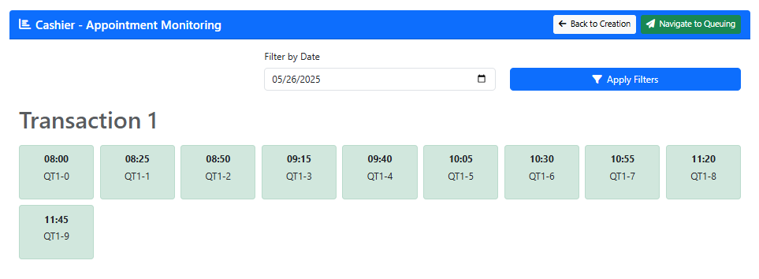
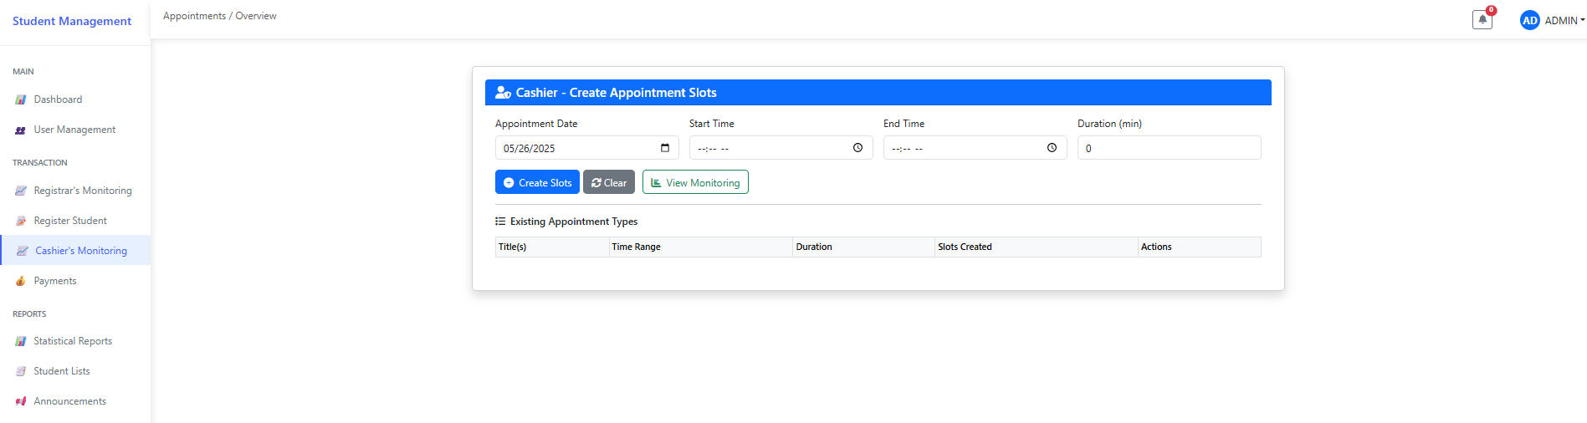

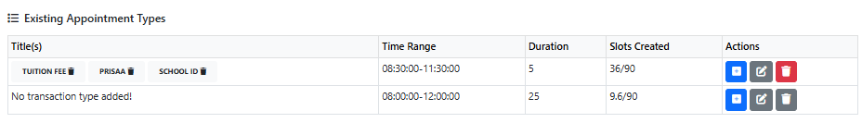

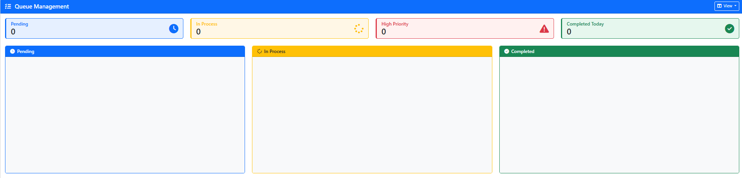

Cashier’s Monitoring
The Cashier’s Monitoring page allows the admin to monitor appointment types and availability slots created by the cashier’s staff. It also shows the current queue status of transactions in the cashier’s office. This page is strictly for viewing and monitoring purposes—admins are not allowed to entertain transactions here, even though they can perform CRUD (Create, Read, Update, Delete) operations on the data.

- Click “Cashier’s Monitoring” to view the list of appointment types created by the cashier’s staff.
- Click “View Monitoring” to see the availability slots that have been scheduled.
- Click “Navigate to Queuing” to check the current queue status of transactions for the cashier’s office.

8
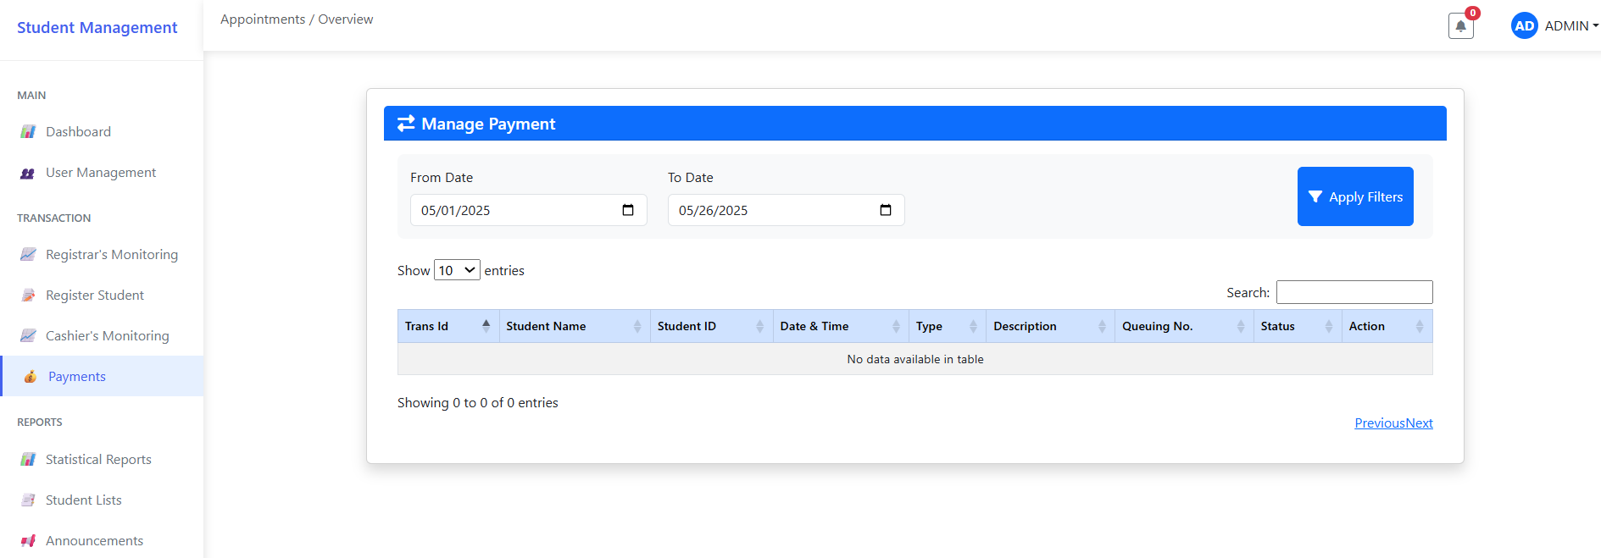
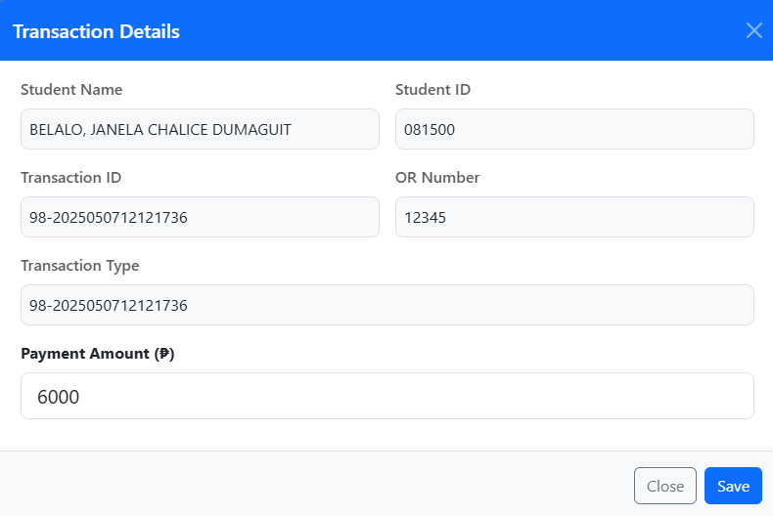

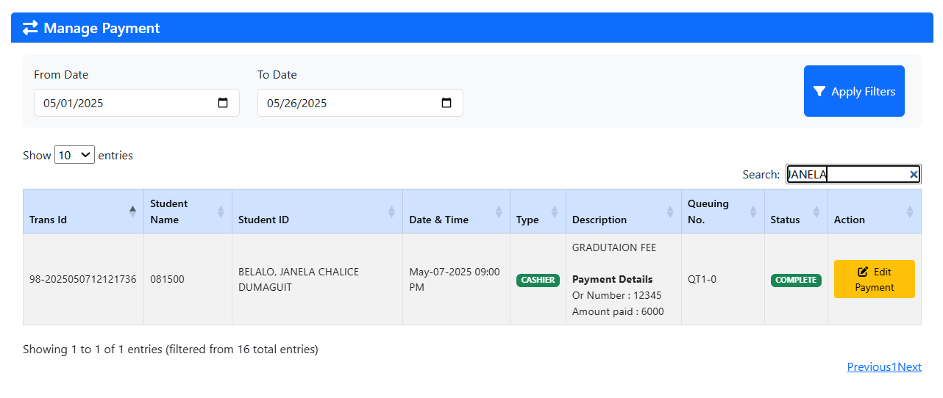

Payment
The admin can click “Payment” to view the list of payment transactions from the cashier’s office made by the cashier’s staff. The admin can read and update payment details, but cannot add or delete records.

- Click “Payment” to display the list of payment transactions made by the cashier’s staff and students.
- To find payment records from previous dates, use the date filters and click “Apply Filters”. You may also use the Search bar to look up a student’s name and check their payment details.
- To edit payment information, click “Edit Payment”, make the necessary changes, and then click “Save” to apply the updates.

9
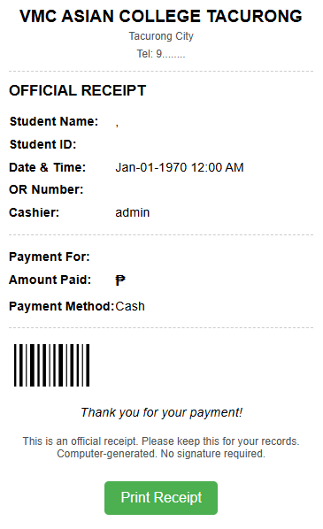
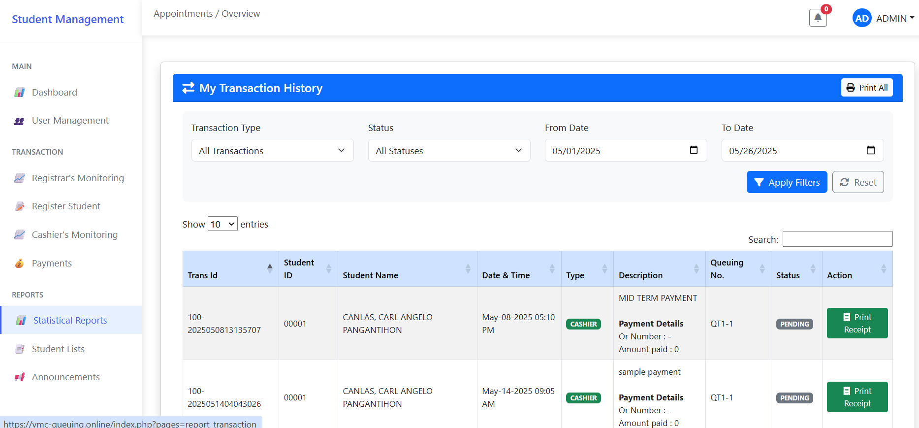

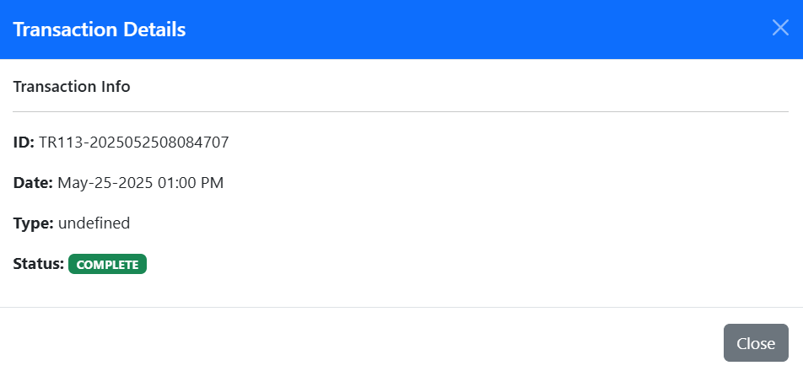
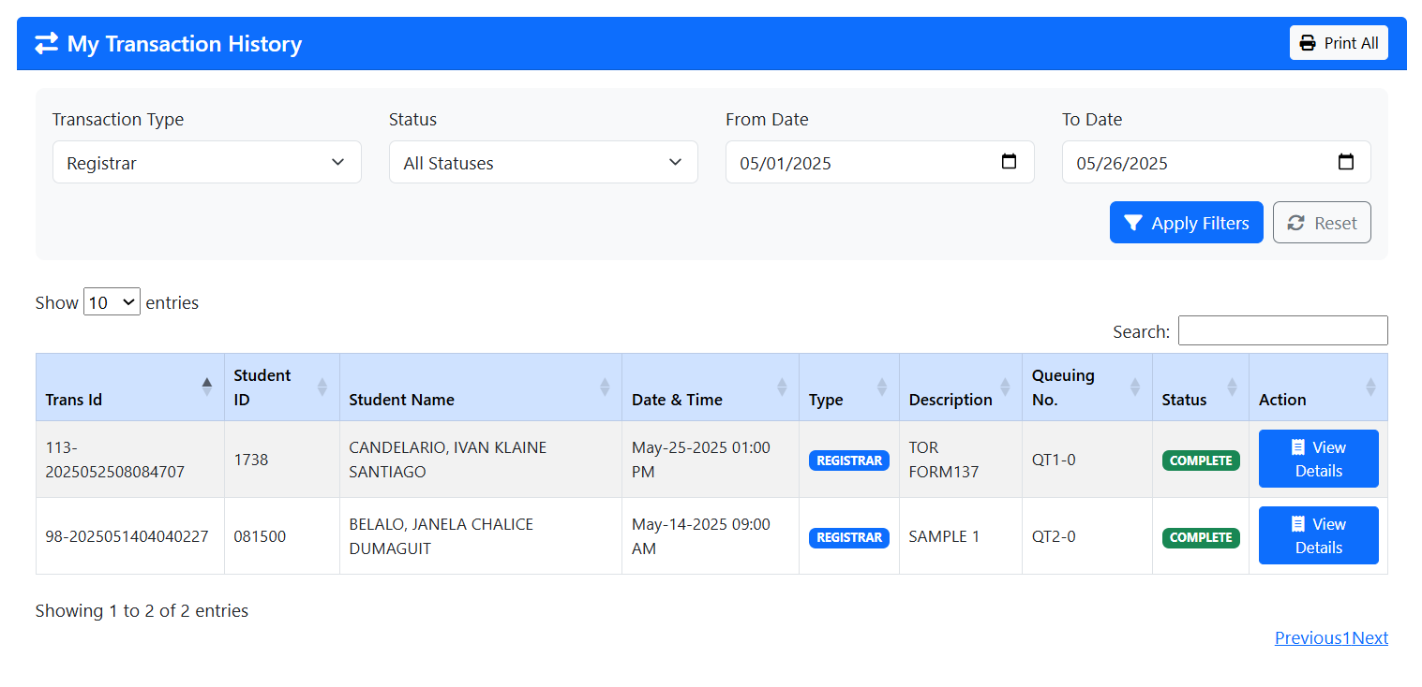

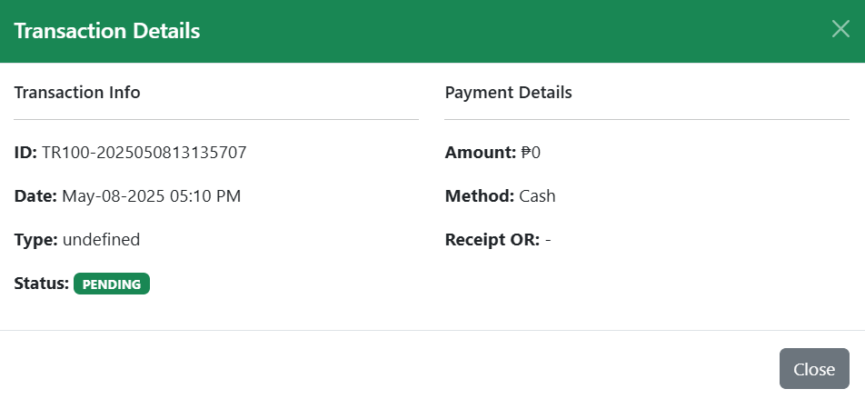
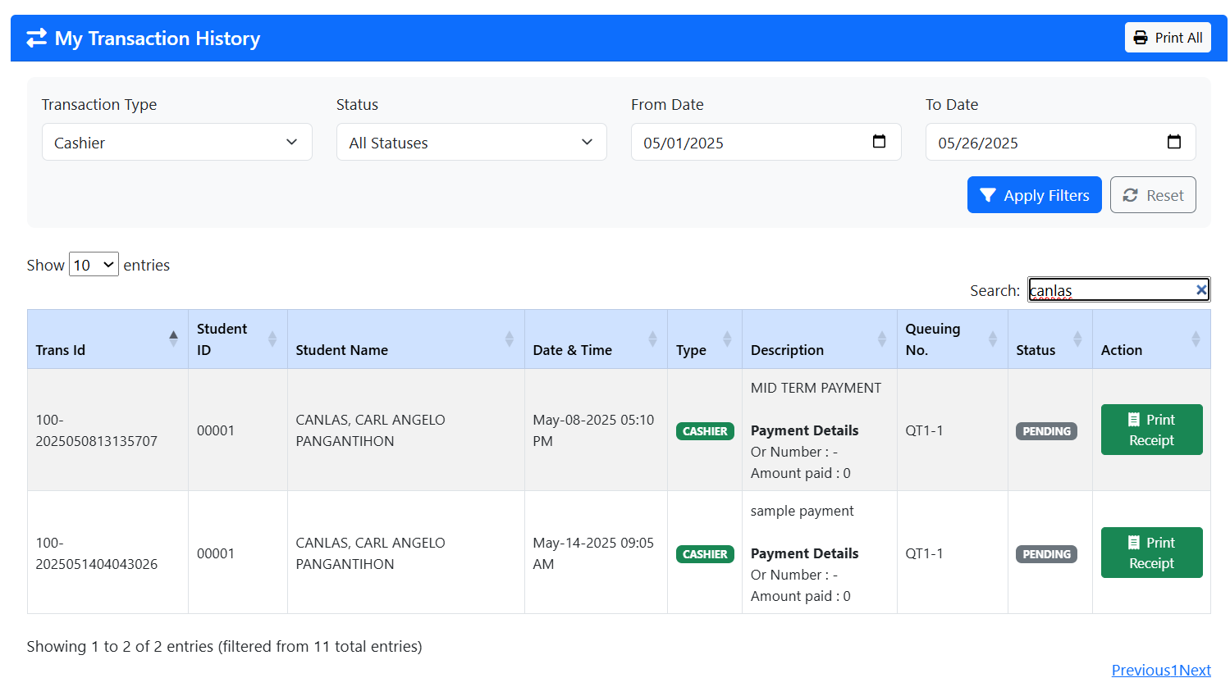

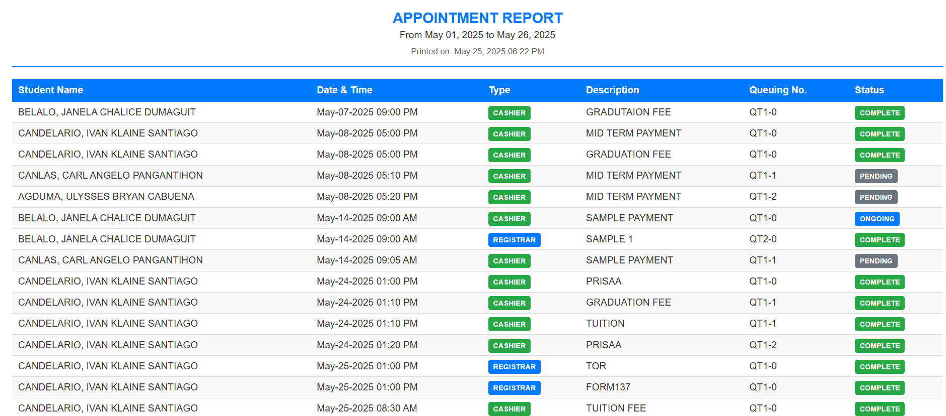

Statistical Reports
The admin can click “Statistical Reports” to view and manage transaction records from both the registrar’s and cashier’s offices.

- Click “Statistical Reports” to display the complete transaction history for both offices.
- To easily find specific data, use the available filters (e.g., transaction types, status, date range). After setting your desired filters, click “Apply Filters”. You may also use the Search bar to quickly find a specific student's transaction data.
- You can print the transaction history by clicking “Print All”. Choose whether to print all transactions or only those from a specific office (e.g., cashier or registrar).
- To view more details about registrar transactions, click “View Details.”
- To view or print a cashier transaction receipt, click “Print Receipt.”
10
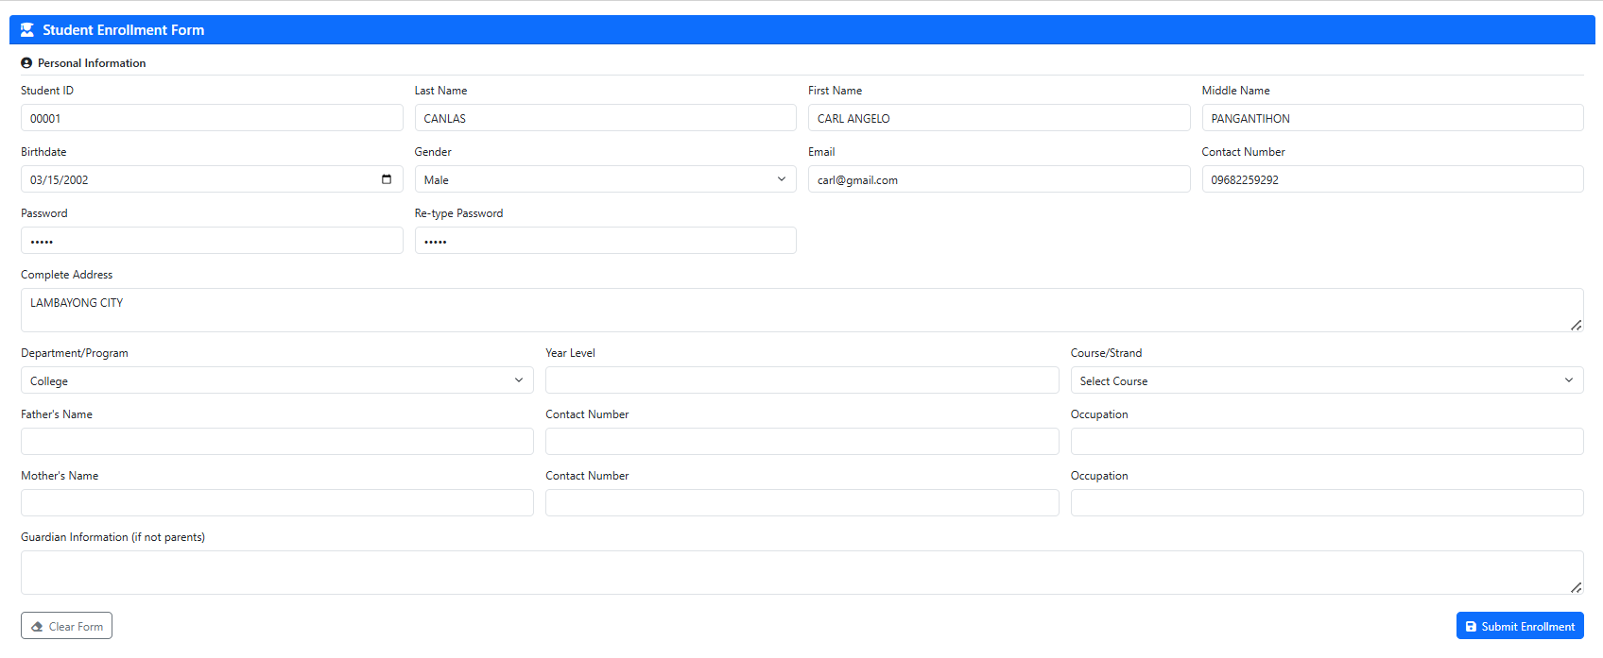
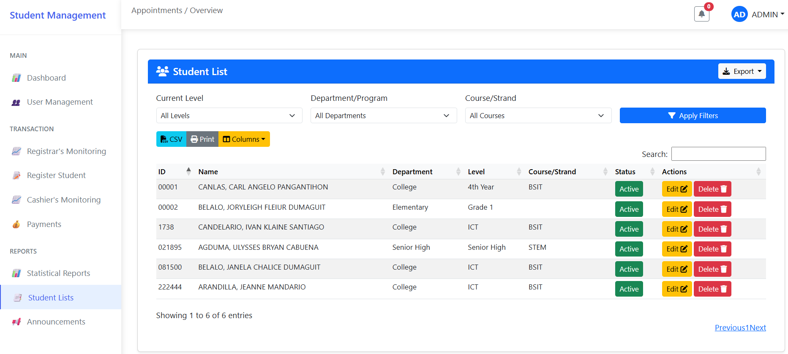

Student Lists
The admin can click “Student Lists” to view and manage student accounts. From this page, the admin can view, update, or delete student records.

- Click “Student Lists” to display the list of student accounts.
- To update a student’s account, click “Edit”, complete or modify the required fields, then click “Submit Enrollment” to save the changes.
- To delete a student’s account, click “Delete”, then confirm by clicking “Delete” again to permanently remove the account.
- To export student account data, click the “Export” button and choose your preferred document format.
- To quickly find specific student data, use the available filters (e.g., Current Level, Department/Program, Course/Strand), then click “Apply Filters”. You may also use the Search bar to locate a student’s account by name.

11
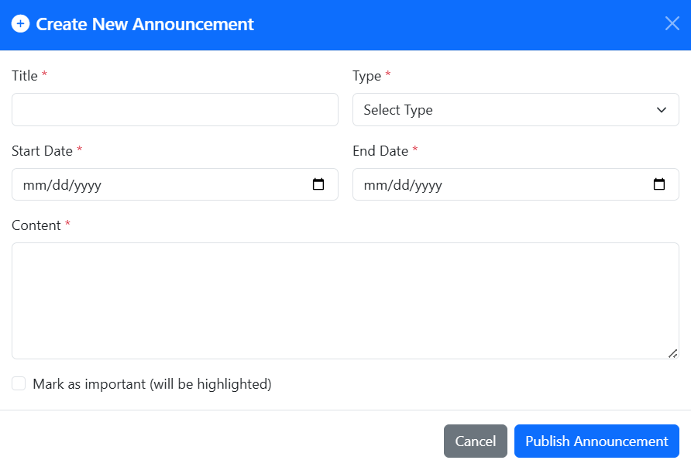
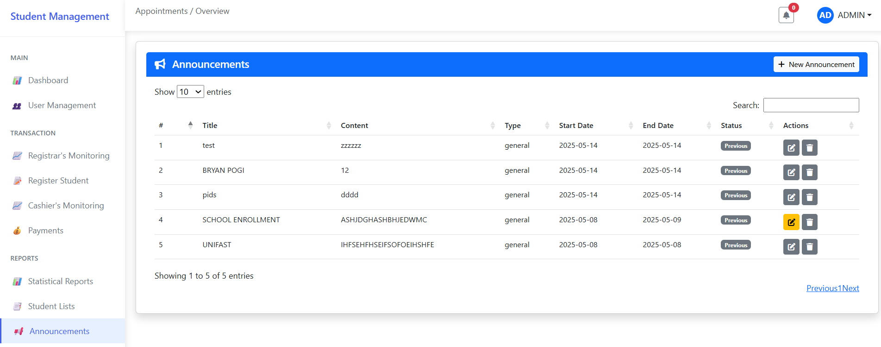

Announcements
On this page, the admin can create, view, update, and delete (CRUD) announcements.

- Click “New Announcement” to create a new announcement.
- Fill out the necessary fields, then click “Publish Announcement” to post it successfully.
- To update an existing announcement, click “Edit”, make the necessary changes, and then click “Publish Announcement” to apply the updates.
- Click “Delete” to remove an announcement.
- To find a previous announcement, use the Search bar to quickly locate it by title or content.

12
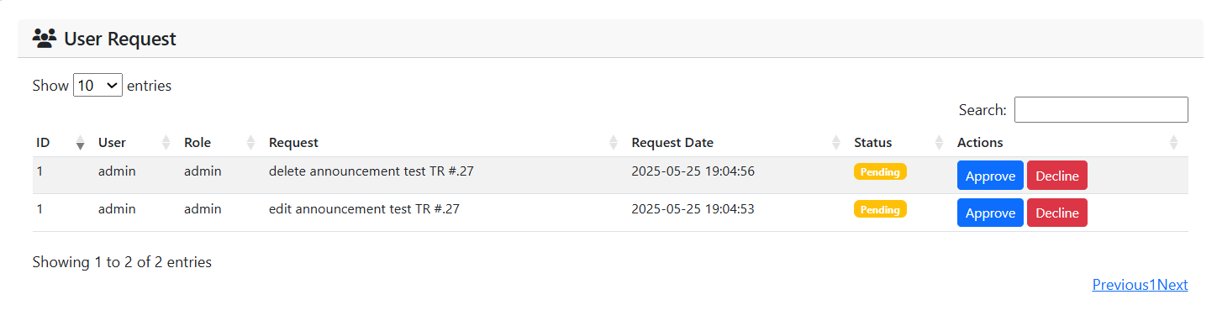

User Request
On this page, the admin can manage user requests submitted by the registrar’s and cashier’s staff.

- Click the notification bell icon to view incoming user requests.
- Click “Approve” to accept a user’s request.
- Click “Decline” to reject a user’s request.
- Use the Search bar to quickly find a specific request.

13

VMC ASIAN COLLEGE FOUNDATION, INC.

College of Computer Studies

WEB-BASED SCHOOL MANAGEMENT AND QUEUING SYSTEM OF VMCACFI WITH SMS NOTIFICATION

2025

CASHIER USER’S MANUAL

NAME OF RESEARCHERS:
PLARIDEL CEDRIK GUERRERO
IVAN KLAINE CANDELARIO
JANELA CHALICE BELALO
ULYSSES BRYAN AGDUMA
JEANNE ARANDILLA JR.

1
TABLE OF CONTENTS

Title Page 1
Table of Contents 2
Figure 1. Login Page 3
Figure 2. Cashier’s Interface 4
Dashboard 4
Cashier’s Monitoring 5
Payments 6
Statistical Reports 7
Student Lists 8
Announcements 9
Profile 10

2

Figure 1. Login Page.
Before accessing the system, users must sign up to receive a
unique ID and password. Follow the steps below:

- Click on “Create New Account” (see Figure 1).
- Complete all required fields in the registration form.
- Click “Register” to create your account.
- Navigate to the “Admin Portal” to log in.
- Enter your ID and Password.
- Click the “Login” button to access the system.
- If the login is successful and the account has cashier privileges, you will be directed to the Cashier Interface (see Figure 2).
- If the login fails, an error message will appear. Re-enter your ID and password to try again.

3
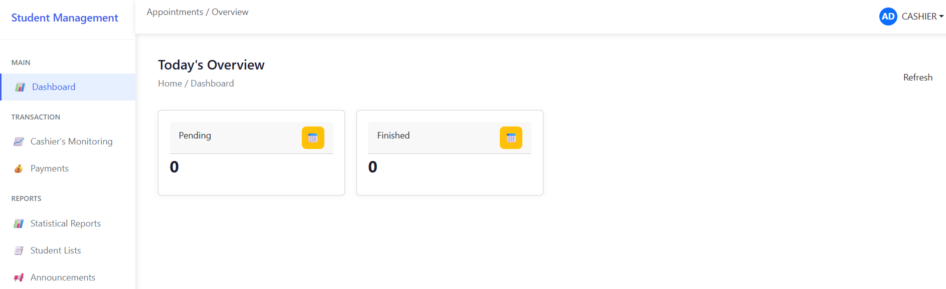

Figure 2. Cashier’s Interface.
After logging in as a cashier, the system will direct you to the Cashier’s Homepage. This interface includes a sidebar with various navigation options.

Dashboard
The Dashboard provides an overview of the cashier’s daily tasks, including both pending and completed transactions.

Steps to Access the Dashboard:

- Click “Dashboard” on the sidebar.
- The system will display a summary of daily task updates.

4
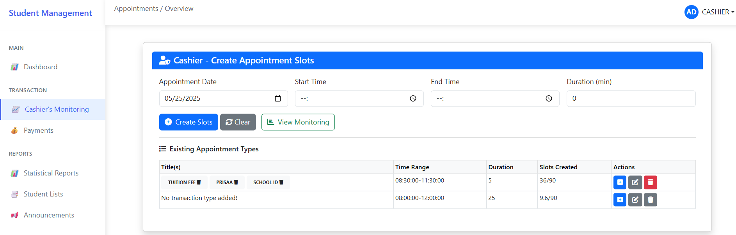
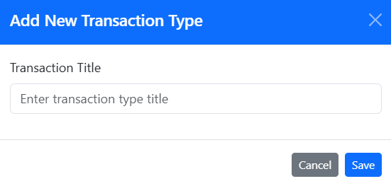

Cashier’s Monitoring
The Cashier’s Monitoring page allows the cashier to create appointment types and availability slots. Cashiers can only update or delete appointment types if permission has been granted by the admin. A request must be submitted by the cashier’s staff before these actions can be performed.

- To create slots, fill out the required fields (appointment date, start time, end time, and duration), then click the “Create Slots” button to book your availability.
- Click the blue button in the Action box to create appointment types. Then click “Save” to successfully add the appointment type.
- Click the “Edit” button to update an appointment type. This function is only available if the admin has granted you permission.
- Click the “Delete” button to remove an appointment type. This also requires admin permission.
- Click “View Monitoring” to see the availability slots you have scheduled.
- Click “Navigate to Queuing” to check the current queue status for transactions in your office.

5
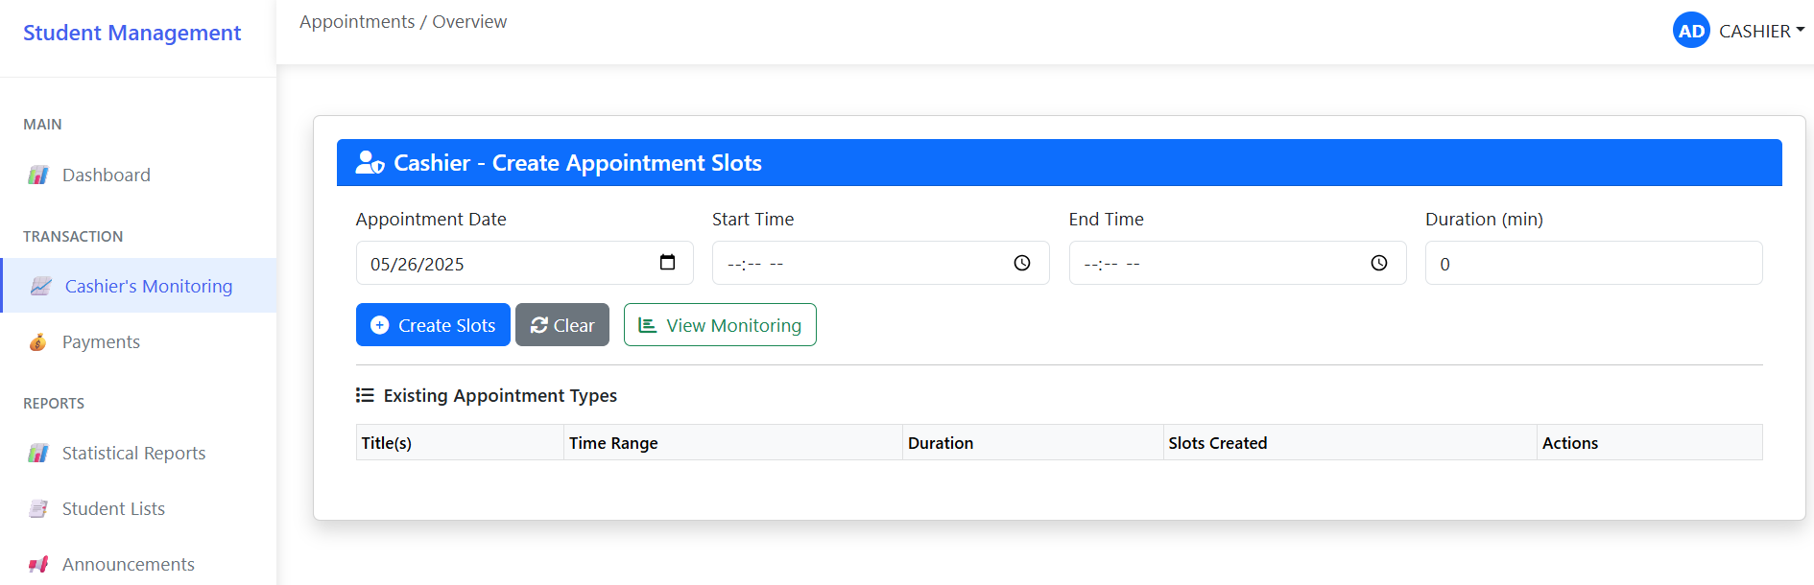

Payment
The Cashier can click “Payment” to view a list of payment transactions they have processed. While the cashier can view and edit payment details (with admin permission), they cannot add or delete records.

- Click “Payment” to display the list of payment transactions you have processed with students.
- To find payment records from previous dates, use the date filters and click “Apply Filters”. You may also use the Search bar to look up a student’s name and view their payment details.
- To edit payment information, click “Edit Payment”, make the necessary changes, and then click “Save” to apply the updates. This feature is only available if the admin has granted you permission.

6
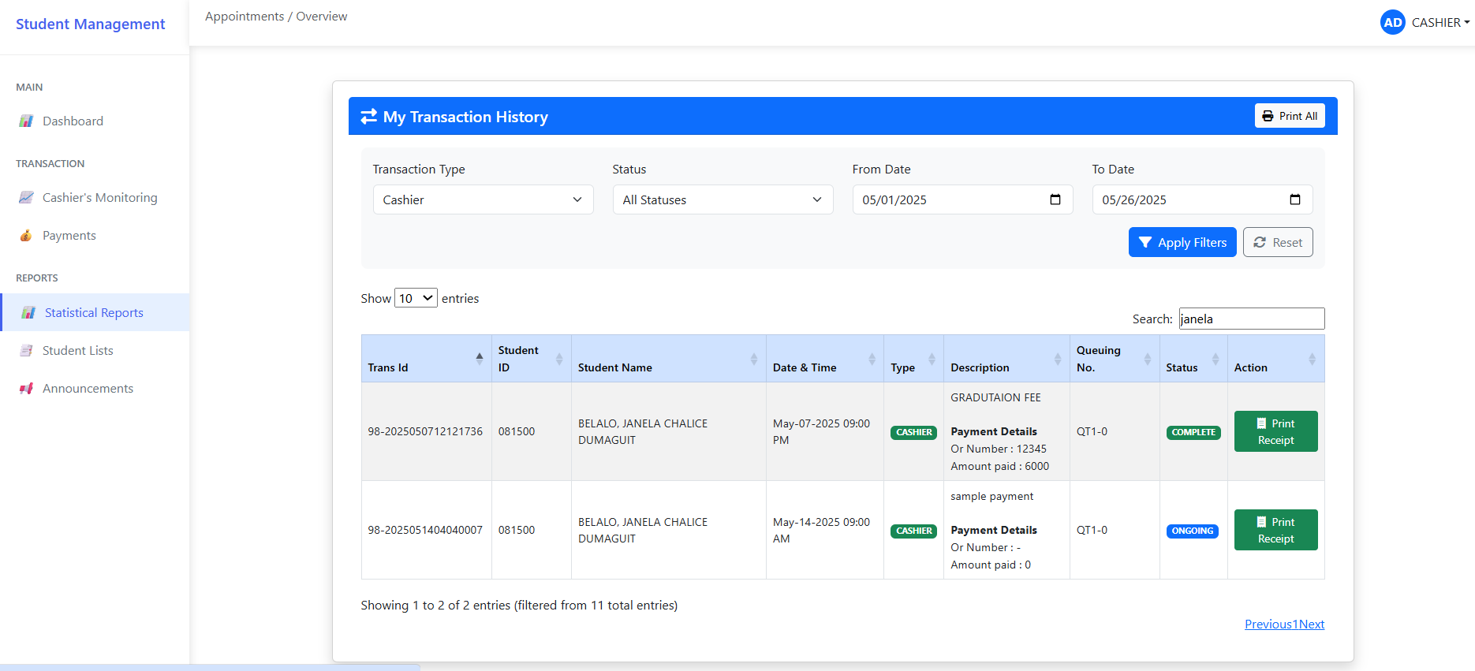
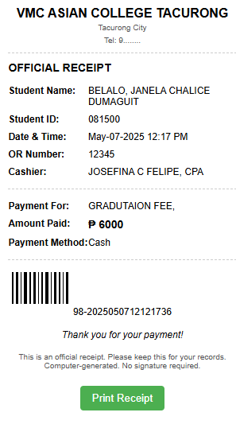

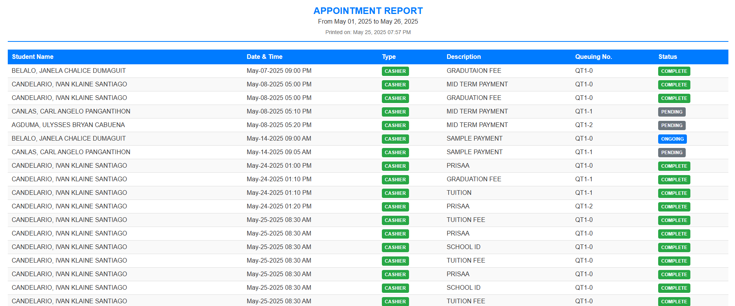

Statistical Reports
The Cashier can click “Statistical Reports” to view and
manage transaction records from their office.

- Click “Statistical Reports” to display the complete transaction history for your office.
- To easily find specific data, use the available filters (e.g., status and date range). After setting the desired filters, click “Apply Filters”. You may also use the Search bar to quickly locate a specific student's transaction data.
- To print the entire transaction history, click “Print All”.
- To view or print an individual transaction and its receipt, click “Print Receipt.”

7
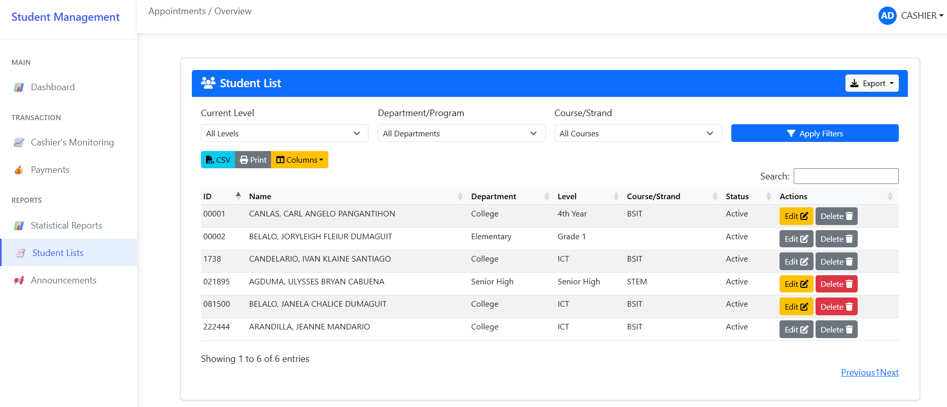

Student Lists
The Cashier can click “Student Lists” to view and manage student accounts. From this page, the cashier can view, update, or delete student records only if permitted by the admin.

- Click “Student Lists” to display the list of student accounts.
- To update a student’s account, click “Edit”, complete or modify the required fields, then click “Submit Enrollment” to save the changes. This function is only available with admin permission.
- To delete a student’s account, click “Delete”, then confirm by clicking “Delete” again to permanently remove the account. This action is also restricted to those with admin permission.
- To export student account data, click the “Export” button and select your preferred document format.
- To quickly locate specific student data, use the available filters (e.g., Current Level, Department/Program, Course/Strand), then click “Apply Filters.” You may also use the Search bar to find a student’s account by name.

8
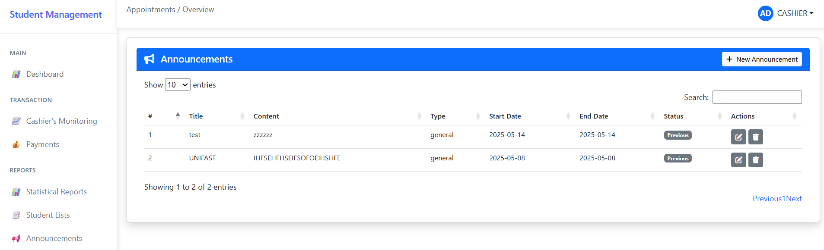

Announcements
On this page, the Cashier can create and view announcements. However, updating or deleting announcements is only allowed if the admin grants permission.

- Click “New Announcement” to create a new announcement.
- Fill out the required fields, then click “Publish Announcement” to post it successfully.
- To update an existing announcement, click “Edit”, make the necessary changes, and then click “Publish Announcement” to apply the updates. This option is only available with admin permission.
- Click “Delete” to remove an announcement. This action is restricted and will only work if the admin permits it.
- To locate a previous announcement, use the Search bar to quickly find it by title or content.

9
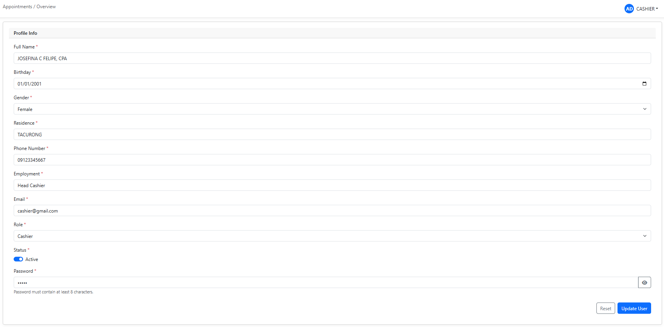

Profile
On this page, the Cashier can update their personal information.

- Click the “Cashier” icon, then select “Profile” to view your account details.
- Make the necessary changes, then click “Update User” to successfully save your updated information.

10

VMC ASIAN COLLEGE FOUNDATION, INC.

College of Computer Studies

WEB-BASED SCHOOL MANAGEMENT AND QUEUING SYSTEM OF VMCACFI WITH SMS NOTIFICATION

2025

REGISTRAR USER’S MANUAL

NAME OF RESEARCHERS:
PLARIDEL CEDRIK GUERRERO
IVAN KLAINE CANDELARIO
JANELA CHALICE BELALO
ULYSSES BRYAN AGDUMA
JEANNE ARANDILLA JR.

1
TABLE OF CONTENTS

Title Page 1
Table of Contents 2
Figure 1. Login Page 3
Figure 2. Registrar’s Interface 4
Dashboard 4
Registrar’s Monitoring 5
Register Student 6
Statistical Reports 7
Student Lists 8
Announcements 9
Profile 10

2

Figure 1. Login Page.
Before accessing the system, users must sign up to receive a
unique ID and password. Follow the steps below:

- Click on “Create New Account” (see Figure 1).
- Complete all required fields in the registration form.
- Click “Register” to create your account.
- Navigate to the “Admin Portal” to log in.
- Enter your ID and Password.
- Click the “Login” button to access the system.
- If the login is successful and the account has registrar privileges, you will be directed to the Registrar Interface (see Figure 2).
- If the login fails, an error message will appear. Re-enter your ID and password to try again.

3
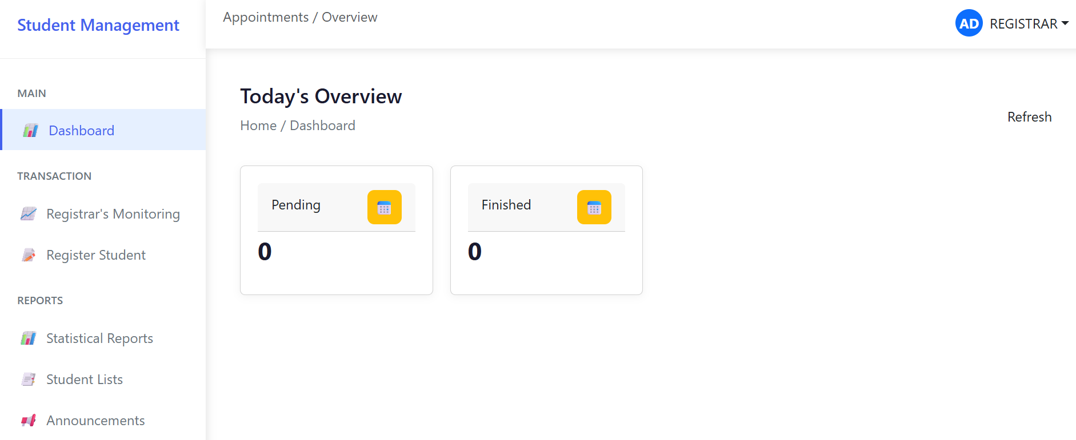

Figure 2. Registrar’s Interface.
After logging in as a registrar, the system will direct you to the Registrar’s Homepage. This interface includes a sidebar with various navigation options.

Dashboard
The Dashboard provides an overview of the registrar’s daily tasks, including both pending and completed transactions.

Steps to Access the Dashboard:

- Click “Dashboard” on the sidebar.
- The system will display a summary of daily task updates.

4
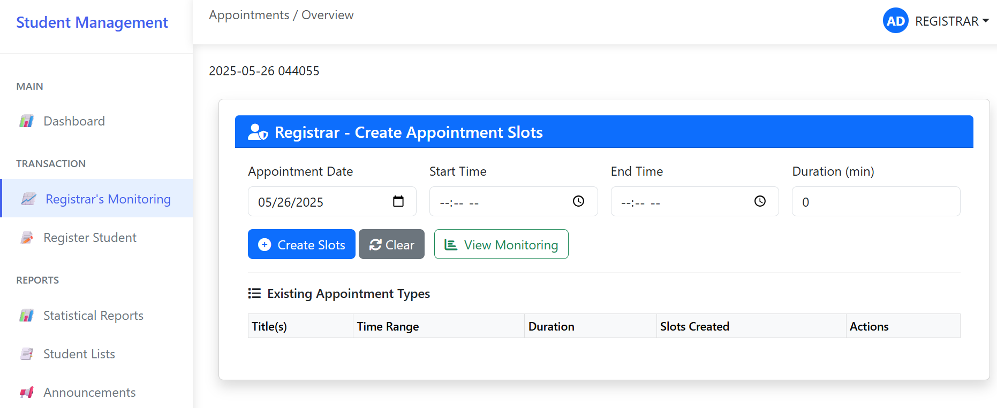

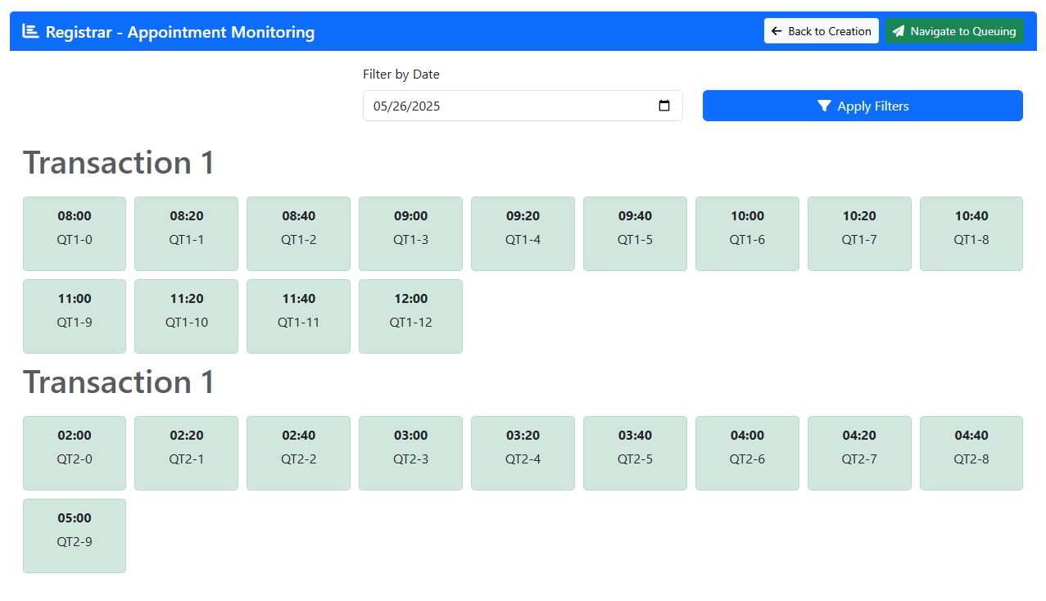

Registrar’s Monitoring
The Registrar’s Monitoring page allows the registrar to create appointment types and availability slots. Registrars can only update or delete appointment types if permission has been granted by the admin. A request must be submitted by the registrar’s staff before these actions can be performed.

- To create slots, fill out the required fields (appointment date, start time, end time, and duration), then click the “Create Slots” button to book your availability.
- Click the blue button in the Action box to create appointment types. Then click “Save” to successfully add the appointment type.
- Click the “Edit” button to update an appointment type. This function is only available if the admin has granted you permission.
- Click the “Delete” button to remove an appointment type. This also requires admin permission.
- Click “View Monitoring” to see the availability slots you have scheduled.
- Click “Navigate to Queuing” to check the current queue status for transactions in your office.

5
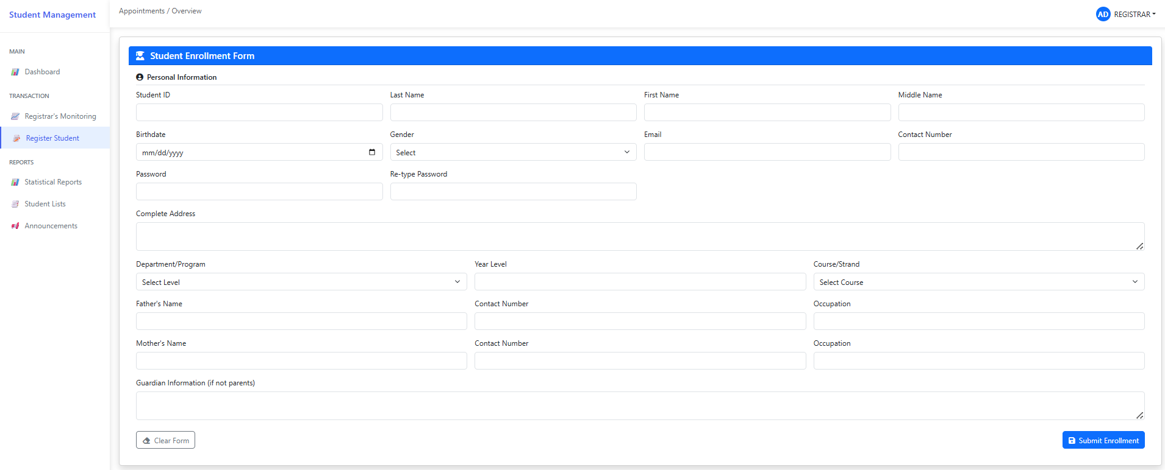

Register Student
The registrar can register a student’s account through the Register Student feature.

- Click “Register Student” to open the student registration form.
- Fill out all the required fields in the form.
- Click “Submit Enrollment” to successfully create the student’s account.

6
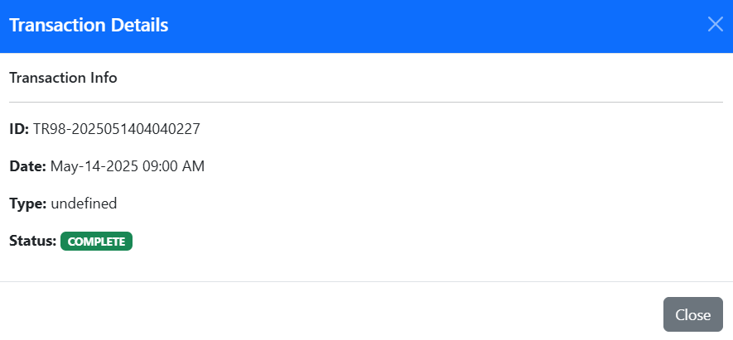
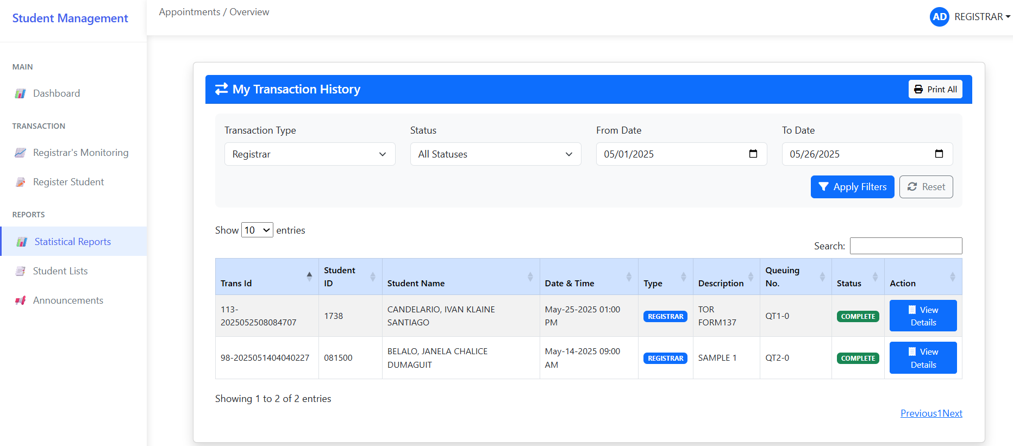

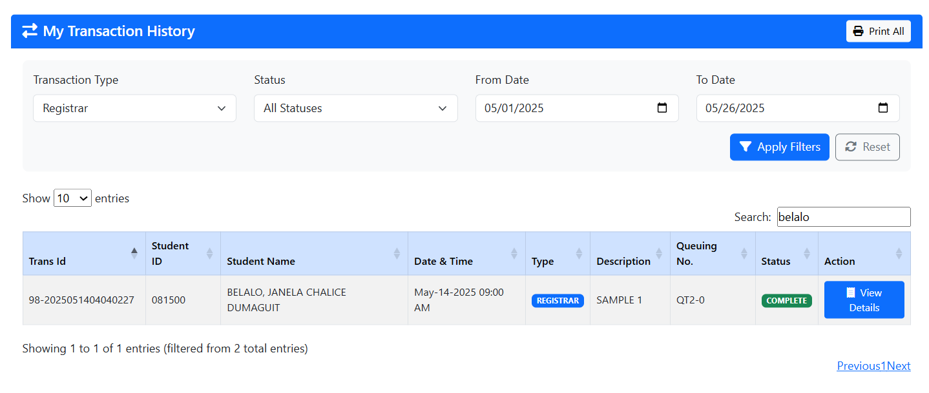
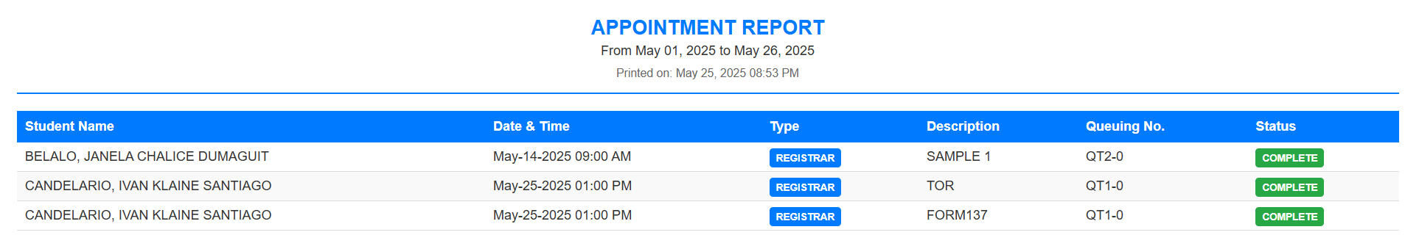

Statistical Reports
The Registrar can click “Statistical Reports” to view and manage transaction records from their office.

- Click “Statistical Reports” to display the complete transaction history for your office.
- To easily find specific data, use the available filters (e.g., status and date range). After setting the desired filters, click “Apply Filters”. You may also use the Search bar to quickly locate a specific student's transaction data.
- To print the entire transaction history, click “Print All”.
- To view more details about registrar transactions, click “View Details.”

7
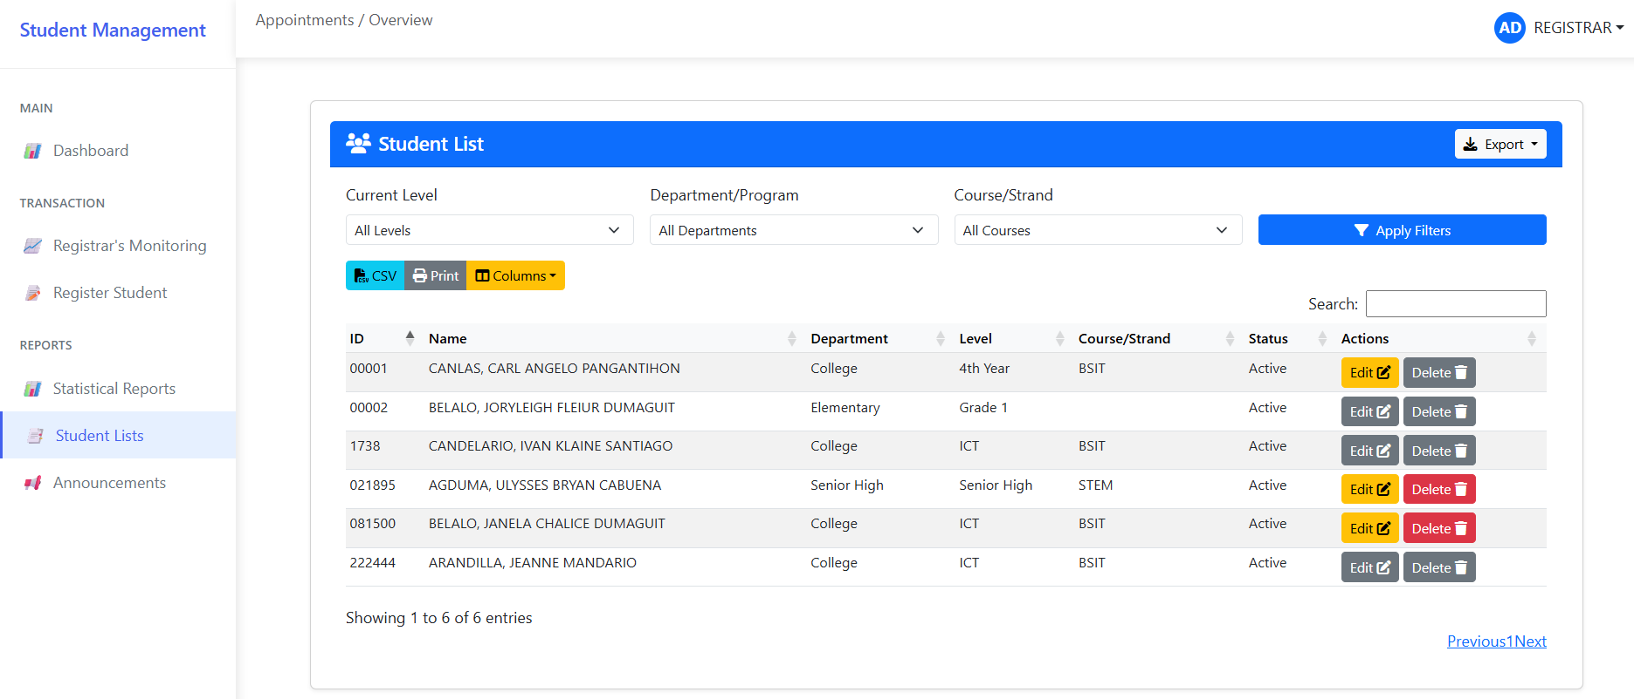

Student Lists
The Registrar can click “Student Lists” to view and manage student accounts. From this page, the registrar can view, update, or delete student records only if permitted by the admin.

- Click “Student Lists” to display the list of student accounts.
- To update a student’s account, click “Edit”, complete or modify the required fields, then click “Submit Enrollment” to save the changes. This function is only available with admin permission.
- To delete a student’s account, click “Delete”, then confirm by clicking “Delete” again to permanently remove the account. This action is also restricted to those with admin permission.
- To export student account data, click the “Export” button and select your preferred document format.
- To quickly locate specific student data, use the available filters (e.g., Current Level, Department/Program, Course/Strand), then click “Apply Filters.” You may also use the Search bar to find a student’s account by name.

8
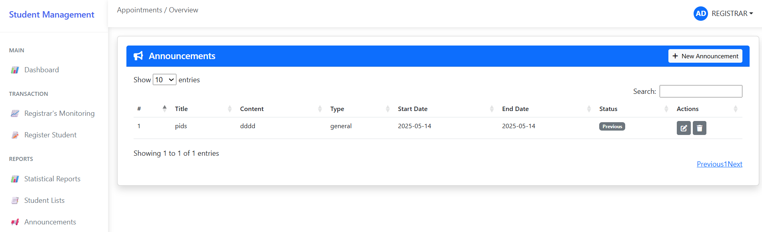

Announcements
On this page, the Registrar can create and view announcements. However, updating or deleting announcements is only allowed if the admin grants permission.

- Click “New Announcement” to create a new announcement.
- Fill out the required fields, then click “Publish Announcement” to post it successfully.
- To update an existing announcement, click “Edit”, make the necessary changes, and then click “Publish Announcement” to apply the updates. This option is only available with admin permission.
- Click “Delete” to remove an announcement. This action is restricted and will only work if the admin permits it.
- To locate a previous announcement, use the Search bar to quickly find it by title or content.

9
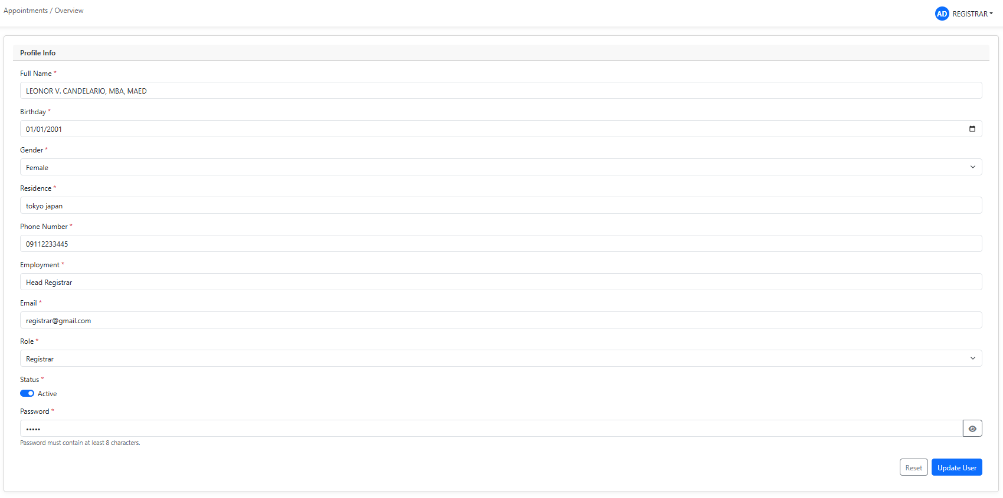

Profile
On this page, the Registrar can update their personal information.

- Click the “Registrar” icon, then select “Profile” to view your account details.
- Make the necessary changes, then click “Update User” to successfully save your updated information.

10

VMC ASIAN COLLEGE FOUNDATION, INC.

College of Computer Studies

WEB-BASED SCHOOL MANAGEMENT AND QUEUING SYSTEM OF VMCACFI WITH SMS NOTIFICATION

2025

STUDENT USER’S MANUAL

NAME OF RESEARCHERS:
PLARIDEL CEDRIK GUERRERO
IVAN KLAINE CANDELARIO
JANELA CHALICE BELALO
ULYSSES BRYAN AGDUMA
JEANNE ARANDILLA JR.

1
TABLE OF CONTENTS

Title Page 1
Table of Contents 2
Figure 1. Login Page 3
Figure 2. Student’s Interface 4
Dashboard 4
Announcements 5
Registrar’s Appointment 6
Cashier’s Appointment 7
Transaction Reports 8
Profile 9

2
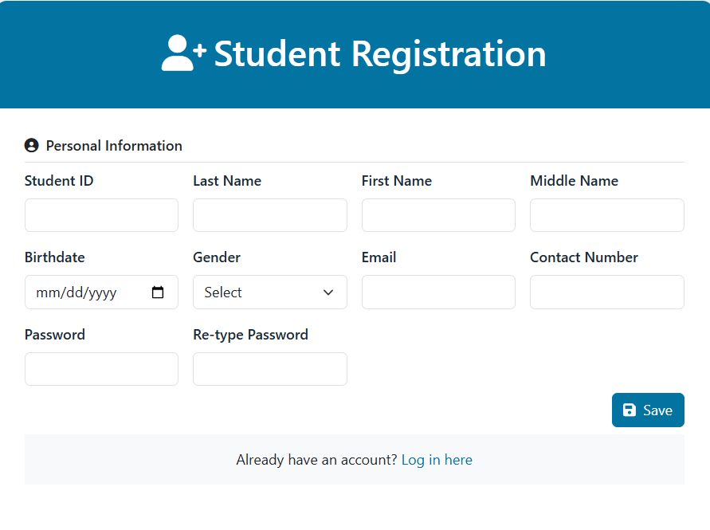
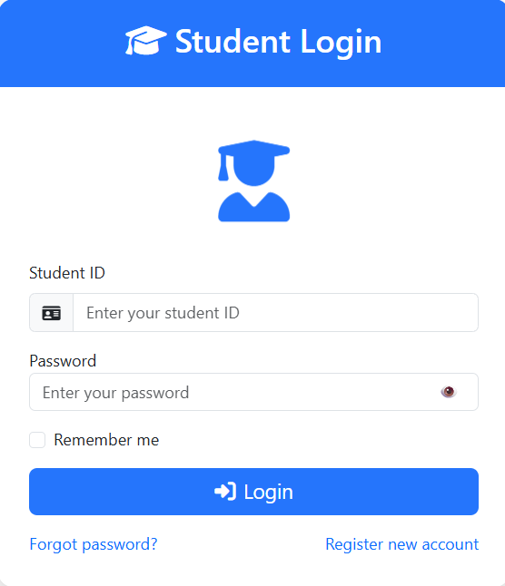

Figure 1. Login Page.
Before accessing the system, users must sign up to receive a
unique ID and password. Follow the steps below:

- Click “Register New Account” (see Figure 1).
- Complete all required fields in the registration form.
- Click “Save” to create your account.
- Navigate to the “Student Login” page to log in.
- Enter your ID and Password.
- Click the “Login” button to access the system.
- If the login is successful and your account has student privileges, you will be directed to the Student Interface (see Figure 2).
- If the login fails, an error message will appear. Re-enter your ID and password to try again.

3
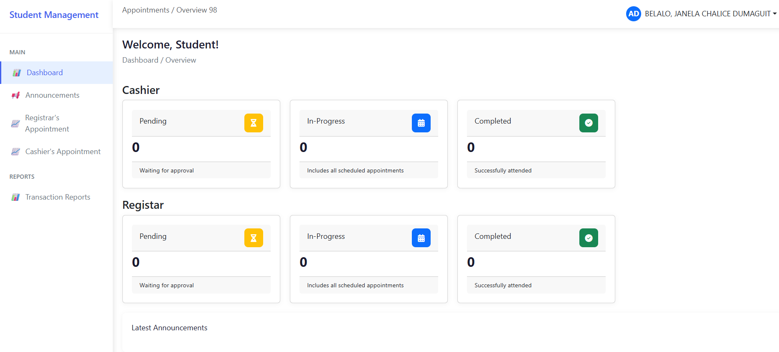

Figure 2. Student’s Interface.
After logging in as a student, the system will direct you to the Student Homepage. This interface includes a sidebar with various navigation options.

Dashboard
The Dashboard provides an overview of the current queue status for both the Registration Office and the Cashier’s Office and it also shows the glimpse of latest announcements.

Steps to Access the Dashboard:

- Click “Dashboard” on the sidebar.
- The system will display a summary of the queue status for both offices and the glimpse of latest announcements.

4
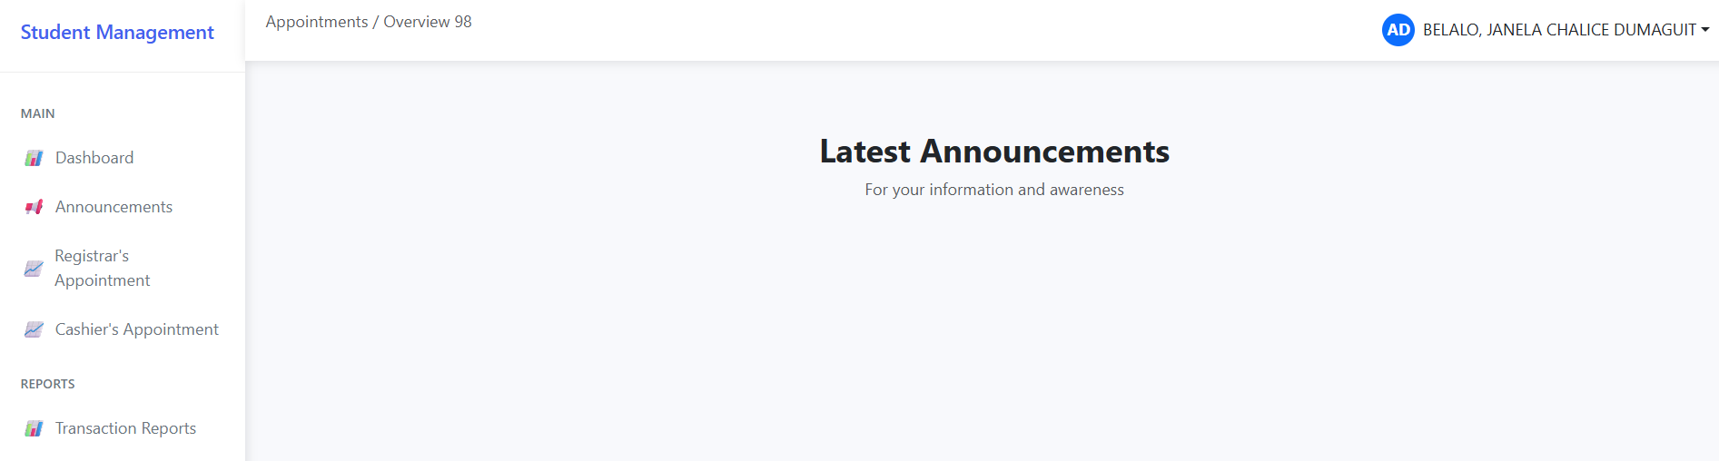

Announcement
Students can view all announcements posted by the admin, cashier, and registrar on this page.

Steps to View Announcements:

- Click “Announcement” from the sidebar to view the full list of announcements.

5
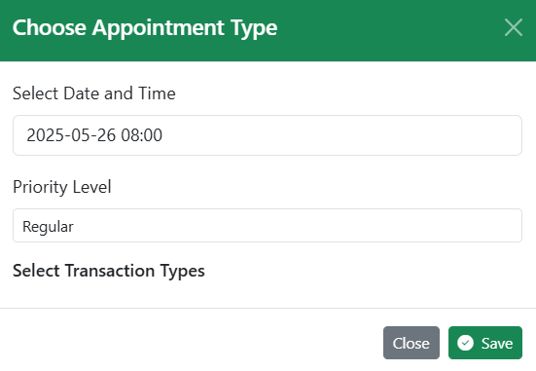
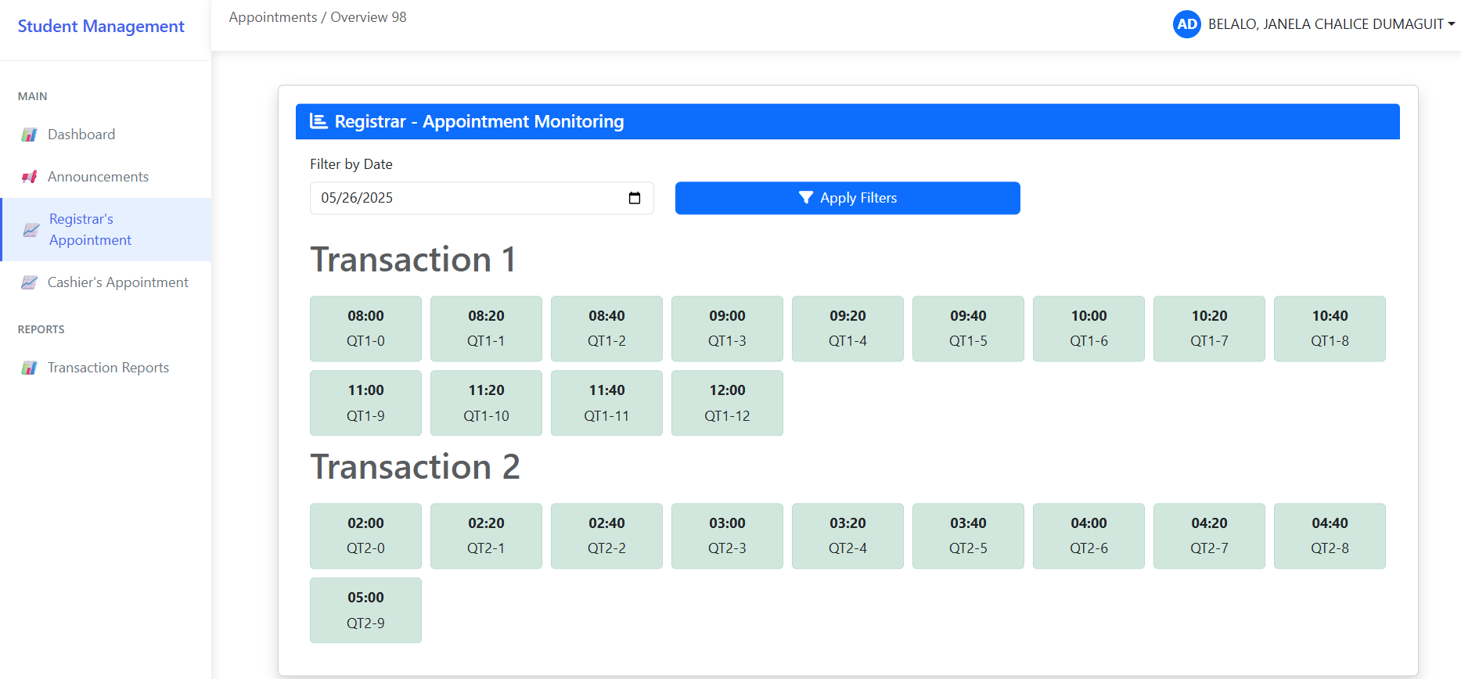

Registrar’s Appointment
Students can book available time slots with the Registrar through this page. Booking is done by selecting a time slot that matches the student's queue number.

Steps to Book an Appointment:

- Click the green box that corresponds to your queue number and preferred time slot.
- From the dropdown options, select your priority level, then choose the transaction type you want to book.
- Click “Save” to successfully book your appointment.

6
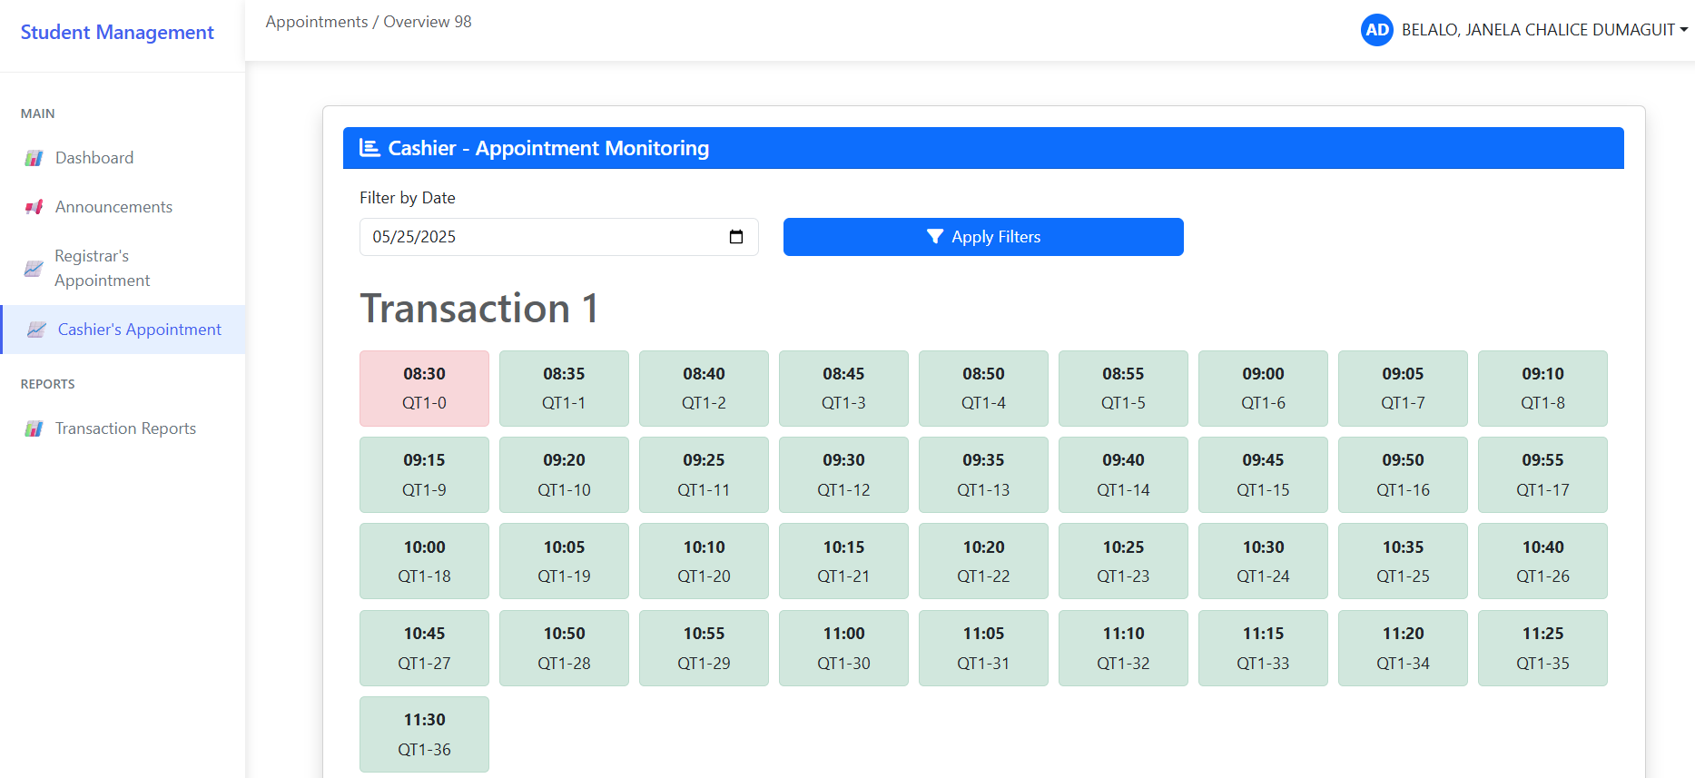
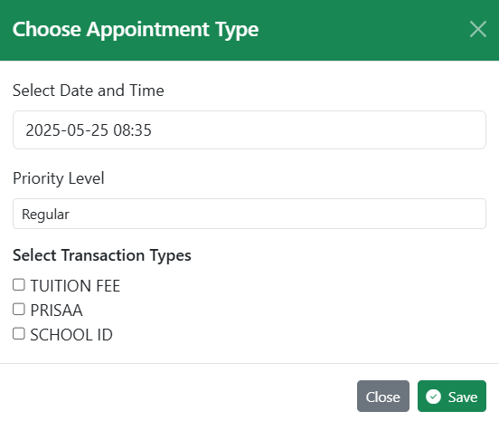

Cashier’s Appointment
Students can book available time slots with the Cashier through this page. Booking is done by selecting a time slot that matches the student's queue number.

Steps to Book an Appointment:

- Click the green box that corresponds to your queue number and preferred time slot.
- From the dropdown options, select your priority level, then choose the transaction type you want to book.
- Click “Save” to successfully book your appointment.

7
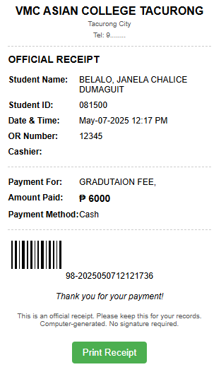
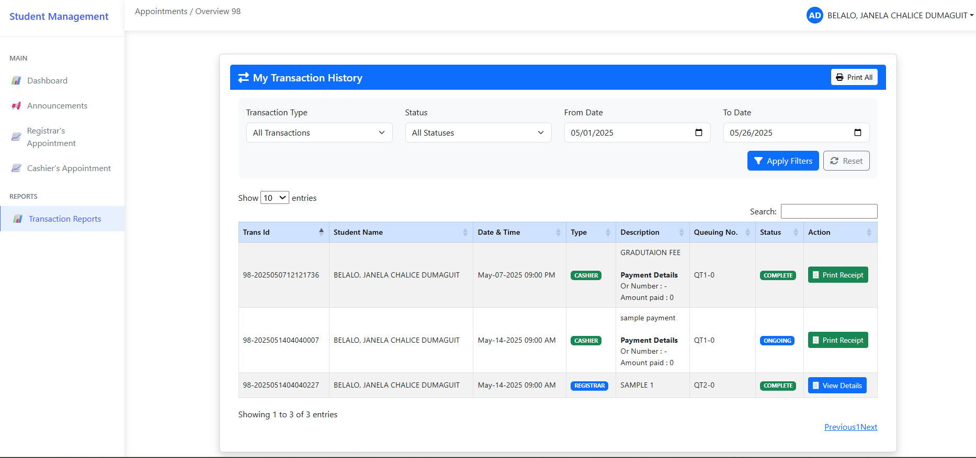

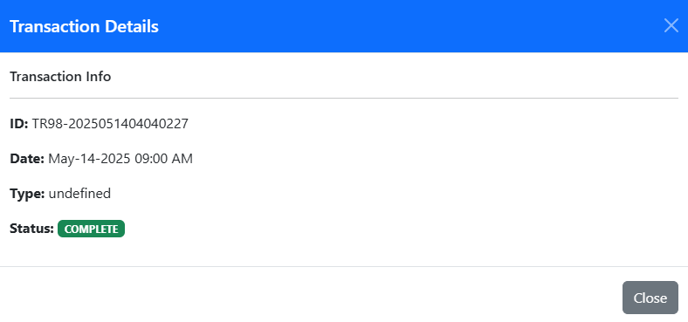

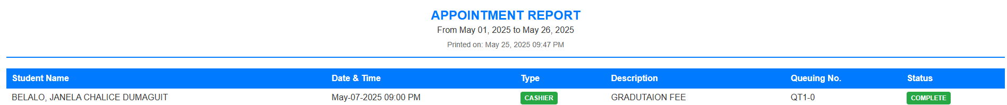
Transaction Reports
Students can click “Transaction Reports” to view and print transaction records from both the Registrar’s Office and the Cashier’s Office.

- Click “Transaction Reports” to display your complete transaction history from both offices.
- To easily find specific data, use the available filters (e.g., transaction type, status, or date range). After setting your filters, click “Apply Filters.” You may also use the Search bar to quickly locate a specific transaction.
- To print your transaction history, click “Print All.” You can choose to print all transactions or filter them by office (e.g., Cashier or Registrar).
- To view more details about a registrar transaction, click “View Details.”
- To view or print a cashier transaction receipt, click “Print Receipt.”

8
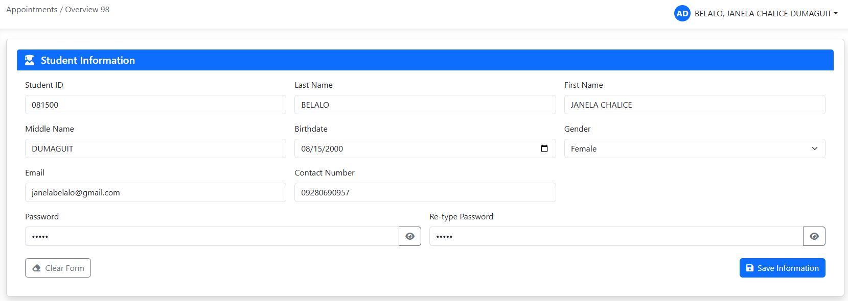

Profile
On this page, students can update their personal information.

Steps to Update Your Profile:

- Click your name icon, then select “Profile” to view your account details.
- Make the necessary changes, then click “Save Information” to successfully update your details.

9

