ImmuneCare: Smart Immunivation Registry with automated Scheduling system and alerts

JFORD F. MARQUEZ
JOHN LIOYD MAGNO BIACA
MARK ANJELOU O MEDIANA
MICHAEL JOHN F. SUCUANO

SUBMITTED TO THE FACULTY OF THE COLLEGE OF COMPUTER STUDIES VMC ASIAN COLLEGE FOUNDATION INC. IN PARTIAL FULFILLMENT OF THE REQUIREMENTS FOR THE DEGREE OF

BACHELOR OF SCIENCE IN INFORMATION TECHNOLOGY

JUNE 2025
Chapter l
INTRODUCTION

Background of the Study
Immunization is one of the most effective and cost-efficient public health interventions, safeguarding populations from preventable diseases and contributing to overall community health. In local healthcare settings, especially in barangay health centers, the process of managing immunization records, scheduling vaccination appointments, and monitoring follow-ups remains largely manual and paper-based. This often results in inefficiencies, delays, and missed vaccination schedules, placing vulnerable groups such as infants, children, and elderly residents at risk. Recognizing the importance of timely and well-organized immunization services, the integration of a smart, digital system becomes crucial to improving the delivery and management of vaccination programs in community health centers.
The growing necessity of modernizing healthcare information systems, particularly in immunization management. According to the World Health Organization (2021), the COVID-19 pandemic exposed significant gaps in health information systems globally, highlighting the need for efficient immunization registries with automated scheduling and reminder mechanisms. Likewise, Pascual et al. (2022) noted that in the Philippines, many rural health units still rely on outdated methods for tracking vaccinations, contributing to missed doses and delayed immunization coverage. With increasing emphasis on digital health innovations, health authorities have been encouraging the implementation of smart systems that automate and streamline health service delivery processes.
The existing immunization process in many barangay health centers faces several critical problems. Manual record-keeping often results in incomplete, misplaced, or illegible immunization records. Scheduling conflicts and forgotten vaccination dates contribute to a lower immunization completion rate among residents. Furthermore, the lack of real-time notifications and alerts for upcoming or missed immunization schedules affects both health workers' efficiency and patients' compliance. These inefficiencies not only burden health workers with additional workload but also compromise the overall quality of healthcare services provided to the community.
To address these challenges, this study proposes the development of ImmuneCare: Smart Immunization Registry with Automated Scheduling System and Alerts. This system is designed to digitize immunization records, automate the scheduling of vaccination appointments, and send SMS or system-generated alerts to both healthcare workers and patients. By providing a reliable, accessible, and efficient immunization management tool, ImmuneCare aims to improve service delivery, ensure timely vaccinations, and strengthen public health outcomes in barangay communities.
Objective of the Study
General Objectives
The general objective of this study is to develop and implement ImmuneCare: Smart Immunization Registry with Automated Scheduling System and Alerts that will enhance the management of immunization records, automate vaccination scheduling, and provide timely notifications and alerts for both healthcare workers and patients in barangay health centers.
Specific Objectives:
This study specifically aims to:
- Manage user’s account (admin, midwife, nurse);
- Design and develop a web- based platform for recording and storing immunization data of patients;
- Provide a feature that the client can set appointment;
- Integrate SMS and Email Notification that notifies patients;
- Develop a system that the admin can transfer file/data to municipal health center
- Enable search and filtering functionality:
  - Per Gender
  - Per Purok
  - Per Diagnosis
  - Age
  - Daily and Monthly
- Generate Reports such as;
  - List of Patients
  - List of appointments
  - Patients Information
  - Diagnosis
- Evaluate the system in terms of;
  - Functionality
  - Accuracy
  - Effectiveness
  - Security

Significance of the Study
The study entitled “ImmuneCare: Smart Immunization Registry with Automated Scheduling System and Alerts” was beneficial to the following users:
To Healthcare Providers (Doctors, Nurses, Clinics, Hospitals)
- This study was beneficial to healthcare providers by providing a more efficient and accurate way to manage patient immunization records. Instead of relying on manual records or disparate systems, they could access a centralized, comprehensive registry of immunization histories. This saves time, reduces administrative burden, minimizes errors in record-keeping, and ensures that patients receive the correct vaccines at the appropriate times. It also aids in identifying patients overdue for vaccinations, optimizing vaccine inventory, and generating reports for public health initiatives.
To Patients and Guardians
- The study was beneficial to patients and guardians as it provides real-time access to their or their child's immunization records. They can easily view their vaccination history, upcoming schedules, and receive automated alerts and reminders for due vaccinations. This empowers them to stay informed and proactive about their health, reducing the likelihood of missed appointments and ensuring timely protection against preventable diseases. It also offers peace of mind, knowing that their immunization data is securely managed and easily accessible.
To Public Health Organizations
- This study was beneficial to public health organizations by offering a robust system for monitoring immunization coverage rates, identifying areas with low vaccination uptake, and tracking disease outbreaks. The centralized data provided by ImmuneCare can facilitate more effective public health campaigns, resource allocation, and policy development aimed at achieving herd immunity and preventing epidemics. It provides a clearer picture of community health status and helps in planning targeted interventions.
To Policy Makers and Government Agencies
- The study was beneficial to policy makers and government agencies by providing accurate and up-to-date data on immunization trends and coverage. This information is crucial for informed decision-making regarding public health policies, budget allocation for vaccine procurement, and the development of national immunization programs. ImmuneCare can support evidence-based policy formulation to strengthen healthcare infrastructure and improve population health outcomes.
To the Researchers
- This study was beneficial to researchers as it allowed them to apply their knowledge and skills in developing an innovative and impactful healthcare system. They gained hands-on experience in designing and implementing a smart immunization registry with automated functionalities, leveraging technology to address critical public health needs. This enhances their expertise in health informatics, system development, and data management
To the Future Researcher
- The study was helpful in enhancing the knowledge and curiosity of future researchers. It provides a foundation and reference point for further advancements in digital health solutions, particularly in the domain of immunization. Future researchers can build upon the findings and methodologies of ImmuneCare to explore new features, integrate emerging technologies (e.g., AI for predictive analytics), and expand the system's applicability to other healthcare domains.

Scope and Limitation of the Study
This study focuses on the development and implementation of a web-based immunization management platform entitled ImmuneCare: Smart Immunization Registry with Automated Scheduling System and Alerts. The system is specifically designed to improve the immunization services offered by selected barangay health centers by providing a modern, organized, and automated method of handling patient immunization records, appointment scheduling, data reporting, and patient notifications. The system will cater to three types of users: Admin, Midwife, and Nurse. The Admin user will be responsible for managing the overall system operations, including the creation, modification, activation, and deactivation of user accounts. In addition, the Admin will oversee the management of immunization data, monitor patient records, and ensure the accuracy of the information encoded into the system. The Admin will also have the authority to transfer immunization data and related reports to the municipal health center using the system’s data export feature. Furthermore, the Admin will be able to generate essential reports, including lists of patients, scheduled appointments, diagnosis records, and immunization summaries. These reports can be filtered based on various categories such as gender, purok, diagnosis, age, and specific date ranges, including daily and monthly reports.
The Midwife and Nurse users will be responsible for the daily operation of the system by recording patient information, updating immunization records, encoding diagnosis data, and managing the appointment scheduling module. Healthcare personnel will set immunization appointments for patients through the scheduling feature, which will automatically trigger SMS and email notifications to the patients about their upcoming appointments or any changes made to their schedule. The system will also enable healthcare workers to search and filter patient records using various categories, including gender, purok, diagnosis, age, and appointment dates, to support efficient data retrieval and management. Additionally, Midwives and Nurses will be able to generate reports of the patients they have attended to, including the details of administered vaccines and patient visits.
The system will include a web-based platform where healthcare personnel can record, update, and store detailed patient information, including personal details, immunization history, diagnosis, and contact numbers. The appointment scheduling module will allow health workers to assign specific immunization dates to patients, which will then be reflected in the system’s appointment records. An integrated SMS and email notification system will send timely reminders and updates to patients regarding their scheduled immunizations. The system will also feature a data transfer function, allowing the Admin to securely transmit patient immunization records and generated reports to the municipal health center in digital format. Furthermore, a search and filtering feature will be available to enable health personnel to easily locate patient records by gender, purok, diagnosis, age, or specific appointment dates, supporting faster and more accurate data access. A notification ringtone feature will be incorporated into the Admin interface to alert barangay health personnel of newly scheduled appointments or pending tasks, provided the system remains active on the workstation.
To assist in monitoring immunization activities, the system will generate various reports such as lists of registered patients, appointment schedules, immunization histories, and diagnosis records. These reports will be categorized and generated daily, weekly, or monthly, as needed, to support administrative reporting and data-driven decision-making in barangay health centers. Additionally, the system will be evaluated based on its functionality, accuracy, effectiveness, and security to determine its overall reliability and usability within healthcare operations.
However, the study has specific limitations. The system will be limited to the management of immunization records and appointment scheduling services in the selected barangay health centers and will not cover other healthcare services such as general consultations, maternity care, or laboratory records. The system will not allow patients to create their own accounts or set appointments independently; all records and schedules will be managed by healthcare personnel within the system’s backend. Moreover, the automated SMS and email notifications are dependent on stable internet and telecommunication services, and as such, message delivery delays or failures may occur in areas with poor network connectivity. The data transfer feature will be limited to file exporting and sharing and will not integrate with existing municipal health information systems.
Furthermore, the system will not include functionalities for online payment processing, telemedicine consultations, or digital health card issuance. The migration of existing, paper-based patient records into the digital system must be performed manually by health workers, as automated digitization of old records is beyond the scope of the project. The notification ringtone feature will only function within the admin interface and will require the system to remain open and running to activate alerts. Lastly, the development of the system will be conducted at VMC Asian College Foundation, Inc. and will be pilot-tested only in selected barangay health centers. The implementation of the system in other barangays, municipalities, or a broader regional healthcare network is beyond the scope of this study.

Definition of Terms
The following terms were theoretically and operationally defined as used in this study:
Admin - refers to the authorized health personnel, typically assigned at the barangay or municipal health center, responsible for managing the ImmuneCare system. The admin can create and manage user accounts, oversee patient immunization records, transfer data files to the municipal health center, generate reports, and monitor system activities.
Age-Based Filtering - refers to the system’s capability to sort and present immunization records by patient age, supporting age-specific immunization schedules and reporting.
Appointment Scheduling - a system feature that enables health workers or patients to set, view, and manage vaccination appointments. This aims to improve the immunization process by reducing waiting times and organizing patient flow.
Data Transfer Functionality - a feature of the ImmuneCare system that allows the admin to securely transfer or back up immunization data and reports from the barangay health center to the municipal health center, ensuring continuity and centralized data management.
Daily and Monthly Reports - documents generated by the system summarizing immunization records, patient appointments, administered vaccines, and other operational statistics, categorized by day or month.
Diagnosis-Based Filtering - a system function that categorizes and retrieves patient records according to their recorded medical diagnosis related to immunization or associated illnesses.
Email Notification - an electronic messaging feature integrated into the system, used to inform patients about appointment reminders, immunization updates, and health-related notices via their registered email addresses.
Functionality - refers to the system’s ability to perform its intended operations effectively, including user account management, immunization recording, appointment scheduling, notification sending, data transfer, searching, and report generation.
Gender-Based Filtering - the ability of the system to search and display patient immunization records based on gender classification (Male, Female, or Others).
Immunization Data - refers to the medical information of patients that includes details about vaccines administered, immunization schedules, patient demographics, diagnoses, and other health-related records recorded and stored in the ImmuneCare system.
Midwife/Nurse - health workers granted specific access rights within the system. They can record, update, and manage immunization records, view scheduled appointments, and assist in patient data management and reporting.
Notification Alerts - system-generated real-time alerts delivered to patients via SMS or email to inform them about upcoming immunization appointments, reschedules, and other essential updates related to their health care.
Patient - refers to an individual, typically a resident of a barangay, whose immunization records are registered, managed, and monitored through the ImmuneCare system.
Patient Information - the complete personal and health-related data of a patient stored within the system, including their full name, age, gender, contact details, immunization history, diagnosis, and appointment schedules.
Purok - a territorial subdivision within a barangay used to classify and organize residents and health data geographically for easier report generation and record management.
Reports - system-generated documents containing organized summaries of data, including List of Patients, Appointments, Patient Information, Diagnoses, and immunization records used for health monitoring and decision-making.
Search and Filtering Functionality - a system tool that allows users to locate specific patient records or immunization data using defined categories such as Gender, Purok, Diagnosis, Age, and records within a specific Daily or Monthly timeframe.
SMS Notification - a feature integrated within the ImmuneCare system that sends automated text message alerts to patients registered mobile numbers to notify them of upcoming vaccination appointments, schedule changes, and other immunization-related announcements.
System Accuracy - the degree to which the ImmuneCare system correctly processes, stores, and displays information, ensuring that immunization records, appointments, and notifications are error-free and reliable.
System Effectiveness - refers to the system’s ability to deliver its intended health service outcomes efficiently, particularly in improving immunization tracking, scheduling, patient management, and communication.
System Evaluation - the process of assessing the ImmuneCare system based on Functionality, Accuracy, Effectiveness, and Security, ensuring that it meets healthcare data management and patient service standards.
System Security - encompasses the protective measures integrated within the ImmuneCare system to safeguard patient records, user accounts, and system processes against unauthorized access, data breaches, or system misuse.
Web-Based Platform - a digital application accessible via the internet designed to allow health workers to manage immunization records, schedule appointments, send notifications, and generate reports through a centralized interface.

Chapter II
REVIEW OFRELATED LITERATURE ANDSTUDIES
This chapter discussed the review of related literature and studies of the study entitled “ImmuneCare: Smart Immunivation Registry with automated Scheduling system and alerts”.

Related Literature
Advancements in Immunization Management for Personalized Vaccine Scheduling with IoT and Machine Learning
According to Madheswaran et al (2024) this study covers preprocessing, vaccine scheduling with DTs, and integrating IoT data. When handling private health information, it places a strong emphasis on ethics and data protection. Public health is improved by the use of IoT and DTs for personal vaccine schedule. As the system develops, regulations that safeguard privacy and provide access to individualized immunization schedules are crucial. This new approach has the potential to improve immunization programs, save healthcare expenses, and save lives.
Evaluating the “Zindagi Mehfooz” Electronic Immunization Registry
According to Mechael et al (2024) the electronic immunization registry (EIR) is a full suite of digital health interventions designed to increase the timely, equitable, and comprehensive coverage of child vaccinations. It includes a call center, web-based dashboards for managers and supervisors, text message alerts and reminders for caregivers, and a smartphone app for vaccinators.
Health Systems as a Catalyst for Immunization Delivery
According to Alexander et al (2021) health systems are described by the Agency for Healthcare Research and Quality as consisting of a minimum of one hospital and a minimum of one group of physicians who offer comprehensive treatment, including primary and specialty care, and are linked to one another through joint management or common ownership.
The Childhood Immunization Reminder Project Pilot Study
According to Marfo et al (2022) this study aimed to assess the effectiveness and acceptability of using SMS text messages containing a link to web-based immunization information in different languages to remind parents of their child’s 18-month immunization appointment. A trial program called the Childhood Immunization Reminder Web-based questionnaires filled out by parents and public health center employees were used to assess the intervention's acceptability.
Effect of Mobile Phone Text Message Reminders on the Completion and Timely Receipt of Routine Childhood Vaccinations
According to Mekonnen et al (2021) vaccination appointments is a major problem because it can be hard to keep track of regular vaccination schedules. In Ethiopia, the timely administration of the recommended vaccinations is low, and three out of ten children are not fully vaccinated.

Related Studies
Mobile App and a Web-Based Notification Platform for Surveillance of Adverse Events Following Influenza Immunization
According to Bota (2023) Vaccine safety monitoring is a fundamental part of immunization programs that keeps track of vaccine safety for the public, policymakers, and medical professionals. When a vaccine safety surveillance program is put in place, public trust in newly introduced vaccinations is increased.
The Use of Digital Technologies to Support Vaccination Programmers in Europe
According to Odone et al (2021) Vaccines have significantly decreased the burden of infectious diseases and the mortality that goes along with them globally, making them one of the most effective primary prevention measures for advancing both individual and public health.
Health Centers’ Intention with SMS-Based Vaccination Reminder and Management System
According to Karkonasasi et al (2020) This study aims to realize influential factors of intention to use VHC among Malaysian health centers by considering the technology acceptance model (TAM) as an underlying theory. The proposed model will be verified using data collected from self-directed questionnaires answered by nurses working in Malaysian government hospitals and government clinics.
Immunization and Vaccine Preventable Disease Surveillance Programs
According to Rachlin et al (2024) The use of these siloed data for programmatic decision-making is not without its problems, though, such as inadequate data accessibility and delayed analysis, which can lead to missed vaccinations, immunity gaps, and, ultimately, VPD outbreaks in populations with limited access to basic healthcare services and immunizations.
A cross-stack methodology for developing an intelligent vaccination reminder system for children
According to Perumal et al (2025) the Smart Vaccination System offers an SMS-based vaccine reminder system designed to assist parents in making sure their kids' immunizations are up to date. Written schedules are used in traditional techniques to arrange vaccination appointments, but they are often insufficient since busy parents may overlook important dates. This problem has been addressed by the development of a web-based vaccine reminder tool that promptly notifies users when a child's next immunization is due.
Effectiveness of Immunecare Learning Application in Increasing Knowledge and Awareness of Body Immunity
According to Zaeni et al (2025) This study is that the Immunecare learning application is very effective in increasing knowledge and awareness of body immunity. The implications of this study indicate that this application can be a useful alternative media for the public to understand and improve their immune system.

Conceptual Framework
PROCESS

OUTPUT

INPUT
“(ImmuneCare: Smart Immunivation Registry with automated Scheduling system and alerts)”

- User Account Information
- Patient Information
- Immunization Records
- Appointment Details
- Notification Content
- Transfer Data/Files
- Search and Filtering Functionality
- Report selection inputs
- Evaluation feedback and test results

Determine
- Immunization records and patient profiles are processed and compiled manually, causing delays.
Assess
- The Manual process leads to time-consuming
- Incomplete vaccination records
Identify
- Lack of real-time notifications and alerts
Recommendation
- Addressing these problems through a web-based system will improve healthcare services and record management.

FEEDBACK

Figure 1. The Conceptual Framework of the Study
Figure 1 shows the conceptual framework showed the concept of the web application, ImmuneCare: Smart Immunivation Registry with automated Scheduling system and alerts.
INPUT
The INPUT contained User Account Information, Patient Information, Immunization Records, Appointment Details, Notification Content, Transfer Data/Files, Search and Filtering Functionality, Report selection inputs, Evaluation feedback and test results.
PROCESS
The PROCESS addressed the actual problems and situations of the existing manual immunization records system, where the researchers strived to build, design, test, and launch an improved web-based solution for the benefit of the respondents and future researchers.
OUTPUT
The OUTPUT is to develop a web application entitled “ImmuneCare: Smart Immunivation Registry with automated Scheduling system and alerts” to address these problems.
FEEDBACK
The FEEDBACK process gathered end-users' the ImmuneCare System successfully processed and utilized essential inputs such as user and patient information, immunization records, appointments, notifications, and reports, delivering accurate, secure, and efficient outputs that improved the overall management of immunization services.

Chapter III
METHODOLOGY

This chapter presented the Methodologies and Materials used in the study
Project Development Description
The following materials were identified and acquired by the researchers to ensure that the development process would not be delayed.
Table 1. Hardware Requirements
QTY. | COMPONENTS | SPECIFICATION
1 | PC | SAMSUNG (8GB RAM, Intel(R) Core (TM) i5-3210M CPU @ 2.50GHz 2.50 GHz, 1TB (HDD)
1 | PRINTER | BROTHER DCP T420W
 | OTHER PERIPHERALS | Keyboard, mouse, mouse pad, flash drive
1 | WIFI | PLDT

Table 1 showed the tabular representation in the hardware requirements that was used in developing the system, the researchers provided 1 laptop with the brand and specifications such as SAMSUNG (8GB RAM, Intel(R) Core (TM) i5-3210M CPU @ 2.50GHz 2.50 GHz, 1TB (HDD)64-Bit operating system), 1 printer, (BROTHER) and 1 Wireless Fidelity, (PLDT Wi-Fi).
Table 2. Software Requirements
Database Application | MSQL
Web Scripting Language | PHP
Front-end Framework/Web Framework | Bootstrap
Web Designing Tool | HTML, CSS
Operating System | Windows 10
Office Application | WPS (Word, and PowerPoint)

Table 2 showed the tabular representation of the software requirements used in the system. The researchers used the following software applications and tools in the development of the system: Web Scripting Languages (PHP), Front-end Framework/Web Framework (BOOTSTRAP), Web Designing Tools (HTML, CSS), Operating System (Windows 10 and 11), and Office Application WPS (Word and PowerPoint)
Table 3. Budgetary Requirements
Quantity | Description | Unit Price | Amount
Software
 | System Software | 20,000.00 | 30,000.00
 | Website Hosting | 3,000.00
Hardware
 | Biometric with Face Recognition | 5,000.00 | 5,000.00
Materials
4 Ream | Bond Paper | 240.00 | 4,240.00
 | Prints | 4,000
Miscellaneous
 | Outline Defense English Critic Statistician Final Defense | 400.00  1,000.00  7,000.00  500.00 | 7,100.00
Sub Total |  |  | 46,340.00
 | Contingency (10%) |  | 4,429.00
Overall Total |  |  | 50,769.00

Table 3 showed the bills of supplies and materials used in the system as well as the miscellaneous bill for incidental expenses and supplies
Activities | Duration (AY 2023-2025)
Activities | Aug | Sept | Oct | Nov | Dec | Jan | Feb | Mar | Apr | May
Conceptualization For Title Proposal
Title Defense
Gathering Tools and Equipment
Outline Defense
Construction Of Project
Testing
Finalization Of Design Project
Gathering Data and Information
Final Defense
Finalization Of Manuscript

Project Duration
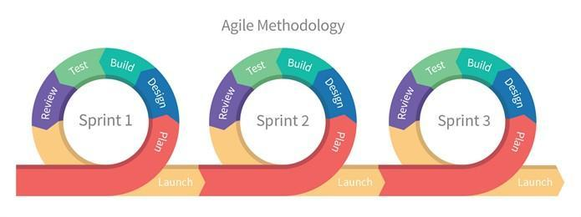
Table 4 show the timeline, task, duration, of the project, and expected completion date. It also displays the horizontal bar chart that shows the expected project’s planned schedule and task over the assigned timeframe. The horizontal axis represents the time or the months and the vertical axis shows the task involve the development system
Methods Used in Developing the System
Agile Software Development Methodology was developed to ensure satisfaction of the requirements among existing computerized system. It is a methodology construction to make sure that the requirements planning, development and implementation, testing of the system follows logical approach and technical ways
Figure 2. Agile Methodology Model
Sets of related activities are organized inside of Agile Model.
- Plan
- Design
- Build
- Test
- Review
- Launch

Sprint 1
This sprint focused on the planning, designing, building, testing, and launching of Objective 1, which is to manage the user’s information and account. The researchers concentrated on the development of the User Account Management Module within the Web-Based Immunization Records System with Email and SMS Notifications for Barangay Liberty, Norala, South Cotabato. The researchers began by planning out the design and user interface for the module, which involved creating user accounts for three types of users: Admin, Midwife, BHW and Nurse. The researchers planned out the user registration form, application modules, and submission process through a responsive web-based system. During this phase, diagrams such as context diagrams, data flow diagrams (DFD), and entity relationship diagrams (ERD) were created to outline the process flow and data handling procedures. Development tools used included PHP for server-side scripting, Bootstrap for front-end design, HTML/CSS for structure and styling, and MySQL for database management. The feature was tested for functionality and data accuracy before being launched.
Sprint 2
This sprint focused on the planning, designing, building, testing, and launching of Objective 2, which involves designing and developing a web-based platform for recording and storing resident and application data. The development team prioritized creating system modules that allow the admin to record, store, update, and manage resident information, clearance, and permit application records efficiently and securely. The researchers planned out the user registration form, application modules, and submission process through a responsive web-based system. During this phase, diagrams such as context diagrams, data flow diagrams (DFD), and entity relationship diagrams (ERD) were created to outline the process flow and data handling procedures. Development tools used included PHP for server-side scripting, Bootstrap for front-end design, HTML/CSS for structure and styling, and MySQL for database management. The feature was tested for functionality and data accuracy before being launched.

Sprint 3
This sprint focused on the planning, designing, building, testing, and launching of Objective 3, which provides a feature that allows residents to conveniently set appointments through the web-based platform. The development team began by outlining the appointment-setting process and identifying the necessary system modules for residents to select available dates and times for document verification or pickup. An appointment scheduling page was designed, allowing residents to input their details, select preferred dates from an available calendar, and specify the type of transaction for which the appointment was being made. To manage this, an appointment table was added to the database, storing resident information, appointment details, status, and timestamps. The researchers planned out the user registration form, application modules, and submission process through a responsive web-based system. During this phase, diagrams such as context diagrams, data flow diagrams (DFD), and entity relationship diagrams (ERD) were created to outline the process flow and data handling procedures. Development tools used included PHP for server-side scripting, Bootstrap for front-end design, HTML/CSS for structure and styling, and MySQL for database management. The feature was tested for functionality and data accuracy before being launched.
Sprint 4
This sprint focused on the planning, designing, building, testing, and launching of Objective 4, which integrates SMS and Email notifications to notify patients about their immunization schedules, appointment confirmations, and system updates. The researchers integrated a third-party SMS gateway API and an email sending function into the system. Notification templates for appointment scheduling, reminders, cancellations, and vaccination updates were configured for automatic sending. The system was tested by simulating multiple transactions and verifying the successful delivery of messages to registered mobile numbers and emails. The researchers planned out the user registration form, application modules, and submission process through a responsive web-based system. During this phase, diagrams such as context diagrams, data flow diagrams (DFD), and entity relationship diagrams (ERD) were created to outline the process flow and data handling procedures. Development tools used included PHP for server-side scripting, Bootstrap for front-end design, HTML/CSS for structure and styling, and MySQL for database management. The feature was tested for functionality and data accuracy before being launched.
Sprint 5
This sprint focused on the planning, designing, building, testing, and launching of Objective 5, which enables the admin to transfer files and data reports to the municipal health center. A data export module was developed, allowing the admin to generate patient records, immunization reports, and appointment summaries in CSV and PDF formats for easy transfer. Secure data transfer protocols were integrated to ensure confidentiality. The system was tested by simulating data exports and verifying the successful creation and sending of files via email and direct download options. The researchers used the following tools and software applications in the development of the system: Web Scripting Language (PHP), Front End Framework/Web Framework (BOOTSTRAP), Web Designing Tools (HTML, CSS), Operating System (Windows 10 and 11), and WPS (Word and PowerPoint). The system was tested, reviewed, and launched soon
Sprint 6
This sprint focused on the planning, designing, building, testing, and launching of Objective 6, which incorporates search and filtering functionalities within the system for better record management. Filtering options were developed for the following criteria: Per Gender, Per Purok, Per Diagnosis, Per Age, Daily and Monthly. Search fields and filter dropdown menus were added to the patient records, appointments, and immunization data tables. The database queries were optimized to quickly retrieve and display filtered results. The system was tested by simulating different search and filter combinations to ensure accuracy and responsiveness. Development tools included PHP, Bootstrap, HTML/CSS, JavaScript, and MySQL. The feature passed all testing scenarios and was launched for use.
Sprint 7
This sprint focused on the planning, designing, building, testing, and launching of Objective 7, which generates system reports for various records and activities. The following report generation modules were developed: List of Patients, List of Appointments, Patients Information, Diagnosis Reports. Each report was designed with options to view, print, and export data in PDF and CSV formats. The reports feature real-time data retrieval and summaries based on selected dates or categories. The team tested report generation by simulating various data inputs and verified the accuracy and layout of the reports. Tools used included PHP, Bootstrap, HTML/CSS, MySQL, Operating System (Windows 10 and 11) and WPS Office for formatting reports. After successful tests and revisions, the report modules were finalized and launched.
Sprint 8
This sprint focused on the planning, designing, testing, and final evaluation of Objective 8, assessing the system’s performance based on key quality metrics: Functionality: The team tested all system modules to verify if each feature operates according to its intended purpose. Accuracy: Data processing, record retrieval, search filters, and notification triggers were examined to ensure precise outputs. Effectiveness: User feedback was gathered to evaluate system responsiveness, ease of use, and reliability in actual operations. Security: User authentication, data validation, and access control mechanisms were tested to safeguard sensitive information. The system evaluation was conducted using a test checklist and evaluation form, gathering both quantitative scores and qualitative feedback from test users. Results indicated that the system met the required standards for deployment. The team tested report generation by simulating various data inputs and verified the accuracy and layout of the reports. Tools used included PHP, Bootstrap, HTML/CSS, MySQL, Operating System (Windows 10 and 11) and WPS Office for formatting reports. After successful tests and revisions, the report modules were finalized and launched.

Context Diagram of the Existing System
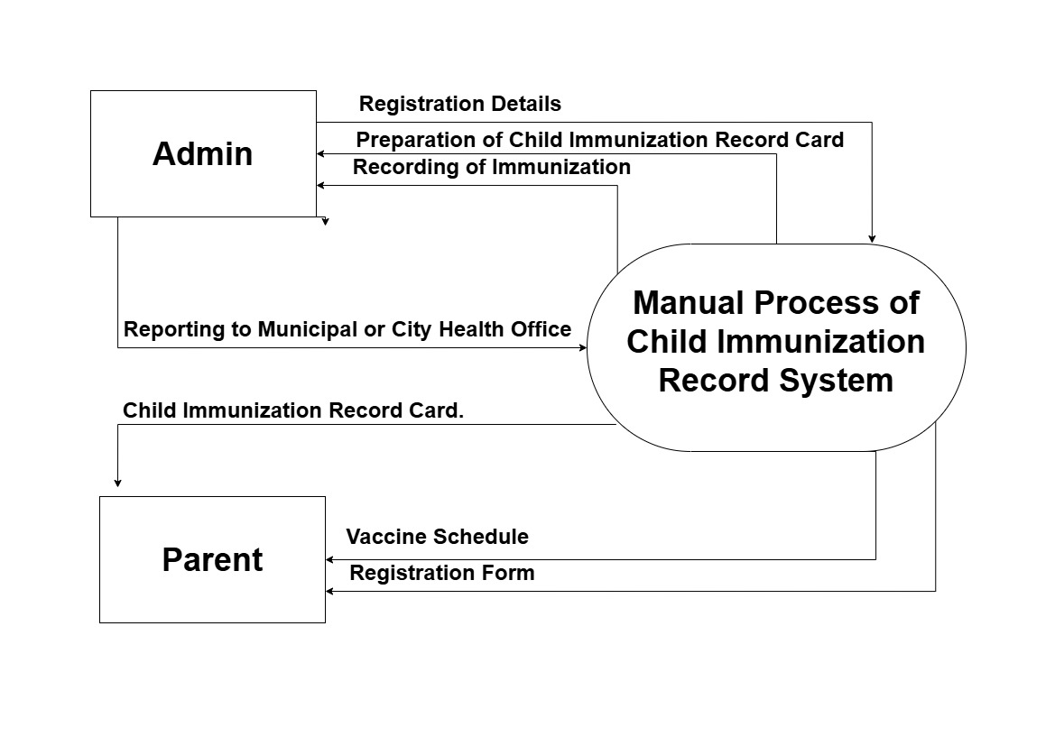
Figure 3. Context Diagram of the Existing System
Figure 3 Context Diagram of the Existing System Figure showed the diagram of the existing system, which details the process of manual child immunization record management. The parent provides a registration form, which the admin processes to prepare the child immunization record card and schedule vaccinations. After immunization is administered, the admin records the vaccination details for tracking purposes. Additionally, the admin submits reports to the Municipal or City Health Office to ensure centralized monitoring of immunization coverage. The system functions as a coordinating platform, organizing vaccination records and tracking information through outlined inputs and outputs to ensure a structured flow of immunization data between parents, administrators, and health officials.

Logical Data Flow Diagram of the Existing System
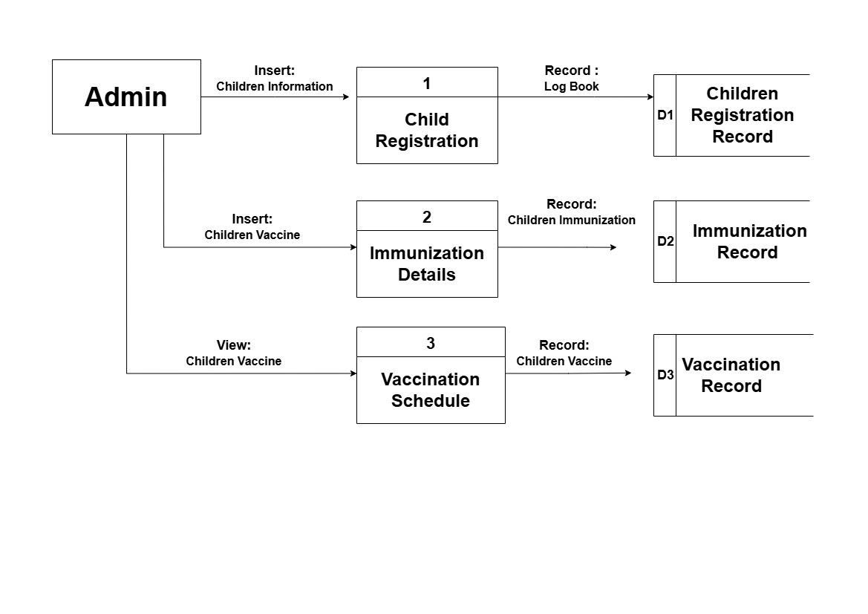
Figure 4 Logical Data Flow Diagram of the Existing System
Figure 4 Logical Data Flow of the Existing System Figure 11 showed the diagram of the existing system, which outlines the process of managing children’s immunization records through structured administrative steps. The process begins with the admin registering children’s information, which is recorded in a log book and stored as the Children Registration Record. Following registration, the admin inputs immunization data, which is captured in the Immunization Record. Finally, the Admin reviews and manages the vaccination schedule, storing the details in the Vaccination Record. The system acts as a centralized hub, streamlining the recording and tracking of immunization data within the barangay. This structured process ensures that children's health records are properly documented, updated, and easily accessible. It supports transparency, accuracy, and efficiency in delivering reliable immunization services to the community.

Continue…
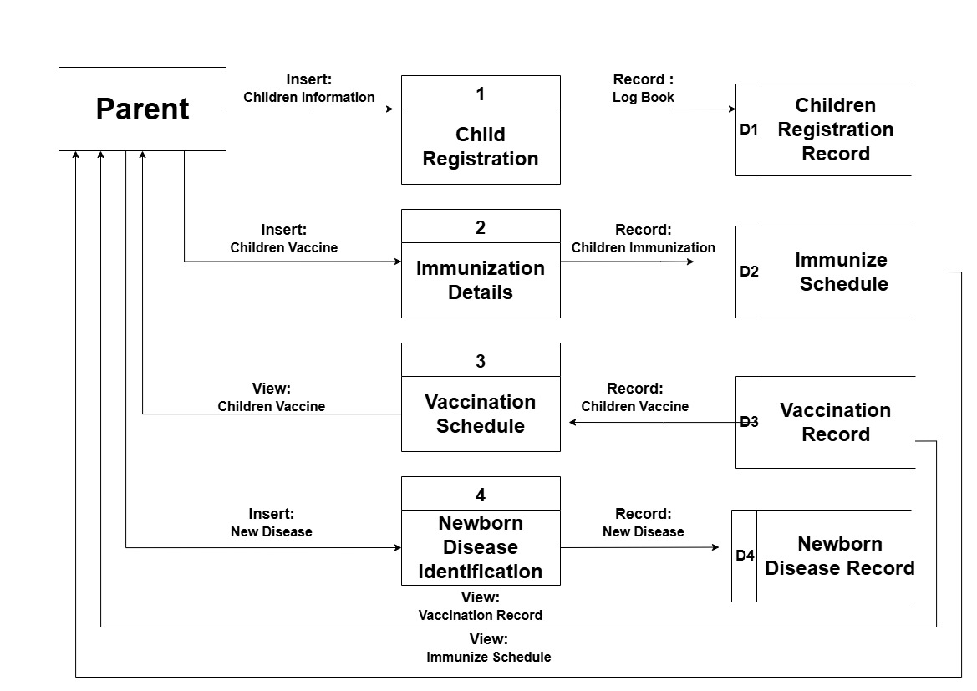

Figure 5. Logical Data Flow Diagram of the Existing System
Figure 5 Logical Data Flow Diagram of the Existing System Figure 12 showed the diagram of the existing system, which outlines the steps taken by the Parent in managing immunization records. The process starts with child registration, where the parent inputs the child’s information into the log book, resulting in the creation of the Children Registration Record. Next, the parent adds immunization details, which are documented in the Children Immunization Record and linked to the Immunize Schedule. The parent then views their child’s vaccine information, generating an update to the Vaccination Record. In cases where newborn diseases are identified, the parent records these in the New Disease section, which is used to create a Newborn Disease Record. Parents can also access both the vaccination record and immunization schedule, allowing them to stay informed and engaged in their child’s healthcare process. This system provides a clear and organized structure for managing child health information. It promotes parental participation, accurate data collection, and improved coordination within the immunization program at the barangay level.

Context Diagram (Proposed System)
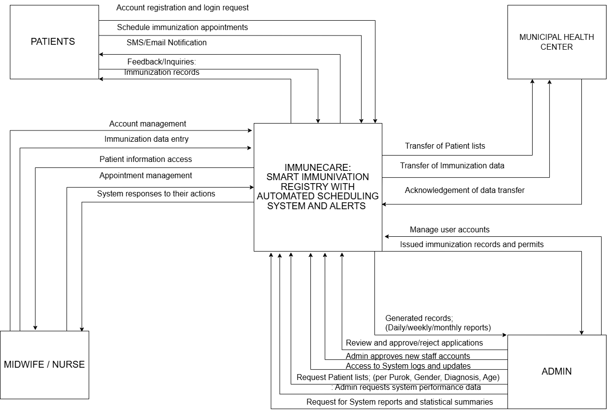
Figure 6. The Context Diagram of the Study
Figure 6 shows the context diagram of the IMMUNECARE: Smart Immunization Registry with Automated Scheduling System and Alerts. It illustrates the interactions between the system and its external entities: Patients, Midwife/Nurse, Municipal Health Center, and Admin. Patients can perform account registration and login, schedule immunization appointments, receive SMS/Email notifications, provide feedback/inquiries, and access their immunization records. Midwives/Nurses manage accounts, enter immunization data, access patient information, and manage appointments, receiving system responses to their actions. The Municipal Health Center transfers patient lists and immunization data to the system and receives an acknowledgement of data transfer. The Admin manages user accounts, issues immunization records and permits, generates daily/weekly/monthly reports, reviews and approves/rejects applications, approves new staff accounts, accesses system logs and updates, requests patient lists (per Purok, Gender, Diagnosis, Age), and requests system performance data and statistical summaries.

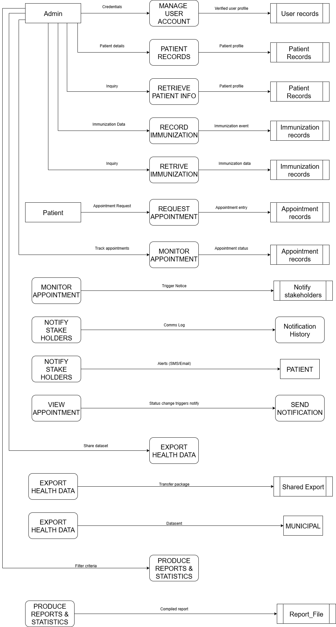
DATAFLOWDIAGRAM(Logical)
Figure 7. The Logical Dataflow Diagram of the System
Figure 7 illustrates the logical data flow within the ImmuCare: Smart Immunization Registry with Automated Scheduling System and Alerts. The system's functionality is centered on the interactions between various users and internal processes, emphasizing data movement and transformation. The Admin user initiates several key processes: managing user accounts by providing credentials which are then processed to update user records; managing patient records by inputting patient details, which are stored as patient records; retrieving patient information through inquiries, accessing stored patient records; recording immunization events, which are then stored as immunization records; and retrieving immunization data through inquiries from the immunization records. The Admin also has the capability to export health data, which can result in a shared dataset for shared export or a dataset for municipal use.
Furthermore, the Admin can produce reports and statistics based on specified filter criteria, generating a compiled report that is then stored as a report file. Patients interact with the system by initiating appointment requests, which are then processed to create appointment entries in the appointment records. Patients can also track their appointments, allowing the system to monitor appointment status from the appointment records. This monitoring can trigger notices. Patients can view their appointments, and any status changes triggered by this view result in a notification being sent. The system also notifies stakeholders, generating a communications log for notification history and sending alerts via SMS or email directly to the patient, with these alerts potentially being triggered by the appointment monitoring process. The system's internal processes include: managing user accounts by verifying user profiles; handling patient records by storing patient details and profiles; retrieving patient information based on inquiries; recording immunization events into immunization records; retrieving immunization data based on inquiries; requesting appointments by creating appointment entries; monitoring appointments to track their status and trigger notices; notifying stakeholders by generating communication logs and sending alerts; sending notifications based on status changes; exporting health data as transfer packages for shared export or datasets for municipal use; and producing reports and statistics by generating compiled reports from filter criteria.
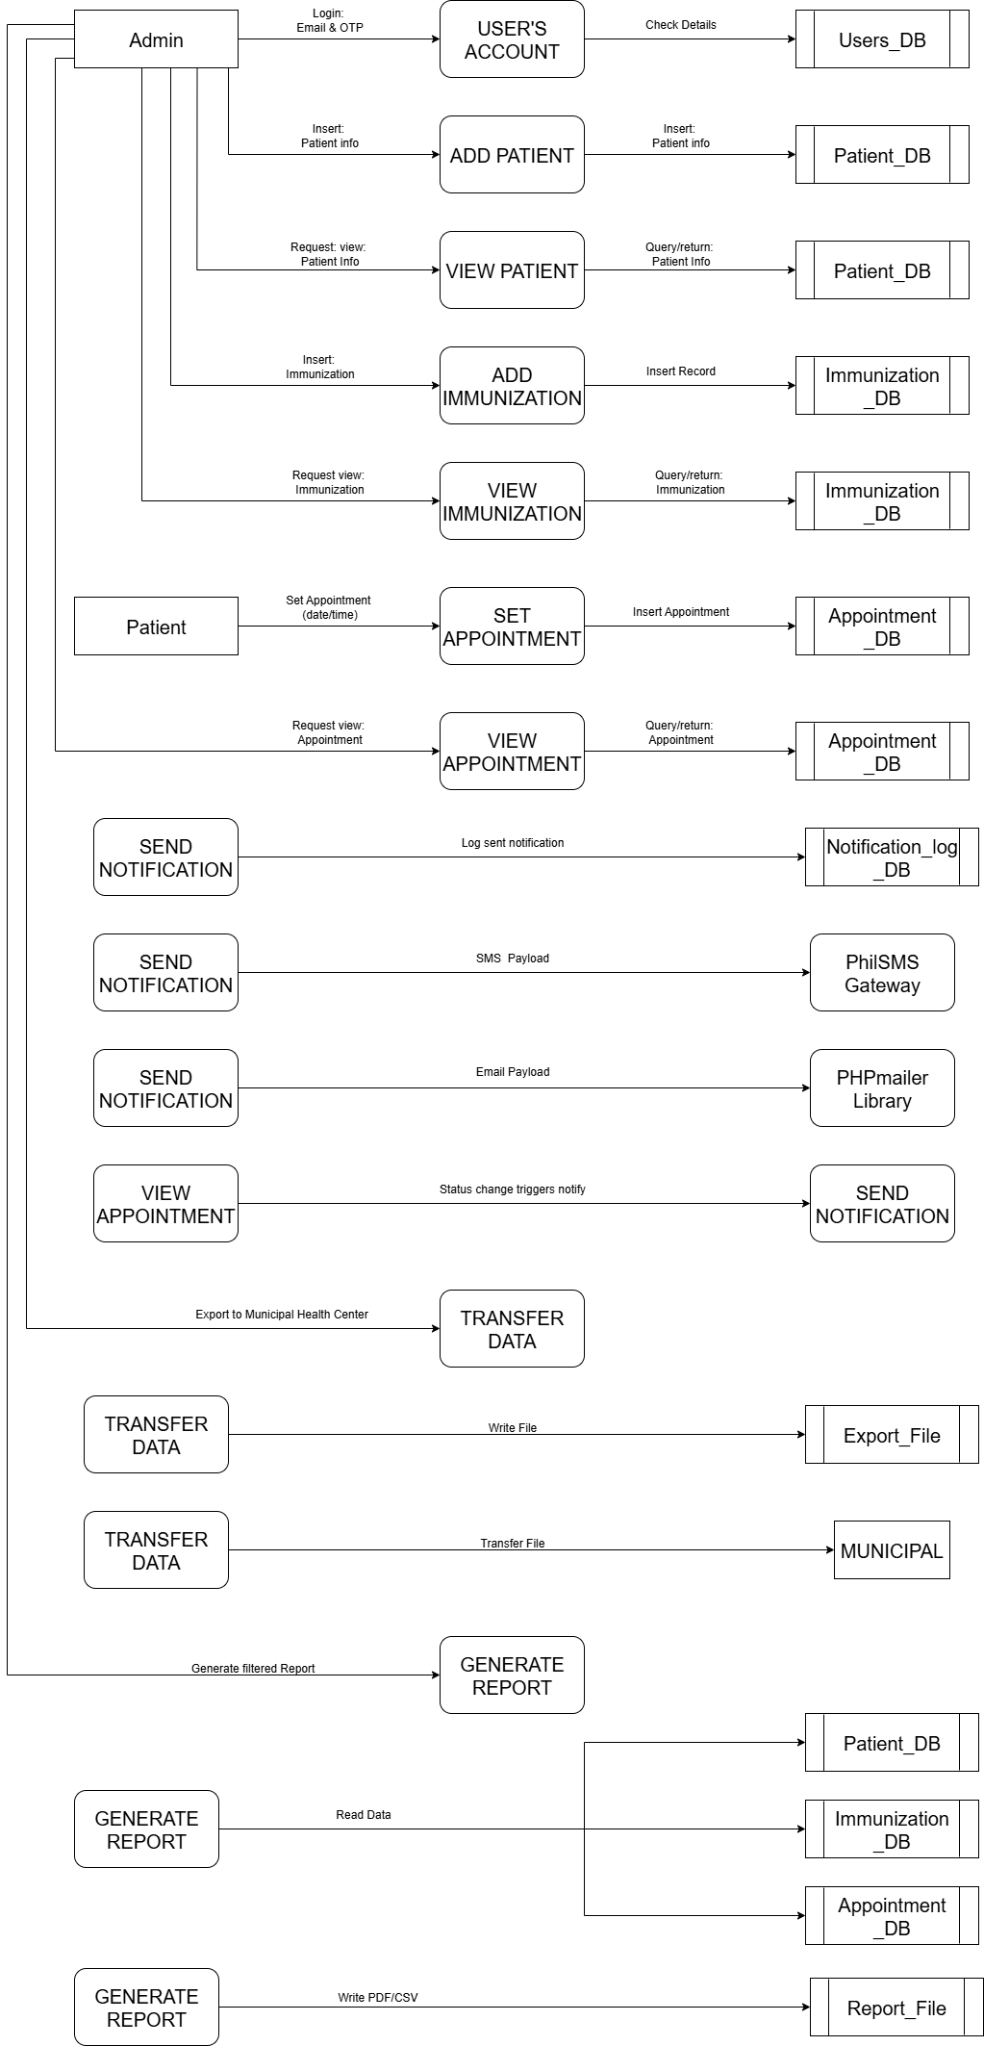
DATA FLOWDIAGRAM (Physical)
Figure 8. The Physical Data Flow Diagram of the System
Figure 8 illustrates the physical data flow entitled ImmuCare: Smart Immunization Registry with Automated Scheduling System and Alerts, detailing the movement of information between specific users, system modules, databases, and external entities. The Admin user initiates several distinct physical processes: managing user accounts by providing login credentials, email, and OTPs to the "User's Account" module, which physically checks these details against the "Users_DB" for verification; managing patient information by inserting new patient data into the "Add Patient" module, which writes to the "Patient_DB," and viewing existing patient information by requesting data from the "View Patient" module that queries the "Patient_DB"; handling immunization records by inserting new data into the "Add Immunization" module, which updates the "Immunization_DB," and viewing existing records by querying the "Immunization_DB" via the "View Immunization" module. The Admin also facilitates data transfer by exporting health data to the Municipal Health Center through the "Transfer Data" module, which writes to an "Export_File" or directly to "MUNICIPAL" systems.
Furthermore, the Admin can generate filtered reports using the "Generate Report" module, which reads data from the "Patient_DB," "Immunization_DB," and "Appointment_DB," and then writes the compiled report as a PDF or CSV file to a "Report_File." The Patient user interacts with the system by physically setting appointments via the "Set Appointment" module, which inserts data into the "Appointment_DB," and by viewing appointments through the "View Appointment" module, which queries the "Appointment_DB."
Finally, the system handles notifications by physically sending "SMS Payload" to the "PhilSMS Gateway" and "Email Payload" to the "PHPMailer Library" via the "Send Notification" module, which also logs these notifications in the "Notification_log_DB" and can be triggered by status changes observed in the "View Appointment" module.

Entity-Relationship Diagram (ERD
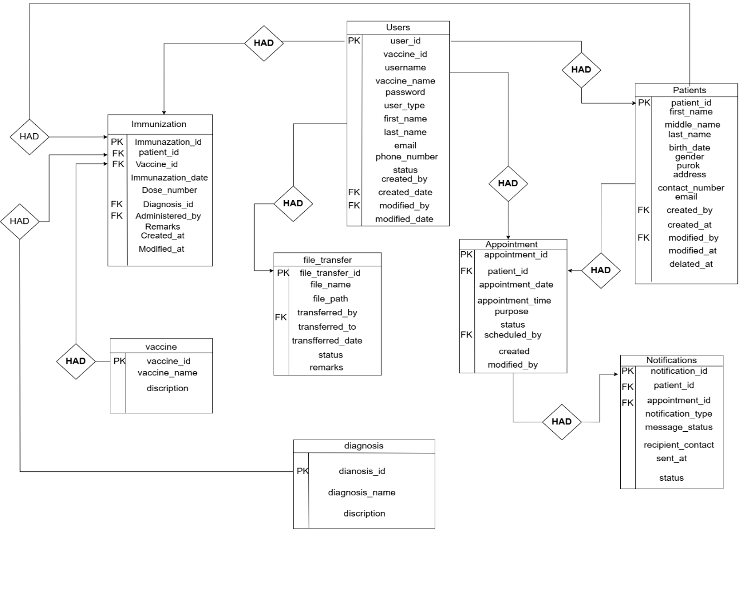
Figure 9 Entity-Relationship Diagram of the Study
Figure 9 showed the proposed ImmuneCare system's data structure and the relationships between its entities. It demonstrates how data about users, patients, vaccines, immunizations, appointments, notifications, file transfers, and diagnoses are organized and connected. The ERD emphasizes primary keys (PK) and foreign keys (FK) to build associations between data, maintaining data consistency and integrity throughout the system. The relationships include:
- One user in tbl_users (with user_type 'admin') had many other users (created by them) in tbl_users.
- One user in tbl_users had many patients listed in tbl_patients.
- One user in tbl_users had many immunization records in tbl_immunizations (as administered_by).
- One user in tbl_users had many appointment records in tbl_appointments (as scheduled_by).
- One user in tbl_users had many file transfer records in tbl_file_transfers. * One patient in tbl_patients had many immunization records in tbl_immunizations.
- One patient in tbl_patients had many appointment records in tbl_appointments.
- One patient in tbl_patients had many notification records in tbl_notifications.
- One vaccine in tbl_vaccines had many immunization records in tbl_immunizations.
- One diagnosis in tbl_diagnosis had many immunization records in tbl_immunizations.
- One appointment in tbl_appointments had many notification records in tbl_notifications.

Database Structure
The database structure described in a formal language supported by the database management system.
Database name: immunecare_db
Table 5. appointments
This table manages appointments for clients.
tbl_appointment
appointment_id (primary) | int | 11 | No | AUTO_INCRIMENT
patient_id | int | 11 | No |  | patients_patient_id
appointment_date | date |  | No
appointment_time | time |  | No
purpose | varchar | 255 | No | ‘vaccination follow-up’,’check-up’
status | enum |  | No | ‘pending’,’confirmed’,’completed’,’cancelled’
sent_by | int | 11 | No |  | users.user_id
created_date | datetime |  | No | Current_timestamp
modified_date | datetime |  | Yes | Null
delated-at | datetime |  | Yes | Null

Table 6. diagnosis
This table stores diagnosis information
tbl_diagnosis
Diagnosis_id (primary) | int | 11 | No | AUTO_INCRIMENT
Diagnosis_name | Varchar | 255 | No | Null
Description | Text |  | Yes | Null

Table 7. file_transfer
This table tracks file/data transfers to municipal health centers.
tbl_ file_transfer
Transfer_file_id (primary) | Int |  | No | AUTO_INCRIMENT
File_name | Varchar | 255 | No | Null
File_path | Varchar | 500 | No | Null
Transferred_by | Int | 11 | No | Null | User.user_id
Transferred_to | Varchar | 255 | No | Null
Transfer_date | Datetime |  | No | Current_timestamp
status | Enum |  | No | ‘success’
remarks | text |  | Yes | Null

Table 8. immunazation
This table records individual immunization details for patients.
tbl_ immunazation
Immunazation_id (primary) | Int |  | No | AUTO_INCRIMENT
Patient_id | Int | 11 | No | Null | Patient.patient_id
Vaccine_id | Int | 11 | No | Null | Vaccine.vaccine_id
Immunazation_date | Date |  | No | Null
Dose_number | Int | 11 | No | Null
Diagnosis_id | int | 11 | Yes | Null | Diagnosis.diagnosis_id
Administered_by | Int | 11 | Yes | Null | User.user_id
Remarks | Text |  | No | Null
Created_at | Datetime |  | Yes | Null
Modified_at | Datetime |  | No | Current_timestamp

Table 9. notification
This table logs SMS and email notification.
tbl_ notification
notification_id (primary) | int |  |  | AUTO_INCRIMENT
Patient_id | int | 11 | No | Null | Patient.patient_id
Appointment_id | int | 11 | Yes | Null | Appointment.appointment_id
Notification_type | Enum |  | No | ‘sms’,’alert’
Message_content | Text |  | No | Null
Recipient_contact | Varchar | 255 | No | Null
Sent_at | Datetime |  | No | Current_timestamp
Status | Enum |  | No | ‘sent’

Table 10. patients
This table records and stores immunization data of patients.
tbl_ patient
patient_id (primary) | Int |  | No | AUTO_INCRIMENT
First_name | Varchar | 100 | No
Middle_name | Varchar | 100 | Yes | Null
Last_name | Varchar | 100 | No
Date_of_birth | Varchar | 200 | No
Gender | ‘Enum’,’male’,’female’ | 100 | No
Address_street | Varchar | 100 | No
Address_purok | Varchar | 100 | No
Address_barangay | Varchar | 100 | No
Contact_email | Varchar | 100 | Yes | Null
Contact_number | Varchar | 20 | Yes | Null
Parent_gaurdian_name | Varchar | 200 | Yes | Null
Created_by | Int | 11 | No
Created_date | datetime |  | No | Current_timestamp
Modified_by | Int | 11 | Yes | Null | User.user_id
Modified_date | datetime |  | Yes | Null
Delated_at | datetime |  | Yes | Null

Table 11. users
This table manage user account (admin, midwife, nurse).
tbl_ user
user _id (primary) | Int | 11 | No | AUTO_INCRIMENT
username | Varchar | 50 | No | Unique
Password | varchar | 255 | No
User_type | ‘Enum’ | 100 | No | ‘admin‘,‘midwife’,’nurse’
First_name | Varchar | 100 | No
Last_name | Varchar | 100 | No
Email | Varchar | 100 | Yes | Null
Phone_number | Varchar | 20 | Yes | Null
Status | varchar | 20 | No | ‘active’,’inactive’
Created_by | Int | 11 | No
Created_date | Datetime |  | No | Current_timestamp
Modified_by | Int | 11 | Yes | Null | User.user_id
Modified_date | Datetime |  | Yes | Null
Delated_at | Datetime |  | Yes | Null

Table 12. vaccines
This table is for different vaccines.
tbl_ user
Vaccine_id (primary) | Int | 11 | No | AUTO_INCRIMENT
Vaccine_name | Varchar | 100 | No | Null
Description | Text |  | Yes | Null

Evaluation Methodology
Evaluation of any system was a crucial part of its development. This determined if the system worked properly, met the objectives, and satisfied the users. Methods of Research
Research Design
This study used the Descriptive Method of Research to evaluate the functionality, accuracy, effectiveness, and security of the ImmuneCare: Smart Immunization Registry with Automated Scheduling System and Alerts. The descriptive method was appropriate for this study as it enabled the researchers to systematically observe, describe, and document the system’s actual performance and its impact on the users and stakeholders, particularly the healthcare workers and administrative personnel involved in barangay immunization services.
Participants of the Study
The respondents were composed of 10 users, which were purposively selected to participate in the evaluation of the system entitled “ImmuneCare: Smart Immunization Registry with Automated Scheduling System and Alerts.” The respondents included 1 Barangay Health Center Admin, 4 Midwives, and 5 Nurses as users of the system. These participants were chosen based on their direct involvement in immunization services and health record management in the barangay, making them the most qualified to assess the system’s functionality, accuracy, effectiveness, and security
Data Gathering Procedures and Statistical Tools
This study used a checklist and a rating scale questionnaire to gather the needed data and responses to evaluate the system. To check the system’s functionality, accuracy, effectiveness, and security, the participants answered a 5-point Likert scale questionnaire. This helped measure how much they agreed or disagreed with statements about the system, specifically relating to its features such as user account management, immunization data recording, appointment scheduling, SMS and email notifications, data transfer to the municipal health center, search and filtering functions, report generation, and overall system performance.
The questionnaires were designed to collect the responses of users about the performance of the ImmuneCare: Smart Immunization Registry with Automated Scheduling System and Alerts. The data from this evaluation provided the system developers with valuable feedback needed to improve and enhance the system based on the comments, experiences, and opinions of the users. The frequency of each rating was counted, and the percentage and weighted mean were calculated and interpreted to summarize the participants’ evaluation results.
Table 13. Rating Scale used in the Study
CODE | MEAN RANGE | DESCRIPTION | LEGEND
5 | 4.20-5.00 | Strongly Agree | SA
4 | 3.40-4.19 | Agree | A
3 | 2.60-3.39 | Agree | MA
2 | 1.80-2.59 | Disagree | D
1 | 1.00-1.79 | Strongly Disagree | SD

Formula For Weighted Mean:
$$x=\frac{Σx_{i}}{n}$$
Where:
$x$ = mean score
n = number of respondents
$∑x_{i}$ = frequency
Formula for Standard Deviation:
$s=\sqrt{\frac{∑{\left(x-\overline{x}\right)}^{2}}{n-:}}$

