Chapter IV

CHAPTER IV RESULTS AND DISCUSSION
RESULTS and discussions
This chapter presents the results of the evaluation of the study entitled “AidTrack: Barangay Bual Real-Time Aid Monitoring, Distribution, and Tracking System with SMS Notification.” The respondents were the Barangay Secretary, Barangay Health Workers, Barangay Officials, and selected Residents of Barangay Bual as system users.
The thesis proposed system was very helpful to the Barangay Secretary, Barangay Health Workers, Barangay Officials, and Residents. The study aimed to manage users’ accounts for clients (residents) and the administrator (Barangay Secretary), secure user authentication for both client and administrator accounts, ensure the correct identification of qualified beneficiaries through registration and verification, and provide a feature that can track dismissed or unclaimed benefits. It also aimed to create an analytics and reporting dashboard that provides information on aid impact assessments, utilization, and distribution progress. Furthermore, the system incorporated a real-time tracking function that enables barangay officials to monitor aid that has been delivered and that is still pending, and integrated SMS notifications for updates and announcements. It also set up a digital system for receipts and acknowledgments to reduce false claims and improve transparency, added a feedback and complaints system for beneficiaries, and allowed residents to upload necessary documents or requirements.
Further, the system could also generate reports such as: List of Residents per Purok, List of Beneficiaries per Benefit, List of Benefits, and Claim Stubs. These features were designed to improve the efficiency, transparency, and accountability of aid distribution within the barangay.
The evaluation aimed to assess the system in terms of Functionality, Accessibility, Security, Acceptability, and Accuracy. Based on the evaluation conducted by the researchers, the system was successfully evaluated by the respondents stated above. The evaluation result and percentage in terms of functionality, effectiveness, acceptability, and overall performance of the system were stated in the following tables.

These are the screenshots that the researcher develops for the project:
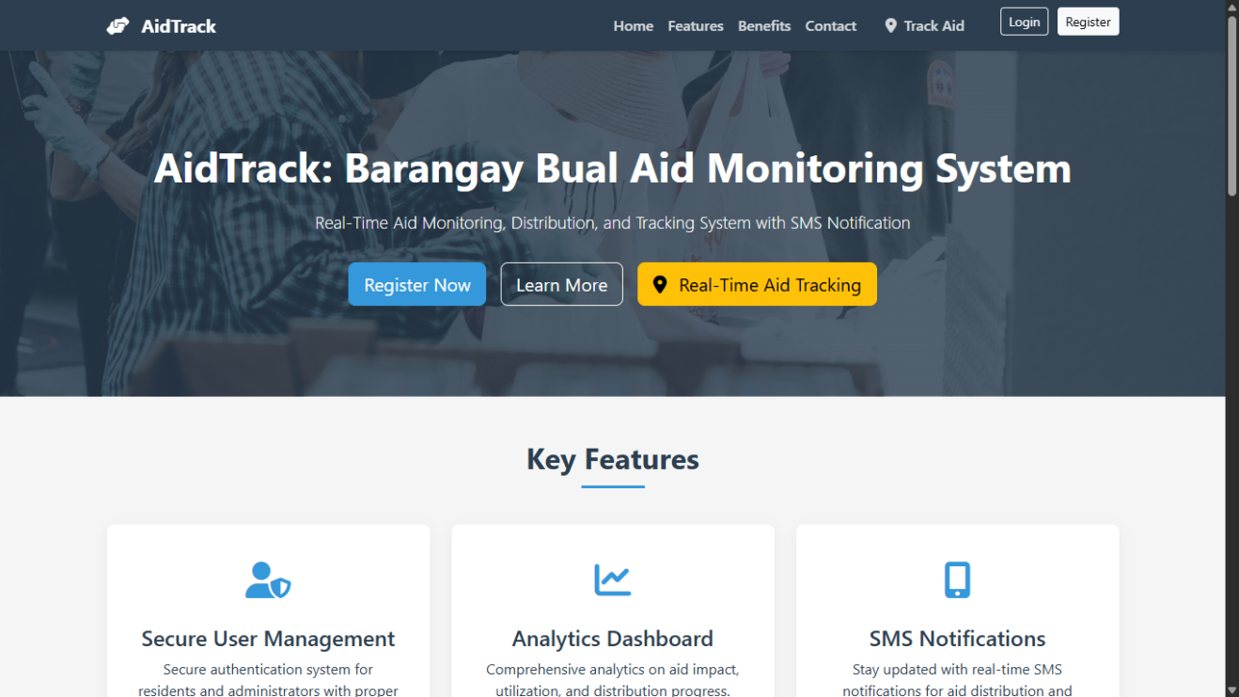

Figure x: Landing Page
This figure shows the landing page of the system entitled AidTrack: Barangay Bual Real-Time Aid Monitoring, Distribution, and Tracking System with SMS Notification. On this page, users are introduced to the system’s core purpose and features. Residents, barangay officials, and Purok Presidents are guided to register, log in, and explore the system’s functionalities. The landing page highlights key features such as secure user management, an analytics dashboard for aid reporting, and a dedicated portal for Purok Presidents to oversee aid distribution in their areas. It also promotes real-time tracking and SMS notifications to ensure timely updates and transparency in aid operations.

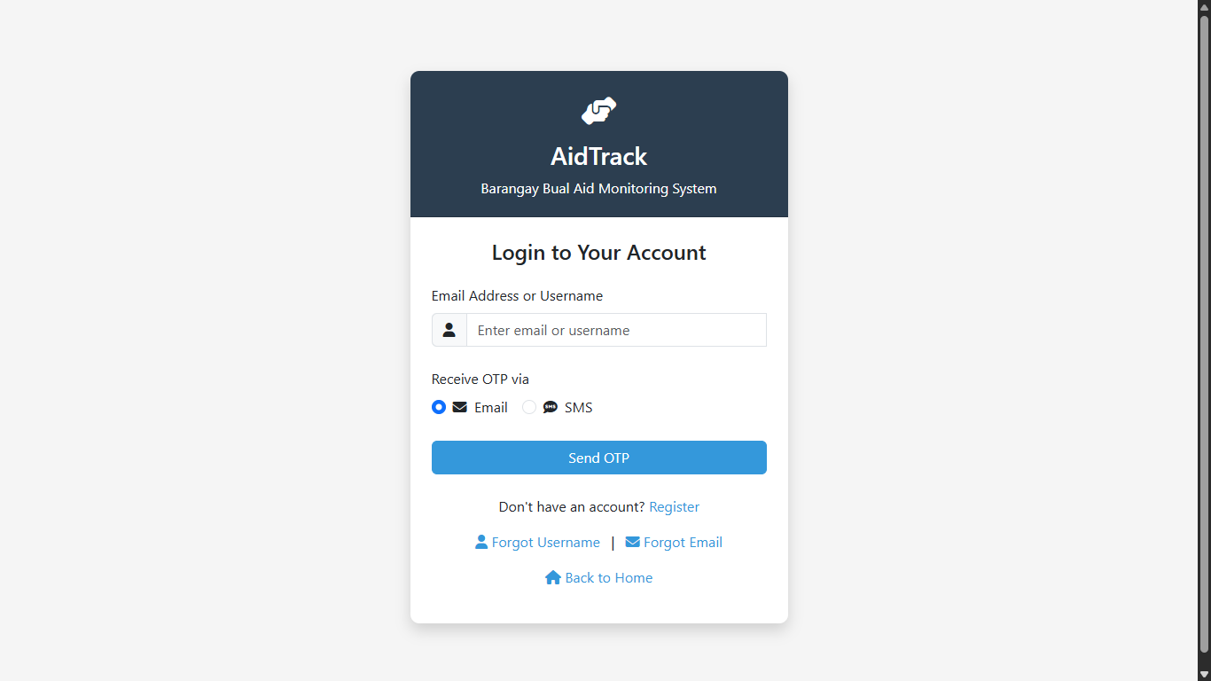

Figure x: Log-in Page
This figure displays the login interface where residents, barangay officials, and Purok Presidents can securely access their accounts. Users may enter their email address or username and request a One-Time Password (OTP) via email or SMS to proceed. The page also includes options for registration, account recovery, and navigation back to the home screen. This login process ensures that only verified users can access the system’s features for aid monitoring and distribution

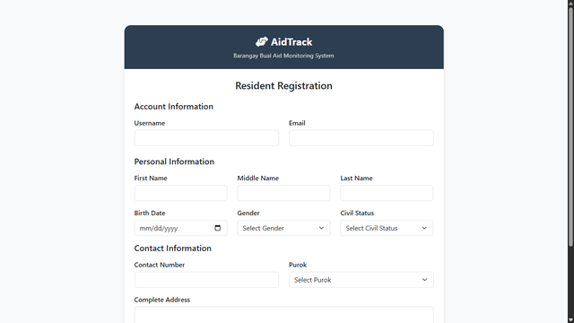

Figure x: Registration Page
This figure shows the registration page where residents can create their accounts by providing personal, account, and contact information. The form is divided into three sections: Account Information, which includes fields for username and email; Personal Information, which collects details such as full name, birth date, gender, and civil status; and Contact Information, which includes contact number, purok selection, and complete address. This structured registration process ensures accurate data collection for aid verification and distribution.

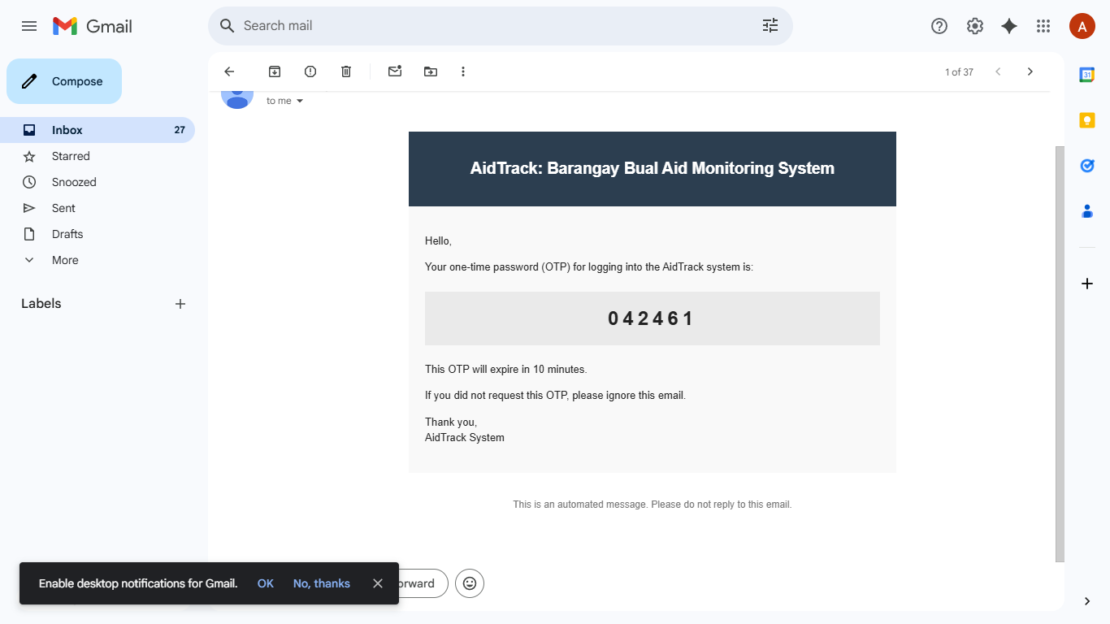
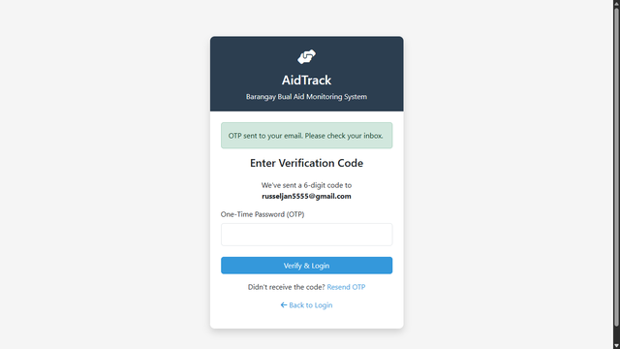
Figure x: Send OTP Page
This figure shows the OTP verification page used during the login process. After entering their email or username, users are prompted to input a One-Time Password (OTP) sent to their registered contact. The interface includes a field for entering the OTP, along with buttons to verify and log in, resend the OTP, or return to the login page. This step ensures secure access and confirms the identity of the user before granting entry to the system.

Figure x: Administrator Dashboard
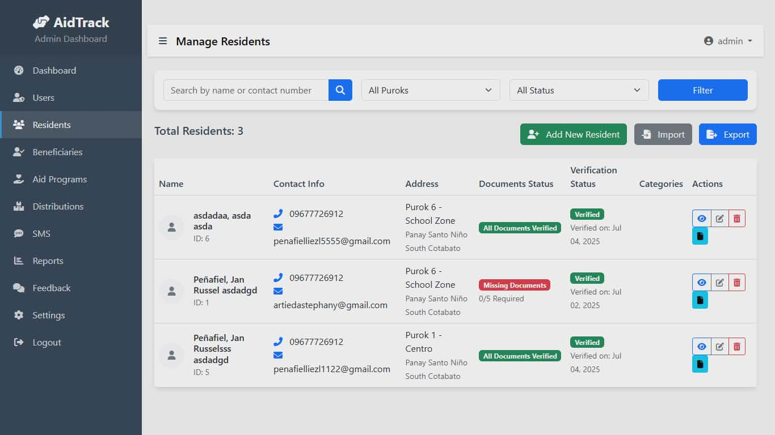
This figure shows the administrator dashboard, specifically the “Manage Residents” section. From this interface, the system administrator can search for residents by name or contact number, filter records by purok and verification status, and perform actions such as adding new residents, importing, or exporting data. The table displays resident details including contact information, purok and zone assignment, verification status, and date verified. Action buttons allow the administrator to edit, delete, or view individual records. This dashboard supports efficient management of resident data for aid distribution and monitoring.

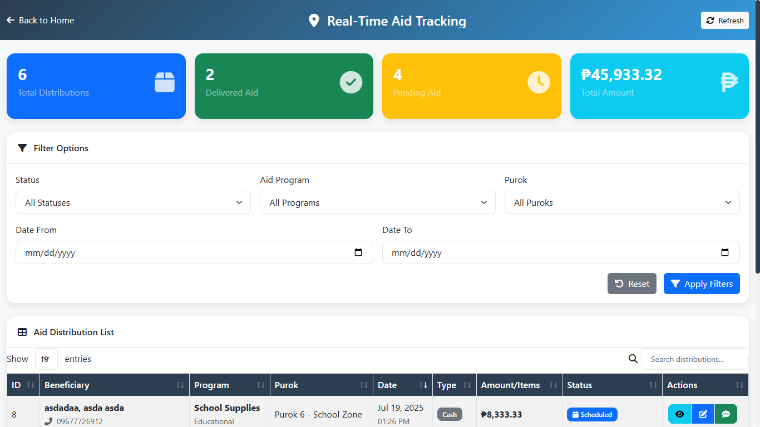

Figure x: Real-Time Aid Tracking Dashboard
This figure shows the real-time aid tracking dashboard used by barangay officials to monitor the status and progress of aid distribution. The top section summarizes key metrics such as total distributions, delivered aid, pending aid, and total amount released. Below, users can filter records by status, aid program, purok, and date range. The aid distribution list displays detailed information including beneficiary name, program type, purok, date, amount or items, and current status. This dashboard provides a clear and organized view of aid activities, supporting transparency and timely decision-making.

Figure x: SMS Notifications

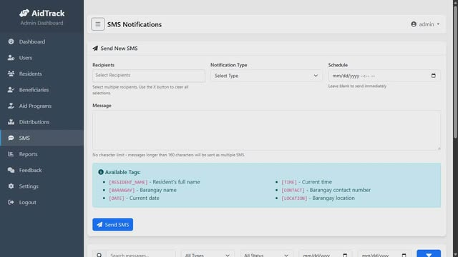
This figure shows the SMS Notifications interface from the administrator dashboard. In this section, barangay officials can compose and schedule SMS messages to selected recipients. The form includes fields for choosing recipients, selecting the type of notification, and setting the date and time for delivery. A guide is provided for using dynamic tags such as [NAME], [CONTACT], [DATE], [TIME], [BARANGAY], and [LOCATION] to personalize messages. This feature supports timely communication and ensures residents receive accurate updates regarding aid distribution and barangay announcements.

Figure x: Distribution Receipt

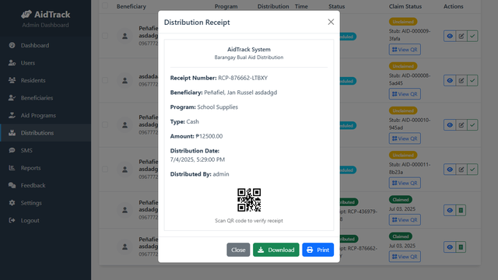

This figure shows the distribution receipt pop-up window from the administrator dashboard. It displays detailed information about a specific aid transaction, including receipt number, beneficiary name, aid program, type of assistance, amount released, distribution date, and the name of the distributor. A QR code is provided for verification purposes, along with options to close, download, or print the receipt. This feature supports transparency and accountability by documenting each aid release and enabling secure verification.

