**BARCODE - OPERATED AMONG CLASS ATTENDANCE MONITORING AT SOUTH CENTRAL MINDANAO COLLEGE OF SCIENCE AND TECHNOLOGY INC. SECONDARY LEVEL**

**JONA MAE V. GONZALES** Researchers

A Thesis Manuscript Submitted to the Faculty of Information System

South Central Mindanao College of Science and Technology, Inc.

Purok Rosal, Barangay New Isabela, Tacurong City,

In Partial Fulfillment of the Requirements

for the Degree of

**BACHELOR OF SCIENCE IN INFORMATION SYSTEM**

**JUNE 2025**

**CHAPTER I**

**INTRODUCTION**

**Background of the Study**

Attendance monitoring is a vital component of the academic environment, ensuring student participation, maintaining discipline, and enforcing institutional policies. Traditional methods, such as paper-based logs and manual roll calls, are inefficient, time-consuming, and susceptible to errors and fraudulent practices like proxy attendance. At South Central Mindanao College of Science and Technology, Inc. (SCMCSTI) High School, these issues burden teachers and administrators, hindering accurate record-keeping and effective management.

Local studies in the Philippines, such as those from Polytechnic University of the Philippines (PUP) and Cebu Institute of Technology-University (CIT-U), highlight the efficacy of technology-driven attendance systems using barcodes and QR codes. These studies demonstrate reduced administrative workload, improved accuracy, and fraud prevention. Nationally, research from the Department of Science and Technology (DOST) and the Commission on Higher Education (CHED) supports digital transformation in education, emphasizing real-time data and operational efficiency. Internationally, Ghazal et al. (2020) in the UAE found that a QR code-based system reduced attendance time and errors, enhancing classroom engagement.

To address these challenges, this study proposes a Barcode-Operated Web-Based System for Class Attendance Monitoring. This system automates the attendance process by enabling students to scan unique barcodes via a web interface, with data recorded in a centralized, cloud-based database. It offers real-time tracking, automated record management, and accessible attendance reports, empowering educators and administrators to make informed decisions about student engagement and compliance.

**Objectives of the Study**

Generally, this study aims to develop a **Barcode-Operated Among Class Attendance Monitoring** that streamlines and automates the attendance-taking process. The system aims to enhance accuracy, security, and efficiency in tracking student attendance while minimizing manual effort for instructors.

**Specifically, this study aims to the following:**

1. To automate and simplifying the attendance monitoring process by developing a barcode scanning feature within a web interface that allows students to register attendance efficiently and reduces manual errors.
2. To allow real-time attendance logging and data management by integrating a secure, cloud-based database to store and retrieve attendance records instantly.
3. To ensure accurate and secure student identification by assigning unique barcode identifiers to each student, preventing duplication and fraudulent attendance marking.
4. To evaluate the system in terms of:

4.1 Accuracy;

4.2 Usability; and

4.3 Efficiency.

**Significance of the Study**

This study aims to determine the impact and results of the proposed Barcode-Operated Web-Based System on SCMCSTI High School.

**To the Students.** The system provides a fast, reliable way to log attendance, reducing errors and proxy attendance while allowing students to access their records online.

**To the Administrators.** It ensures efficient data management, enhances security, and delivers real-time insights for decision-making and policy enforcement.

**To the Researchers** The study contributes to the development of automated, web-based attendance systems, offering a foundation for further innovations in educational technology.

**Scope and Delimitations of the Study**

The system enhances attendance tracking efficiency and accuracy through a web-based platform where students scan unique barcodes. Attendance data is logged in real-time into a cloud-based database, accessible remotely by instructors for monitoring and reporting. It includes notifications for attendance status and class reminders. Limitations include dependency on internet connectivity, potential downtime, and the need for digital literacy. The system is designed for SCMCSTI High School and excludes biometric or RFID methods, focusing solely on barcode scanning.

**Definition of Terms**

The following terms are operationally defined by the researchers for faster understanding.

|  |  |  |
| --- | --- | --- |
| **Barcode** |  | A machine-readable pattern of lines uniquely identifying students for attendance tracking. |
| **Class Attendance Monitoring** |  | The automated process of recording and managing student attendance data. |
| **Manual Errors** |  | Mistakes in data entry or recording due to human oversight in traditional methods. |
| **Real-Time Tracking** |  | Instant logging and updating of attendance data in a database. |
| **Web-Based System** |  | An online platform accessible via browsers, facilitating attendance monitoring through barcode scanning. |

**CHAPTER II**

**REVIEW OF RELATED LITERATURE AND STUDIES**

This chapter presents the relevant literature and previous studies connected to the research. It serves as a basis for understanding the topic and guiding direction of the study.

**Barcode-Operated Web-Based System**

The Barcode-Operated among Class Attendance Monitoring at South Central Mindanao College of Science and Technology Inc. Secondary Level is an innovative solution designed to modernize the traditional attendance-taking methods. Through the integration of barcode scanning technology and a web-based platform, students can simply scan their personalized barcodes to log their presence. The attendance records are immediately stored in a centralized cloud database, allowing real-time monitoring and reporting. This approach ensures that the processes of recording, managing, and accessing attendance data become more efficient, reliable, and transparent compared to manual methods.

Developing the Barcode-Operated among Class Attendance Monitoring aims to enhance the accuracy, efficiency, and security of the attendance process at SCMCSTI High School. It seeks to reduce time-consuming tasks associated with manual attendance-taking, minimize human errors, and prevent fraudulent attendance practices such as proxy signing. Furthermore, it empowers educators and school administrators by providing instant access to updated attendance records, aiding in the generation of reports and strategic academic decision-making. Ultimately, the system endeavors to improve institutional efficiency while fostering a culture of responsibility and punctuality among students. By modernizing the attendance process, the school aligns itself with national and global efforts to integrate digital solutions into educational management.

Several local studies in the Philippines have explored the effectiveness of digital attendance monitoring systems in educational institutions, providing relevant context for the application of such systems at South Central Mindanao College of Science and Technology Inc. (SCMCSTI). Santos (2018) conducted a study at De La Salle University, where he introduced a barcode-based attendance system for senior high school students. The results of the study showed significant improvements in the accuracy of attendance tracking and the ease of retrieving data. Santos emphasized that the barcode system helped eliminate common issues such as the loss of attendance sheets and human error, which are typically prevalent in manual attendance-taking, leading to better classroom management.

Lopez (2019) implemented a QR code-based system for large lecture classes at the University of the Philippines Diliman. This system reduced proxy attendance incidents by approximately 60%, highlighting the potential of technology-based attendance systems to encourage honesty and reduce absenteeism. This finding is particularly relevant for SCMCSTI, where preventing fraudulent attendance practices like proxy signing is a priority.

Garcia (2020) conducted a comparative cost-analysis study at the Technological Institute of the Philippines, evaluating barcode, RFID, and biometric systems for attendance monitoring. The study concluded that barcode systems offered a balance between affordability and reliability, making them a highly suitable solution for institutions with limited budgets, such as SCMCSTI. Similarly, Villanueva (2020) from Mapua University developed a mobile application integrated with QR code scanning for attendance monitoring, reporting a 30% increase in student punctuality. This increase was attributed to the convenience and immediacy of the system, suggesting that mobile integration in attendance systems could enhance engagement and punctuality at SCMCSTI.

Salazar (2019) tested a barcode-based attendance system in laboratory settings at Mindanao State University and found that students became more accountable for their attendance records, leading to a decrease in unexcused absences. This study supports the notion that barcode systems can promote responsibility among students, an important aspect SCMCSTI hopes to foster. Torres (2020) from San Beda University conducted a study on the relationship between digital attendance systems and compliance with academic policies. The results indicated that students using automated attendance systems exhibited higher compliance with attendance policies compared to those using manual systems. This finding suggests that the introduction of a barcode-operated system at SCMCSTI could improve adherence to academic attendance regulations.

Mendoza (2020) found that a barcode-based attendance system boosted student responsibility through increased awareness. Similarly, Cruz (2021) showed a positive link between barcode-tracked attendance and academic performance. These findings support SCMCSTI’s system, highlighting its potential to enhance accountability and academic outcomes.

Dela Cruz (2021) at the Polytechnic University of the Philippines-Taguig implemented a cloud-based attendance system, which centralized data management and reduced instances of lost records. This system streamlined administrative processes and enhanced data accessibility, a crucial factor for SCMCSTI, where real-time monitoring and easy access to attendance data are needed for effective decision-making.

Internationally, studies have similarly demonstrated the effectiveness of digital attendance systems. Brown (2018) at the University of Manchester explored the time-saving benefits of barcode scanning systems in large university lectures. He found that attendance checks, which previously took up to 20 minutes, could now be completed in less than 5 minutes, thus allowing more time for instruction. This improvement in efficiency would be beneficial at SCMCSTI, particularly in large classes, where time management is critical. Williams (2019) at Monash University studied the psychological effects of attendance tracking and found that students who were aware their attendance was being electronically monitored increased their commitment to attending classes by 20%. This study underscores the positive impact of accountability mechanisms on student behavior, which could lead to better attendance rates at SCMCSTI.

Nguyen (2020) at the University of Toronto compared the cost-effectiveness of barcode scanning systems to RFID and biometric methods, concluding that barcode systems provided an affordable yet reliable solution, particularly for institutions with tight budgets. This finding further supports the feasibility of implementing a barcode-based system at SCMCSTI. Miller (2019) at Stanford University examined the relationship between automated attendance systems and absenteeism, finding that the introduction of a web-based system resulted in a 15% reduction in absenteeism among students.

In a similar vein, Yamamoto (2020) from the University of Tokyo explored mobile-supported barcode attendance systems, finding that mobile integration improved system accessibility and increased participation among students. This suggests that incorporating mobile technology into SCMCSTI's attendance system could make the process more accessible and user-friendly for students. Patel (2018) at the Indian Institute of Technology Bombay observed a 15% increase in student attendance following the adoption of a barcode system in large engineering classes, noting a reduction in administrative conflicts related to attendance disputes.

Schneider (2019) at the Technical University of Munich explored the workload implications of automated attendance systems, noting that the use of such systems reduced the administrative burden on teaching staff by providing real-time data analytics. This benefit would likely apply to SCMCSTI, where teachers and administrators could save valuable time and resources by automating attendance tracking. Alhassan (2019) at King Saud University in Saudi Arabia evaluated the transition from manual to QR-based attendance systems and found that the system was not only more efficient but also helped foster a culture of punctuality and responsibility among students. Similarly, Choi (2020) from Seoul National University found that mobile scanning attendance systems reduced data errors and improved student satisfaction with attendance procedures.

Tan (2021) at the National University of Singapore analyzed the scalability and reliability of cloud-based barcode attendance systems for large academic programs. His study concluded that real-time reporting and cloud storage improved accessibility for both students and faculty members, highlighting the benefits of such systems for large-scale institutions like SCMCSTI.

The consistent results across both local and international studies reinforce the advantages of digital attendance solutions. Barcode and QR code technologies offer tangible benefits such as minimizing human error, reducing administrative workload, promoting punctuality, enhancing data management, and improving overall academic engagement. These studies also reveal that the success of digital attendance systems often depends on thoughtful implementation, user-friendly interfaces, mobile accessibility, and proper administrative support—all factors that would contribute to the success of the proposed system at SCMCSTI.

**Related Studies**

Torres (2020) at Polytechnic University of the Philippines (PUP) developed a barcode-based attendance system for college students, testing it across five departments with over 1,000 participants. The system reduced attendance-taking time by 70%, from 20 minutes to 6 minutes per session, and eliminated proxy attendance by requiring physical barcode scans. Torres noted high teacher satisfaction due to simplified record-keeping, supporting the proposed web-based system’s potential to enhance efficiency at SCMCSTI High School.

Gomez (2021) at Cebu Institute of Technology-University (CIT-U) implemented a hybrid QR code and barcode attendance app, evaluated in classes of 50-70 students. Results showed a 90% accuracy rate in attendance records, with manual errors dropping from 15% to 1% compared to paper logs. Gomez highlighted the system’s adaptability to web platforms, informing the proposed system’s focus on precision through barcode technology at SCMCSTI High School.

Reyes (2019) at Technological Institute of the Philippines (TIP) explored a barcode-operated system for classroom monitoring across 10 classes. Teachers saved an average of 15 minutes per session, equivalent to 2.5 hours weekly, allowing more instructional time. The study praised the system’s simplicity but noted occasional scanner malfunctions, suggesting robust web-based alternatives. This supports the proposed system’s time-saving goals for SCMCSTI instructors.

Cruz (2022) at University of Santo Tomas (UST) tested a mobile app with barcode scanning for 300 high school students. The system improved record accuracy by 85% and provided administrators with real-time reports, enabling stricter absenteeism policies that reduced tardiness by 30%. Cruz’s findings reinforce the proposed system’s aim to deliver accurate, web-accessible data for SCMCSTI’s administrative needs.

Santos (2020) at Ateneo de Manila University developed an Android-based barcode attendance tool for 200 students. It reduced administrative workload by 60% and was rated easy to use by 90% of teachers, though internet dependency caused delays during outages. This study informs the proposed web-based system’s reliance on stable connectivity while highlighting its usability potential at SCMCSTI High School.

Lim (2021) at De La Salle University (DLSU) introduced a barcode system integrated with Firebase, tested in six courses with 150 students each. It achieved near-perfect data synchronization, with updates reflected in under two seconds, and allowed effortless weekly summaries that saved faculty 5 hours monthly. Lim’s success with real-time data validates the proposed system’s cloud-based approach for SCMCSTI High School.

Perez (2018) at University of the Philippines (UP) Diliman evaluated a barcode attendance app in lecture classes of 100+ students. The study reported a 95% student satisfaction rate due to its speed—attendance took 3 minutes versus 12 manually—though barcode sharing occurred in 2% of cases. This guides the proposed system’s design to minimize fraud through unique identifiers and web-based verification at SCMCSTI.

Mendoza (2022) at Far Eastern University (FEU) implemented a barcode-based system with notifications for 500 students. Attendance compliance rose by 20% after students received automated reminders via SMS, reducing absences by 50 instances monthly. Mendoza’s findings support the proposed system’s inclusion of web-based notifications to boost accountability at SCMCSTI High School.

Dela Cruz (2019) at Miriam College tested a barcode scanning app for 200 grade school students. It reduced errors by 80%, from 10% to 2% daily, and provided parents with access to attendance logs, increasing parental involvement by 40%. This suggests the proposed system could extend web-based access to SCMCSTI stakeholders beyond instructors for greater transparency.

Garcia (2020) at Mapúa University developed a barcode-operated system for 300 engineering students. It cut proxy attendance by 75%, as unique barcodes prevented unauthorized scans, though initial setup took two weeks. Garcia’s success with security reinforces the proposed system’s strategy of using distinct barcodes within a web platform at SCMCSTI High School.

Ghazal, Zahid, and Ahmed (2020) in the UAE implemented a QR code-based attendance system at a university with 2,000 students. Attendance time dropped from 10 minutes to 2 minutes per session, achieving a 98% accuracy rate, with errors limited to rare scanning failures. This international benchmark supports the proposed system’s aim to drastically improve efficiency and accuracy at SCMCSTI High School.

Patel (2021) in India developed a barcode attendance app for rural schools with 400 students. Its low-cost design—using printed barcodes and basic devices—improved efficiency by 65%, even with intermittent internet, due to an offline mode. Patel’s study suggests potential offline enhancements for the proposed system, though its initial focus remains web-based for SCMCSTI.

Smith and Jones (2019) at a US university tested a barcode scanning app for 600 undergraduate students. It reduced administrative time by 50%, from 20 hours to 10 hours weekly, and improved accountability, though it lacked advanced fraud prevention like biometrics. This informs the proposed system’s need for web-based security enhancements at SCMCSTI High School.

Tanaka (2020) in Japan explored a barcode-based system for high schools with 800 students. It achieved a 90% error reduction, from 8% to 0.8% daily, and provided real-time data that cut truancy by 15% through swift disciplinary action. Tanaka’s results align with the proposed system’s goals of accuracy and real-time tracking for SCMCSTI.

Kumar and Singh (2022) in Malaysia implemented an barcode app for 1,000 college students. It reduced manual workload by 60% and linked attendance to performance analytics, revealing a 10% grade improvement among regular attendees. This suggests the proposed web-based system could expand to include analytical features for SCMCSTI in future iterations.

Brown (2021) in the UK developed a barcode attendance system for secondary schools with 500 students. It improved record accuracy by 70%, from 20% to 6% errors weekly, and earned a 95% teacher satisfaction rating for its simplicity. Brown’s study supports the proposed system’s focus on usability and reliability at SCMCSTI High School.

Ali and Hassan (2020) in Pakistan tested a barcode app in a public university with 3,000 students across multiple campuses. It cut processing time by 80%, from 25 minutes to 5 minutes per class, and scaled easily, though stable internet was essential. This mirrors the proposed system’s reliance on connectivity for web-based functionality at SCMCSTI.

Chen (2019) in China evaluated a barcode-operated system for vocational schools with 1,200 students. It achieved an 85% success rate in preventing proxy attendance and cost just $500 to implement, making it affordable for large populations. Chen’s findings reinforce the proposed system’s cost-effective design for SCMCSTI High School.

Taylor (2022) in Australia implemented a barcode attendance app with real-time reporting for 700 students. It increased administrative efficiency by 55%, saving 8 hours weekly, and provided detailed trends that informed timetable adjustments. Taylor’s study supports the proposed system’s reporting capabilities for SCMCSTI’s institutional planning.

Nguyen and Tran (2021) in Vietnam developed a barcode-based app for primary schools with 300 students. It reduced manual errors by 90%, from 12% to 1.2% daily, and improved parental engagement by 50% through notifications. This highlights the proposed system’s potential to enhance communication via its web platform at SCMCSTI High School.

**CONCEPTUAL FRAMEWORK**  
 **INPUT PROCESS OUTPUT**

**-BARCODE OPERATED**

**-WEB BASED FOR CLASS ATTENDANCE MONITORING**

**-MANUAL ERRORS**

**-TIME CONSUMING**

**-PROXY ATTENDANCE**

**-INEFFICIENT RECORD KEEPING**

**-BARCODE SCANNING**

**-REAL TIME DATABASE**

**-ATTENDANCE LOGGING**

**-REPORT GENERATION**

**-SECURITY MEASURE**

**-USER INTERFACE DESIGN**

**FEEDBACK**

**Figure 1. Conceptual Framework of the Study**

Input the first frame represents the inputs, which include the challenges of traditional attendance systems at SCMCSTI High School, such as manual errors, time-consuming processes, proxy attendance, and inefficient record-keeping. These issues justify the need for an automated solution. Process the second frame outlines the processes involved in developing the Barcode-Operated Class Attendance Web Based System. This includes designing a barcode scanning feature, integrating a real-time database, automating attendance logging, generating reports, implementing security measures, and creating a user-friendly interface. Output the output is the Barcode-Operated Class Attendance Web Based System for Class Attendance Monitoring, a fully functional system that enhances efficiency, accuracy, and security in tracking student attendance. Feedback feedback pertains to the responses and suggestions from users (students, instructors, and administrators) and the results of the system’s evaluation. This feedback loop ensures continuous improvement of the system based on real-world usage.

**CHAPTER III**

**METHODOLOGY**

This chapter outlines the methods and procedures employed by the researchers in developing the Barcode-Operated Web-Based System for Class Attendance Monitoring. The goal is to provide a clear, systematic process for creating a system that enhances attendance tracking at South Central Mindanao College of Science and Technology, Inc. (SCMCSTI) High School. The discussion includes the tools and equipment, project duration, software development methodology, perspective plan, evaluation of methodology, research design, research locale, respondents, data gathering procedures, data gathering instruments, statistical tools, and ethical considerations.

**Tools and Equipment**

The researchers utilized specific tools and equipment to develop the Barcode-Operated Web Based system efficiently. The following table lists the materials used in the development process:

**Table 1. Tools and equipment used in the study**

|  |  |  |
| --- | --- | --- |
| Tools/Equipment | Description | Quantity |
| Loptop | Used for coding, testing, and system design | 1 |
| VSCODE | For editing and programming the system |  |
| Python | Programming language for developing system |  |
| Barcode Scanner | Open-source integrated for barcode reading | 1 |

These tools were selected for their compatibility with Web Based System development, accessibility, and widespread use in mobile-based systems. The laptop specifications include at least 8GB RAM and an AMD Ryzen 5 processor to ensure smooth performance during coding and testing.

**Project Duration**

This part of the study outlines the actual phases and stages of the project and the corresponding time duration to finish and achieve the goal of each level.

**Table 2. Project Duration**

|  |  |  |  |  |  |  |  |  |  |  |  |  |  |
| --- | --- | --- | --- | --- | --- | --- | --- | --- | --- | --- | --- | --- | --- |
| **Activities** | **Duration (2nd Sem 2024-2025)** | | | | | | | | |  | |  | |
| **Jan** | **Feb** | **Mar** | **Apr** | **May** | **Jun** | **Jul** | **Aug** | **Sep** | | **Oct** | **Nov** | **Dec** |
| **Conceptualiza-tion** |  |  |  |  |  |  |  |  |  | |  |  |  |
| **Title Defense** |  |  |  |  |  |  |  |  |  | |  |  |  |
| **Data Gathering** |  |  |  |  |  |  |  |  |  | |  |  |  |
| **Outline Defense** |  |  |  |  |  |  |  |  |  | |  |  |  |
| **Construction of the project** |  |  |  |  |  |  |  |  |  | |  |  |  |
| **Testing** |  |  |  |  |  |  |  |  |  | |  |  |  |
| **Finalization of the Design Project** |  |  |  |  |  |  |  |  |  | |  |  |  |
| **Evaluation of the Device** |  |  |  |  |  |  |  |  |  | |  |  |  |
| **Final Defense** |  |  |  |  |  |  |  |  |  | |  |  |  |
| **Finalization of Manuscript** |  |  |  |  |  |  |  |  |  | |  |  |  |

Table 2 presents the project duration of our thesis. The arrows indicate the months when each task was carried out. The conceptualization phase began in January and continued until February. The title defense took place on February, as shown by the arrow in that month. Data gathering was conducted from February to March, while the outline defense was held in May. These arrows clearly show the flow and progress of our thesis activities over time.

**Software Development Methodology**

The researchers adopted the Waterfall Model as the development methodology for the Barcode-Operated Web-Based System. This model follows a linear, sequential process comprising five phases: Requirements Analysis, System Design, Implementation, Testing, and Deployment with Maintenance. The structured approach ensures a systematic workflow, aligning with the needs of SCMCSTI High School for an efficient attendance monitoring solution.

Requirements

v

Maintenance

Deployment

Testing

Design

Implementation

**Figure 2. Software Development Methodology**

**Requirements Analysis:** The researchers gathered data from students, instructors, and administrators at SCMCSTI High School to define system needs, such as barcode scanning, real-time logging, and report generation. This phase established the foundation for addressing manual attendance inefficiencies.

**System Design:** A comprehensive blueprint was drafted, including the web architecture, user interface layouts, and database schema. The design prioritized a browser-based platform with barcode scanning and cloud database integration for seamless interaction.

**Implementation:** The design was translated into functional code using HTML, CSS, JavaScript for the frontend, and Python for backend processes, integrating with Firebase for data storage. This phase created a cohesive web-based system.

**Testing:** The system underwent rigorous testing, including unit tests for barcode scanning accuracy, integration tests for database connectivity, and user acceptance tests for usability and efficiency. This ensured reliability for SCMCSTI users.

**Deployment with Maintenance:** The fully operational system was deployed at SCMCSTI High School, with user accounts configured. Ongoing support addresses issues, implements updates based on feedback, and maintains security and effectiveness.

***Perspective Plan***

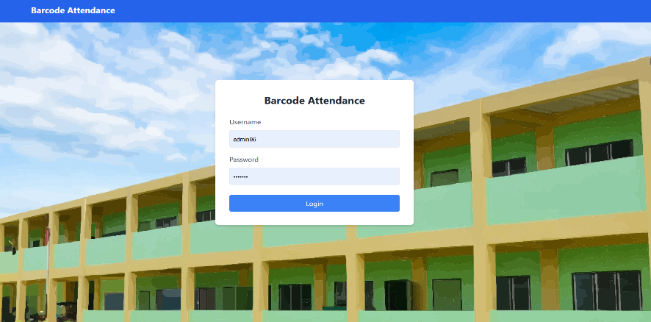

**Figure 3. Attendance System login**

Attendance System Login shows the login interface of the attendance system. It is the first screen users see when accessing the system. Users are required to enter their username and password to proceed. This ensures that only authorized personnel can access the system’s features and data.

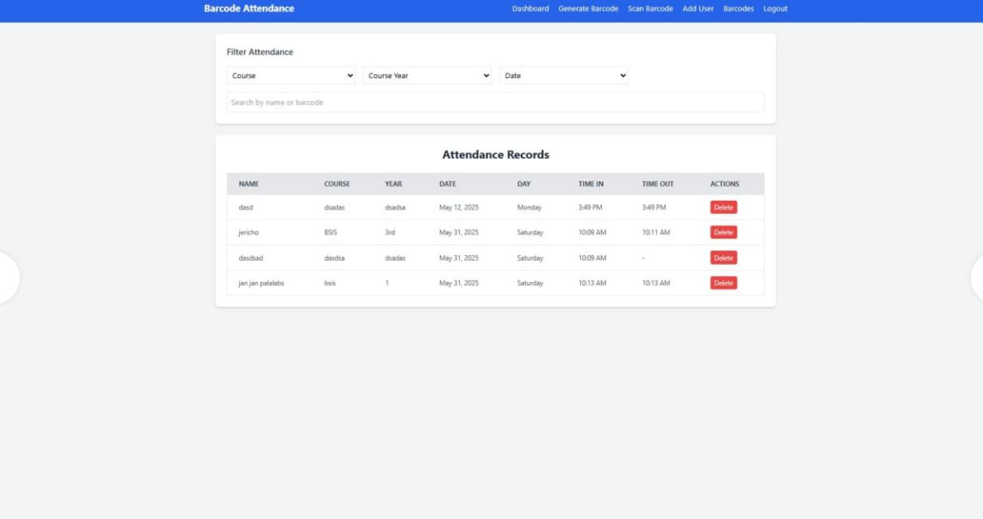

**Figure 4. Attendance System generate barcode, scan, and attendance table**

Attendance System generate barcode, scan, and attendance table presents the system’s main dashboard after a successful login. It includes key functions such as generating barcodes for students, scanning barcodes for attendance, and filtering attendance records based on course, year, and date. Below these controls, a table displays the recorded attendance details including student name, date, time-in, and time-out.

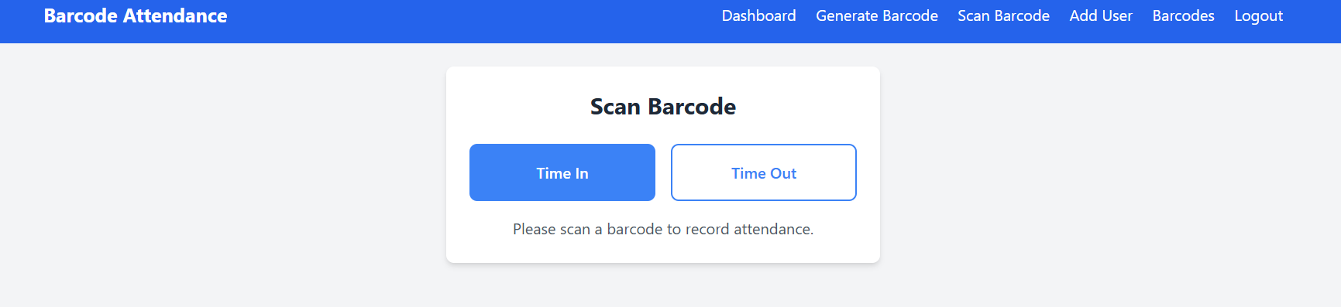

**Figure 5. Attendance System Scanner area**

Attendance System Scanner area displays the scanner section of the system. Once activated, the **barcode scanner** is used to scan the student’s barcode. When a barcode is detected, the system reads and records the attendance in real-time, allowing for a quick and contactless check-in process.

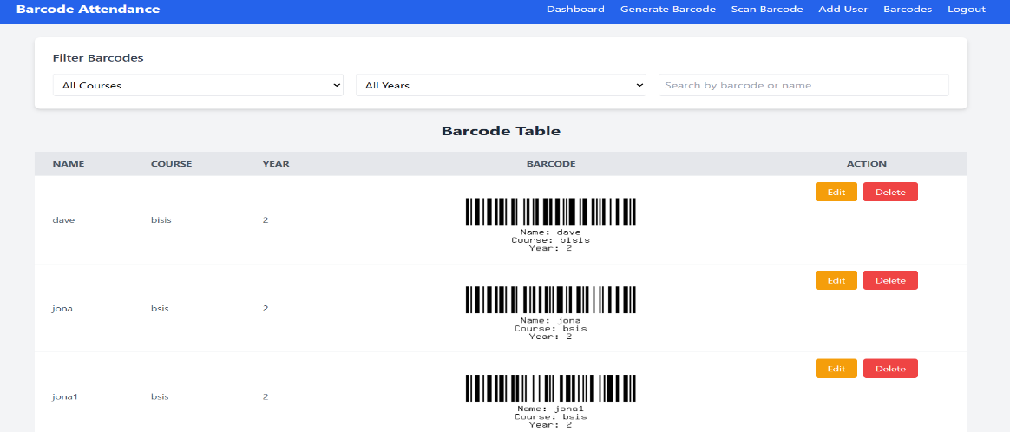

**Figure 6. Barcode Table**

Barcode Table displays the barcode table used in the system to store student information and their corresponding barcode. Each entry includes the student’s name, course, year level, and a unique barcode generated by the system. This barcode is used for scanning during attendance to quickly and accurately identify each student. The table helps administrators manage and 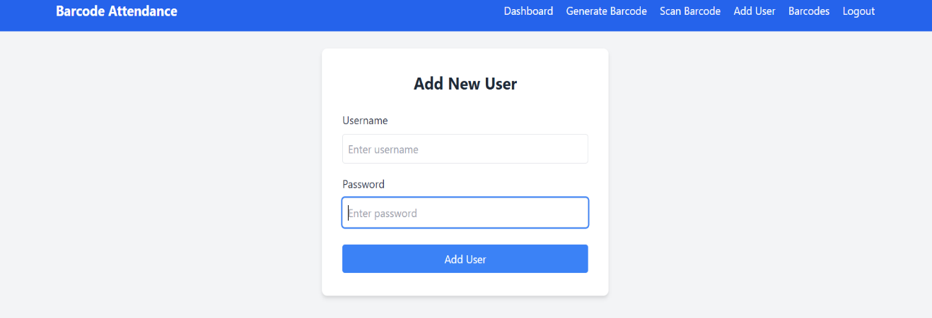organize student data efficiently.

**Figure 7. Add New User**

Add New User This figure shows the form used to add a new user to the system. The administrator inputs a **username** and **password**, which the user will use to log in. This function is important for managing system access and ensuring that only authorized users can enter and use the attendance system.

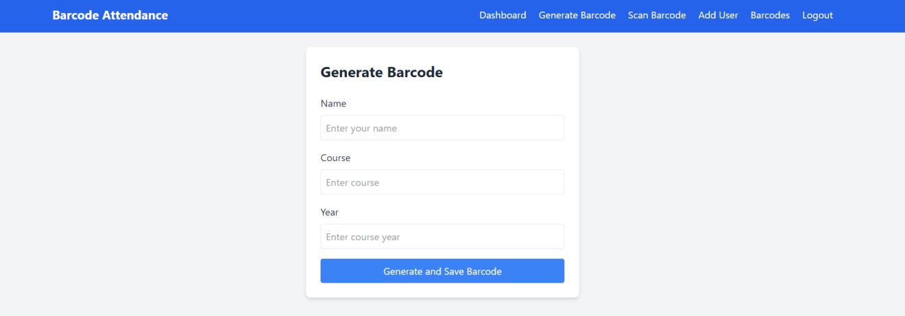

**Figure 8. Generate Barcode**

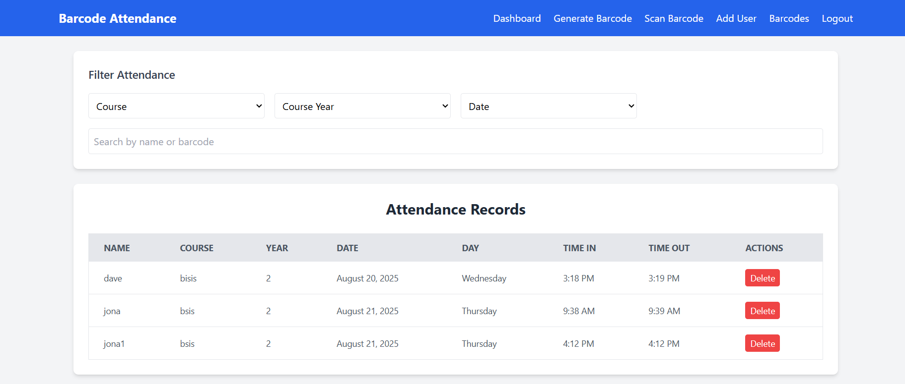Generate Barcode shows the form used to generate a barcode for a student. The administrator inputs the student's **name**, **course**, **year level**, and **email address**. After submitting the form, the system automatically creates a unique barcode linked to the student's information. This barcode is then used for scanning and tracking attendance efficiently and accurately.

**Figure 9. Attendance Table**

Attendance Tableshows the attendance records page of the system. It displays a table that lists each student’s name, course, year level, date, day, time-in, and time-out. The system records this information automatically each time a student scans their barcode. A delete button is also available for each entry, allowing administrators to remove incorrect or duplicate records. The filter options at the top help users search and sort attendance data by course, year, or date, making monitoring and reporting easier.

**SCHEMATIC DIAGRAM**

START

OPEN SYSTEM

LOGIN

ENTER USERNAME AND PASSWORD

SUBMIT

USERNAME PASSWORD VALID

ENTER NAME, COURSE, YEAR

Create barcode for student

Logged in to the system

Create Barcode

Generate Barcode

END

SCAN BARCODE

**Figure 6. Schematic Diagram**

The schematic diagram for the Barcode-Operated Web-Based System for Class Attendance Monitoring provides a structural overview of the system’s design tailored for SCMCSTI High School, illustrating the key components and their interconnections. It likely includes the web-based user interface—showcased in Figures 3 (login), 4 (barcode generation/scanning), and 5 (scanner area)—where students scan barcodes and instructors access records, alongside a barcode scanner module integrated with a device camera or external hardware. The diagram would also feature a cloud database (Firebase) for storing attendance data, a backend server powered by Python to process scans and manage logic, and a notification system to alert users, all linked to emphasize the system’s reliance on internet connectivity and browser compatibility. This static representation serves as a blueprint for developers, highlighting how hardware (laptops) and software components work together to automate attendance tracking, aligning with the study’s aim to enhance efficiencyand accuracy in a resource-constrained educational setting.

**DATA FLOW DIAGRAM**

user

logout

login

Submit

Dashboard

Generate Barcode

Scan Barcode

**Figure 7. Dataflow Diagram**

The Data Flow Diagram (DFD) for the Barcode-Operated Web-Based System illustrates the dynamic movement of data within the attendance monitoring process at SCMCSTI High School, detailing how information flows between entities, processes, and the cloud database. In a Level-0 context diagram, it depicts students, instructors, and administrators as external entities interacting with a central “Attendance System” process, where barcode scans are inputted and attendance records, reports, and notifications are outputted, with the cloud database Firebase serving as the data store. A Level-1 DFD refines this into sub-processes: barcode scanning validates student IDs, attendance logging records them with timestamps in real-time, data retrieval generates reports for instructors, and notifications alert users—all interconnected via the database for seamless updates. This diagram underscores the system’s automation, showing how it reduces manual errors and speeds up record-keeping, directly supporting the study’s goals of accuracy, efficiency, and usability through a clear visualization of data handling.

**Evaluation of Methodology**

The evaluation of the Barcode-Operated Web-Based System involves a thorough assessment to ensure it meets its goals of enhancing efficiency, accuracy, and usability in attendance tracking at SCMCSTI High School. Success criteria include reduced attendance processing time, error-free records, and positive user feedback. Evaluation methods encompass questionaire with users, performance testing for system speed and reliability, usability testing for interface intuitiveness, data accuracy verification, compliance with the Data Privacy Act of 2012, a cost-benefit analysis comparing manual and automated methods, and iterative improvements based on findings.

**Research Design**

The research design employs quantitative methods to evaluate the system’s accuracy, usability, and efficiency comprehensively. Structured surveys using a five-point Likert scale will quantify user perceptions and system performance, providing measurable data on its effectiveness in automating attendance tracking at SCMCSTI High School.

**Research Locale**

The study will be conducted at South Central Mindanao College of Science and Technology, Inc. (SCMCSTI) High School, located in Purok Rosal, Barangay New Isabela, Tacurong City, Philippines. This locale was selected due to its reliance on inefficient manual attendance methods, making it an ideal setting to test the proposed web-based solution.

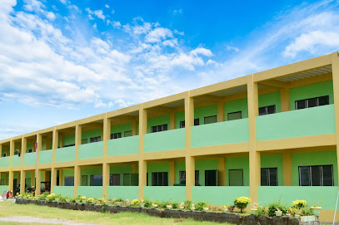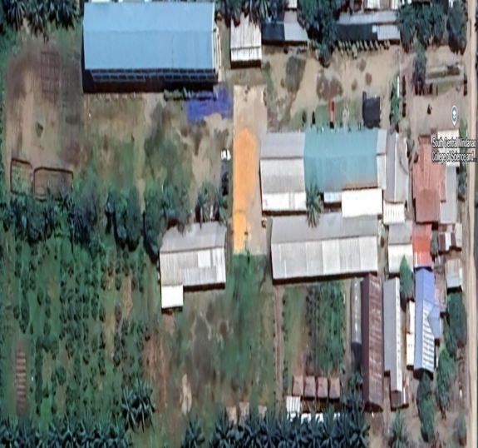

**Figure 8. Map of the Research Locale**

**Respondents of the Study**

The respondents will consist of 30 high school students who will test the barcode scanning feature of the system. Their feedback will provide valuable insights into the functionality, usability, and effectiveness of the solution from the perspective of the primary users.

**Data Gathering Procedures**

Preparing the system for evaluation the fully developed Barcode-Operated Web Based System will be installed on test devices and connected to the Firebase database. Formulating an evaluation form a survey questionnaire will be designed to assess accuracy, usability, and efficiency, based on a five-point Likert scale. Finalization of evaluation forms the forms will be reviewed and approved by the research adviser to ensure clarity and relevance. Distribution of evaluation forms will be distributed to respondents during a scheduled testing period at SCMCSTI School. Actual evaluation and testing respondents will use the system in a controlled environment (during class sessions) and complete the evaluation forms based on their experience.

**Data Gathering Instruments**

The main tool used for collecting data in this study is a survey questionnaire. It will gather important feedback from respondents about the system’s performance, ease of use, and overall efficiency.

In order to gather the different feedback and interpretation of the respondents the best way to answer and to test the accuracy, usability and efficiency of the system is to have this evaluation forms.

**Table 3. Scoring procedure for Accuracy**

|  |  |  |
| --- | --- | --- |
| **RANGE OF MEAN** | **DESCRIPTION** | **INTERPRETION** |
| 4.20 - 5.00 | Always | Highly Recommended |
| 3.30 - 4.19 | Often | Very Recommended |
| 2.60 - 3.29 | Sometimes | Recommended |
| 1.80 - 2.59 | Rarely | Less Recommended |
| 1.00 - 1.79 | Never | Not Recommended |

Scale used in Table 3 represents the interpretative to interpret the researcher sighted mean when evaluating the system survey question. The minimum and maximum lengths of the five-point Likert scale are defined by (1-5=4) and then divide by three (3) because the largest value of scale is (4/3= 1.33). The above table summarize the findings. The table shows that the mean of 4.20 - 5.00 is regarded as always. The range of 3.30 - 4.19 is considered as often. A mean of 2.60 – 3.29 is considered as sometimes, while mean 1.80 - 2.59 is considered Rarely. Lastly, the mean Range of 1.00 - 1.79 is considered Never.

1. **Table 4. Scoring Procedure for Usability**

|  |  |  |
| --- | --- | --- |
| **RANGE OF MEAN** | **DESCRIPTION** | **INTERPRETION** |
| 4.20 - 5.00 | Always | Highly Recommended |
| 3.30 - 4.19 | Often | Very Recommended |
| 2.60 - 3.29 | Sometimes | Recommended |
| 1.80 - 2.59 | Rarely | Less Recommended |
| 1.00 - 1.79 | Never | Not Recommended |

Table 4 represents the interpretative scale used to interpret the researcher sighted mean when evaluating the system survey question. The minimum and maximum lengths of the five-point Likert scale are defined by (1-5=4) and then divide by three (3) because the largest value of scale is (4/3= 1.33). The above table summarize the findings. The table shows that the mean of 4.20 - 5.00 is regarded as always. The range of 3.30 - 4.19 is considered as often. A mean of 2.60 - 3.29 is considered as sometimes, while mean 1.80 - 2.59 is considered Rarely. Lastly, the mean Range of 1.00 - 1.79 is considered Never.

1. **Table 5. Scoring procedure for Efficiency**

|  |  |  |
| --- | --- | --- |
| **RANGE OF MEAN** | **DESCRIPTION** | **INTERPRETION** |
| 4.20 - 5.00 | Always | Highly Recommended |
| 3.30 - 4.19 | Often | Very Recommended |
| 2.60 - 3.29 | Sometimes | Recommended |
| 1.80 - 2.59 | Rarely | Less Recommended |
| 1.00 - 1.79 | Never | Not Recommended |

Table 5 represents the interpretative scale used to interpret the researcher sighted mean when evaluating the system survey question. The minimum and maximum lengths of the five-point Likert scale are defined by (1-5=4) and then divide by three (3) because the largest value of scale is (4/3= 1.33). The above table summarize the findings. The table shows that the mean of 4.20 - 5.00 is regarded as always. The range of 3.30 - 4.19 is considered as often. A mean of 2.60 - 3.29 is considered as sometimes, while mean 1.80 - 2.59 is considered Rarely. Lastly, the mean Range of 1.00 - 1.79 is considered Never.

**Statistical Tools and Treatment of Data**

The researchers will employ descriptive statistics to summarize user feedback on the system’s accuracy, usability, and efficiency. Mean scores from the Likert scale evaluation forms will be computed using the formula:

Researcher Computed Mean = ∑(xi) / n

Where:

∑ = summation (sum of all values)

xi = each respondent’s score on the 5-point Likert scale (1 to 5)

n = the total number of respondents

Data treatment techniques, such as cleaning (removing incomplete responses) and normalization, will ensure reliability. Results will be visualized using charts (bar graphs) to facilitate interpretation and comparison across metrics.

**Ethical Consideration of the Study**

  The study adheres to ethical guidelines and regulations, ensuring the following:

**Voluntary Participation:** Respondents are free to choose whether to participate, with the study’s purpose and benefits clearly explained. Their right to withdraw is respected at any time.

**Privacy and Confidentiality:** In compliance with the Data Privacy Act of 2012 (RA 10173), a signed consent note will accompany the questionnaire, assuring respondents that their data will remain confidential, used solely for academic purposes, and destroyed after the study if required.

**Informed Consent Process:** Respondents will provide deliberate consent through a signed form, ensuring respect and transparency. Authorization from SCMCSTI High School administration will also be secured.

**Risks:** The study poses no significant risks to respondents’ health, well-being, or socioeconomic status. Testing schedules will be coordinated to avoid disruption, and questionnaires will be left with unavailable respondents for later retrieval.

**Benefits:** The research advances understanding of automated attendance systems, benefiting the education sector by offering insights for policy formulation and improved administrative efficiency.

**Authorship:** Contributions to the investigation and reporting are solely attributed to the researchers, Jona Mae V. Gonzales and Jan Aron V. Palabrica.

**LETTER TO CONDUCT THE STUDY**

**MS. CELESTINA O. CONSUMO _______ __** HIGHSCHOOL PRINCIPAL Date

Purok Rosal, Barangay New Isabela,

Tacurong City, Sultan Kudarat

Dear Maam:

We are the students of South Central Mindanao College of Science and Technology, Inc. Conducting research entitled of Barcode - Operated among Class Attendance Monitoring At South Central Mindanao College Of Science And Technology Inc. Secondary Level. The study will to design and develop a barcode-operated, web-based system that will streamline the process of recording and monitoring student attendance .

I would like to ask permission from your good office to allow me to distribute my survey questionnaire to the students of South Central Mindanao College of Science and Technology Inc.

I believe that your office adheres to the data privacy and voluntary participation of students at South Central Mindanao College of Science and Technology Inc.. Thus, any arrangement for the approval of our request will be highly appreciated. Coding of data will be done in order to protect privacy.

Rest assured that all data received and gathered data will be treated with the utmost confidentiality and for research purposes only.

Your assistance is vital for the success of our research. We are looking forward to your kind consideration on this request. Thank you and more power!

Respectfully yours,

**JONA MAE V. GONZALES**

**JAN ARON V. PALABRICA**

Researchers

Noted:

**NORIEL A. GALOSO JAYSON S. TORALBA LPT Rcrim**

Adviser Research Coordinator

______________________________

College Dean

Approved:

______________________________

Manager

**SURVEY QUESTIONNAIRE ONBARCODE - OPERATED AMONG CLASS ATTENDANCE MONITORING AT SOUTH CENTRAL MINDANAO COLLEGE OF SCIENCE AND TECHNOLOGY INC. SECONDARY LEVEL**

The undersigned are students of South Central Mindanao College of Science and Technology, Inc. who are currently undertaking a research study entitled **“**Barcode - Operated among Class Attendance Monitoring At South Central Mindanao College Of Science And Technology Inc. Secondary Level **”.** In this regard, please answer the questionnaire honestly and rest assured that your responses will be used for the sole purpose of this research adherence to policies and protocols and be treated with utmost anonymity and confidentiality.

The success of this study heavily relies on your cooperation and participation. Thank you for your cooperation and time.

**JONA MAE V. GONZALES**

**JAN ARON V. PALABRICA**

Researchers

Name (Optional) ____________________________________

Sex: ___Male ___Female

### **Instructions:** Please indicate your level of agreement with the following statements by marking (✓) under the appropriate column.

#### **Scale:**

**5-Always**

**4-Offen**

**3-Sometimes**

**2-Rarely**

**1-Never**

|  |  |  |  |  |  |
| --- | --- | --- | --- | --- | --- |
| **Evaluate the system in terms of:**  **A) Accuracy** | **5** | **4** | **3** | **2** | **1** |
| 1.The system logs attendance accurately without errors. |  |  |  |  |  |
| 2.The system reliably prevents duplicate or fraudulent entries. |  |  |  |  |  |
| 3.The system synchronizes data with the database precisely in real-time. |  |  |  |  |  |
| 4.The system consistently identifies students correctly through barcode scans. |  |  |  |  |  |
| 5.The system maintains error-free attendance records over multiple sessions. |  |  |  |  |  |
| **B) Usability** |  |  |  |  |  |
| 1.The system’s interface is intuitive for scanning barcodes and viewing records. |  |  |  |  |  |
| 2.The instructions within the app are clea clear for new users. |  |  |  |  |  |
| 3.The overall design of the system is user-friendly. |  |  |  |  |  |
| 4.The system allows easy navigation between features without confusion. |  |  |  |  |  |
| 5.The system provides helpful feedback during the barcode scanning process. |  |  |  |  |  |
| **C) Efficiency** |  |  |  |  |  |
| 1. The system processes attendance quickly compared to manual methods. |  |  |  |  |  |
| 2.The system effectively reduces the time spent on attendance tasks. |  |  |  |  |  |
| 3.I am satisfied with the overall performance of the system. |  |  |  |  |  |
| 4.The system completes attendance logging in a minimal number of steps. |  |  |  |  |  |
| 5.The system saves significant effort for instructors managing large classes. |  |  |  |  |  |