Steps for running

1. go into the next path by “ cd microblog”
2. Then “source venv/bin/activate
3. “ flask run”
4. The address of website shoud be <http://127.0.0.1:5000/> or http://127.0.0.1:5000/index
5. Uploaded file will be stored in static/Database
6. If you want to upload file in other devices, in step3, you need to run

flask run -h 0.0.0.0 -p 3000

( 3000 is the port, you can change but not 0.0.0.0)

And the address is not http://0.0.0.0:port It’s your ip address. For me it is 192.168.101.40:port/index (the port is the one you set)

You need to check you ip address before doing it.

All devices must under the same router

If you have mackbook, then you can type ‘inconfig’

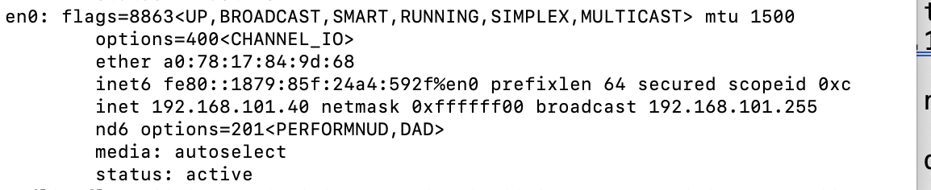



Let me know if you have any question