Contents

Self Evaluation Questions (4 points, one point each): 3

Project Definition 4

Product Description 4

Competitors 4

Minimum Viable Product 6

List of Additional Features 6

User Task Flows 7

User story 8

Lo – Fi Sketches 8

Data Model 14

DGL 214 Semester Project Rubric - Milestone 1

This Milestone has three parts.

1. Project Definition – 4 mks

2. Lo-fi Sketches – 4 mks

3. Storyboards – 4 mks

4. Data Model – 3 mks

For each part, score yourself as follows (16 points):

0 - no work completed on this portion of the assignment

2 - work was done, but it clearly has significant room for improvement

3 - a good effort was made, and the result was solid

4 - the work is excellent in every regard and could not be further improved

## Self Evaluation Questions (4 points, one point each):

1. How much time did you spend on this assignment/project?

*I spent approximately twelve (12) hours on this assignment, from initial ideation to storyboarding.*

2. How difficult did you feel this project was? Was it too easy, too difficult, or about right for you?

*The project was about right for me because I had previous knowledge and experience from another class in how to write about a minimal viable product and create wireframes. The process of articulating, developing the idea and representing it required time and attention to detail.*

3. What challenges did you come across while working on this project?

*The main challenge with this project was the time it took and my lack of clarity with regard to the difference between storyboards and wireframes. I also struggled a bit with userflows.*

4. What things would you like to learn more about after having worked on this assignment?

*I need to learn more about the functionality of PHP and databases, more insight into what is possible would have spoken to the idea and design.*

*I also would like to understand more about storyboarding and user flows.*

Total Score (out of 20): **19**

## Project Definition

### Product Description

This app will help the user to make progress on their learning journey by quickly and easily connecting them with tutors. It does this by giving them options for tutorial type, subject, level and time of day then presents them with options of tutors to choose from including cost. The app also provides study tips, news in education such as curriculum changes, and time tracking with tutors and independent study along with reports on time and cost summaries per subject or per tutor for different time ranges, that is, weekly, monthly etc.

### Competitors

findatutor.ca

<https://findatutor.ca>

Services

Offers 20 subjects based on level, type of tutorial session. User must enter zip code and list of tuors is displayed.

Pros

* The search results are returned very quickly
* The user enters information in one tight area and doesn’t have to go to multiple screens
* No sign-up is required to get list of tutors

Cons

* The search is limited to one city or town so the user has to redo the request for another city or town that may be close to them

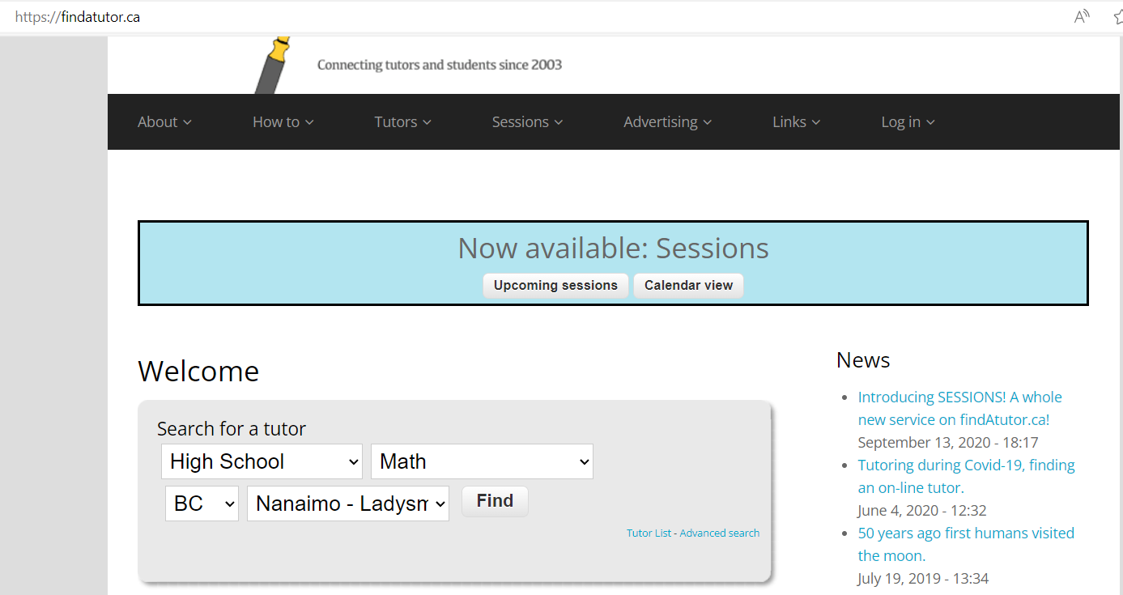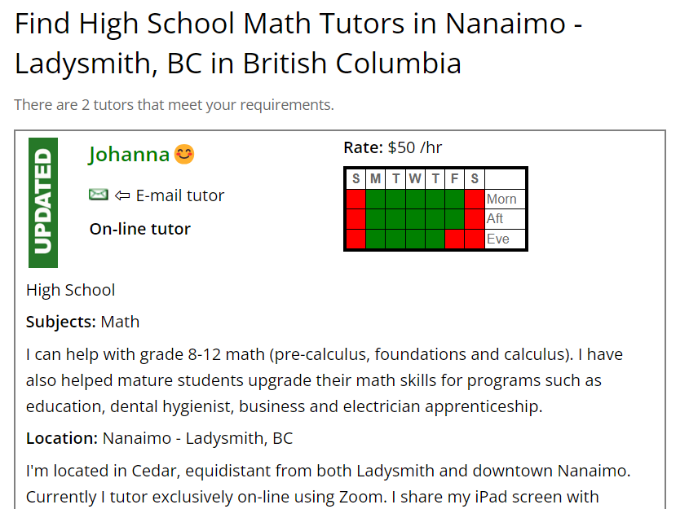

### Minimum Viable Product

* Register user, including email, username, postal code and password
* Add student (student maybe user) this requires name, age and level
* Delete a student
* Create a tutor request
  + Required data: tutorial type, subject, level and time of day, all of these will be selected via drop-down menus
  + Submit – to submit request
  + Reset – to clear fields and create another request
* Display list of tutors based on request criteria, including name, rating, fees, experience, location, subjects offered, type of tutorial (in-person or online)

### List of Additional Features

* Display news about education trends including change in curriculum, study permit rules, college entry etc
* Display tips for studying successfully
* Keep track of
  + hours spent with tutor
  + cost of tutor
  + hours spent on study in subject area
  + grades
* Provide comparison reports per week, month and yearly time periods of
  + hours spent with tutor
  + cost of tutor
  + hours spent on study in subject area
  + grades

## User Task Flows

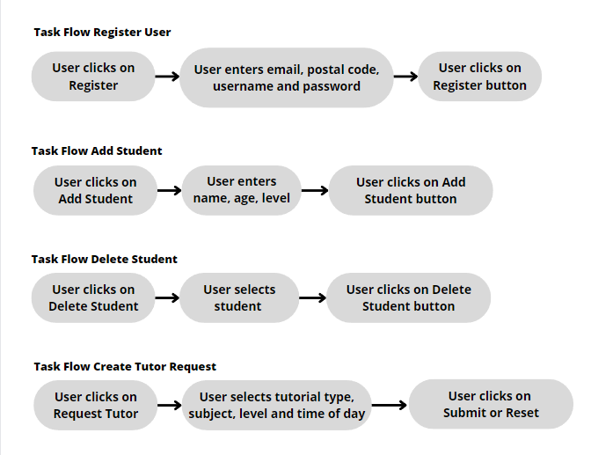

## User story

Kim -

As a parent, I want to easily find good tutors that suit my location and budget for my child, so that they can improve their grades in weak subject areas.

Julio -

As a student, I want to select a tutor from a set of options I am given based on my criteria, so that I can excel at school and graduate with honours.

## Lo – Fi Sketches

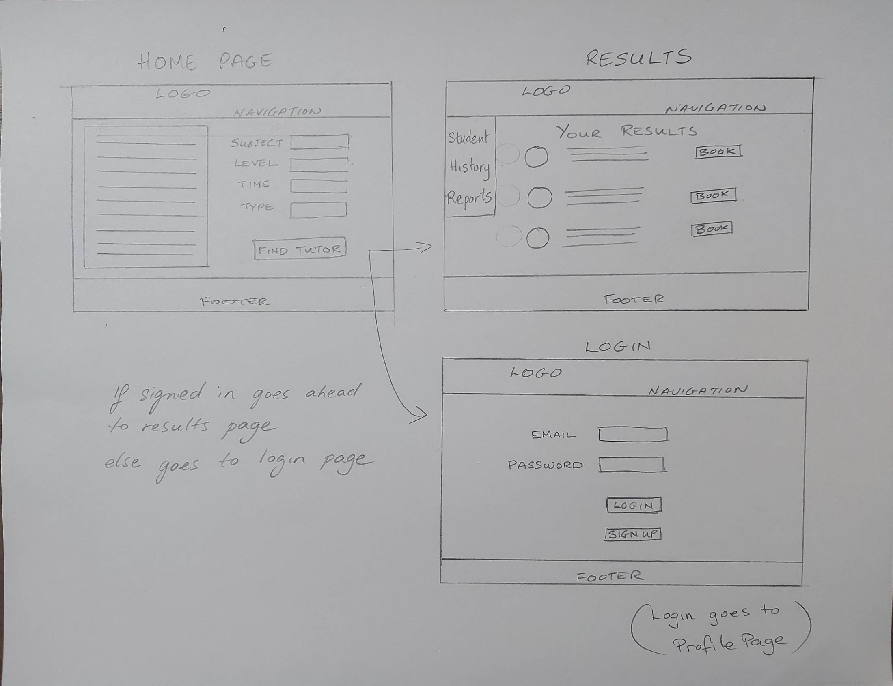

## StoryBoards

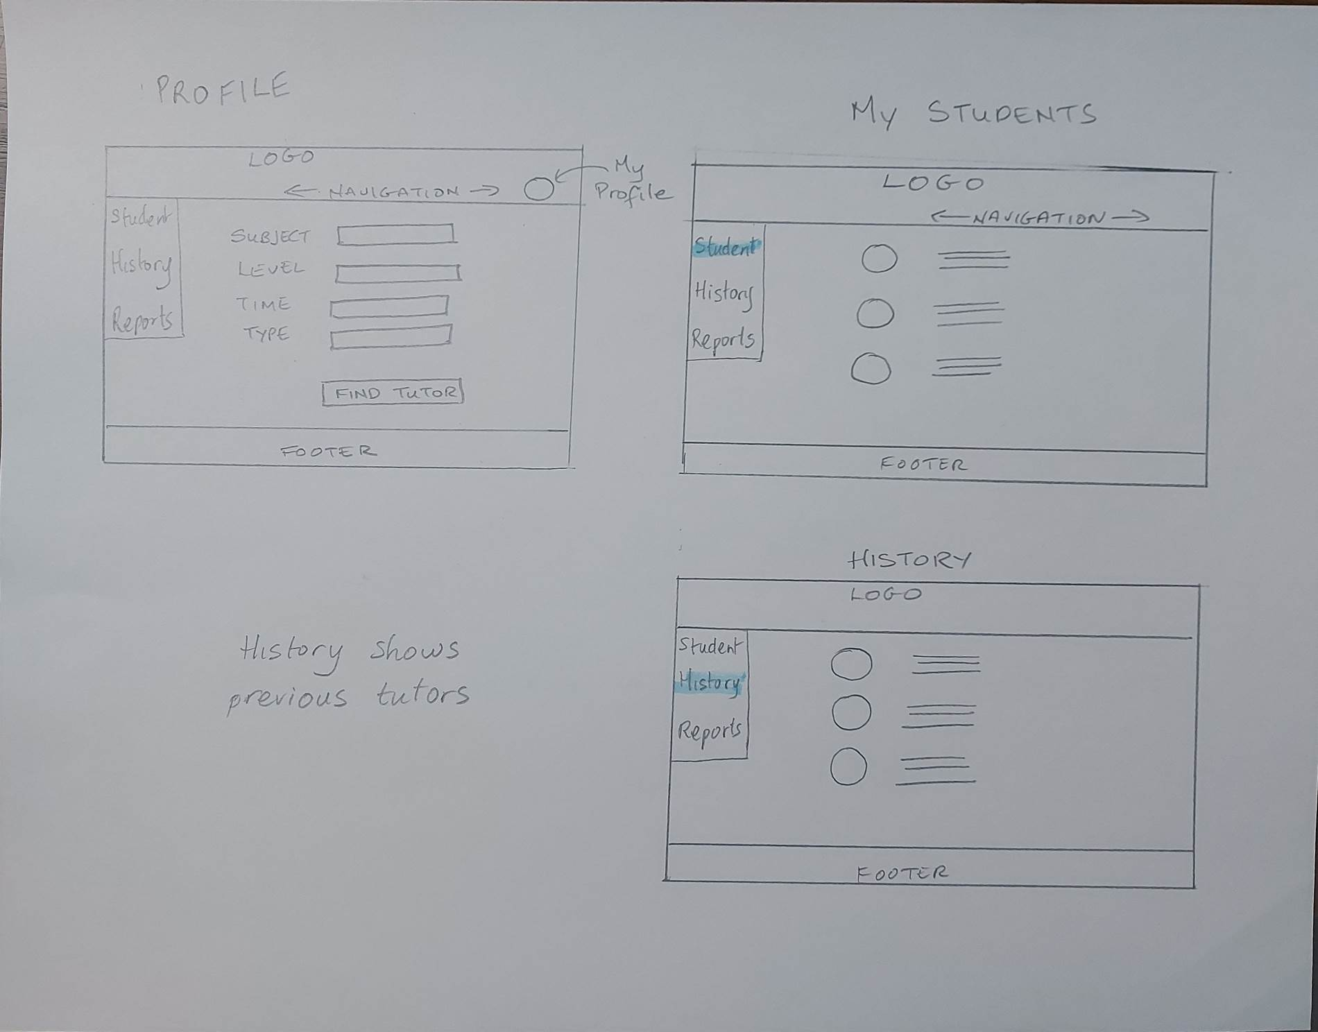

All pages have these options on top navigation bar. Clicking on:

Home -> HOME PAGE

News -> NEWS PAGE

Study Tips -> STUDY TIPS PAGE

Log In -> LOG IN PAGE

|  |  |
| --- | --- |
|  | HOME PAGE  Clicking on Find a Tutor Button -> LOG IN PAGE |

|  |  |
| --- | --- |
|  | **LOG IN PAGE**  Clicking on Log In Button -> PROFILE PAGE  Clicking on No Account Button -> SIGN UP PAGE |

|  |  |
| --- | --- |
|  | **SIGN UP PAGE**  Clicking on Sign Up Button -> PROFILE PAGE |

|  |  |
| --- | --- |
|  | PROFILE PAGE   * *New menu appears on left* * *Sign In is now My Profile*   Clicking on Find a Tutor Button -> TUTOR RESULTS PAGE  Clicking on Students -> STUDENT PAGE  C licking on My Tutors -> TUTORS PAGE |

STUDENT PAGE (MY TUTORS PAGE is very similar)

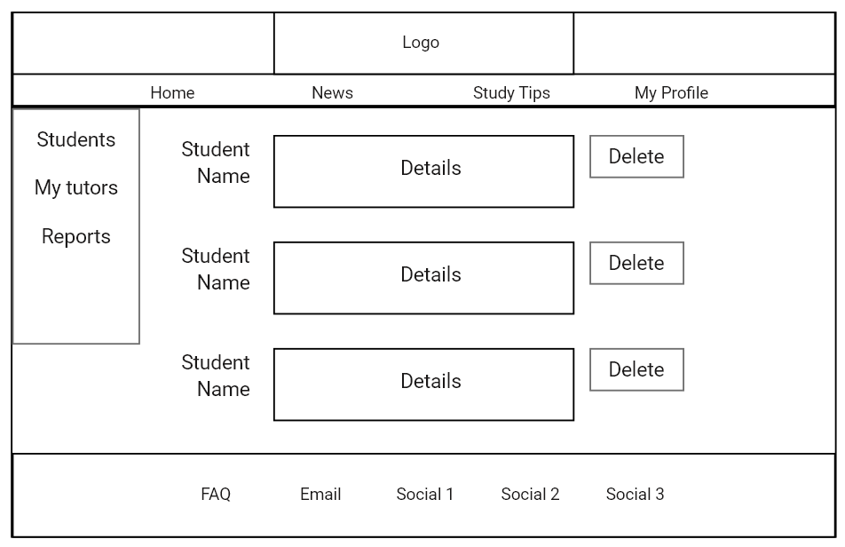

TUTOR RESULTS PAGE

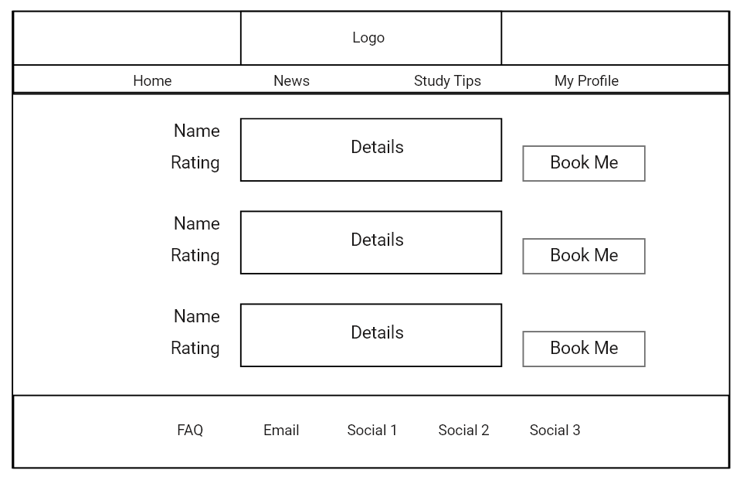

## Data Model

Has

Student

User

Tutors

Books

Tutorial

Tutor

Has

Review

Tutor

Key: tutor_ID

|  |  |
| --- | --- |
| Field name | Data Type |
| tutor_ID | integer |
| tutor_first | text |
| tutor_last | text |
| rating | integer |
| location | text |
| subjects | text |
| in_person | boolean |
| online | boolean |

Tutor_Reviews

Key: tutor_ID, review_ID

|  |  |
| --- | --- |
| Field name | Data Type |
| tutor_ID | integer |
| review_ID | integer |
| review | text |

User

Key: user_ID

|  |  |
| --- | --- |
| Field name | Data Type |
| user_ID | integer |
| email | text |
| password | text |
| postal_code | text |

Student

Key: user_id / student_number

|  |  |
| --- | --- |
| Field name | Data Type |
| user_ID | integer |
| student_number | integer |
| DOB | date |
| current_level | text |

Tutorial

Key: user_ID, tutor_ID, session

|  |  |
| --- | --- |
| Field name | Data Type |
| user_ID | integer |
| tutor_ID | integer |
| session | date |