Contents

GitHub Link 2

Data Flow Diagram 3

phpMyAdmin/ SQL 4

Current Functionality 4

Screenshots of App 5

Milestone 3 Project Rubric 9

# GitHub Link

[Jan-elle-Chan/FindTutor (github.com)](https://github.com/Jan-elle-Chan/FindTutor)

# Data Flow Diagram

Student information request

Tutor criteria entry

Student query results

## 

Tutor query results

# phpMyAdmin/ SQL

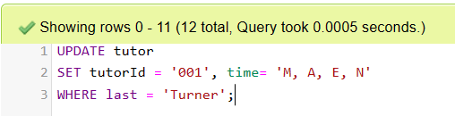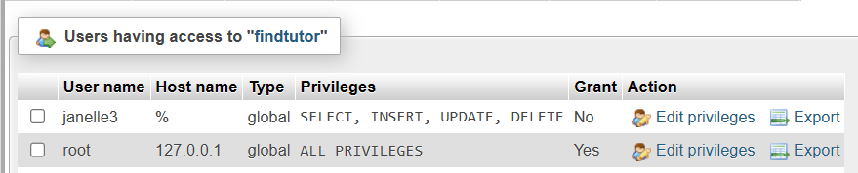

# Current Functionality

* The back-end and front-end are connected
* Data capture on the Find a tutor form is passed to query string
* Results are displayed on search page, meaningfully formatted
* Students linked to a specific user are displayed on the Students page, however this is not yet based on user login

# Screenshots of App

The following screenshots are of the improved front end. Some changes that need to be made include following:

* Login and user sign up
* Displaying students based on user logged in

Home Page/ Find a Tutor – the content on this page has been updated and options on the form have been added in drop-down boxes

My Profile >> Search Results Page

Page showing 1 result

Page showing multiple results

My Profile>>>Students Page, currently this page displays results for one user

These pages are not yet functional: Login and Sign Up

Login Page

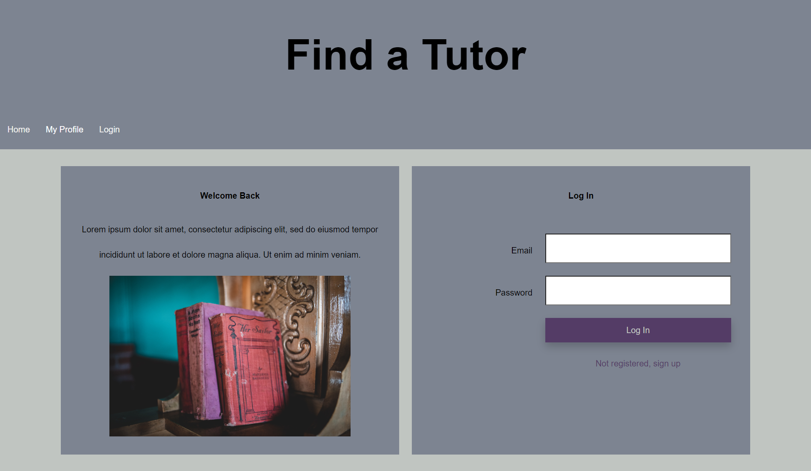

Sign Up Page

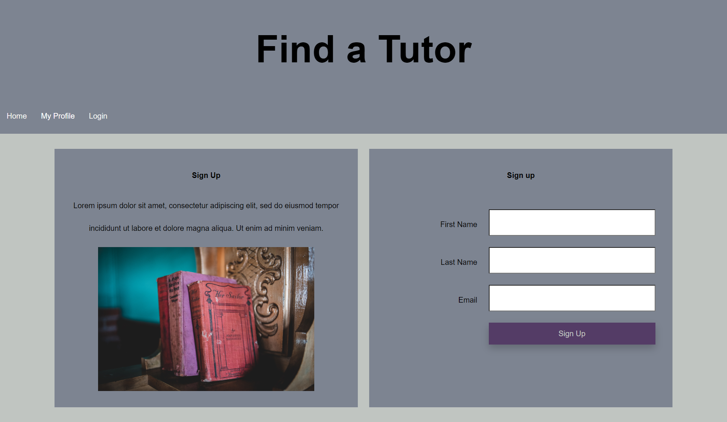

# Milestone 3 Project Rubric

INSTRUCTIONS: Please fill out the following form and submit it on BrightSpace. Choose only one of the corresponding numbers in your answer for sections A-F. Answer the questions in section G in sentence form.

Please total your self-evaluation score at the bottom of the rubric. **17/ 20**

1. Code Quality
2. - Nothing - No submission
3. - Below Expectations - Code renders but the code is unreadable
4. - Meets Expectations - Good formatting and uses naming conventions but can be improved
5. - Exceeds Expectations - Code is exceptionally clean and best practices are used

**Your Answer: 2**

1. Content
2. - Nothing - No submission
3. - Below Expectations - Content not related to assignment or project (lorem ipsum, for example)
4. - Meets Expectations - Content is related to assignment or project and gets the point across
5. - Exceeds Expectations - Content is exceptionally detailed and well put together

**Your Answer: 2**

1. Layout / Organization
2. - Nothing - No Submission
3. - Below Expectations - Long sections of code with no divisions or random code layout
4. - Meets Expectations - Code that is modular and divided into sections; subprograms and functions
5. - Exceeds Expectations - Code is exceptionally well organized. **Your Answer: 3**
6. Comments/Commits/Documentation
7. - Nothing - No Submission
8. - Below Expectations - Excessive, unnecessary, and irrelevant remarks; infrequent commits; missing documentation
9. - Meets Expectations - Comments identify authorship and code's intention
10. - Exceeds Expectations - Comments and documentation are clear succinct; wizardry points are explained

**Your Answer: 3**

1. Rendering and Interface
2. - Nothing - Page does not load or render
3. - Below Expectations - Page renders, but has errors and/or has apparent design issues
4. - Meets Expectations - Page renders and produces no errors; Interface logically laid out
5. - Exceeds Expectations - Page renders and displays properly for multiple screen sizes and browsers; Exceptional usability

**Your Answer: 2**

1. Process
2. - Nothing - Project not attempted
3. - Below Expectations - code and documents not added to repository at correct times (all at once, for example)
4. - Meets Expectations - code tested regularly, pushes throughout milestone period, implementation targets met
5. - Exceeds Expectations - all design goals accomplished, submissions organized, instructions carefully followed, steps thoroughly documented

**Your Answer: 2**

1. Self Evaluation Questions (half point each):
   1. How much time did you spend on this assignment/project? ***15 hrs***
   2. How difficult did you feel this project was? Easy, moderate, difficult?

***Moderate to difficult***

* 1. What challenges did you come across while working on this project? ***Issues with code, needing to debug***

4. What things would you like to learn more about after having worked on this assignment? ***I need to refine queries and do login/ sign up***

**Total Score 2**

***Total Score : 16/20***