KETCo Unified Digital Platform
Requirements & Business Architecture Specification Document
Name: Jan Arno Coetzer
Date: October 2026

Table of Contents
Project Overview & Scope 4
Profile of the Organization 4
Current Process 4
Core Business Problems 4
Expected Outcomes 4
Known Constraints 4
Stakeholder and Actor Catalogue 4
Stakeholder Profiles 4
Actor-Goal Catalogue 4
System Boundaries 4
In-Scope Functions 4
Out-of-Scope Functions 4
Dependencies and Information Gaps 4
External Dependencies 4
Critical Information Gaps 4
Requirements and Business Rules 4
Requirements Catalogue 5
Business Rules and Constraints 5
Assumptions and Constraints 5
System Risks 5
Clarification Questions 5
Behavioural & Use-Case Modelling 5
Domain Association Diagram 5
Use-Case Specifications 5
Gherkin Feature Specifications 5
Domain Analysis & Conceptual Model 5
Candidate-Concept Filtering Rationale 5
Domain Glossary 5
Traceability & Project Execution 5
Traceability Matrix 6
Recommended Repository Structure 6
Reflection & AI Declaration 6
Critical Design Decisions & Revisions 6
Limitations & Unresolved Questions 6
AI Level Disclosure & Interaction Log 6

Project Overview & Scope

Profile of the Organization
The Kerry Environmental Testing Cooperative (KETCo) operates a central laboratory in Tralee, County Kerry. KETCo tests water and soil samples for rural and local stakeholders. Clients give samples directly to the Tralee laboratory. Alternatively, KETCo technicians collect samples in the field.
- Clients request tests for three reasons:
- General environmental monitoring.
- Specific project work.
- Investigations after unexpected environmental changes.

Current Process
Intake and Logging: Staff use paper forms, spreadsheets, and emails. They manually record requests, labels, field data, and test assignments.
Collection: Field technicians, clients, or partner organizations collect samples.
Receipt and Screening: Staff check samples at the intake desk. They look for leaks, label errors, temperature changes, and low volume. Staff write a laboratory reference number on the container.
Internal Routing: Staff move samples between laboratory stations. They track steps with paper bench sheets.
Testing and Referrals: The manager assigns tests. The manager checks machine availability and analyst training. Analysts split samples or send fractions to external laboratories.
Review and Reporting: Analysts record raw measurements. They calculate data manually. A reviewer must verify the data before report release. Staff use a manual workflow for report corrections.

Core Business Problems
High Administration Workload: Staff write the same data many times across paper logs and spreadsheets.
This creates workflow bottlenecks.
Data and Entry Errors: Staff use different names for the same location. Handwritten labels are frequently illegible.
Custody Log Failures: Paper bench sheets make audit tracking difficult. Staff mix up sample bottles within the same batch.
Sample Loss Risk: The laboratory does not have a digital check for container types, preservation states, and holding times. Staff analyze degraded samples, which creates invalid data.
Security and Report Vulnerabilities: Customers can see unverified provisional values before review. A lack of data isolation risks exposing sensitive data to competitors.

Expected Outcomes
Unified Digital Platform: Replace paper and spreadsheets with one central software application.
Digital Chain of Custody: Create a permanent digital log from collection to disposal to stop bottle mix-ups.
Standard Locations: Separate broad text descriptions from precise GPS coordinates in the database.
Real Time Visibility: Give the manager a live dashboard for intake checks, active tests, machine delays, and pending reports.
Versioned Reports: Transmit secure reports. Keep a full history of version numbers, revision notes, and recipient logs.

Known Constraints
- The system manages only water and soil samples.
- The internet is stable in the Tralee office but weak at rural collection points.
- One request can have many samples, and one sample can have many tests.
- Split fractions must link to the parent sample reference number.
- Machine calibration and Quality Control (QC) check failures delay testing.
- Unusual results are data anomalies. They do not prove environmental pollution or causes.

Stakeholder and Actor Catalogue

Stakeholder Profiles
Direct Stakeholders (Laboratory Staff): Receptionists, analysts, and managers must reduce double entry workload. They must avoid bottle mix ups.
Indirect Stakeholders (KETCo Executive Board): The board must decrease liability risks from unverified provisional data releases. They must stop competitors from viewing multi-tenant data.
External Stakeholders (Clients): Rural farmers and commercial entities require reliable and fast turnarounds.
They demand total isolation of their sensitive commercial environmental profiles.
Partner Organizations: Partners require clear and simple drop-off field procedures under weak network conditions.

ACTOR GOAL CATALOGUE
Actor Name | Type | Description | Core System Goals
Reception Technician | Primary | Staff managing intake desks. | Generate unique IDs. Run baseline rule checks. Assign provisional status safely.
Field Technician | Primary | Remote operator collecting physical samples. | Log collection metrics offline. Capture stable coordinates linked to parent location profiles.
Analyst | Primary | Lab specialist doing technical assays. | Log numeric measurements. Flag departures. Instrument validations safely.
Quality Manager | Primary | Certified data reviewer and auditor. | Verify raw data metrics. Sign off version 1 records. Process version-controlled replacements.
Laboratory Manager | Primary | System supervisor monitoring operations. | Monitor bottlenecks via a dynamic console. Oversee active delays and anomalies.
Customer Portal | Primary | External representative interacting via web UI. | Query secure chronological version stacks. Download validated reports safely.
Notification Subsystem | Supporting | Internal engine distributing data alerts. | Distribute SMS/Email flags automatically within 5 minutes of critical failures.

System Boundaries

IN SCOPE FUNCTIONS
Intake: Record customer requests, track sample quality metrics, and manage provisional acceptance.
Mapping: Separate broad locations from precise GPS coordinates in the database.
Custody Log: Track sample movement, handler IDs, station changes, and bench sheet references with timestamps.
Architecture: Link parent samples to internal splits and external laboratory records.
Management: Assign tests by analyst training certificates, track test status, and record raw measurements.
Instruments: Log machine availability, calibration data, and pre-test QC checks.
Reporting: Create final reports with sequential version numbers, mandatory notes, and access control.

OUT OF-Scope Functions
Machine Connections: No direct hardware APIs or drivers. Analysts must enter all machine data manually.
Regulatory Compliance: No evaluation of statutory limits. No automated alerts to government authorities.
Accounting: No processing of client invoices, billing data, or financial workflows.
Consultation: No automated environmental conclusions or professional advice.

Dependencies and Information Gaps

External Dependencies
Rural Networks: Mobile operations depend on local network coverage or offline data caching.
Partner Accuracy: Early tracking depends on partner organizations recording field data correctly.
Third Party Labs: Final reports depend on the delivery schedules of external laboratories.

Critical Information Gaps
Provisional Rules: Criteria for provisional acceptance and maximum holding times before system rejection.
Rejection Matrix: Rules that map physical defects to automatic test unsuitability.
Tracking Standards: Naming standards for internal splits and external referral samples.
Privilege Matrix: Definitions of roles that can approve method departures, override failed QC checks, or start re tests.
SLA Logic: System logic to recalculate completion dates when machines fail.
Correction Governance: Review workflows and clearances to approve and distribute replacement reports.
Data Isolation: Access rules to restrict view permissions by customer type

Requirements and Business Rules

Requirements Catalogue
ID | Subsystem | Name | Description | Priority | Rationale
FR-101 | Intake | Unique ID Generation | The system must generate a unique reference ID for each sample at receipt. | Must | Rationale: Fundamental operational dependency.  Verify: Inspection of data rows.
FR-102 | Intake | Spatial Mapping | The system must record GPS coordinates and link them to a parent location ID. | Must | Rationale: Solves geographical naming ambiguity.  Verify: Entry mapping demo.
FR-103 | Intake | Condition Status | Let technician set status to 'Provisionally Accepted' and force note entry. | Must | Rationale: Handle incomplete field data safely.  Verify: Null note rejection test.
FR-104 | Intake | Suitability | Check temperature, container, and elapsed time against rules. | Should | Rationale: Prevent testing degraded samples.  Verify: Test edge metrics.
FR-105 | Tracking | Splits | Support sample splits and link to parent reference key. | Must | Rationale: Mandatory for external referrals.  Verify: Inspect DB relations.
FR-106 | Tracking | Immutable Log | Add log row automatically when location or staff ID changes. | Must | Rationale: Eliminate mix-ups and log failures.  Verify: Delete/update blocking.
FR-107 | Lab Ops | Segregation | Separate raw data from reportable fields until review is done. | Must | Rationale: Prevent customer viewing unverified values.  Verify: Portal isolation test.
FR-108 | Lab Ops | Validation | Verify analyst ID against certified methods list before save. | Should | Rationale: Quality assurance check. Verify: Uncertified save block.
FR-109 | Lab Ops | Machine Block | Set test to 'Delayed' if machine fails QC check or is out of service. | Must | Rationale: Prevent execution on uncalibrated hardware.  Verify: Status shift demo.
FR-110 | Reports | Version Ctrl | Increment version number and force revision notes during corrections. | Must | Rationale: Vital for audit trails and liability protection.  Verify: Blank note block test.
FR-111 | Reports | Dashboard | Show unapproved corrected reports, anomalies, referrals, and delays. | Should | Rationale: Live operational visibility for managers.  Verify: UI rendering check.
NFR-201 | Offline | Sync Cap | Store 200 logs offline and sync in under 30 seconds. | Must | Rationale: Counteract weak rural networks.  Verify: Cache sync simulation.
NFR-202 | Security | Multi-Tenant | Filter queries by sensitivity flag; return HTTP 403 error. | Must | Rationale: Absolute multi tenant isolation. Verify: Token injection attempt.
NFR-203 | Alerts | Latency | Send email/SMS within 5 minutes when Rejected or Delayed. | Should | Rationale: Improve response speed. Verify: Timestamp log check.
NFR-204 | Scope | Isolation | Zero software dependencies on billing or enforcement modules. | Must | Rationale: Enforce defined brief boundaries.  Verify: Architecture tree inspection.

Business Rules and Constraints
- Role Based Testing: Staff can assign tests to analysts only if the analyst has recorded training for that method.
- Mandatory Data Separation: The system must separate general text descriptions from precise GPS data in the database.
- Release Hierarchy: Raw machine data are provisional values. The system must block the release of provisional values to customers until a Quality Manager approves the report.
- Data Access Restrictions: When a customer record has an active commercial sensitivity flag, the system must hide these test results from all other customers.

Assumptions and Constraints
- Provisional Sample Lifespan: The system assumes a maximum holding time of 48 hours for provisional samples before automatic rejection.
- Component Level Suitability: If one test fails sample suitability checks, other compliant tests on the same sample can stay active.
- Chain of Custody Inheritance: Sample portions automatically inherit the primary Laboratory Reference ID as a parent reference.
- Unreliable Connectivity: Internet access is stable at the Tralee office but weak at rural collection points.
The field module must support offline data entry.

System Risks
- Traceability Breakdowns: Complex custody processes can cause staff to bypass the digital system. This leads to continued sample mix ups.
- Premature Machine Integration: Direct connections to laboratory hardware APIs can cause project schedule delays.
- Data Siloing Failures: Incorrect data access controls can allow unauthorized users to see sensitive customer data.

Clarification Questions
- What is the maximum time a sample can stay provisionally accepted before automatic rejection?
- Is there a matrix that maps specific container defects directly to the tests they invalidate?
- Which specific roles can authorize repeat tests, method departures, or corrected reports?
- Should updated completion dates notify the customer immediately or wait for manager review?
- What specific fields should be visible to partner organizations versus field technicians?

BEHAVIOURAL & USE CASE MODELLING

Domain Association Diagram
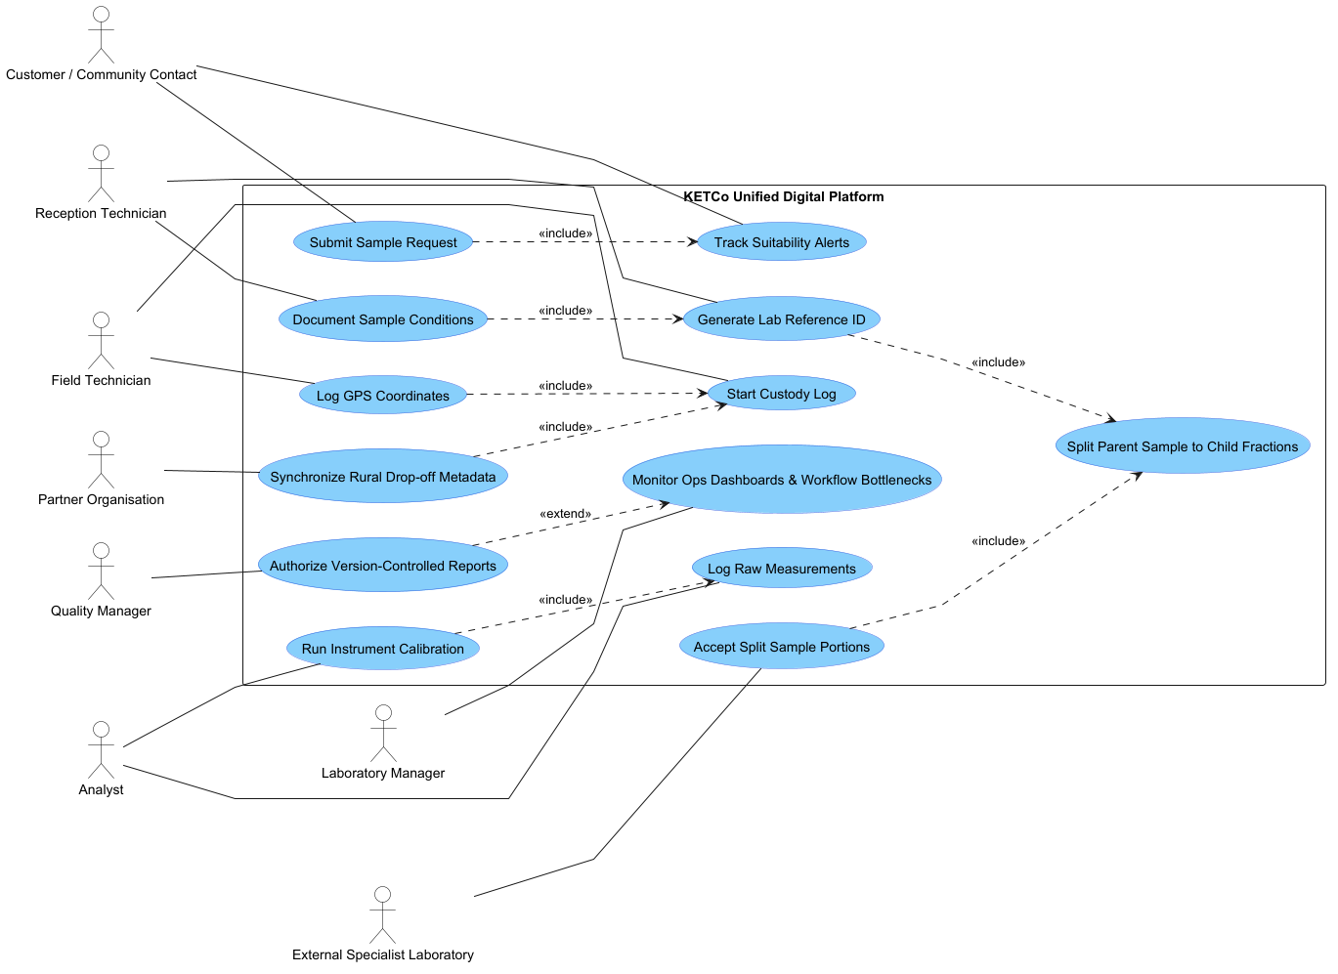Use Case Diagram.png - Use Case Diagram.puml

USE CASE SPECIFICATIONS
Use Case | UC-101 Rationale: Fundamental operational dependency. Verify: Inspection of data rows.
Actor: | Reception Technician
Preconditions: | The system is online. A physical sample arrives at the Tralee laboratory. A sample request exists in the system.
Trigger: | The technician starts the intake workflow on the system.
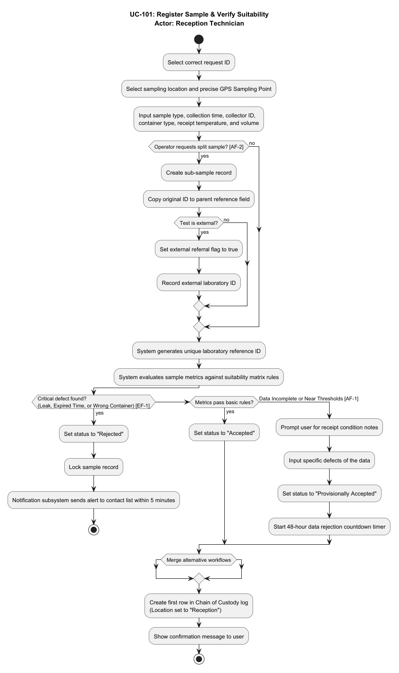
ActivityDiagram.png - ActivityDiagram.puml

Gherkin Feature Specifications
Intake and mapping
Feature: Unique Identification and Coordinate Mapping
As a Reception Technician
I want to register incoming physical samples with automatic IDs and spatial rules
So that location errors stop, and the digital chain of custody starts correctly

Background:
Given a valid sample request exists in the system

Rule: Every logged sample must have a unique identifier and spatial mapping

Scenario: Successful sample intake under standard conditions
Given a physical water sample has arrived at the laboratory intake desk
When the Reception Technician logs the sample with a receipt temperature of "4.2°C"
And selects the exact GPS Sampling Point coordinates "52.2674, -9.6963"
Then the system must generate a unique laboratory reference ID
And set the sample status to "Accepted"
And add an initial row to the Chain of Custody log with the location set to "Reception"

Scenario: Incomplete intake records trigger provisional acceptance status
Given a physical soil sample has arrived at the laboratory intake desk
When the Reception Technician logs the intake metrics but leaves the collection time blank
Then the system must force the technician to write mandatory receipt condition notes
And set the sample status to "Provisionally Accepted"
And start a 48 hour data rejection countdown timer

Scenario: Critical sample container defects force immediate system rejection
Given a physical water sample has arrived at the laboratory intake desk
When the Reception Technician enters a sample that has a broken or leaking container
Then the system must set the sample status to "Rejected"
And lock the sample record to stop test assignments
And send a failure notification to the contact list in less than 5 minutes
Offline field collection

Feature: Offline Field Collection
As a Field Technician
I want to save sample data on my mobile device when the network is not available
So that rural collection work is stable and data transfers fast after connection

Rule: Field applications must support offline operations and rapid data synchronization

Scenario: Capture sampling coordinates during cellular network disconnection
Given the mobile field application detects that network connection is not available
When the Field Technician saves the GPS coordinates and collection data for a new sample
Then the system must store the collection log line safely in the local device cache

Scenario: Automatic synchronization of cached records upon network re-establishment
Given the mobile field application has stored 200 logs in its offline cache
When a stable network connection becomes available again
Then the system must automatically sync all cached records to the central database in

Chain of custody

Feature: Sample Splitting and Custody Tracking
As an Analyst or Handler
I want to split samples and move custody with clear records
So that data errors stop through an unchangeable digital audit log

Rule: Sample portions must inherit parent identity, and custody logs must be immutable

Scenario: Creating a child sample fraction for external referral testing
Given an environmental water sample exists in the system with an active status of "Accepted"
When an Analyst runs a split command to make a sub sample fraction for an external test
Then the system must automatically link the parent sample reference ID to the new fraction
And set the external referral flag to true

Scenario: Appending a secure transaction block to the custody log during internal routing
Given a sample with an active laboratory reference ID moves to a new testing station
When the operator updates the internal location to "Station B" and enters a valid bench sheet reference
Then the system must automatically log the staff identifier and the current timestamp
And block all standard tries to change or delete this custody log row
Data privacy and segregation
Feature: Data Privacy and Segregation
As a Quality Manager
I want raw data separated from customer portals and sensitive client metrics isolated
So that unverified values stay safe and cross customer data views cannot happen

Rule: Customer portals must isolate multi tenant records and hide unverified metrics

Scenario: Hiding unapproved provisional laboratory metrics from the customer portal
Given a set of raw machine measurements waits for technical validation
When a customer searches for their active request through the web UI portal
Then the system must hide the provisional test values
And show only the current workflow step as "Under Review"

Scenario: Promoting verified data to reportable results upon manager sign off
Given a Quality Manager reviews raw sample measurements
When the Quality Manager approves the provisional metrics
Then the system must copy the data to the reportable results block
And make a secure version 1 report for the portal

Domain Analysis & Conceptual Model

CANDIDATE CONCEPT FILTERING RATIONALE
Extracted Noun | Category | System Decision | Rationale
Customer | Person/Role | KEEP | Core structural user requiring high data isolation profiles.
Field Technician | Person/Role | KEEP | Primary operational actor generating remote coordinates.
Handwritten Label | Attribute | REMOVE | Replaced entirely by the system's digital ID logic.
Environmental Sample | Physical Entity | KEEP | Central business concept; holds state, volume, and material type.
Sample Portion | Physical Entity | KEEP | Essential split object linking directly to a primary parent ID.
Bench Sheet | Logical Entity | MERGE | Merged inside the structural layout of the Custody Log entity.
Hardware API Driver | Design Element | REMOVE | Explicitly out of scope based on baseline boundary conditions.
Provisional Value | Data Attribute | KEEP | Must be held in separate data segments away from final views.

Domain Glossary
Entity / Role | Description | Primary Relations
Customer | Person or group that requests testing. | Sample Request, Approved Report
Field Technician | Operator who collects field samples. | Sampling Point, Environmental Sample
Reception Technician | Worker who receives samples at lab. | Laboratory Reference, Suitability
Analyst | Specialist who performs lab testing. | Requested Test, Calibration, QC Check
Quality Manager | Person who verifies data and reports. | Reportable Result, Approved Report, Corrected Report
Laboratory Manager | Supervisor who monitors lab operations. | External Lab, Operations Dashboard
Sample Request | Submission documenting requested tests. | Customer, Environmental Sample, Sampling Location
Sampling Location | Broad description of where sample is taken. | Sampling Point, Sample Request
Sampling Point | Exact GPS coordinates of collection. | Sampling Location, Field Technician, Environmental Sample
Environmental Sample | Water or soil quantity meant for testing. | Sampling Point, Sample Portion, Sample Request
Sample Portion | Split or fraction of a parent sample. | Environmental Sample, External Lab
Laboratory Reference | Unique ID assigned at intake. | Reception Technician, Sample, Chain of Custody
Chain of Custody | Chronological record of sample transfers. | Bench Sheet, Laboratory Reference
Requested Test | Analytical test chosen by customer. | Sample Request, Analyst
Instrument Calibration | Adjustment process using standard controls. | Analyst, Quality Control Check
Quality-Control Check | Metric run to verify machine accuracy. | Calibration, Reportable Result
Provisional Value | Calculated value awaiting technical review. | Observation, Reportable Result
Reportable Result | Final data reviewed and approved for release. | Provisional Value, Quality Manager, Approved Report
Approved Report | Final authorized compilation for customer. | Customer, Reportable Result, Quality Manager, Corrected Report
Corrected Report | Replacement report tracking revisions. | Approved Report, Quality Manager

Conceptual Domain Model (UML)
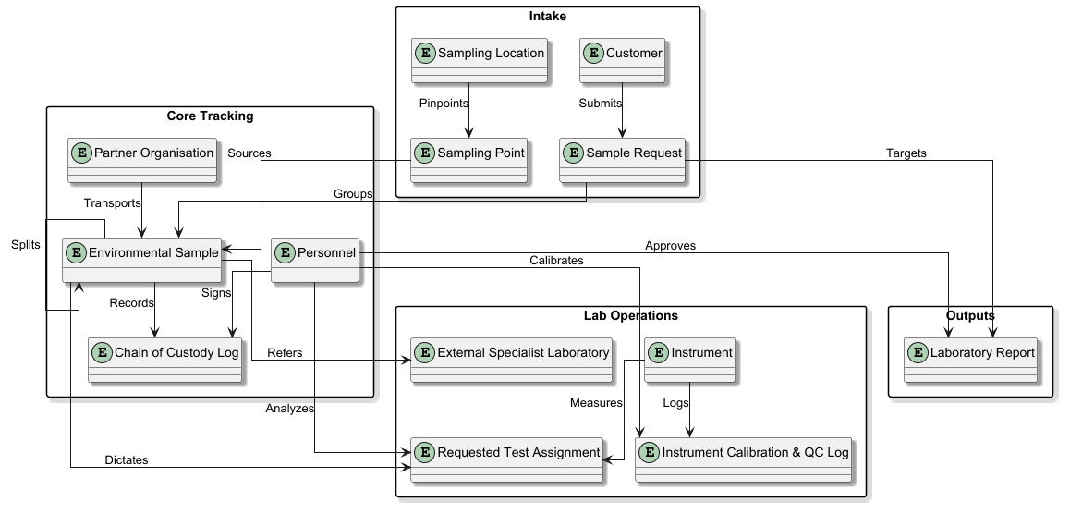
Domain_Analysis.png - Domain_Analysis.puml

Traceability & Project Execution
Traceability Matrix
Problem / Desired Outcome | Req ID | Use Case ID | Gherkin Acceptance Scenario | Domain Concepts
Entry Errors  / Digital Platform | FR-101 | UC-101 | Feature 1: System registers sample with success. | Environmental Sample, Laboratory Reference
Data Ambiguity  / Standardization | FR-102 | UC-102 | Feature 1: System registers sample with success. | Sampling Location, Sampling Point
Resource Drain  / Intake Paper Silos | FR-103 | UC-101 | Feature 1: Intake check sets sample to provisional status. | Provisional Acceptance, Reception Technician
QC Risk  / Degraded Samples | FR-104 | UC-101 | Feature 1: Critical sample defect causes rejection. | Sample Suitability, Requested Test
Custody Failure  / Bottle Mix-ups | FR-105 | UC-101 / UC-103 | Feature 3: System generates child split fraction for external test. | Sample Portion, External Specialist Laboratory
Custody Failure  / Bench Sheets | FR-106 | UC-103 | Feature 3: Internal location change updates custody logs. | Chain of Custody, Bench Sheet
Security  / Provisional Exposure | FR-107 | UC-105 / UC-106 | Feature 5: Data segregation hides raw measurements. | Observation / Measurement, Provisional Value
Bottlenecks  / Analyst Certification | FR-108 | UC-105 | Feature 4: System checks analyst certification before assignment. | Analyst, Requested Test
Quality Control  / Machine Failures | FR-109 | UC-104 / UC-105 | Feature 4: QC check failure locks instrument automatically. | Instrument Calibration, Quality Control Check
Reporting  / Post-Release Errors | FR-110 | UC-107 | Feature 6: System compels revision notes and increases version. | Approved Report, Corrected Report
Visibility  / Manager Console | FR-111 | UC-108 | Verified by user interface data collection rules. | Laboratory Manager, Unusual Result
Unreliable Rural Connectivity | NFR-201 | UC-102 | Feature 2: System stores collection logs in local cache. | Field Technician, Partner Organisation
Security  / Customer Privacy Breach | NFR-202 | UC-109 | Feature 5: System blocks customer query from different customer. | Customer, Approved Report
Visibility  / SLA Notifications | NFR-203 | UC-101 | Feature 1: Critical sample defect causes rejection and sends alert. | Customer, Sample Suitability
Strict Out-of-Scope Boundaries | NFR-204 | UC-108 | Verified by software structure test rules. | Laboratory Manager, External Dependencies

Recommended Repository Structure
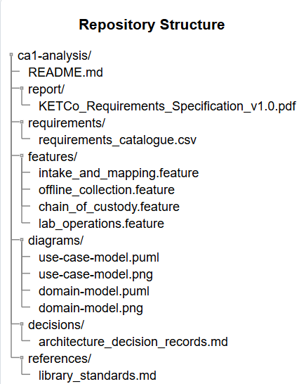
Repository_Structure.png - Repository Structure.puml

Reflection & AI Declaration

Critical Design Decisions & Revisions
- Permanent Custody Records: Users cannot change or delete data in the Chain of Custody log. This lock stops data tampering and keeps a full audit trail.
- Separation of Location Data: The system separates broad text locations from precise GPS data points.
This rule prevents geographic errors during data mapping.
- Controlled Data Visibility: The system stores provisional values in separate data blocks from final results. This protection stops customers from seeing unverified data before the quality review.

Limitations & Unresolved Questions
The document does not explicitly state what the quality control parameters are and what counts as an invalid sample, also with privacy between actors what data can be shared and what cant inside the system.
- Material Data Validation: Laboratory managers must verify the numeric values that connect container materials to soil test limits.
- Access Permissions: The project team must define the data fields that partner organizations can see during transit if rules change.

AI Disclosure & Interaction Log
I used generative AI tools strictly for low level mechanical tasks such as document formatting, verification, and formatting the layout and language to ASD-STE100 (Simplified Technical English) standard.
Checked and Rejected AI Suggestion Example:
AI Suggestion: the AI recommended implementing an automated webhook or alert mechanism to programmatically notify state environmental authorities whenever an Unusual Result flag was triggered. Then the ai started to add to the documentation and heading in a direction not defined by my input I rejected this suggestion because from a business perspective an unusual result could be an anomaly and not proof of environmental pollution.
Reflection on the use of Ai
Working with generative AI on this document quickly turned into a balancing act between automated formatting and scope creep. While the model was efficient at mechanical tasks like verification and ASD-STE100 formatting, The Ais default generation behaviour presented a challenge and inherent tendency toward text bloat and unauthorized feature expansion.

