Tutorial imlook4d
Innehållsförteckning
Tutorial imlook4d 1
Introduction 1
Installation 1
Open files 1
Introducing the imlook4d window 2
Region of interests 4
Creating ROIs 4
Analyzing ROI data 5
Working with ROIs 6

Introduction
Imlook4d is a tool for visualisation of medical images (2D), volumes (3D) and time-dependent volumes (4D). Imlook4d is written in Matlab, which means that it has to be installed into the Matlab path. Only the basic Matlab is required, that is, the imaging toolbox is not needed.

Installation
- Download imlook4d (http://dicom-port.com/product/imlook4d/ )
- Unzip.
- Open Matlab and select “Set path”.
1) Click “Add with Subfolders”, and select the imlook4d folder you unzipped.
2) Press “Save” so that Matlab remembers the path to imlook4d in the future.
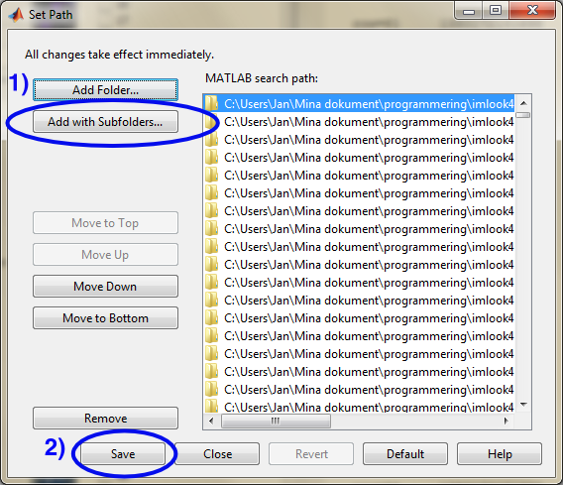
- Run imlook4d, by typing imlook4d in the Matlab command line.

Open files
- Start Matlab.
- Type imlook4d in the Matlab command line
- Select “File” in the dialog window
- Select one of the DICOM-files in a series
(or other supported file formats: ECAT 7, Analyze, Nifti, Freesurfer, ITK, Hamamatsu SHR, Interfile, or Binary ). There are example files in the imlook4d program directory (folder: imlook4d/test_data)

From the now opened imlook4d window, subsequent files can be opened from the “File/Open” menu.

Introducing the imlook4d window
The opened file is displayed in a new window:
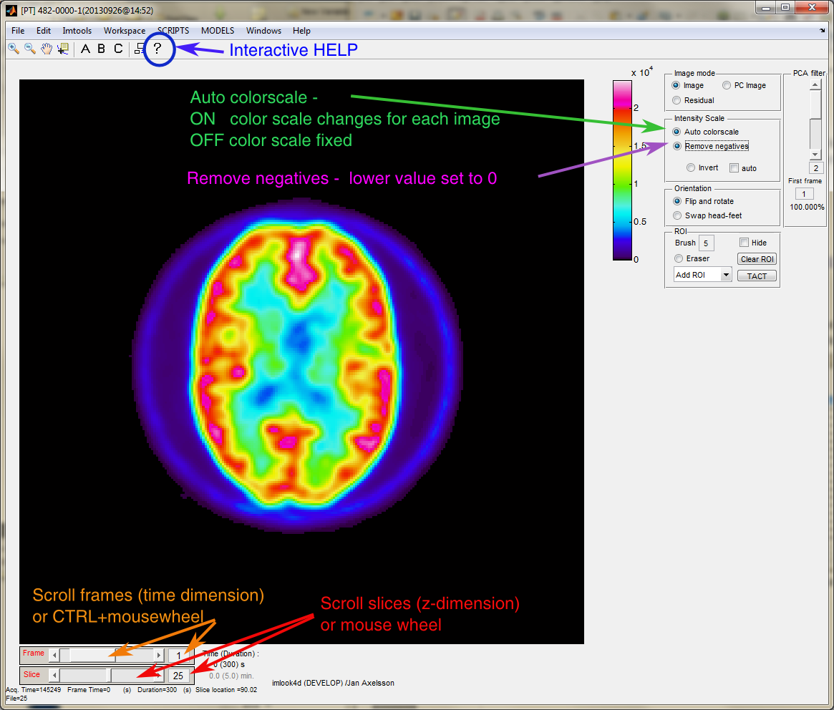
Lets try it!
First try the interactive HELP.
- Press the question mark help button. Now click around on menues and in the interface, and you should see help on the things you clicked.
- Don't forget: Press the question mark help button again to turn off the help. Otherwise .
Basic navigation in the volumes uses the tools marked in above figure:
- Move in volume (change slice). Use mouse-wheel, or the slice-slider or box with slice number (red in figure).
- Move in 4:th dimension (change time, phase, etc). Use CTRL-key and mouse-wheel, or the frame-slider or box with frame number (orange in figure).
Modifying the intensity display using the radio-buttons:
- “Auto colorscale” selected (ON), means that the min-max intensity range on is automapped to the full color scale (green in figure).
- “Auto colorscale” de-selected (OFF), means that only pixel intensities in the range on the color scale are displayed (violet in figure).
- “Remove negatives” displays all negative values as zero.

Region of interests
Region of interests (ROI) are pixels marked for analysis by the ROI tool. Multiple ROIs can be created. Pixels can only be connected to one of the ROIs, that is, overlapping ROIs are not possible. A ROI can consist of pixels from multiple slices, so a ROI in imlook4d is really the same as what some people call a Volume of Interest.

The tools used for ROI creation are marked in the figure:
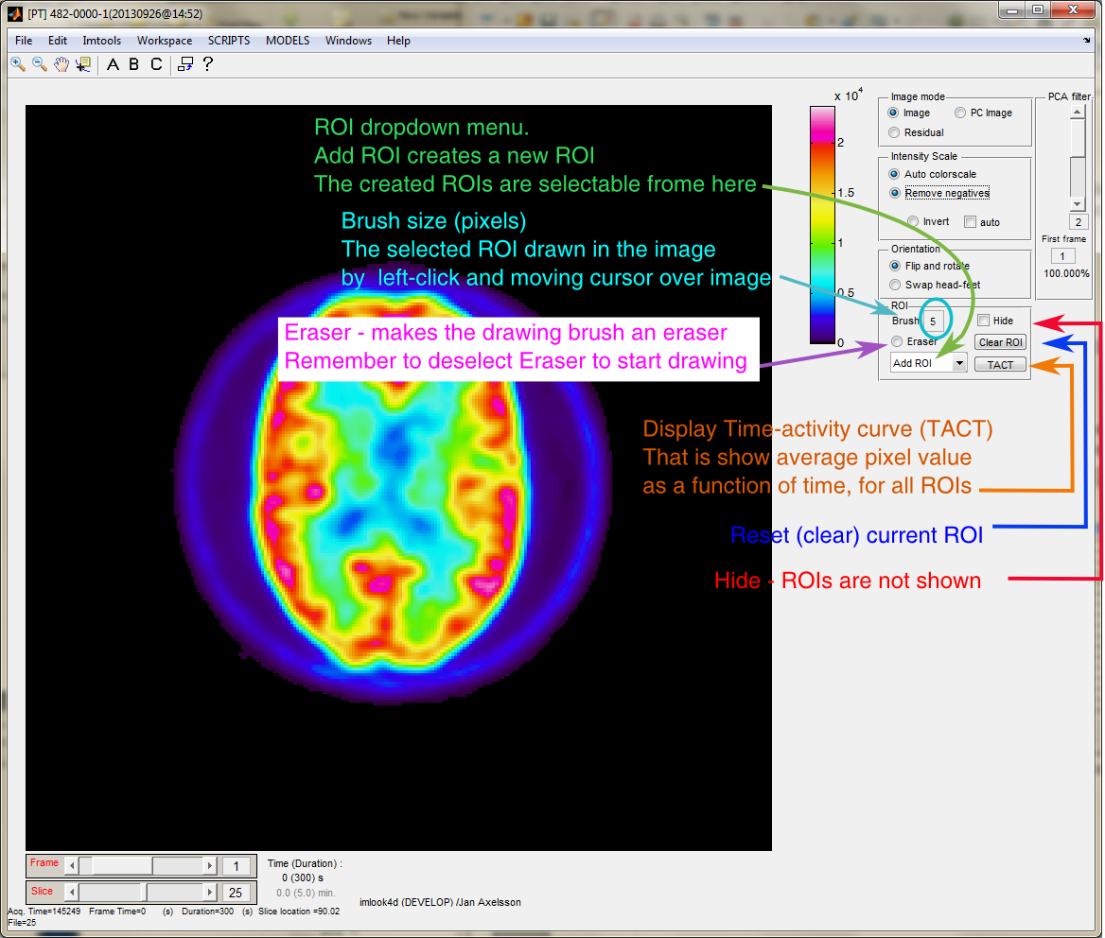
Lets try it!

Creating ROIs
We will now make a ROI, and try the different manipulations you can do:
Create a ROI
- Click “Add ROI”, and type a name in the dialog. Lets call it “My ROI”. We have now defined a ROI (an empty volume of interest), to which we can assign pixels.
- The ROI name that you see in the ROI dropdown menu is the currently selected ROI. Press the dropdown menu again, and select “Add ROI”.
- Select you first ROI again from the dropdown menu.
Draw the ROI
- Click in the image, and you will see a colored circle. This represents the pixels that are now assigned to the ROI. Try to draw using with the left mouse button pressed.
- Click on the Brush, and replace the brush size with another number, for instance 1. Left-click and draw in the image.
- Change slide and draw. These pixels are assigned to the same ROI.
Erase pixels in the ROI
- Click on the Eraser radio button, and now draw on ROI pixels in the image. You can now erase and adjust your ROI. Do not forget to turn the eraser off, by clicking in the Eraser radio button again.
- Press Clear ROI button to clear all assigned pixels in the currently selected ROI.
Tip! Hide and show selected ROIs
- Select the ROI you want to hide from the ROI dropdown menu.
- Right-click on the ROI dropdown menu, and select hide. This ROI will not be show in the image, and will not be displayed in the time-activity plot.
- Right-click on the ROI dropdown menu, and select show or show all, to enable the display of this ROI again.
Rename ROIs
- Select the ROI you want to rename from the ROI dropdown menu.
- Right-click on the ROI dropdown menu, and select rename. Type in the new name
Save and load ROI definition
- Click “File/Save ROI” to save all your ROI definitions.
- Now, draw a little extra on your ROIs.
- Click “File/Load ROI” to load your previously saved ROI definitions. You can now see that you got back your saved ROIs, instead of the little extra you just drew.

Analyzing ROI data
The ROI data can be extracted different ways.
- Edit/Copy TACT gives the average pixel value for each ROI into the clipboard. If a dynamic study, ROI data for all frames are printed.
- TACT button. Draws a time-activity diagram, and opens a save dialog to save the data to a format that can be opened into Excel.
The saved data contains frame number, frame time and duration, the ROI average intensity for each frame and the standard deviations for each frame.
If you just wish to view the data, press Cancel button in the dialog window.
- “SCRIPTS/ROI/ROI data to workspace” prints data to the Matlab workspace for the current time-frame, for instance:
ROI-name mean volume[cm3] # of pixels max min stdev
Heart 2084.08650 12.02899 123 4271.47998 917.47028 7.665747e+02
Liver 2008.85801 6.74797 69 4427.41113 960.95160 6.115689e+02
Pixel dimensions=(5.4688, 5.4688, 3.27) [mm]
and, creates the data structure imlook4d_ROI_data in the Matlab workspace that can be used for scripting (see Scripting tutorial). This structure contains ROI data for all frames.
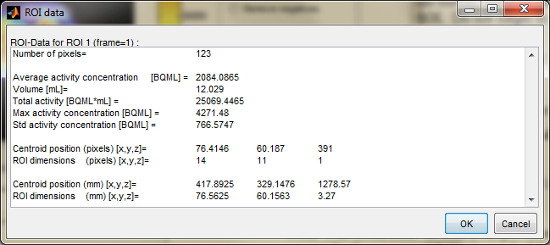
- “SCRIPTS/ROI/ROI info” opens a window with plenty of data about the currently selected ROI:

Working with ROIs

Advanced ROI manipulations
In the SCRIPTS/ROI menu a large number of ROI manipulation tools exists:
- There are scripts for copying the ROI in current slice to other slices (to create a volume ROI in a quick way). This is very handy when a rough ROI is made prior to the “threshold within ROI” mentioned below.
- There are scripts for “threshold”, and “threshold within ROI” (which shrinks a defined ROI to encompass only pixels above a certain threshold value)
- There are scripts for manipulating pixels values, where the ROI is used to define what pixels should be manipulated. These scripts are “Remove Pixels” and “Keep Pixels”.
- There are scripts for displaying ROI data. “ROI Info” pops up a window showing all kinds of ROI info for selected ROI and frame. “ROI data to workspace” prints out information to the MATLAB command window for current ROI, but more importantly, also creates a variable imlook4d_ROI_data containing everything from ROI statistics, to every single pixel value from the ROIs. This is a very useful command if you want to develop your own MATLAB code.

Further reading
- See also the tutorial “Thresholding complex images”

