**Container Packing App**

The Container Packing App is designed to efficiently pack boxes into containers. Given a container and a list of boxes, the app returns a set of containers such that all boxes are included, and the total number of containers is minimized. The minimization is achieved using evolutionary algorithms combined with heuristics.

**Input File**

The input file contains the properties of the container and a list of boxes.

* **Container properties:** sizes (X, Y, Z) and maximum weight.
* **Box properties:** sizes, weight, and unique ID for each box.

Example input files can be found in the **TestInputs** repository.

**Output File**

The output file contains a list of containers, each with its details (unique ID, weight and occupied volume) and the boxes packed inside. For each box, the output specifies:

* its rotation,
* the region it occupies within the container,
* its ID.

Example output files are available in the repository.

**Program Setting Window**

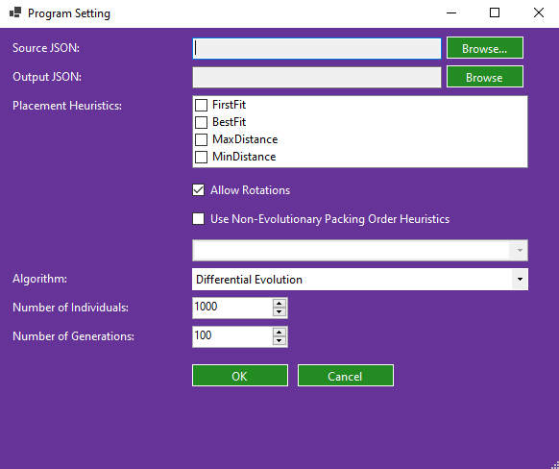

In the settings window, you can configure the following:

1. **Input and Output Files**
   * Choose the source input JSON file.
   * Specify where the output JSON file should be saved.
2. **Placement Heuristics**
   * **Single heuristic:** The same heuristic is applied to all boxes.
   * **Multiple heuristics:** The evolutionary algorithm selects the best heuristic for each box individually.
3. **Box Rotations**
   * If enabled, boxes can be rotated at right angles along any axis.
4. **Non-Evolutionary Packing Order Heuristics**
   * If selected, the evolutionary algorithm does not sort the boxes. Instead, one of the predefined order heuristics is used.
   * This can yield good results quickly, but over time, evolutionary methods typically perform better.
5. **Evolutionary Algorithm Parameters**
   * **Number of individuals:** The number of solutions in each generation. Higher values increase diversity but also computation time.
   * **Number of generations:** The number of iterations the algorithm will run. The process stops early if the lower bound on the number of containers is achieved (i.e., the minimal possible number of containers for the given boxes).

**Notes and Recommendations**

* Ensure all boxes fit within the container dimensions (considering possible rotations); otherwise, packing may fail.
* When using Differential Evolution, it is recommended that the population size is larger than the number of generations. Otherwise, the population may quickly become very similar, causing the evolutionary process to stagnate.