WHAT IS “CV SERVER”

CV Server is a small battery-powered HTTP server based on ESP8266 WiFi SoC. It was designed and built as a supplement to the job application substituting cover letter. The website served by the server was written in Preact.js – fast React.js alternative with small code footprint. The contents may be viewed in both English and Polish (this includes downloadable CV). The battery should last for at least two hours of continuous usage.

HOW TO USE “CV SERVER”

1. Turn the device on by sliding the switch outwards.
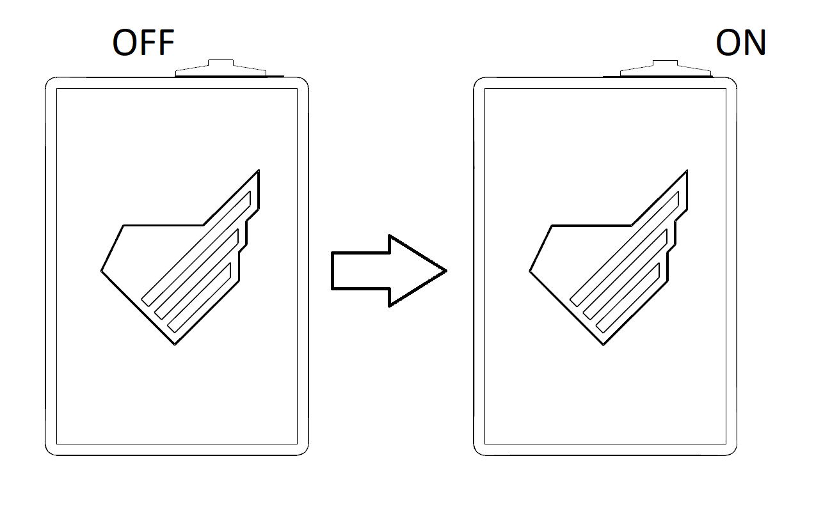

2. Connect to “Jan Chodorowski” Access Point using either mobile device or computer.
3. Open favorite web browser.
4. Ignore the “no Internet”alerts if any.
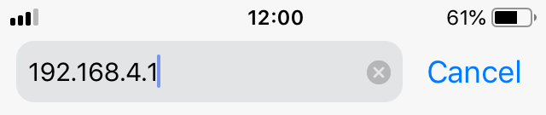
5. Navigate to 192.168.4.1.

6. After using the device turn it off by reversing step 1.
* When navigating to github via link user will be informed of the need of connecting to the WiFi with the access to the Internet.

IN CASE OF RUNNING OUT OF BATTERY

1. Make sure the power switch is in the OFF position.
2. Connect provided microUSB cable to the device.
3. Connect the cable to 5V power source.
4. Wait until the red light on the bottom of the device turns blue indicating fully charged battery.
5. Disconnect the cable form the power source and the device.

