Final report coursera capstone

**Finding a suiting business location in Ghent**

# Introduction

An aspiring restaurant/pub owners knows that want to build a new business somewhere in the city centre of Gent , Belgium. This is a very touristic and old city with a huge client base. The area is marked inside the black circle.

The main goal is to combine the popularity of certain neighbourhoods, finding popular business types in combination with lack those types in borrows of that neighbourhood.

The intel that can be gathered is of great use for people that want to start a business in the city centre of Ghent but that are confused by the large variety of the city. Thus finding a business location and type that fills the need inside the city in order to be highly profitable.

The end goal is to find a popular type of restaurant, with as much as possible tourists while still being unique in the area (for example, a noodle bar in an touristic hotspot in the neighbourhood that has no noodle bars while still being popular in the rest of the city)

# Necessary data

There is a need of all businesses in Gent.

1. All restaurants/pubs in order to find which places are touristic hotspots
2. Developing a logic that finds the ‘best locations’ for each type of restaurant
3. By combining the touristic hotspots and ‘best locations’ will decide which popular type of pubs/restaurant is ‘missing’ somewhere

These 3 factors combines will make it possible to find the best type of restaurant for the best location in order to find the missing money making business

The insight of neighbourhoods in Ghent is available on Wikipedia

The Data of businesses in Ghent can be found via the Foursquare API

# Methodology

There are multiple aspects that he wants to know before deciding what and where to do it, the combination of following properties of the restaurant/pub need to be combined together:

1. Being original is too big of a risk 🡪 the owner wants to pick a type of restaurant/pub that is already popular in the area
2. Choosing the best location must be in a location with many other restaurants/pubs that are of a different type 🡪 choosing a touristic hotspot in order to be profitable
3. The exact location of the chosen restaurant/pub must be as far as possible of other similar type 🡪 being in a hotspot, with a popular type of business with the least amount of direct competition as possible

The steps that will we used in order to combine these requirements are the following (picture is a visualisation):

1. First the city is dived in a raster of points, each separated by 200 meter. In order to scan the city locally
2. For each point there is a call to the API in order to find how many businesses are present in a 250m range (with 250m every thing is scanned)
3. Based on the result of 2) there is decided a cut-off of popular areas, which is taken on 22 businesses in that 250m range and with this cut-off a selection of regions that are popular enough to start a new business
4. For those selected locations a scan is done to find all businesses in a 200m range AND in a 280m range.
5. For every selected location are the results of the 200m scan and the 280m scan compared. Business types that are present in a 280m range BUT NOT in a 200 meter range for that locations are selected
6. The result is a selection of popular locations that miss some type of business
7. The result gives an answer to the problem that was initially stated

As seen on the picture, the type of venue must be popular in the red circle but must be absent in the inner green circle.

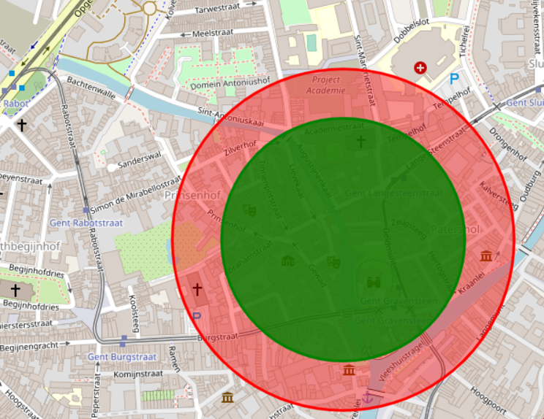

# Results

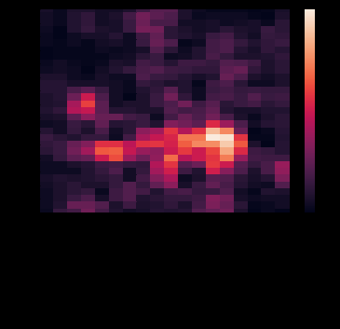The first part is the selection of which areas of Ghent are popular, this can be seen on a heatmap that shows the main touristic areas. Map is more abstract but shows the process that is used to find popular areas. The more bright, the more popular. This popularity is linked to the neighbourhoods.

The main result can be visualized on the Folium map of Ghent.

The red dots are locations where Bars should be placed, the blue dot is where a Nightclub could have its place and the green dot is missing a Pub.

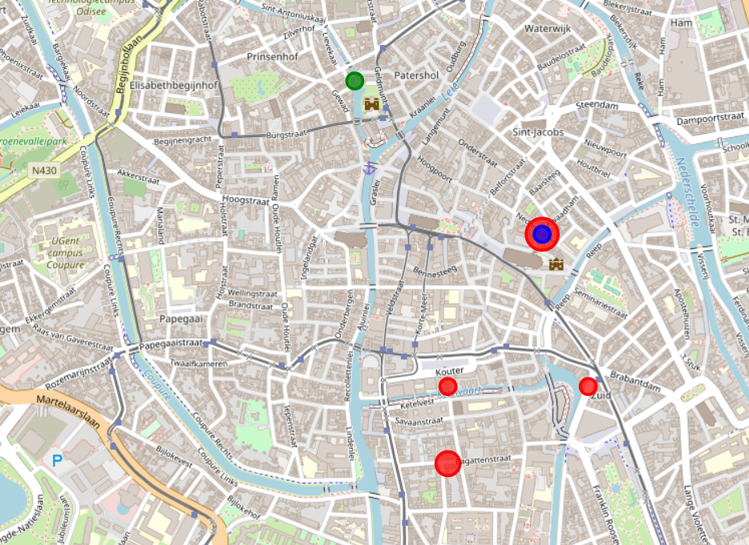

# Discussion

The most interesting spot to start a new business is to start a bar between Kouter and Bagattenstraat, which are two red dots close to each other and therefor create the best business opportunity.

Although there are more parameters that indicate the best location than just the lack of other businesses, like price and availability of buildings to open a bar. There is enough choice to start looking for a location at the marked point.

# Conclusion

There are 5 business opportunity locations based on the used algorithm. They can be found on the maps, there are 3 locations for a bar, one location for a bar or nightclub and one location suited for a Pub.

The best location would be around Kouter in Ghent to start a bar.