An aspiring restaurant/pub owner knows that he wants to build a new business somewhere in the city centre of Gent , Belgium. This is a very touristic and old city with a huge client base. The area is marked inside the black circle.

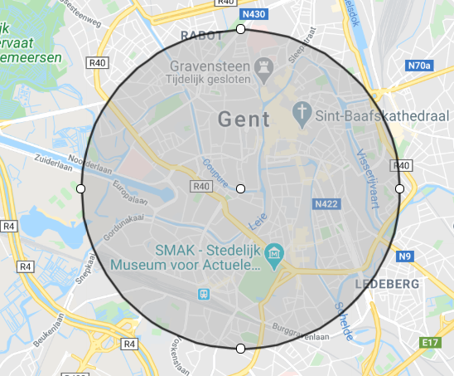

There are multiple aspects that he wants to know before deciding what and where to do it, the combination of following properties of the restaurant/pub need to be combined together:

1. Being original is too big of a risk 🡪 the owner wants to pick a type of restaurant/pub that is already popular in the area
2. Choosing the best location must be in a location with many other restaurants/pubs that are of a different type 🡪 choosing a touristic hotspot in order to be profitable
3. The exact location of the chosen restaurant/pub must be as far as possible of other similar type 🡪 being in a hotspot, with a popular type of business with as least amount of competition as possible

The end goal is to find a popular type of restaurant, with as much as possible tourists while still being unique in the area (for example, a noodle bar in an touristic hotspot in the neighbourhood that has no noodle bars while still being popular in the rest of the city)

Thus finding a business location and type that fills the need inside the city in order to be highly profitable.