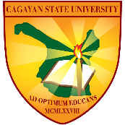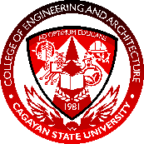 | Cagayan State University  COLLEGE OF ENGINEERING AND ARCHITECTURE, CARIG CAMPUS  COEA-SR04
Adviser Consultation Form
This form serves as a record for consultations regarding the research of the proponent(s). Student Researchers and Research Advisers are expected to have at least 10 consultation meetings per semester.

THESIS TITLE
TokTokMelon: Development of a Non-Destructive Acoustic-Based Frequency-to-Brix Sensor Using Refractometer-Based Measurement for Detecting Watermelon Sweetness | Program | ECE
 | Major

PROPONENT(S)
Proponent(s) | Guzman, James Laurence S.  Aquino, Kaye Angelique O.  Roque, Celhesmerences C.
Research Adviser | Engr. Eulogio Neil A. Mallillin

CONSULTATIONS
Date | Time | Place | Topic/Area/Content of Consultation | Adviser’s Signature
August 27, 2026 | 1:00 PM | COEA FACULTY | Consultation on the Proposed Research Title and Scope
August 28, 2026 | 9:00 AM | COEA FACULTY | Consultation on the Finalization of the Research Topic
September 3, 2026 | 9:00 PM | ONLINE | Research Paper Checking and Consultation
October 21, 2026 | 2:00 PM | COEA FACULTY | Consultation regarding the review and checking of the research paper and panel comment sheet.

