

Bank Management System

**Instructor:** Sir Adeem Ali Anwar

C++ Project

The University of Lahore

2020

Project Participants

Bank Management System

# Basic File Structure

# Brief Overview of Project Files

## consoleUI.h

This header file includes following Global Functions:

* void readAccSeries()  
  Reads four values from “accountSeriesNumber.csv” file as string and converts, and store these values as an integer in num, num1, num2, num3 respectively.
  + “num” for customer account serial number (1,2, 3,…)
  + “num1” for employee account serial number (1,2,3,…)
  + “num2” for manager account serial number (1,2,3,…)
  + “num3” for ATM history session serial number (1,2,3,…)
* void writeAccSeries()  
  Write above mentioned four values separated by commas in “accountSeriesNumber.csv” fil.
* string getAccountUserName()  
  Takes string input of Account User Name from the user and returns.
* int getAccountPassword()  
  Takes integer input of Password from the user and returns.
* bool getAccountType()  
  Takes Boolean input of Account Type from the user and returns.
* string getAccountNumber()  
  Takes string input of Account Number from the user and returns.
* string generateCustomerAccountNumber()  
  Generates Customer Account Number as string in the form of “CACN#” where “CACN” is fix while “#” is a variable number.
* string generateEmployeeAccountNumber()  
  Generates Employee Account Number as string in the form of “CACN#” where “EACN” is fix while “#” is a variable number.
* int getAmount()  
  Takes integer input of Amount from user and returns.
* char getFirstLetter()  
  Takes character input of Single Letter form user and returns.

## Navigation.h

* int employeeUpdateMenu()

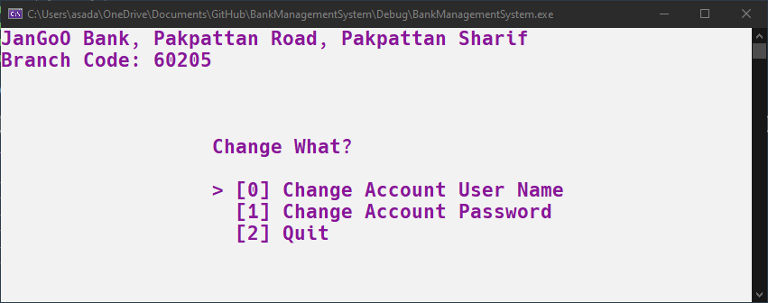

* int customerUpdateMenu()

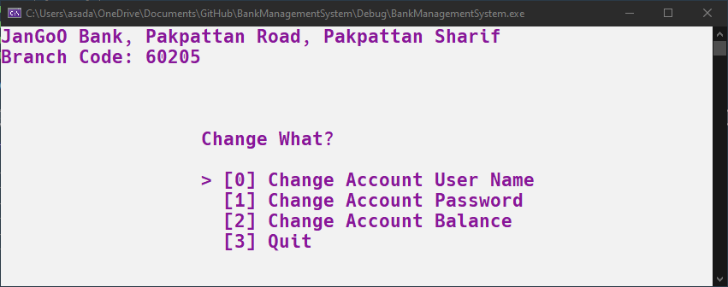

* int managerMiniMenu_0()
* int managerMiniMenu_1()
* int managerMiniMenu_2()
* int managerMiniMenu_3()
* int managerMiniMenu_4()
* int managerMiniMenu_5()  
  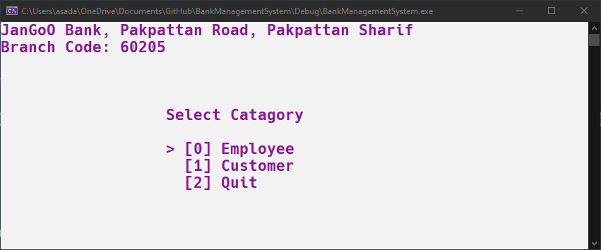
* int managerSubMenu()  
  
* int bankSubMenu()  
  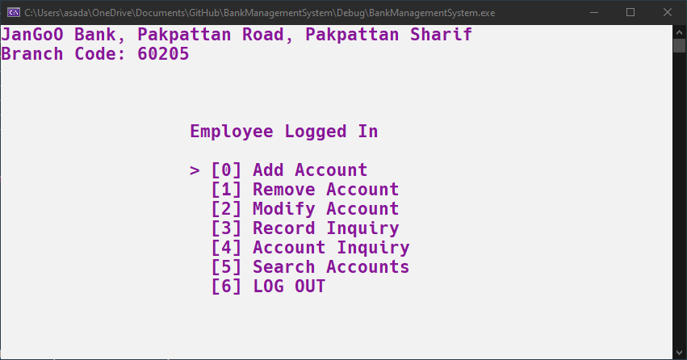
* int atmSubMenu(CustomerAccount* loggedInAccountNumber)  
  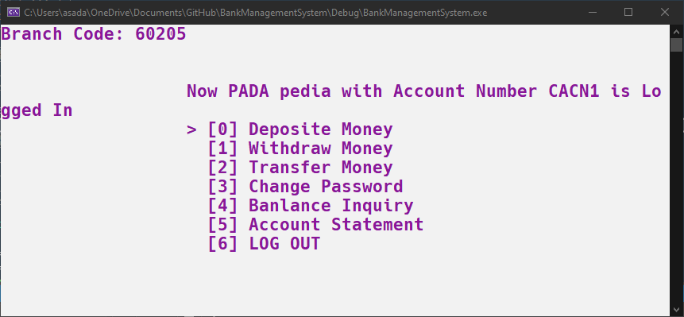
* int bankMenu()  
  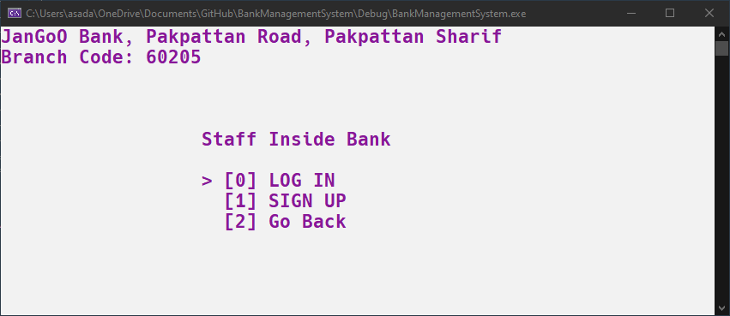
* int atmMenu()  
  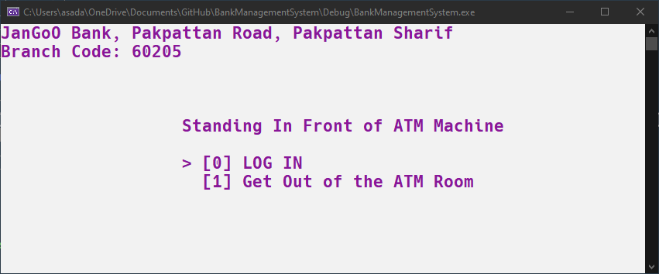
* int entryPoint()  
  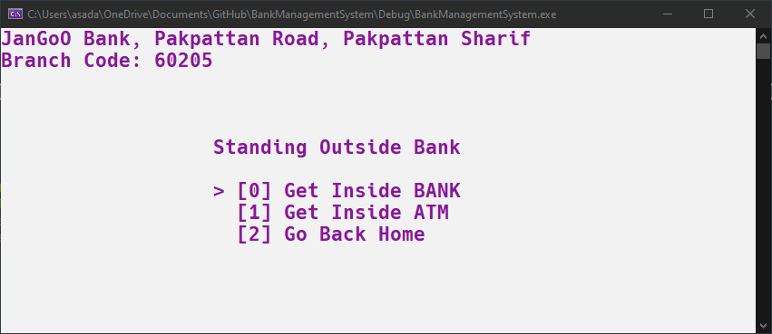

## Bank.h

* class CustomerAccount {};
* class CustomerAccountDataList{};
* class EmployeeAccount{};
* class EmployeeAccountDataList{};
* class ATM{};
* class Bank();

|  |  |
| --- | --- |
|  |  |
|  |  |
|  |  |

## BankManagementSystem.cpp

This file include build-in C++ libraries required in the project. And it also includes above mentioned header files.  
The main() function simply calls the entryPoint() function written in Navigation.h file.