Aufgabe 1) Ja, die Reihenfolge ist egal.
LayOut 1)
<v-app>
<v-app-bar class="blue lighten-5" app>
<span class="text-h4">Drink</span>
<v-img
class="mx-2"
src="./assets/logo.svg"
max-height="60"
max-width="60"
contain
></v-img>
</v-app-bar>
<v-main class="blue"> </v-main>
</v-app>
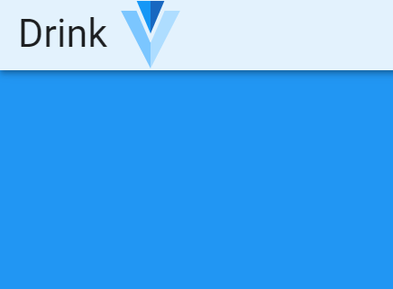
<v-app-bar class="blue lighten-5" app>
<span class="text-h4">Drink</span>
<img src="./assets/logo.svg" style="height: 9>

LayOut2)
<template>
<v-app>
0px; margin-top: 30px" />
</v-app-bar>
<v-main class="blue"> </v-main>
</v-app>
</template>
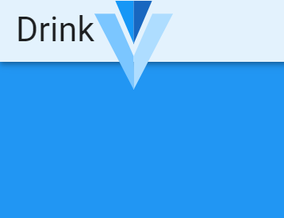

Aufgabe 2)
<v-btn class="black white--text" active-class="yellow" to="/" exact>
Home
</v-btn>
<v-btn class="black white--text" active-class="yellow" to="/about" exact>
About
</v-btn>

Aufgabe 3)
<template>
<v-app>
<v-app-bar class="blue" app>
<v-app-bar-nav-icon
@click.stop="drawer = !drawer"
class="white--text"
></v-app-bar-nav-icon>
<span class="white--text title">Layout Demo</span>
</v-app-bar>
<v-navigation-drawer
app
hide-overlay
disable-resize-watcher
v-model="drawer"
>
<v-list-item-group>
<v-list-item>
<v-list-item-content>
<v-list-item-title class="text-h6"> Menu </v-list-item-title>
<v-list-item-subtitle> Please Select </v-list-item-subtitle>
</v-list-item-content>
<v-btn text @click.stop="drawer = !drawer">Close</v-btn>
</v-list-item>
<v-divider></v-divider>
<v-list-item
v-for="(r, i) in routes"
:key="i"
:to="r.route"
active-class="white--text blue"
>
<v-list-item-content>
<v-list-item-title>{{ r.name }}</v-list-item-title>
</v-list-item-content>
</v-list-item>
<v-divider></v-divider>
</v-list-item-group>
</v-navigation-drawer>
<v-main>
<router-view></router-view>
</v-main>
</v-app>
</template>

<script>
export default {
name: "App",

data: () => ({
drawer: false,
routes: [
{ name: "Home", route: "/" },
{ name: "About", route: "/about" },
{ name: "Products", route: "/products" },
{ name: "Team", route: "/team" },
],
}),
};
</script>

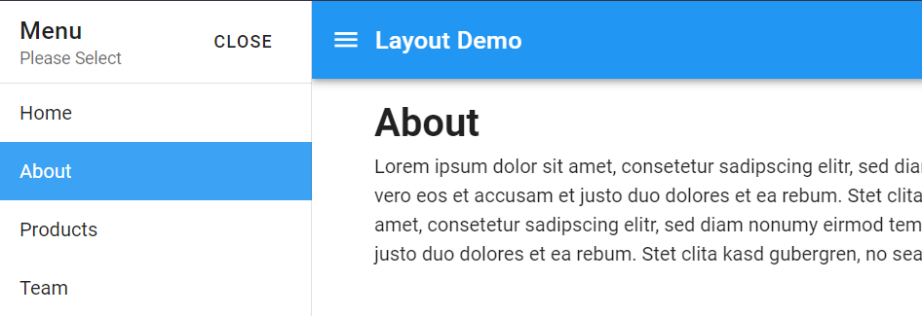

Aufgabe 4)
<template>
<v-app>
<v-app-bar class="grey lighten-5" height="74" app>
<img class="mx-2" src="./assets/logo.svg" style="height: 65px" />
<span
class="text-truncate text-h4 blue-grey--text darken-1"
style="font-family: Poppins"
>A Dog With a Mission</span
>
<v-spacer></v-spacer>
<div class="hidden-md-and-down">
<v-btn
active-class="blue white--text"
to="/"
exact
text-style="margin-left: 15px"
>
Home
</v-btn>
<v-btn
active-class="blue white--text"
to="/products"
exact
style="margin-left: 15px"
>
Products
</v-btn>
<v-btn
active-class="blue white--text"
to="/team"
exact
style="margin-left: 15px"
>
Team
</v-btn>
<v-btn
active-class="blue white--text"
to="/about"
exact
style="margin-left: 15px"
>
About
</v-btn>
</div>
<div class="hidden-lg-and-up">
<v-app-bar-nav-icon
@click.stop="drawer = !drawer"
class="blue--text"
></v-app-bar-nav-icon>

<v-navigation-drawer
app
hide-overlay
disable-resize-watcher
v-model="drawer"
right
>
<v-list-item-group>
<v-list-item>
<v-list-item-content>
<v-list-item-title class="text-h6"> Menu </v-list-item-title>
<v-list-item-subtitle> Please Select </v-list-item-subtitle>
</v-list-item-content>
<v-btn text @click.stop="drawer = !drawer">Close</v-btn>
</v-list-item>
<v-divider></v-divider>
<v-list-item
v-for="(r, i) in routes"
:key="i"
:to="r.route"
active-class="white--text blue"
>
<v-list-item-content>
<v-list-item-title>{{ r.name }}</v-list-item-title>
</v-list-item-content>
</v-list-item>
<v-divider></v-divider>
</v-list-item-group>
</v-navigation-drawer>
</div>
</v-app-bar>
<v-main>
<div class="d-flex">
<div style="width: 250px"></div>
<div class="mt-10" style="flex: 1"><router-view></router-view></div>
</div>
</v-main>
</v-app>
</template>

<script>
export default {
name: "App",

data: () => ({
drawer: false,
routes: [
{ name: "Home", route: "/" },
{ name: "About", route: "/about" },
{ name: "Products", route: "/products" },
{ name: "Team", route: "/team" },
],
}),
};
</script>

<style>
a:not(.v-btn--active) {
color: #2196f3 !important;
background: white !important;
}
</style>

> md
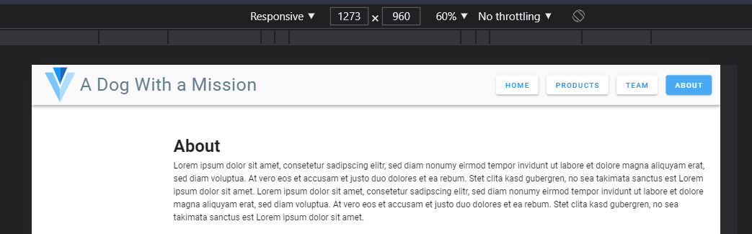
< lg
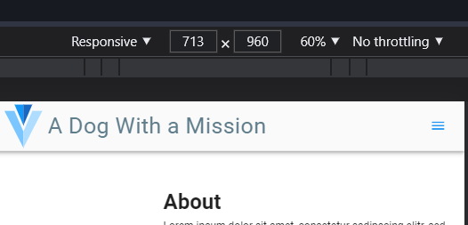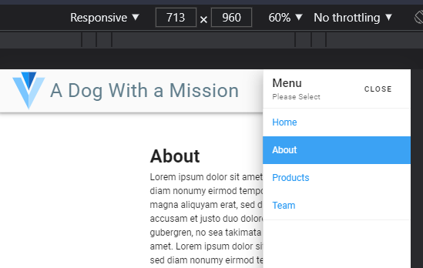

Aufgabe 5)
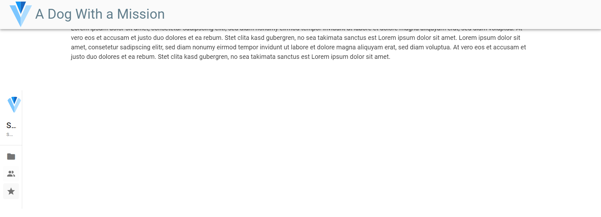
Kein Bock mehr. Ich mag vuetify nicht.

