22/02/2017

The Humanities Advanced Technology and Information Institute

Digital Media & Information Studies 2B

Project: VR & 3D Modelling

**x3D Reconstruction of Sainsbury’s Local Gas Station**

Report

(1000 words)

1. **Introduction**

Virtual reality has brought along a revolution in many areas regarding not only technology, but also education, training, medicine, scientific research and cultural heritage. The simplest purpose of presenting information in new digital form to enhance our computer gaming experience has evolved into pushing boundaries of technology in order to:

- **save lives** whether by training troops in safe simulation of dangerous environment or by training doctors on virtual patients before executing surgery on real people

- **make new discoveries** in a sense of making researchers able to analyse certain objects on scale from atoms to complex bacteria on a whole new level

- **educate** public by providing access to cultural heritage, that otherwise wouldn’t be observed at all or not by such a big audience as it can be with use of virtual reality

However, as with all new kinds of technology, which VR most definitely is, there are always certain drawbacks that need to be addressed to move forward the development of this computer-generated content:

* **Lack of detailed standards and guidelines for 3D modelling process**
* **Lack of immersive functionality** (real-world physics elements)
* **Incompatibility with older browsers** (such as older versions of IE)
* **Currently unable to compete with more advanced graphic editors for 3D modelling**
* **Lack of testing strategies for x3D models**
* **Lack of purpose of certain visualisations** (stemming up from no means for use in education)
* **Missing areas in models caused by insufficiency of data**

For this project, I have decided to make a model of **Sainsbury’s gas station** to demonstrate some of the limitations of 3D modelling with x3DOM and to show how to reconstruct data from real-world into virtual representation. I have started by developing the model from geometric primitives using the same dimensions as real measures of objects to make model represent real-world data as truthfully as possible.

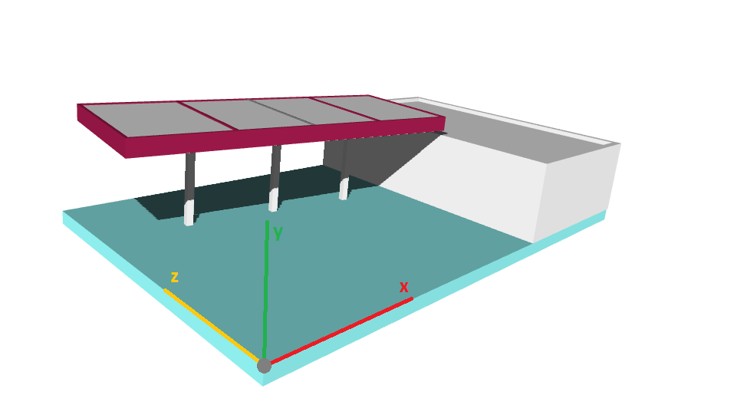

**Screenshot_01:** Modelling building

Then I have used Adobe Illustrator for creation of textures, which also allowed me to match dimensions with real-world surfaces for the materials applied.

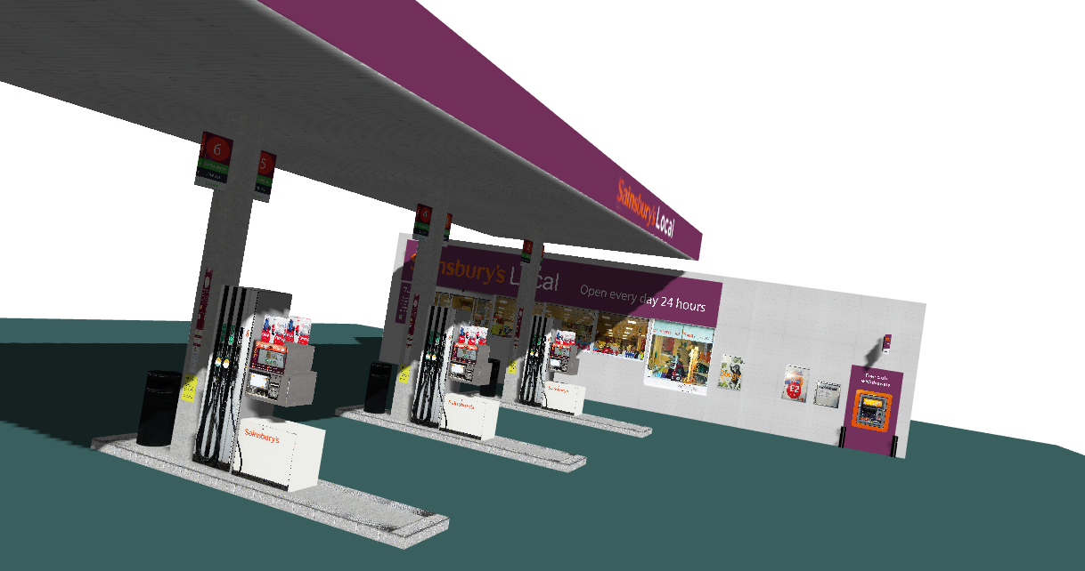

**Screenshot_02:** Applyin**g** textures

Finally, I created viewports to allow for interactive and immersive viewing system of the finished model.

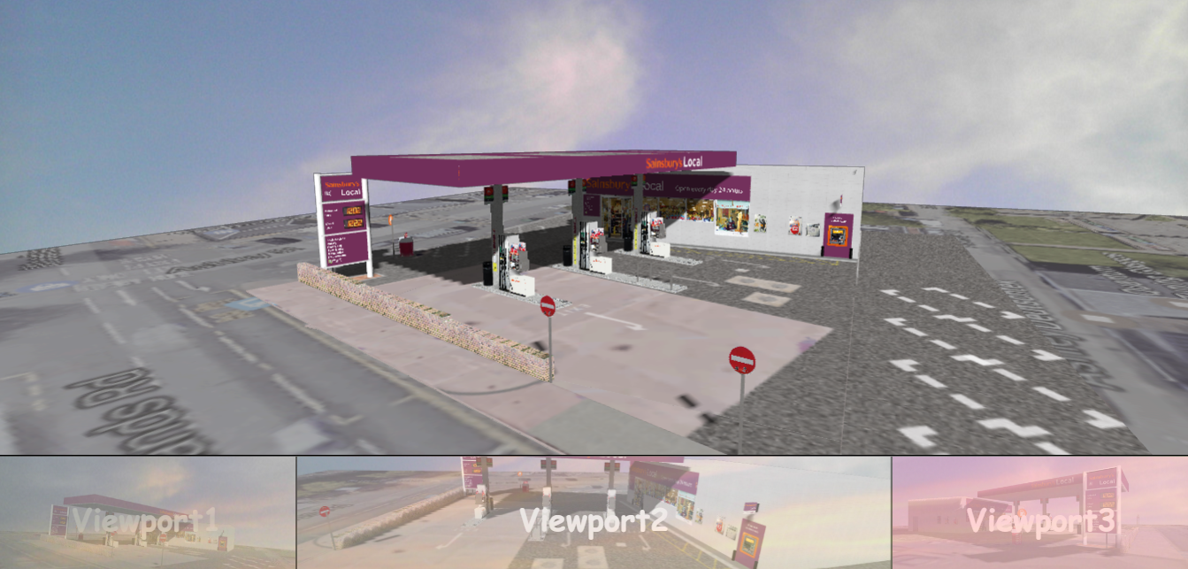

**Screenshot_03:** Viewports UI

**1.1 Strengths of model:**

* **Data structure –** functional and interactive model
* **Highly portable digital model –** easy further manipulation and transportation within devices
* **XML-core –** easy preservation and compatibility with HTML
  1. **Weaknesses of model:**
* **Redundancy in code –** repetitions of the same pattern while cloning objects
* **Low-quality model –** low-polygon modelling resulting from both limited time scope and only basic geometric primitives available for use
* **Insufficiency of data –** in certain aspects of the model, it was impossible to gather required data for virtual representation

*As an example, I could state either the impossibility of exactly measuring inaccessible objects of the gas pump, such as the pump roof and columns or acquiring texture of the whole ground under the gas pump, which is obviously covered by the buildings themselves.*

1. **Design Process**
   1. **Analysing requirements and choosing an object**

First step involved analysing the task requirements and according to those choosing an appropriate object that would be able to demonstrate techniques for creating an x3D reconstruction and emphasize the reasons for doing such a representation.This step is more widely discussed in section **3. Object choice analysis.**

* 1. **Planning the creation process**

Before starting gathering the data at the site, I needed to plan the creation process of the model, which allowed me to realise what kind of data and material l needed to get to be able to make the reconstruction.

* 1. **Gathering material**

As a next step, I went to the site with a camera and a notebook to gather all required data. This activity included observing the site and adjusting my creation plan, taking measures of certain objects to be able to create a credible model with correct dimensions and taking photographs of surfaces and objects, which were to be used to create high quality textures.

* 1. **Choosing tools for modelling**

As an editor for .html file I have chosen **Brackets.io**, because it offers a very convenient **live preview** function, therefore I didn’t have to refresh page every time I changed the code, but could see changes automatically updated which was especially useful with applying transformations like **translation**.

I have also used **Adobe Illustrator CS6 (AI)** to modify my photographs and to create textures with specific dimensions relevant to objects being applied to.

* 1. **Constructing model**

I have started constructing the model by creating a base plane to which I have applied top view of the pump from Google Maps, for the purpose of correctly aligning items on the ground. After starting by creation of the basic model of the shop building and pump roof, I went on building smaller items like posters on walls, pump stands, windows of the shop and all other small items. Almost all of these were created by multiple boxes of different dimension, while in certain cases I made use of cylinders and spheres.

* 1. **Applying textures**

Applying textures has actually taken me more time than modelling itself. Even though, I thought I would apply all the textures after finishing the modelling process, I quickly realised that in case of x3D it is more simple to texture the object straight away. The reason for this was that despite nicely nesting HTML tags and using descriptive comments, after creating almost hundred items the code becomes very hard to navigate through.

* + 1. **My method for applying textures**
* Create the object and position it to correct place
* Use the dimensions of the object to create a template for texture

in Adobe Illustator

* Import photo of object into Adobe Illustrator and align it with the template
* Save texture, upload it to **Imgur** and copy image link to **url** attribute of **Image Texture** tag
  1. **Refining model**

After finishing the model, I have created directional light for the scene, applied a background and created several viewpoints to be compared with real world examples.

However, because of the time scope for the project certain parts of the model are simplified and not developed in ideal way. Further refining of the model in question is discussed in section **Future Model Enhancements**

1. **Object choice analysis**

I have decided to create a model of **Sainsbury’s gas station** for several reasons as following:

* The building itself and its surrounding object are quite geometric in their shape, which allowed me to create quite realistic representation of the setting, despite being limited to mostly using only geometric primitives like **box** or **cylinder.**

*This leads to developing low-polygon model with notably decreased number of faces (polygons) which subsequently allows for bigger speed of rendering of the scene.*

* The gas station as an object in real world that I could access also allowed me to gather

a huge amount of data required for the creation of the model. I was able to take measures of the setting, objects and items, gather photographic material for creation of textures or confront my model with real-world example at any time to evaluate and adjust my creation process.

* The gas station offered multiple possibilities for taking high-quality photos of surfaces, that could later be transformed into textures of relevant dimensions to model, using software like Adobe Illustrator CS6.
* After finishing the model, I was able to set up viewports and create photos of the scene in a way, that both real photo and 3D scene could be compared from exactly the same angle.

1. **Future Model Enhancements**

Further improvements of the model would involve:

* Testing model for functionality and usability
* Refactoring the code for better performance

*e.g. making sure an effective use of DEF and USE nodes is in place*

* Scanning the object for shortcomings in design
* Adding multiples of objects to make the reconstruction more detailed
* Creating more sophisticated textures of higher quality
* Creating more sophisticated 3D model in editor such as Maya, Autodesk 3Ds Max or Blender with included real-world physics and importing it into webpage code through <inline> tag.

1. **Issues with 3D modelling process**

During the modelling process, I have experienced several issues related to modelling

with x3DOM:

* **Focus on detail daunted by limited range of basic geometric primitives**
* **Dependency on range of experience and skills with graphic editors for creation of usable textures**
* **Impossible to visualise certain areas, because of data insufficiency or inaccuracy**
* **Unable to modify lights and shadows on more advanced level**

*e.g. creating simulation of daylight*

* **No technical guidance on construction technique or integration of evidence**

1. **References**

* **Tutorials** from <https://doc.x3dom.org/tutorials/>
* **Official x3DOM documentation**

<https://doc.x3dom.org/gettingStarted/background/index.html>

* **Extensible x3D Tooltips Guide**

<http://www.web3d.org/x3d/content/X3dTooltips.html#>

* **X3D: 3D Graphics for Web Authors,** by Don Brutzman and Leonard Daly

Published by Morgan Kaufmann Publishers; Copyright 2007 Elsevier

* **3D Visualization of simulation data with x3dom** (further reading)

<https://www.logilab.org/blogentry/4386317>

1. **Conclusion**

This report has discussed several limitations of x3DOM that affected the development process of the model, but also stated methods, process and reasons for creating such representation of data in x3DOM and the benefits of using this platform.

With more time available for refurbishing of the representation, it would be possible to not only eliminate many of the limitations of the model but also to add various functionality and interactive content. Creating sophisticated high-poly model in 3D graphic editor, setting up realistic lights, involving real world physics such as gravity, creating animations or even something as sophisticated as using jQuery and Javascript to automatically update and display the current gas price on the gas pump stand, all of these could move model further and further to its desired position of truthful representation of real-world data.