**Dimensions and lines manual v1.0.9**

made by: Jan Holinka, jan.holinka@seznam.cz, jan.holinka3@gmail.com

Addon was developed and tested on Blender version 4.1 and tested and released with version 4.2.

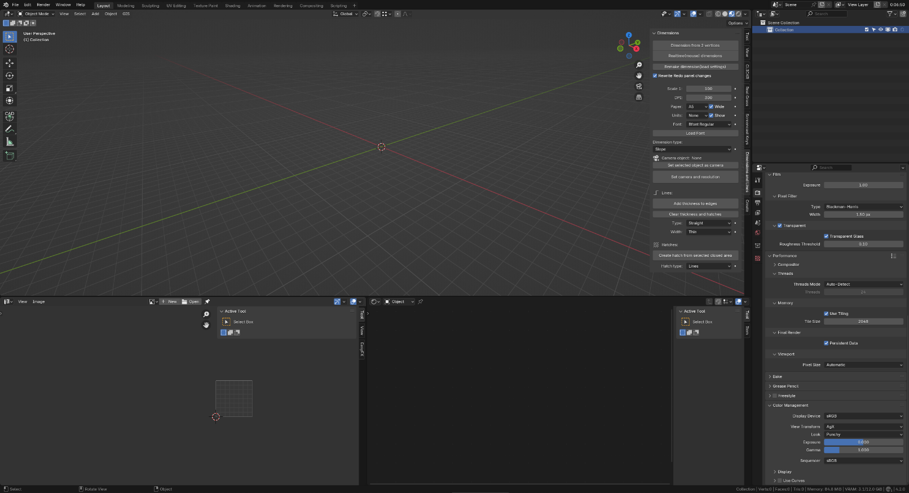

This corner is displaying info during „Realtime(mouse) dimensions“ creation.

**Quick start**

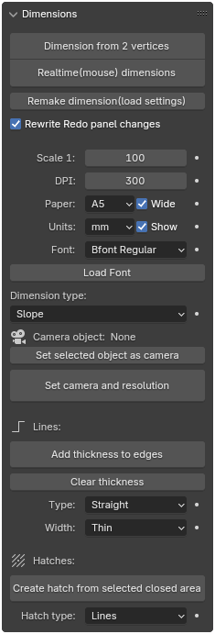Creates dimension from 2 selected vertices.

Creates dimension with mouse. All necessary info is displayed  
in the left bottom corner of 3D viewport.

It will identify if selected object is dimension created by addon and   
measure it and recreate it. It can alter created dimension with ReDo   
panel and can serve to „load“ custom dimensions proportions  
on existing projects (if you switch off „Rewrite ReDo panel changes“).

Checked by default. If you turn this off, addon will remember ReDo   
panel changes when creating next item in the current Blender session.

Scale for „printing on paper“. It affects size of everything created.

Depth per inch (pixel) affects render resolution set up by „Set camera and resolution“. Paper settings affects camera size.

Settings of text of creating dimension.

Dimension type.

Selected camera.

Set up camera object to orthographic with scale calculated from Scale and Paper size settings. Also set up render resolution based on DPI settings.

Creates faces around all edges in selected mesh object. Object must not contain any faces. Created geometry is hidden in edit mode (and of course visible in object mode). Dimension snaping also snaps only to visible geometry (so you can always snap to center of lines). It also deletes all previous hidden geometry – so you can edit edges and recreate lines infinitely.

Deletes all hidden geometry in selected mesh object.

Settings for thickness. Final width depends on Scale settings.

Creates hatch from selected edges as child mesh object.

It is meant to be used on objects with real-life 1:1 scale – wich is best ratio due to Blender default workings and settings.

**Complete info**

Dimension from 2 vertices – BUTTON

This button creates a dimension from two selected vertices of an object. Exactly one mesh object must be selected, and it must have exactly 2 vertices selected, otherwise it will not execute and show error info. Works both in object mode and edit mode. It should return in mode that it was called from.

You can edit dimension settings and proportions in ReDo panel.

Realtime(mouse) dimensions – BUTTON

This button creates a dimension with the mouse in real time.

After clicking on this button, snap indicator will appear and snap points loading starts.

Due to Blender internal workings, it loads points only when there is an event (like mouse movement atc.) till it reach 5 – 20 miliseconds execution time, and then it goes back to Blender waiting to another event, because otherwise there is poor performence during execution. Script execution pause all Blender actions and it does not support multithreading from operator call. Maybe I will get some multithreading working in the future updates. It is meant to keep something like 60 fps.

Snap loading status is showed in left bottom corner – if there is none, everything is loaded. If you are moving a lot in viewport (with mouse wheel – rotation and zooming) during point selection, it can sometimes starts loading points from old state – probably because absence of sync between viewport draw and event call.

In simply terms, just move mouse to keep loading snap points and move viewport gently with mouse still to reset wrong snaping points.

Cancel with Esc anytime.

Snaping snaps to created dimensions only on its „main“ points – so that it is possible to align dimensions together, but naming convention must be kept to this to work as intended. Hidden objects are ignored by snaping. Non mesh objects are ignored with snaping.

On really big scenes, snaping will load a long time and it will ignore some points – just keep visible only the objects, that you are snaping to, or use „Dimension from 2 vertices“.

Indicator sqaure indicates snap to vertice, triangle to center of edge. You can switch off center of edges detection with „M“ during execution. You can lock axis with keys X, Y, Z. You can specify lengths manually with number keys.

First click sets first point of dimension, second sets second point – if you will write length manually, it will respect current angle created by mouse position and specified length (delete manual length with backspace – you can see current lenght in the left bottom corner). From second mouse click you can specifi distance from base points with mouse or by direct lenght and boundary lines distance from base with mouse scroll (you cannot navigate in viewport during this phase).

After third click you can change dimension proportions and settings in ReDo panel – just like any other operator. It will be slow on really big scenes – there is some name checking, objects creating and deleting and atc. and it loops through all objects a lot.

You can activate continue mode with „C“ key during creation. In that case, new dimension is created right after third click from end point and you can continue with dimensioning.

To keep dimension custom settings and proportions, you need to switch off „Rewrite Redo panel changes“ – before dimension creation.

Remake dimension(load settings) – BUTTON

This button checks if selected object is a mesh and if it matches any of dimension type with its structure (every dimension have specific number of vertices and faces specified by unique sets of vertices) – so if you have not edited created dimension, it will recognize its type, measure it and call an „Dimension from 2 vertices“ operator with measured proportions. So it creates the same dimension again, so that you can edit it with ReDo panel, or load its proportions (if you have „Rewrite Redo panel changes“ turned off) – witch its meant as its primarly use, so that you can load custom dimensions proportions in existing scenes.

Rewrite Redo panel changes – CHECKBOX

By default, this checkbox is checked true and causes, that changes made in the Redo panel are ignored when creating dimensions, and the geometry parameters are set a new according to the UI presets each time. If you want to keep the changes made in the Redo panel for subsequent dimensions, you can do so by unchecking this checkbox.

Scale 1: – VALUE

Sets the scale of the created dimensions and lines. Has a direct impact on the size of the created elements.

DPI: – VALUE

Print resolution. In combination with paper size, it directly affects the render resolution size set during "Set camera and resolution".

Paper: – DROP-DOWN LIST

Sets the paper size along with a checkbox for setting paper orientation. In combination with DPI, it directly affects the resolution size set during "Set camera and resolution". More paper formats/settings will be probably available in future updates.

Units: – DROP-DOWN LIST

Sets the units of dimensions along with a checkbox for adding the unit name to the dimension text.

Font: – DROP-DOWN LIST

Font used for creating dimension text. You have to load fonts manually with „Load Font“ button, or from any „text“ type object data settings. Im using „ISOCPEUR Regular“ from windows fonts folder for technical drawings.

Load Font: – BUTTON

Button to add a font to Blender. Its the same operator, that Blender uses for font loading in text object data settings. The font added this way is then available for selection in the "Font" drop-down list

.

Dimension type: – DROP-DOWN LIST

Selection of dimension type. More types maybe available in future updates – based on user demands.

Set selected object as camera – BUTTON

Sets the selected camera-type object as the default camera for setting the camera with the „Set camera and resolution“ button.

Set camera and resolution – BUTTON

Sets the selected camera, whose name is displayed next to the "Camera object:" info text, to zero rotations, type to Orthographic with a scale determining the camera's view for the chosen paper size. Also sets the rendering resolution according to UI options. To achieve a purely white background, it is recommended to set the background to "Color" of white (select "remove background" and then choose the color) with a "Strength" value of 1.000 and further set "View transform" in the "Color Management" menu to "Standard".

Add thickness to edges – BUTTON

Creates faces around edges according to the UI settings of the selected mesh object, which are meant to represent renderable lines of the drawing.

The object must consist only of edges and vertices and no visible faces, otherwise it will not proceed – this precaution is there mainly to prevent you from accidentally using button on wrong object, because first thing, that this button do is deleting all hidden geometry in selected object.

Created faces are hidden in edit mode. This method ensures that the custom "snap" of the add-on snaps to the centers of lines because it ignores hidden geometry, and also allows the button to restore lines after editing. Upon entering edit mode, only the original edges – the centers of lines are visible, and can be freely edited. After such editing, the button can restore the thickness of lines according to the edited edges, because the previously created lines are hidden, and the button deletes them and creates new ones around the visible edges.

This method is functional only until the user manually starts unhiding or hiding the object's geometry in edit mode. Created faces are always parallel to the "X-Y" plane.

You can edit created lines proportions in ReDo panel.

Clear thickness – BUTTON

Deletes all hidden geometry of the object – useful when the user needs to snap between objects (in object mode) to the centers of created lines, because Blender's internal snap mode does not ignore hidden geometry and thus snaps to all the geometry of lines created by addon. User can delete hidden faces on the object representing lines and then restore them with one click (with the "Add thickness to edges" button).

Type: – DROP-DOWN LIST

Selection of line type.

Width: – DROP-DOWN LIST

Selection of line thickness. Thickness corresponds to the UI settings, where the resulting thickness of the rendered image's line on paper according to the UI options when printing without margins corresponds to 0.28 mm for "Normal" setting, 0.14 mm for "Thin", 0.60 mm for "Thick", and 1.20 mm for "Very Thick".

Create hatch from selected closed area: – BUTTON

Creates a hatch in a closed area formed by selected edges. The area must be closed – adjacent edges must always be formed by the same vertex. It's possible to hatch multiple closed areas at once. Hatches are always parallel to the "X-Y" plane and aligned to the average "Z" coordinates of the selected edges of the closed area. Created hatch forms a child mesh object of selected object including its material.

You can edit created hatch proportions in ReDo panel.

Hatch type: – DROP-DOWN LIST

Selection of hatch type. More hatches in future updates.