CMP105 Coursework Report: *Name of Game*

Student Name

1912345

Git Username:

# Introduction

Here is where you write a short introduction of the project you’ve created. This should be an overview of your game: describe the type of game is it, what is the aim and the major mechanics. Briefly state how the game displays a use of multiple screens, input, sprites, animation, collision detection and response, and audio. Finally, state what unique game mechanics are in your game this gets its own sentence to stress its importance.

# Controls

You may include controls for your game here, but they MUST be built into the game as well in a splash screen or menu or tutorial.

# Game Screens

State what game screens there are (splash, level1, end screen) include images where appropriate.

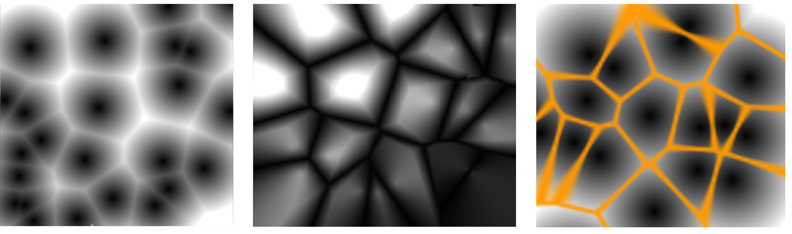

Figure 1: 2D image description (left) a descriptive caption of this image (middle), something from your game (right) You only need (left, middle, right) if there are multiple images. If there are no references then it is assumed to be something you created

You may choose inline or newline formats be sure to right click on the image and add caption Figures will auto number from 1 to n as needed.

# Input

Use this section to discuss what implementation of input you are using and how it works. You may want to tie this back to the player or the user. This should always be focused on technical implementations and improvements beyond the sample code. Use diagrams and pseudo code as needed to help support your explanation of how it works.

# Sprite Work

Outline the important sprite work (animated, NPC and user controlled), including screenshots. Be sure to describe what kind of animation work is being used and how it works. Highlight interesting or novel work. This should be focused on technical implementation.

# Collision Detection and Response

Describe the collision detection methods used and resolutions (what happens after a collision is detected), focus on the important ones. Describe the technical implementation, specifically what does it do and how does it work. Support your work with diagrams and pseudo code, using the image/caption format.

# Audio

Describe the where you have used the audio in relation to input and Collision Response. Describe the technical implementation, specifically what does it do and how does it work. Support your work with diagrams and pseudo code, using the image/caption format.

# Game Logic and Unique Mechanics

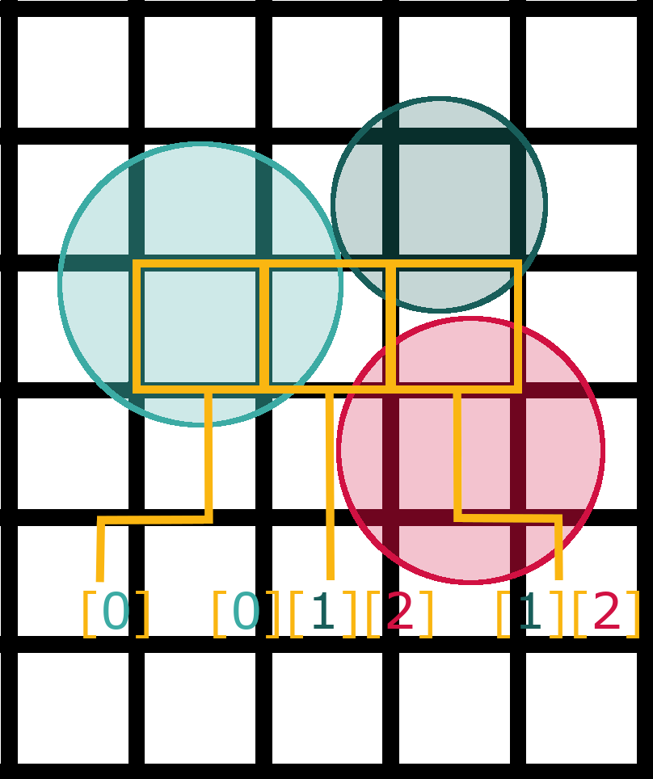This is where you will discuss the unique algorithms and mechanics that you have implemented in your game. For example, if you have a player that uses a grappling hook, use this section to talk about the technical implementation specifically what does it do and how does it work. Describe WHAT the code does for launching a hook sprite and rendering a trail along the vector between the player and the target reticule. Then explain HOW the code works. Support your work with diagrams and pseudo code, using the image/caption format. Be sure to reference any relevant work that helped you. For example, separating out the angle and magnitude is the first step to creating the hook shot (Duffy 2017).

Figure 2: An image from an outside source should be referenced appropriately (Michno 2012)

# Conclusion

Use the start of the conclusion to tie together the technical implementations from the above section. Use the next few sentences to reflect on the process of creating the game. What went well, what did not, what can be carried forward in the future, what should be changed to improve your development process. Focus on the how and the why.

# References

Duffy, S. (2017). *Make a 2D Grappling Hook Game in Unity – Part 1*. [online] raywenderlich.com. Available at: https://www.raywenderlich.com/348-make-a-2d-grappling-hook-game-in-unity-part-1 [Accessed 5 Feb. 2020].

Michno, E (2012). A Cost Effective, Accurate Virtual Camera System for Games, Media Production and Interactive Visualisation Using Game Motion Controllers. In *TPCG* (pp. 49-56).

Be sure to reference anything that is not your own original work, including textures, audio, tutorials, code snippets.