欢迎 (huānyíng/welcome)to Fun with Radicals!

A Radical is a component of a Chinese character. The word for radical in Chinese is 偏旁 (piānpáng), or simply 旁 (páng). This component can help us understand the character’s meaning. There are over 200 radicals! In Lesson I, we’ll just begin a few of them.

Pick a radical out of the radical sky to get started!

NOTE:

Here I’m wondering if the background could be blue and the characters placed around the clouds.

ALSO: each character needs to have a link to a page with its description.

饣忄亻



亻

this is the radical for 人 （rén/person）When it’s used as a radical, it gets squished to become 亻

门 (mén/gate)

亻+门=们 (men/people)

他们 (tāmen/they)

我们 (women/us)

木 (mù/wood)

亻+ 木= 休 (xiū/rest)

*(can you imagine sitting on the ground, resting your back on a tree?)*

忄

this is the radical for 心 (xīn/heart). When it gets squished, it looks like 忄

白(bái/white)

忄+白=怕 (pà/fear)

亡 (literary verb: wáng/perish)

忄+ 亡=忙 (máng/busy)

https://openclipart.org/image/90px/svg_to_png/233226/chineselantern.png sometimes, 心 keeps its basic form and goes UNDER a character instead of to the left of a character.

亡 + 心= 忘 (wàng/forget)

你 (nî/you +心=您 (polite form of you)

饣

This is our favorite radical! It is called the shí radical, and means food! It is written on the left side of a character when used as a radical.

饣+我 (wô/I)= 饿 (è/hungry)

饣+交 (jiāo/hand in or over, pay)=饺 (jiâo/dumpling) *hand over my dumpling!*

https://openclipart.org/image/90px/svg_to_png/233226/chineselantern.pngthe饣radical is a simplified version of 食。

食品 (shípîn/foodstuff, provisions) is a compound word. 食 is not used as a radical.

*come back for Lesson 2! We’ll have a review and learn some new radicals!*

下次见！ 再见！

Xià cì jiàn! Zài jiàn!



欢迎回来第二课！

huānyíng huílaí dì èr kè/welcome back for Lesson 2

*You were introduced to radicals in Lesson I. Now let’s look at how different radicals can change the meaning of the same character.*

We’ll start with 交 (jiāo/hand in, over)

We already learned that the food radical 饣(shí)+ 交 = dumpling 饺子 （子/zi is added to some nouns）

NEW FOR YOU:

木 mù/wood or tree radical

车 chē/vehicle, cart radical

立 lì/to stand radical with

灬 huô/fire radical

广 guâng/wide, broad radical

*we’ll use the radicals with these two characters:* 交 jiāo and 占zhàn

木 

木+交=校 (mù+jiāo=xiào/school) *Hand over the wood so we can build a school!*

车

 

车+交=较

(chē + jiāo = jiào/comparison)

比较 （bîjiào/comparatively）*his car is comparatively bigger!*

NOTICE THE TONE CHANGE!!!

立

lì/to stand

立+占=立占

lì + zhàn = zhàn

stand+ occupy = station

车站

chēzhàn/bus stop

灬

 火 hûo

https://openclipart.org/image/90px/svg_to_png/233226/chineselantern.pngwhen 火 goes UNDER a character,

it becomes 灬

*they look like little drops, don’t they?*

雨点 (yû diân/raindrop)

九 点 (jiû diân/9 o’clock)

一点 (yī diân/ a little bit)

广

guâng/ broad, extensive

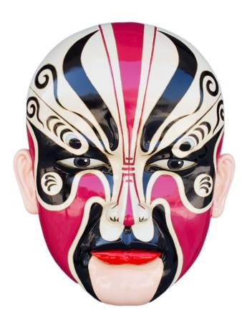*what do you think 广 looks like?*

*A shelter? A cliff with a drop?*

饭店 fàn/meal+diàn=fàndiàn/restaurant

*if you occupy(*占*) a shelter long enough, you can eat there!*

*Or even go shopping because it turns into a store!*

商店 shāng/commerce+diàn=shāngdiàn/shop or store



测试自己

cèshì zìjî/test yourself

which character(s) mean restaurant?

1. 饭店
2. 一点
3. 校
4. 怕

which is the heart radical?

1. 木
2. 广
3. 忄
4. 亻

which character(s) mean school?

1. 占
2. 雨点
3. 商店
4. 校