[http://www.atlantapd.org/Home/ShowDocument?id=2134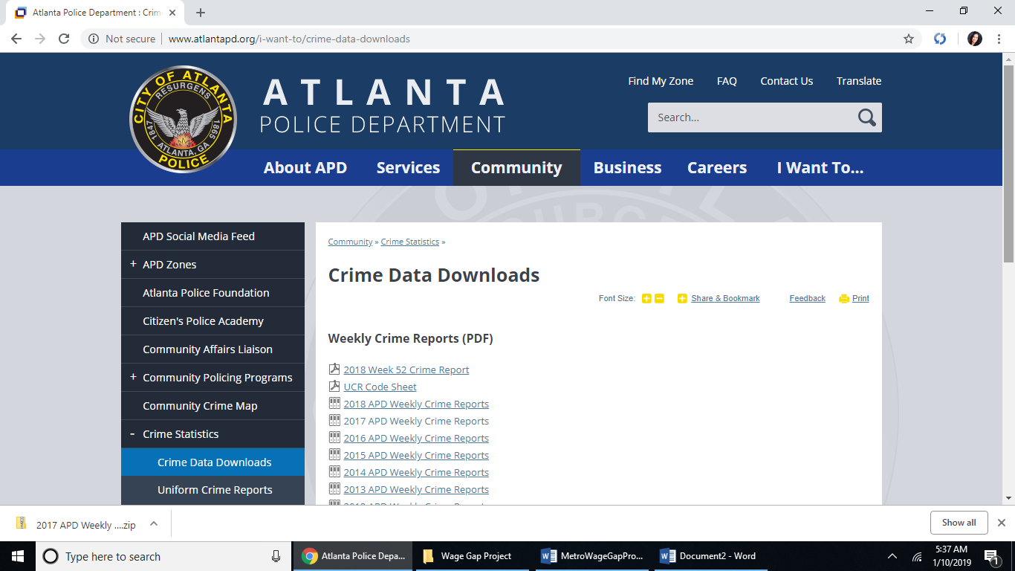](http://www.atlantapd.org/Home/ShowDocument?id=2134#)

