https://data.boston.gov/dataset/crime-incident-reports-august-2015-to-date-source-new-system

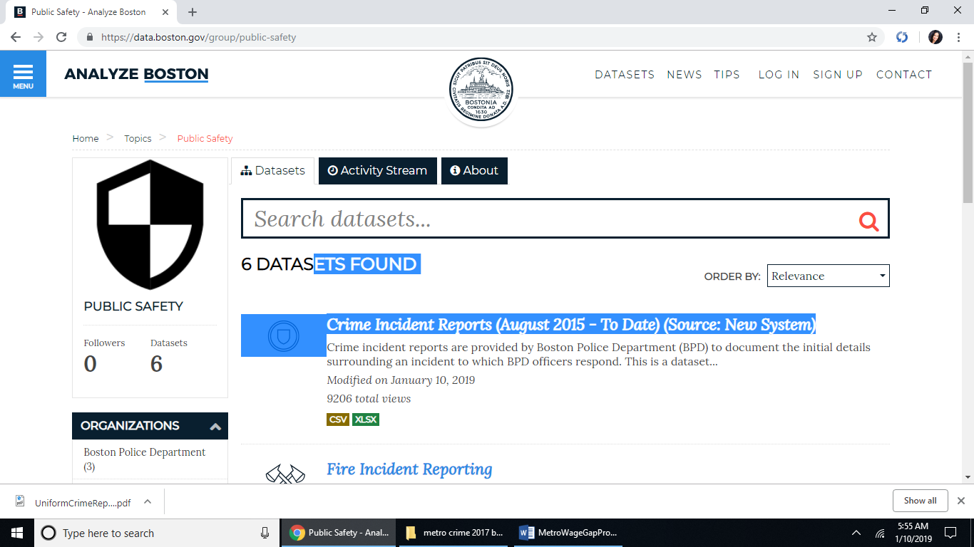

<https://data.boston.gov/dataset/6220d948-eae2-4e4b-8723-2dc8e67722a3/resource/12cb3883-56f5-47de-afa5-3b1cf61b257b/download/crime.csv>

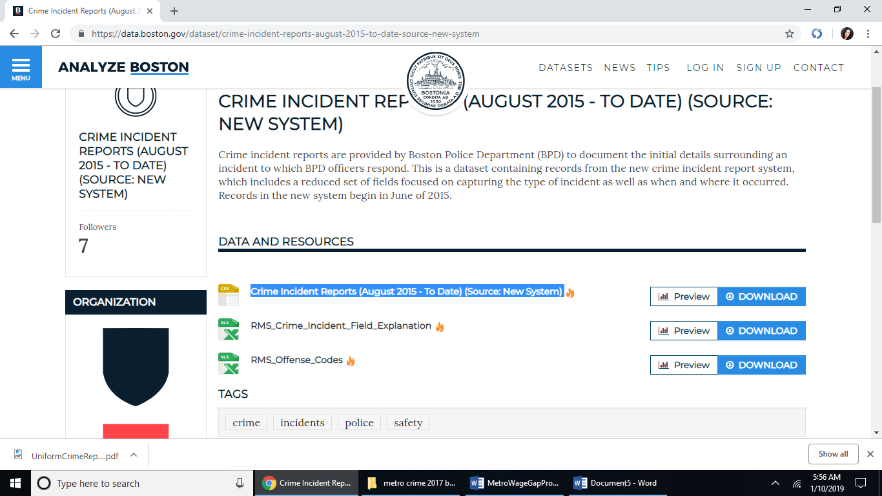

renamed to BostonCrimeData.csv in local file directory