[https://data.cityofchicago.org/api/views/6zsd-86xi/rows.csv?accessType=DOWNLOAD&bom=true&query=select+*](https://data.cityofchicago.org/api/views/6zsd-86xi/rows.csv?accessType=DOWNLOAD&bom=true&query=select+*)

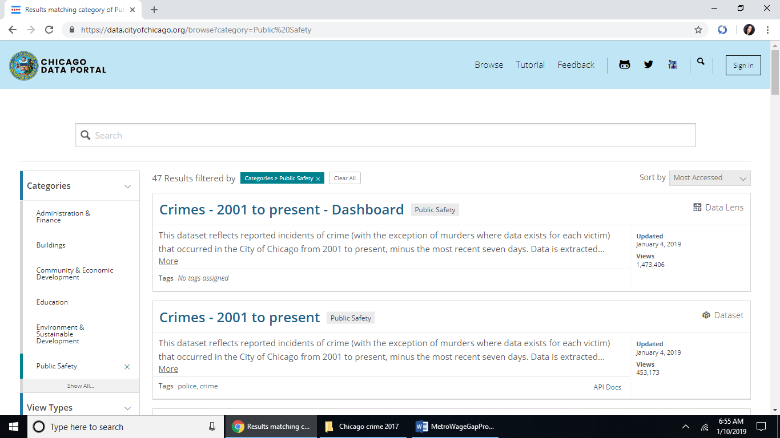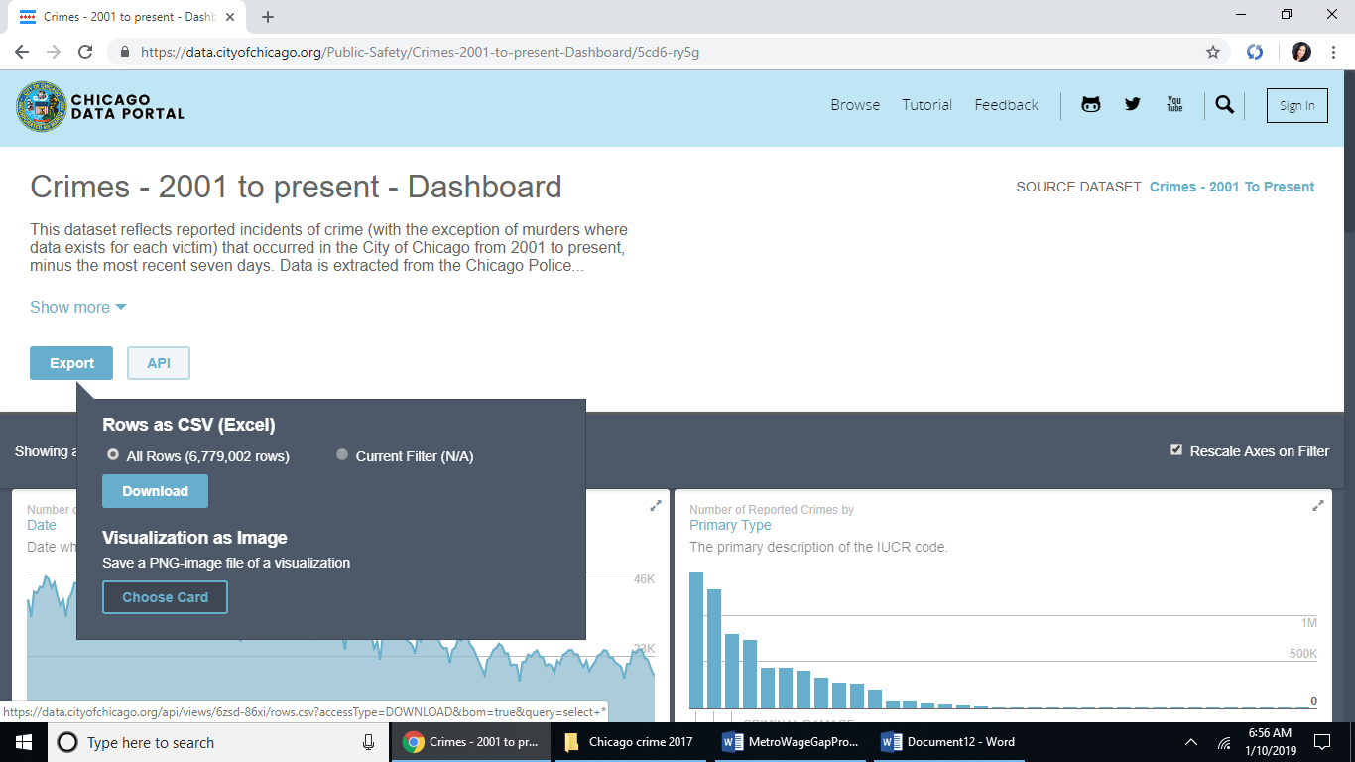

The file is 1.5 Gb in size as csv. The original file name is Crimes_-_2001_to_present.csv

Changed to Chicago_Crimes_2001_to_present.csv