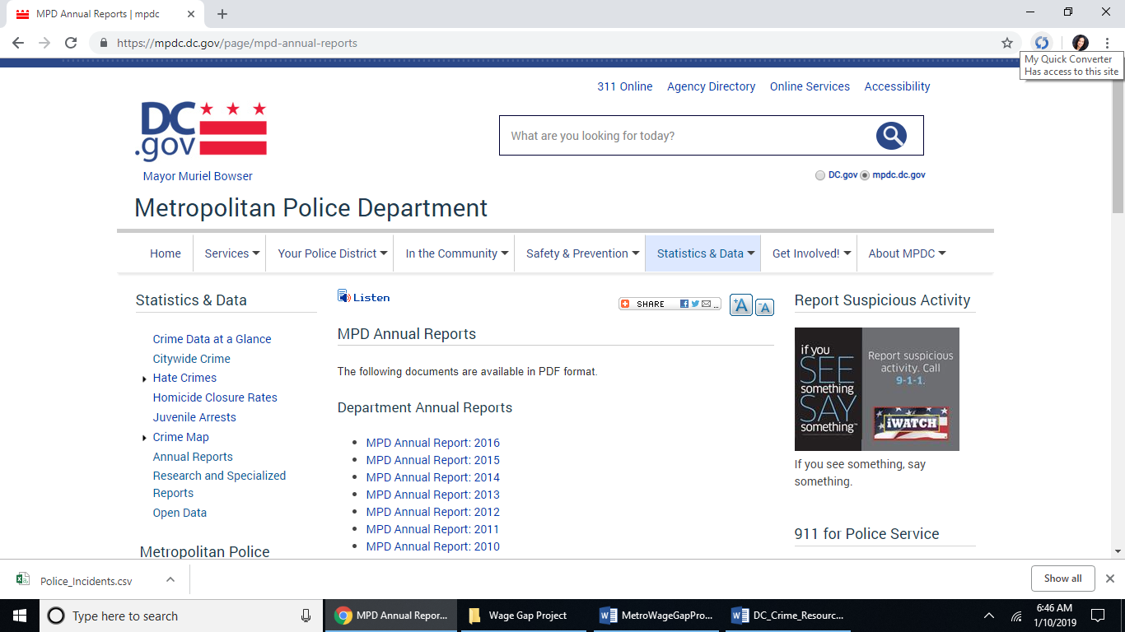

This site doesn’t have 2017 data in the year 2019.

<https://mpdc.dc.gov/page/district-crime-data-glance>

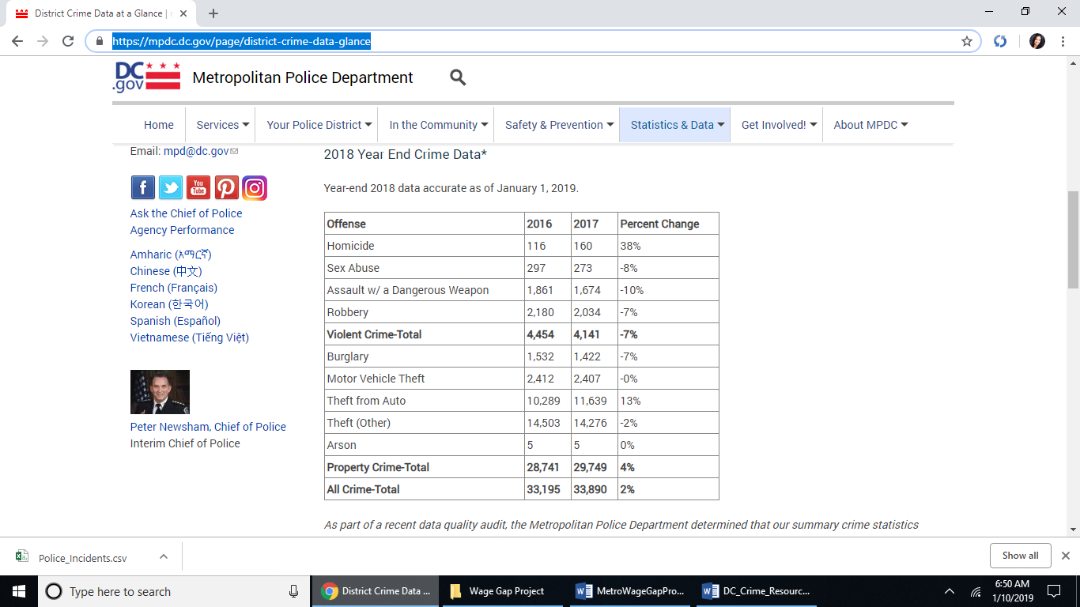

save the following copied and pasted from : <https://mpdc.dc.gov/page/district-crime-data-glance>

Year-end 2018 data accurate as of January 1, 2019.

| **Offense** | **2016** | **2017** | **Percent Change** |
| --- | --- | --- | --- |
| Homicide | 116 | 160 | 38% |
| Sex Abuse | 297 | 273 | -8% |
| Assault w/ a Dangerous Weapon | 1,861 | 1,674 | -10% |
| Robbery | 2,180 | 2,034 | -7% |
| **Violent Crime-Total** | **4,454** | **4,141** | **-7%** |
| Burglary | 1,532 | 1,422 | -7% |
| Motor Vehicle Theft | 2,412 | 2,407 | -0% |
| Theft from Auto | 10,289 | 11,639 | 13% |
| Theft (Other) | 14,503 | 14,276 | -2% |
| Arson | 5 | 5 | 0% |
| **Property Crime-Total** | **28,741** | **29,749** | **4%** |
| **All Crime-Total** | **33,195** | **33,890** | **2%** |

Data above was saved as DC_crime_2017.csv after copying and pasting into excel.