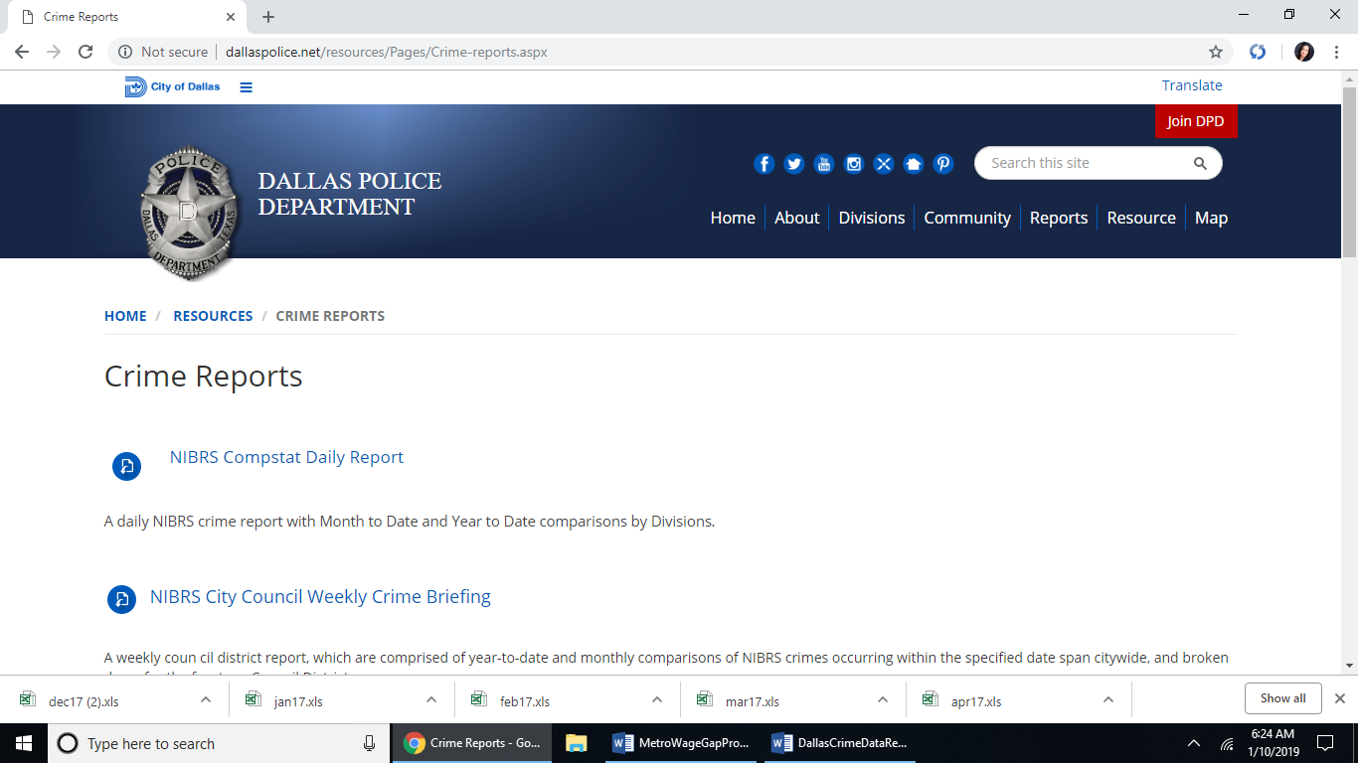

They offer daily or weekly arrest or reported crime reports.

<http://dallaspolice.net/resources/Pages/Crime-reports.aspx>

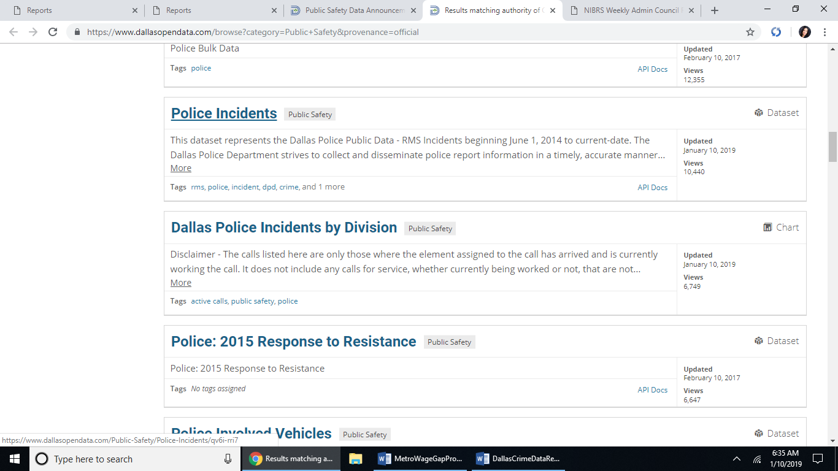 <https://www.dallasopendata.com/browse?category=Public+Safety&provenance=official>

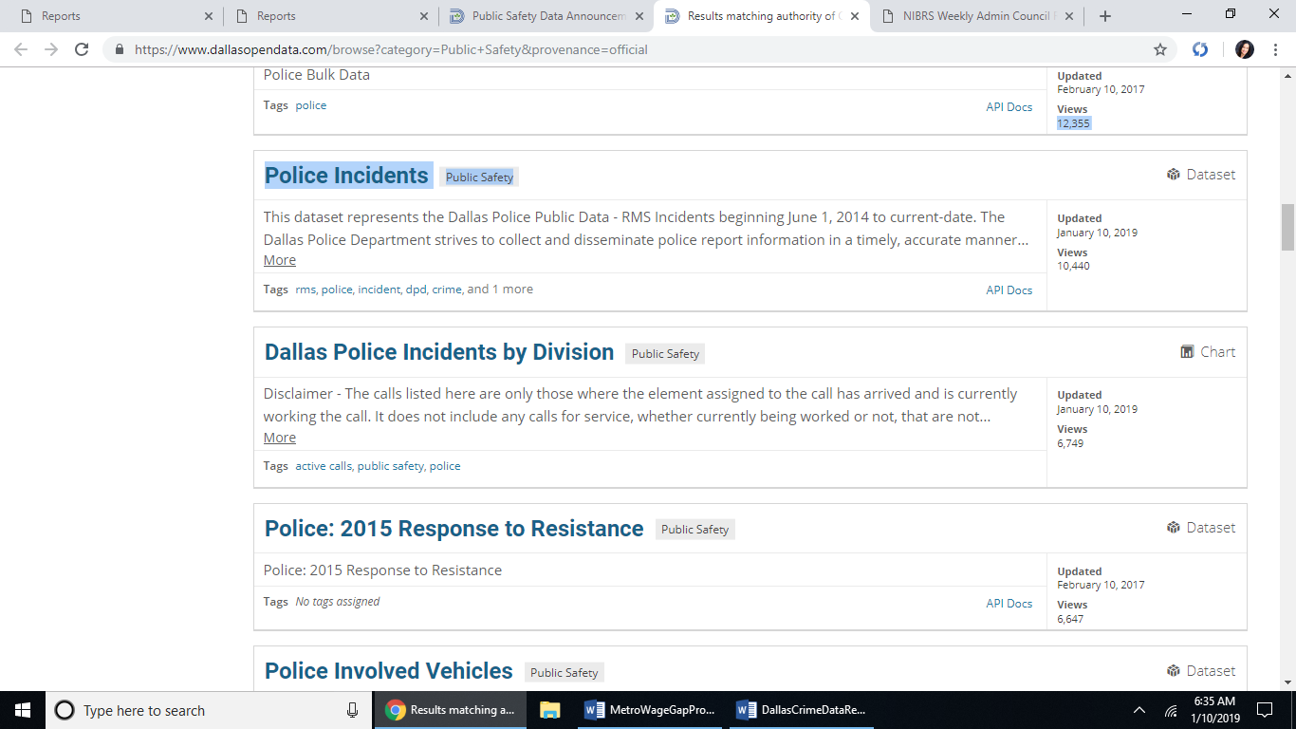

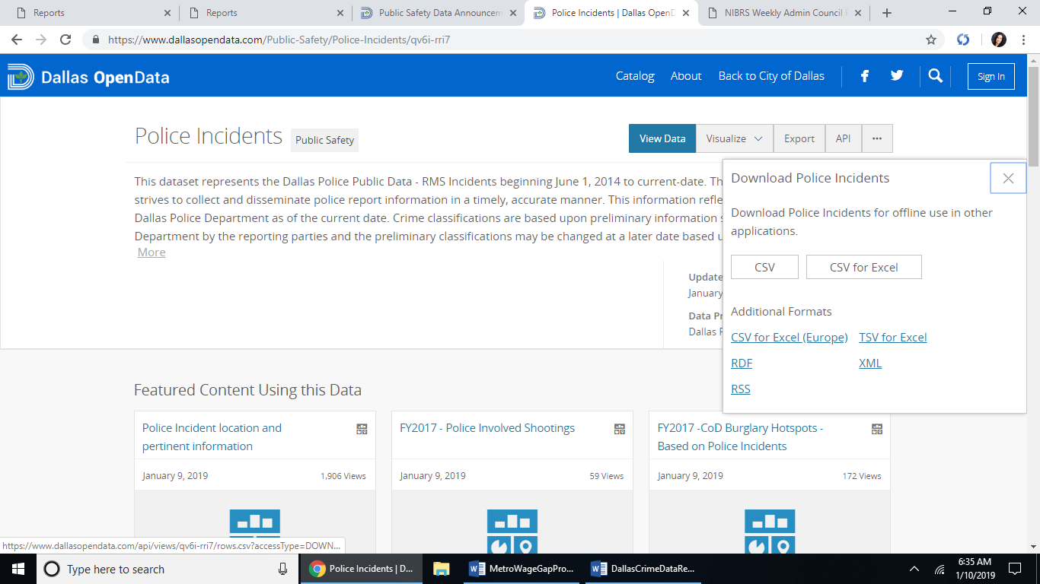 <https://www.dallasopendata.com/api/views/qv6i-rri7/rows.csv?accessType=DOWNLOAD>

Police_Indidents.csv saved as Police_Incidents_Dallas.csv