<http://www.houstontx.gov/police/cs/crime-stats-archives.htm>

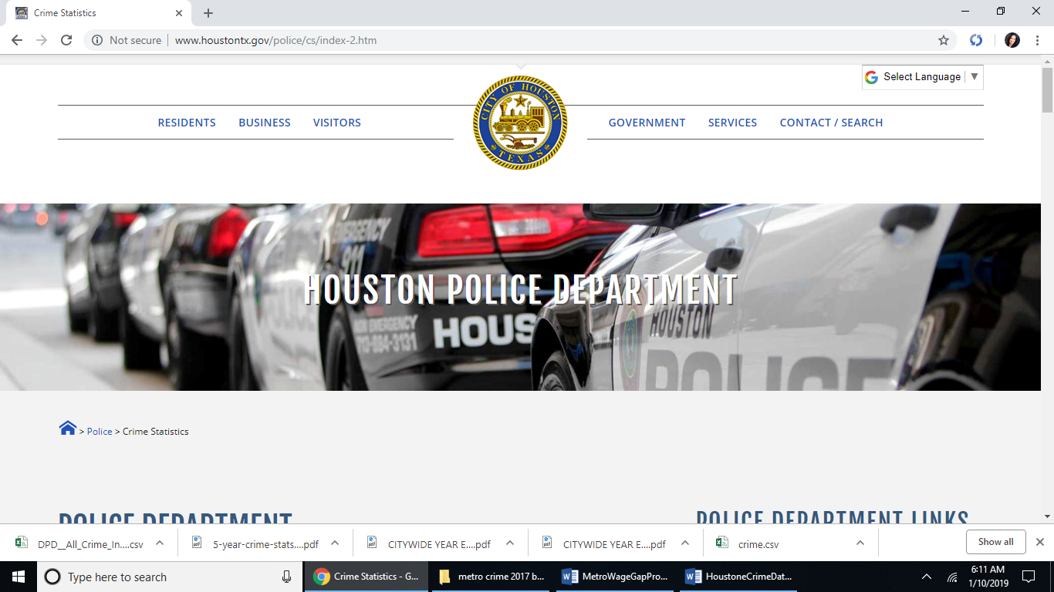

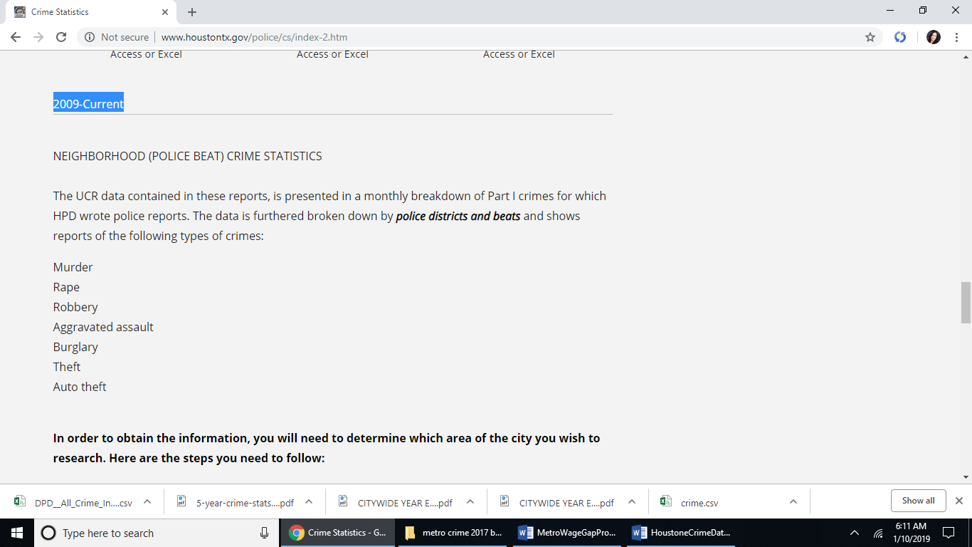 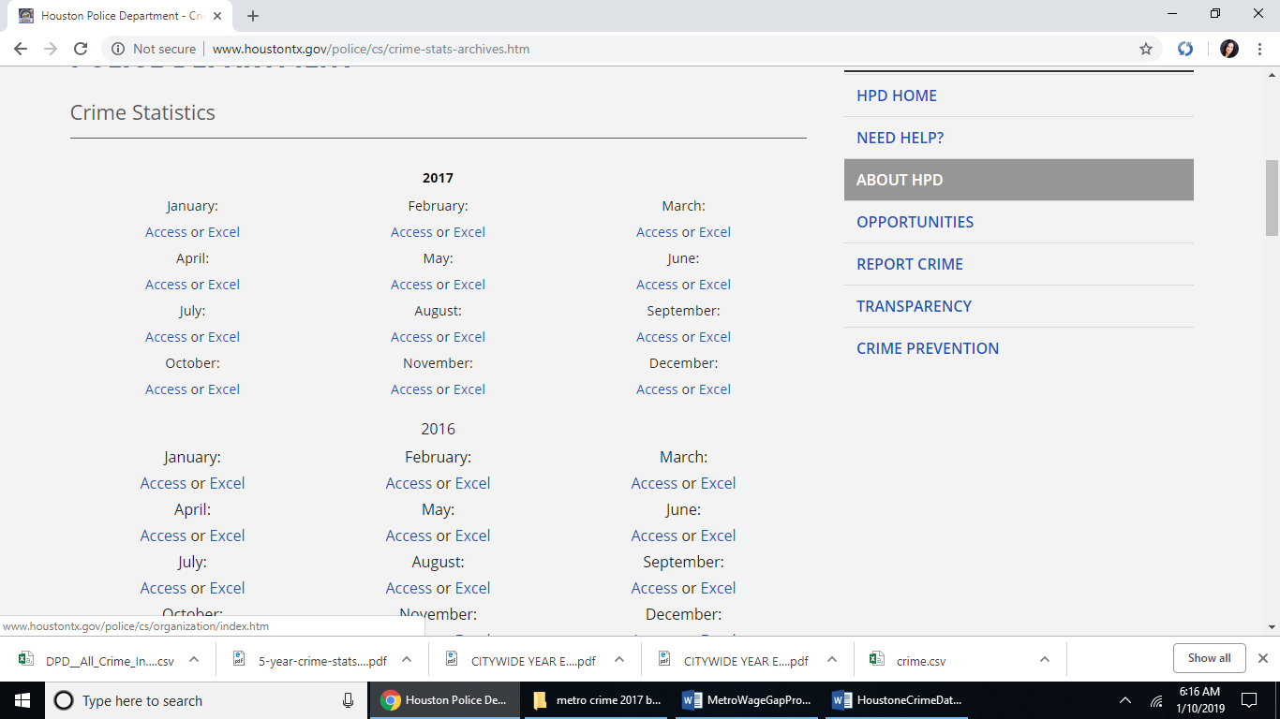

Download for all 12 months of 2017:

<http://www.houstontx.gov/police/cs/xls/jan17.xls>

<http://www.houstontx.gov/police/cs/xls/feb17.xls>

<http://www.houstontx.gov/police/cs/xls/mar17.xls>

<http://www.houstontx.gov/police/cs/xls/apr17.xls>

<http://www.houstontx.gov/police/cs/xls/may17.xls>

<http://www.houstontx.gov/police/cs/xls/jun17.xls>

<http://www.houstontx.gov/police/cs/xls/jul17.xls>

<http://www.houstontx.gov/police/cs/xls/aug17.xls>

<http://www.houstontx.gov/police/cs/xls/sep17.xls>

<http://www.houstontx.gov/police/cs/xls/oct17.xls>

<http://www.houstontx.gov/police/cs/xls/nov17.xls>

<http://www.houstontx.gov/police/cs/xls/dec17.xls>