Some more fields were added to the WageGapInformationTop14MetrosBRTadded2017.csv

The Median State wages field per metro and the Median low wages fields per metro.

Then some calculated fields for different scenarios in field self-explanatory names. The mortgage formula is the monthly APR approximated at 5% and a home mortgage of 25 years with 300 monthly payments using a finance formula internet searched online. The decimal measure is (.004 / (1 - (1 + .004) ^ -300)) = .005729969621 rounded to eight decimal places then multiplied by the Zillow home estimated value field called [3BR Home Median].

The calculated fields and formulas:

WageGapMedianIncomeMinusLowWages

[Median Income]-[MedianAnnualLowWages]

CashFlow2FamiliesLowIncomeSplit3BRHome

([MedianAnnualLowWages]/12)-([Mortgage5PercentAPR25years]/2)

CashFlow3BRHomeMedianIncome

([Median Income]/12)-[Mortgage5PercentAPR25years]

Mortgage5PercentAPR25years

(.00572997) * [3BR Home Median]

CashFlow3BRHomeLowWages

([MedianAnnualLowWages]/12)-[Mortgage5PercentAPR25years]

CashFlowMonthly3BRHomeOnStateWages

[MedianMonthlyStateWages]-[Mortgage5PercentAPR25years]

CashFlowMonthlyStateWagesMinus3BRrent

([Median Annual State Wages]/12) - [3BR Rental Median]

CashFlowMonthlyLowWagesMinus3BRrent

[MedianMonthlyLowWages]-[3BR Rental Median]

WageGapMedianIncomeMinusMedianStateWages

[Median Income]-[Median Annual State Wages]

The field names of new table:

|  |  |  |
| --- | --- | --- |
| Field Name | Table | Remote Field Name |
| MedianAnnualLowWages | CBSA_calc_low_wages.csv | AnnualLowWages |
| MedianMonthlyLowWages |  | Calculation_8162789429673994 |
| WageGapMedianIncomeMinusLowWages |  | Calculation_8162789410684929 |
| Median Annual State Wages | CBSA_calc_state_wages.csv | MedianAnnualStateWages |
| MedianMonthlyStateWages |  | Calculation_8162789429567497 |
| 3BR Home Median | WageGapInformationTop14MetrosBRTadded2017.csv | 3BR Home Median |
| CashFlow2FamiliesMonthlyLowIncomeSplit3BRHome |  | Calculation_8162789416534024 |
| CashFlow3BRHomeMedianIncome |  | Calculation_8162789416423431 |
| Mortgage5PercentAPR25years |  | Calculation_8162789413773316 |
| CashFlow3BRHomeLowWages |  | Calculation_8162789416189958 |
| CashFlowMonthly3BRHomeOnStateWages |  | Calculation_8162789415989253 |
| 3BR Rental Median | WageGapInformationTop14MetrosBRTadded2017.csv | 3BR Rental Median |
| CashFlowMonthlyStateWagesMinus3BRrent |  | Calculation_8162789411971075 |
| CashFlowMonthlyLowWagesMinus3BRrent |  | Calculation_8162789411282946 |
| Affordable Index Ratio | WageGapInformationTop14MetrosBRTadded2017.csv | Affordable Index Ratio |
| Affordable Index | WageGapInformationTop14MetrosBRTadded2017.csv | Affordable Index |
| Burglary Robbery Theft Counts | WageGapInformationTop14MetrosBRTadded2017.csv | Burglary Robbery Theft Counts |
| Buyer Seller Index | WageGapInformationTop14MetrosBRTadded2017.csv | Buyer Seller Index |
| CBSA Title | WageGapInformationTop14MetrosBRTadded2017.csv | CBSA Title |
| Days Home Listed | WageGapInformationTop14MetrosBRTadded2017.csv | Days Home Listed |
| ForeclosuresPer10KHomes | WageGapInformationTop14MetrosBRTadded2017.csv | Foreclosures |
| Home Sales | WageGapInformationTop14MetrosBRTadded2017.csv | Home Sales |
| Median Income | WageGapInformationTop14MetrosBRTadded2017.csv | Median Income |
| Region Name | WageGapInformationTop14MetrosBRTadded2017.csv | Region Name |
| Size Rank | WageGapInformationTop14MetrosBRTadded2017.csv | Size Rank |
| State Name | WageGapInformationTop14MetrosBRTadded2017.csv | State Name |
| WageGapStateAndLowWages | WageGapInformationTop14MetrosBRTadded2017.csv | Wage Gap Annuals |
| WageGapMedianIncomeMinusMedianStateWages |  | Calculation_8162789410050048 |
| Zip Code | WageGapInformationTop14MetrosBRTadded2017.csv | Zip Code |

The current data set is now called: WageGapInformationTop14Metros2017_BRT_CashFlowTypes

The BRT is for Burglaries, Robberies, and Thefts that was also added using an extensive search of the crime data bases made publicly available for the 2017 year for all metro areas. Some were from pdf files that tables were extracted using Tableau and fields named manually due to data interpretation within Tableau having content errors when aligning. All values were checked for accuracy on the original data extractions. The data extractions were then transformed into counts of singular data base burglaries, robberies, or thefts using a filter in tableau for the larger data sets, and a sum measure for aggregate values already supplied in the pdf table documents that only supplied aggregate measures in the publicly available crime or public safety data made available. Some files like Houston supplied monthly reports for 2017 that were combined in R using R programs. All those files and the R codes were uploaded to my github repository, but the file location must be changed in the code to fit your file directory if you upload the files. The screenshots and variables filtered out for thefts, vehicle thefts, auto thefts, burglaries armed or unarmed, or robberies, or stolen property and other descriptions specific to each data base for each metro resource was selected using filter and selecting only those types of descriptive crimes. Some crime descriptors were extensive and some were minimal like the pdf tables that only supplied aggregate values for those crimes.

The github repository is publicly available for accessing the crime database files, R script, and files created and used to build the WageGapInformationTop14MetrosBRTadded2017.csv file that was used to add the fields in this data set. The link is: <https://github.com/JanJanJan2018/AddedCrimeDataForTheftsToWageGapFile>

The original Wage gap files are located at: <https://github.com/JanJanJan2018/WageGapProject>

<https://github.com/JanJanJan2018/WageGapBurglariesRobberiesTheftsAndCashFlowComparisonsStateAndLowWagesAndMedianIncomeAll> is where you can access this document and other files.

<https://public.tableau.com/views/WageGapBetweenAnnualStateandMedianIncomeValuesperMetrowithAddedTheftsBurglariesandRobberiesin2017/Sheet1?:embed=y&:display_count=yes&publish=yes>

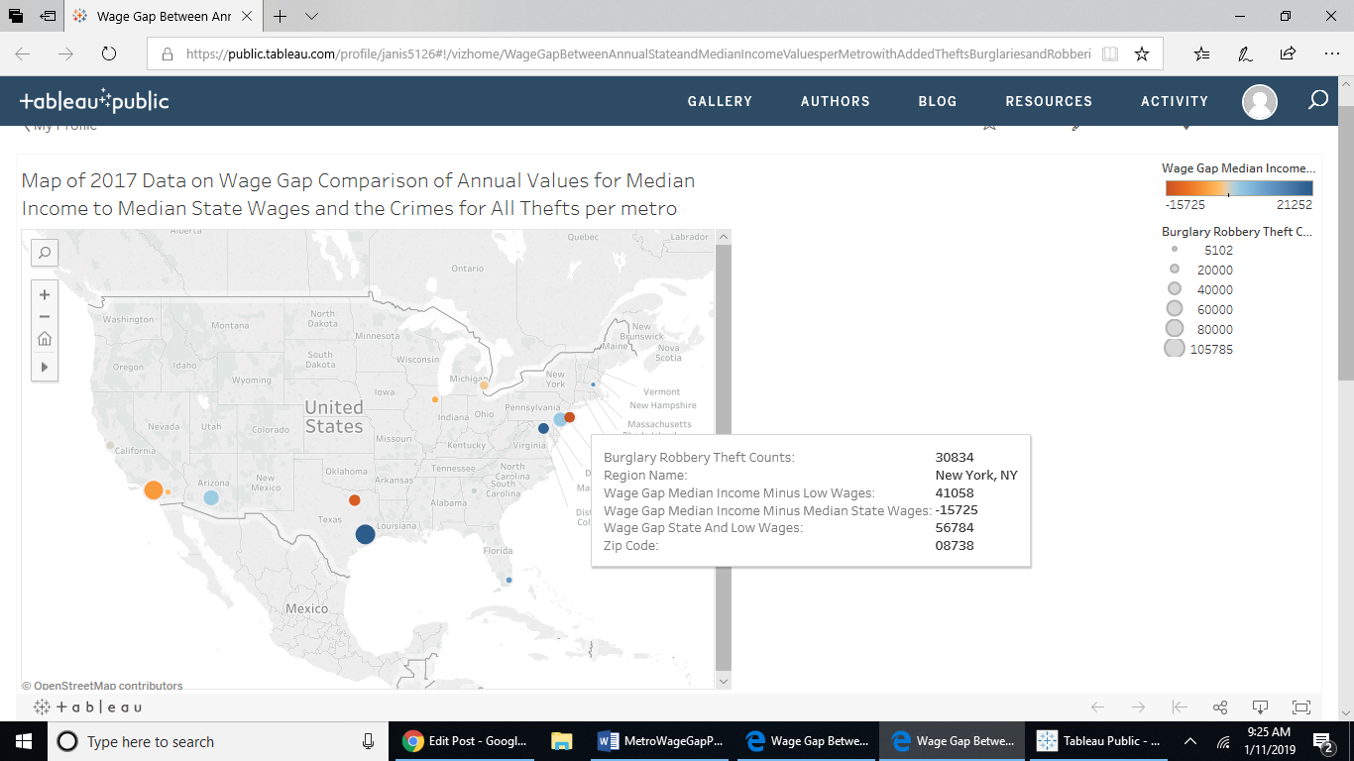

<https://public.tableau.com/views/WageGapBetweenAnnualStateandLowWageValuesperMetrowithAddedTheftsBurglariesandRobberiesin2017/Sheet1?:embed=y&:display_count=yes&publish=yes>

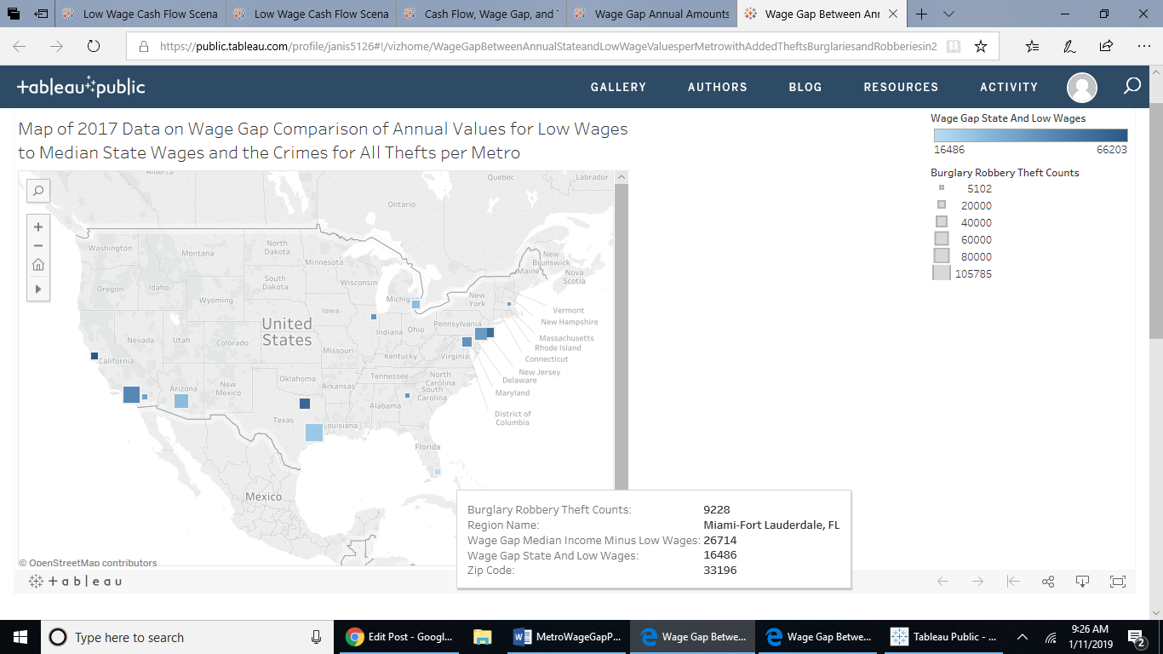

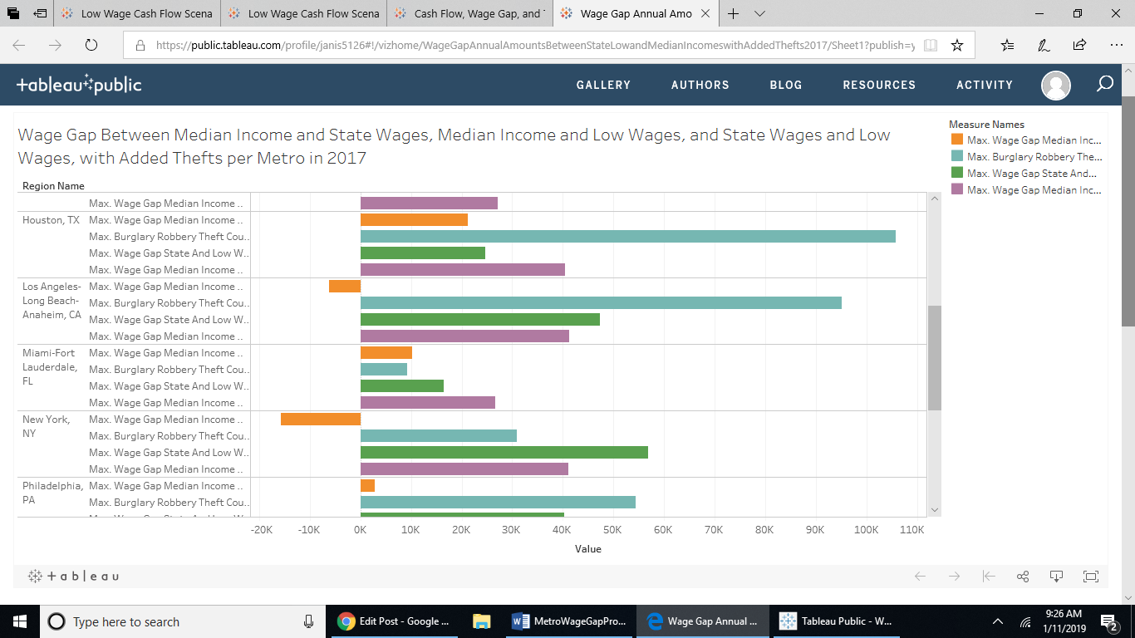

<https://public.tableau.com/views/WageGapAnnualAmountsBetweenStateLowandMedianIncomeswithAddedThefts2017/Sheet1?:embed=y&:display_count=yes&publish=yes>

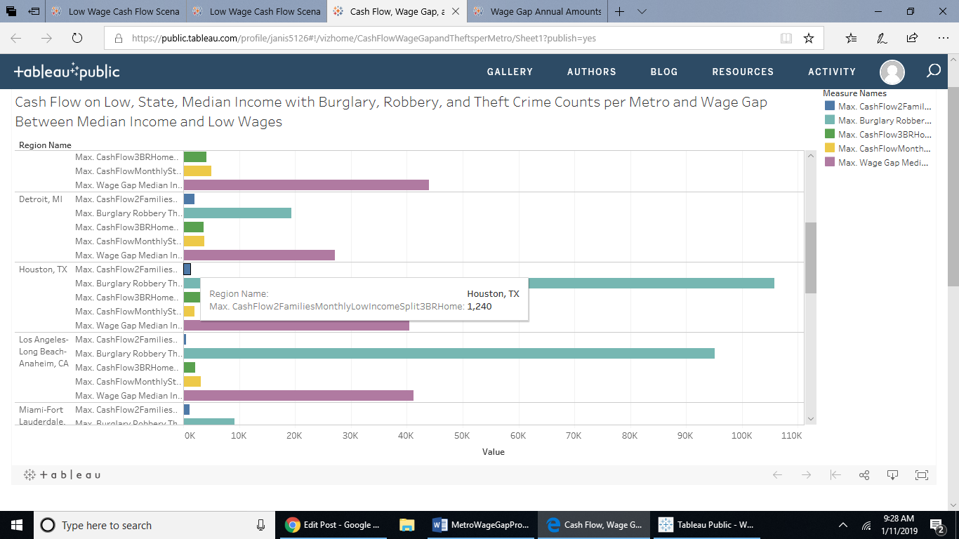 <https://public.tableau.com/views/CashFlowWageGapandTheftsperMetro/Sheet1?:embed=y&:display_count=yes&publish=yes>

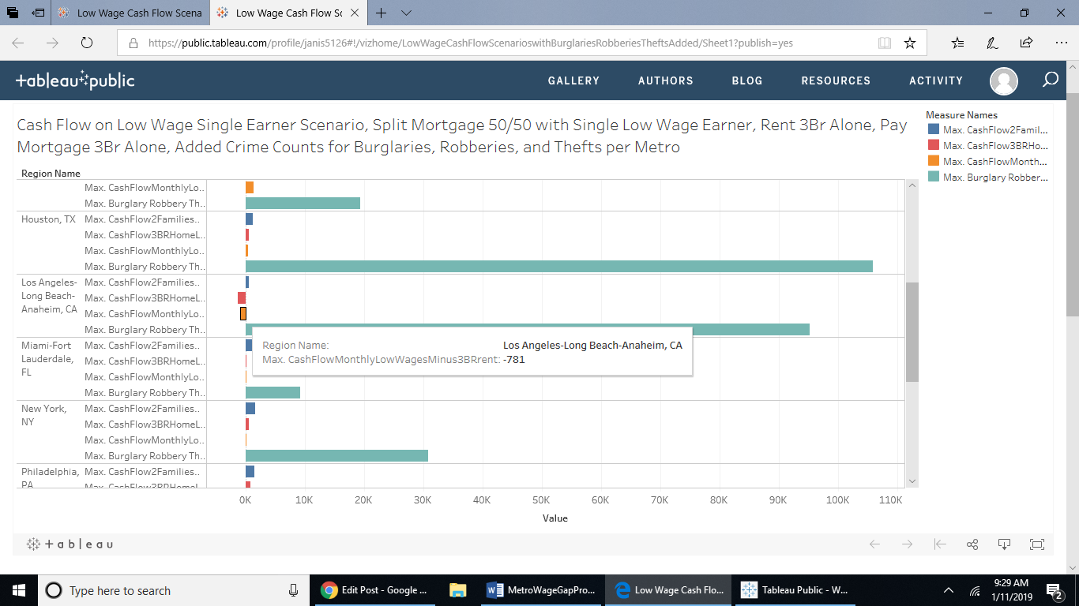

<https://public.tableau.com/views/LowWageCashFlowScenarioswithBurglariesRobberiesTheftsAdded/Sheet1?:embed=y&:display_count=yes&publish=yes>

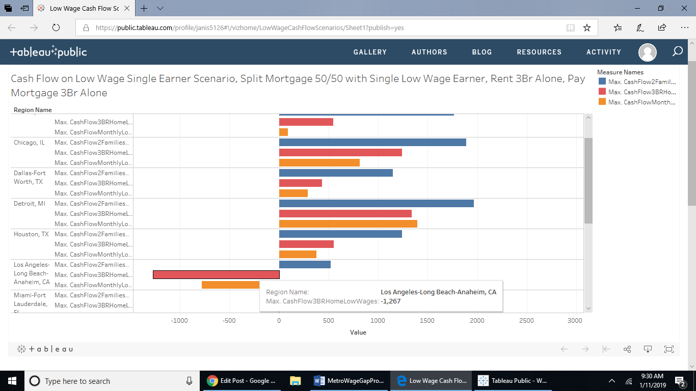

<https://public.tableau.com/views/LowWageCashFlowScenarios/Sheet1?:embed=y&:display_count=yes&publish=yes>