Calf Cramps PubMed

Janis Corona

12/9/2019

## This script takes ten articles from the abstracts on earache articles from NCBI’s PubMed

This creates a directory to stem the abstracts and preprocess from the csv file into a corpus of 20 files in a folder called Earache.

Auto <- read.csv('calf_cramps_PubMed_abstracts.csv', sep=',',  
 header=TRUE, na.strings=c('',' '))  
  
auto <- Auto[complete.cases(Auto$abstract),]  
  
  
dir.create('./Calf_Cramps')  
  
ea <- as.character(auto$abstract)  
setwd('./Calf_Cramps')  
  
for (j in 1:length(ea)){  
 write(ea[j], paste(paste('EA',j, sep='.'), '.txt', sep=''))  
}  
setwd('../')

This code preprocesses and stems the corpus

library(tm)  
library(SnowballC)  
library(wordcloud)  
library(ggplot2)  
  
Calf_Cramps <- Corpus(DirSource("Calf_Cramps"))  
  
  
Calf_Cramps

## <<SimpleCorpus>>  
## Metadata: corpus specific: 1, document level (indexed): 0  
## Content: documents: 20

#Calf_Cramps <- tm_map(Calf_Cramps, removePunctuation)  
#Calf_Cramps <- tm_map(Calf_Cramps, removeNumbers)  
Calf_Cramps <- tm_map(Calf_Cramps, tolower)  
Calf_Cramps <- tm_map(Calf_Cramps, removeWords, stopwords("english"))  
Calf_Cramps <- tm_map(Calf_Cramps, stripWhitespace)  
Calf_Cramps <- tm_map(Calf_Cramps, stemDocument)  
  
dtmCalf_Cramps <- DocumentTermMatrix(Calf_Cramps)  
  
freq <- colSums(as.matrix(dtmCalf_Cramps))

This code orders words stemmed by frequency and finds input correlations

FREQ <- data.frame(freq)  
ord <- order(freq, decreasing=TRUE)  
  
freq[head(ord, 25)]

## cramp muscl calf leg pain patient nocturn   
## 61 47 43 41 32 31 24   
## week effect studi results: signific compar sleep   
## 20 17 16 15 15 14 13   
## treatment pregnant clinic cramps. qualiti report stimul   
## 13 13 12 11 11 11 11   
## inject group methods: syndrom   
## 11 10 10 10

findAssocs(dtmCalf_Cramps, "sleep", corlimit=0.7)

## $sleep  
## qualiti (mos-ss). 0.001), 0.003) 0.007), 0.02)   
## 0.96 0.95 0.95 0.95 0.95 0.95   
## 0.02). 0.03). adequ age) aspect australia.   
## 0.95 0.95 0.95 0.95 0.95 0.95   
## bodili central coast controls. domain eighti   
## 0.95 0.95 0.95 0.95 0.95 0.95   
## explain greater health-rel impact larg less   
## 0.95 0.95 0.95 0.95 0.95 0.95   
## mental mos-ss negat never newcastl peopl   
## 0.95 0.95 0.95 0.95 0.95 0.95   
## primarili problem purpose: quantiti region role   
## 0.95 0.95 0.95 0.95 0.95 0.95   
## sex-match sf-36 sf-36v2 sleep. snore substanti   
## 0.95 0.95 0.95 0.95 0.95 0.95   
## summari survey health life. nocturn life   
## 0.95 0.95 0.89 0.83 0.80 0.76   
## disturb age- south wales, year reduc   
## 0.73 0.73 0.73 0.73 0.73 0.71   
## experienc   
## 0.71

findAssocs(dtmCalf_Cramps, "pain", corlimit=0.5)

## $pain  
## patient patients, rate study. report daili   
## 0.60 0.58 0.58 0.58 0.57 0.56   
## cramp; insomnia discomfort   
## 0.52 0.51 0.51

wf <- data.frame(word=names(freq), freq=freq)  
p <- ggplot(subset(wf, freq>16), aes(word, freq))  
p <- p + geom_bar(stat= 'identity')   
p <- p + theme(axis.text.x=element_text(angle=90, hjust=1))   
p

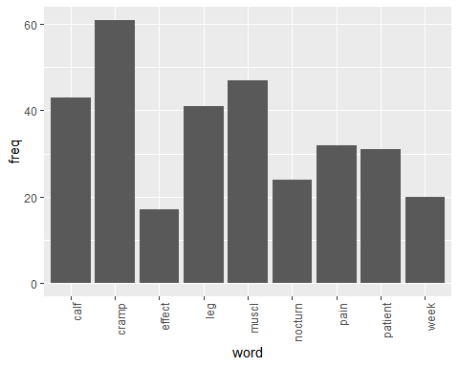

wordcloud(names(freq), freq, min.freq=10,colors=brewer.pal(3,'Dark2'))

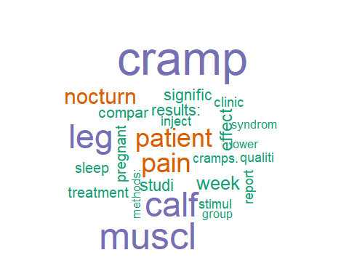

wordcloud(names(freq), freq, max.words=30,colors=brewer.pal(6,'Dark2'))

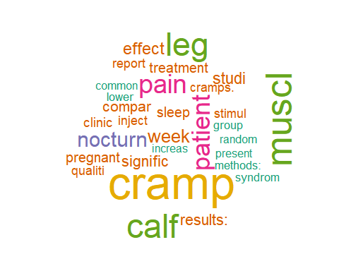

### The above stemmed the corpus, this will lemmatize the original csv file

and add the field to the table and write out to csv, followed by plot the word count frequencies that were lemmatized and the word clouds

library(textstem)  
  
lemma <- lemmatize_strings(auto$abstract, dictionary=lexicon::hash_lemmas)  
  
Lemma <- as.data.frame(lemma)  
Lemma <- cbind(Lemma, auto)  
  
colnames(Lemma) <- c('lemmatizedAbstract','abstract', 'source')  
  
write.csv(Lemma, 'LemmatizedCalf_Cramps.csv', row.names=FALSE)

dir.create('./Calf_Cramps-Lemma')  
  
ea <- as.character(Lemma$lemmatizedAbstract)  
setwd('./Calf_Cramps-Lemma')  
  
for (j in 1:length(ea)){  
 write(ea[j], paste(paste('EAL',j, sep='.'), '.txt', sep=''))  
}  
setwd('../')

library(tm)  
library(SnowballC)  
library(wordcloud)  
library(ggplot2)

Calf_Cramps <- Corpus(DirSource("Calf_Cramps-Lemma"))  
  
Calf_Cramps

## <<SimpleCorpus>>  
## Metadata: corpus specific: 1, document level (indexed): 0  
## Content: documents: 20

#Calf_Cramps <- tm_map(Calf_Cramps, removePunctuation)  
#Calf_Cramps <- tm_map(Calf_Cramps, removeNumbers)  
Calf_Cramps <- tm_map(Calf_Cramps, tolower)  
Calf_Cramps <- tm_map(Calf_Cramps, removeWords, stopwords("english"))  
Calf_Cramps <- tm_map(Calf_Cramps, stripWhitespace)  
  
dtmCalf_Cramps <- DocumentTermMatrix(Calf_Cramps)  
dtmCalf_Cramps

## <<DocumentTermMatrix (documents: 20, terms: 1209)>>  
## Non-/sparse entries: 1989/22191  
## Sparsity : 92%  
## Maximal term length: 20  
## Weighting : term frequency (tf)

freq <- colSums(as.matrix(dtmCalf_Cramps))  
  
FREQ <- data.frame(freq)  
ord <- order(freq, decreasing=TRUE)  
  
freq[head(ord, 25)]

## cramp muscle calf leg patient   
## 66 47 45 42 30   
## pain nocturnal week study btx   
## 28 24 20 16 16   
## result: sleep treatment clinical conclusion:   
## 15 15 14 13 13   
## method: group compare low pregnant   
## 13 13 13 13 13   
## cramp. quality report control significantly   
## 11 11 11 10 10

patient <- as.data.frame(findAssocs(dtmCalf_Cramps, "patient", corlimit=0.70))  
  
Calf_Cramps <- as.data.frame(findAssocs(dtmCalf_Cramps, "calf", corlimit=0.75))  
  
  
treatment <- as.data.frame(findAssocs(dtmCalf_Cramps, "treatment", corlimit=0.55))  
  
patient

## patient  
## assessment 0.84  
## global 0.84  
## interventional 0.84  
## prospective, 0.84  
## improve 0.81  
## frequent 0.77  
## daily 0.75  
## intensity 0.73  
## patient, 0.72

Calf_Cramps

## calf  
## one 0.87  
## 1.13 0.82  
## 1.18 0.82  
## 1.45 0.82  
## 111 0.82  
## 16, 0.82  
## 180 0.82  
## 186 0.82  
## 2.96 0.82  
## 2010 0.82  
## 2012. 0.82  
## 28. 0.82  
## 32. 0.82  
## 342 0.82  
## 39, 0.82  
## 420 0.82  
## 492 0.82  
## 5.76 0.82  
## 50. 0.82  
## 500 0.82  
## 582 0.82  
## 673 0.82  
## 748 0.82  
## 8.02 0.82  
## 952 0.82  
## 971 0.82  
## =349. 0.82  
## =6. 0.82  
## area, 0.82  
## balance 0.82  
## call 0.82  
## china 0.82  
## china. 0.82  
## chinese 0.82  
## classify 0.82  
## cluster 0.82  
## county 0.82  
## dairy 0.82  
## demographic 0.82  
## diagnose. 0.82  
## dietary 0.82  
## dynamic 0.82  
## economic 0.82  
## ffq 0.82  
## first, 0.82  
## fruit 0.82  
## group, 0.82  
## hypertension 0.82  
## information, 0.82  
## intake 0.82  
## mainland. 0.82  
## multi 0.82  
## occupation, 0.82  
## p=0. 0.82  
## pattern 0.82  
## pattern, 0.82  
## pattern. 0.82  
## period; 0.82  
## peripartum 0.82  
## probability 0.82  
## proportional 0.82  
## province 0.82  
## quantitative 0.82  
## questionnaire. 0.82  
## randomization 0.82  
## relatively 0.82  
## residential 0.82  
## respectively, 0.82  
## sample 0.82  
## semi 0.82  
## size 0.82  
## socio 0.82  
## stage 0.82  
## status, 0.82  
## stratify 0.82  
## study; 0.82  
## take 0.82  
## take. 0.82  
## vegetable 0.82  
## muscle 0.81  
## different 0.81  
## investigate 0.80  
## use 0.80  
## value 0.78  
## trimester. 0.78  
## prevalence 0.77  
## factor 0.75

treatment

## treatment  
## effectiveness 0.81  
## decrease 0.67  
## baseline 0.66  
## outcome 0.59  
## follow 0.57  
## inclusion 0.55  
## intervention: 0.55  
## stretch 0.55  
## course 0.55  
## main 0.55  
## participant: 0.55  
## btx 0.55  
## safe 0.55  
## toxin 0.55

wf <- data.frame(word=names(freq), freq=freq)  
p <- ggplot(subset(wf, freq>15), aes(word, freq))  
p <- p + geom_bar(stat= 'identity')   
p <- p + theme(axis.text.x=element_text(angle=90, hjust=1))   
p

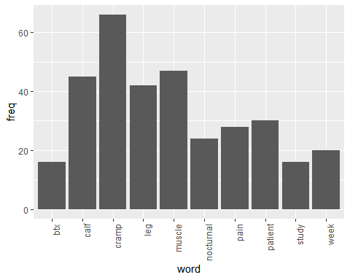

wordcloud(names(freq), freq, min.freq=10,colors=brewer.pal(3,'Dark2'))

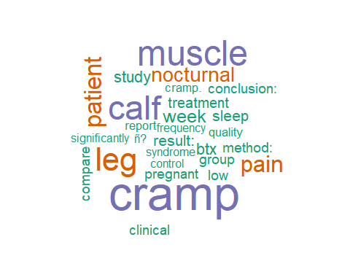

wordcloud(names(freq), freq, max.words=40,colors=brewer.pal(6,'Dark2'))

