Low Back Pain PubMed

Janis Corona

12/9/2019

## This script takes ten articles from the abstracts on earache articles from NCBI’s PubMed

This creates a directory to stem the abstracts and preprocess from the csv file into a corpus of 20 files in a folder called Earache.

Auto <- read.csv('LB_SI_joint_pain_PubMed_Abstracts.csv', sep=',',  
 header=TRUE, na.strings=c('',' '))  
  
auto <- Auto[complete.cases(Auto$abstract),]  
  
  
dir.create('./LowBackPain')  
  
ea <- as.character(auto$abstract)  
setwd('./LowBackPain')  
  
for (j in 1:length(ea)){  
 write(ea[j], paste(paste('EA',j, sep='.'), '.txt', sep=''))  
}  
setwd('../')

This code preprocesses and stems the corpus

library(tm)  
library(SnowballC)  
library(wordcloud)  
library(ggplot2)  
  
LowBackPain <- Corpus(DirSource("LowBackPain"))  
  
  
LowBackPain

## <<SimpleCorpus>>  
## Metadata: corpus specific: 1, document level (indexed): 0  
## Content: documents: 20

#LowBackPain <- tm_map(LowBackPain, removePunctuation)  
#LowBackPain <- tm_map(LowBackPain, removeNumbers)  
LowBackPain <- tm_map(LowBackPain, tolower)  
LowBackPain <- tm_map(LowBackPain, removeWords, stopwords("english"))  
LowBackPain <- tm_map(LowBackPain, stripWhitespace)  
LowBackPain <- tm_map(LowBackPain, stemDocument)  
  
dtmLowBackPain <- DocumentTermMatrix(LowBackPain)  
  
freq <- colSums(as.matrix(dtmLowBackPain))

This code orders words stemmed by frequency and finds input correlations

FREQ <- data.frame(freq)  
ord <- order(freq, decreasing=TRUE)  
  
freq[head(ord, 25)]

## patient pain back studi low group   
## 68 62 50 46 37 32   
## chronic joint compar improv differ pain.   
## 28 27 24 23 22 20   
## signific effect includ lbp treatment function   
## 20 19 18 18 18 18   
## outcom report one use observ sacroiliac   
## 17 17 16 16 16 15   
## disabl   
## 13

findAssocs(dtmLowBackPain, "patient", corlimit=0.7)

## $patient  
## cours characterist questionnair score outcom   
## 0.83 0.78 0.78 0.77 0.74   
## compar improv complet   
## 0.73 0.72 0.70

findAssocs(dtmLowBackPain, "pain", corlimit=0.62)

## $pain  
## also although advantag convent especi   
## 0.69 0.68 0.64 0.64 0.64   
## general non-specif possibl single-blind appli   
## 0.64 0.64 0.64 0.64 0.63   
## myofasci   
## 0.63

wf <- data.frame(word=names(freq), freq=freq)  
p <- ggplot(subset(wf, freq>16), aes(word, freq))  
p <- p + geom_bar(stat= 'identity')   
p <- p + theme(axis.text.x=element_text(angle=90, hjust=1))   
p

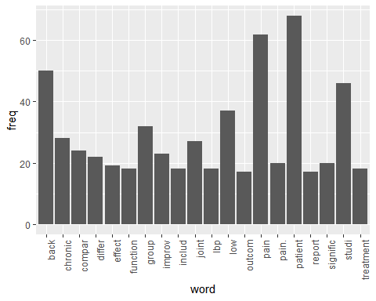

wordcloud(names(freq), freq, min.freq=10,colors=brewer.pal(3,'Dark2'))

## Warning in wordcloud(names(freq), freq, min.freq = 10, colors =  
## brewer.pal(3, : patient could not be fit on page. It will not be plotted.

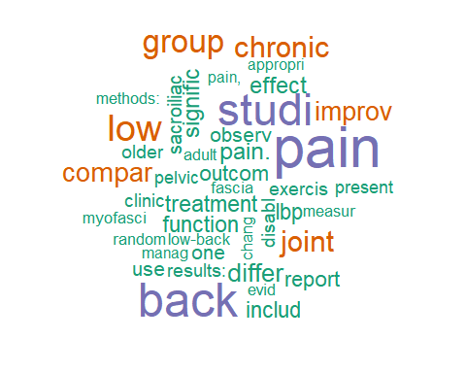

wordcloud(names(freq), freq, max.words=30,colors=brewer.pal(6,'Dark2'))

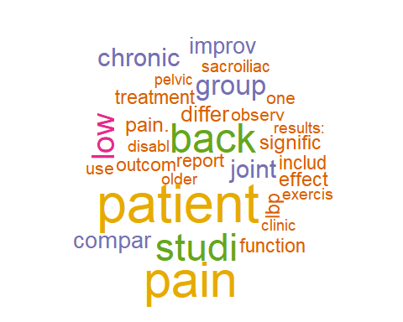

### The above stemmed the corpus, this will lemmatize the original csv file

and add the field to the table and write out to csv, followed by plot the word count frequencies that were lemmatized and the word clouds

library(textstem)  
  
lemma <- lemmatize_strings(auto$abstract, dictionary=lexicon::hash_lemmas)  
  
Lemma <- as.data.frame(lemma)  
Lemma <- cbind(Lemma, auto)  
  
colnames(Lemma) <- c('lemmatizedAbstract','abstract', 'source')  
  
write.csv(Lemma, 'LemmatizedLowBackPain.csv', row.names=FALSE)

dir.create('./LowBackPain-Lemma')  
  
ea <- as.character(Lemma$lemmatizedAbstract)  
setwd('./LowBackPain-Lemma')  
  
for (j in 1:length(ea)){  
 write(ea[j], paste(paste('EAL',j, sep='.'), '.txt', sep=''))  
}  
setwd('../')

library(tm)  
library(SnowballC)  
library(wordcloud)  
library(ggplot2)

LowBackPain <- Corpus(DirSource("LowBackPain-Lemma"))  
  
LowBackPain

## <<SimpleCorpus>>  
## Metadata: corpus specific: 1, document level (indexed): 0  
## Content: documents: 20

#LowBackPain <- tm_map(LowBackPain, removePunctuation)  
#LowBackPain <- tm_map(LowBackPain, removeNumbers)  
LowBackPain <- tm_map(LowBackPain, tolower)  
LowBackPain <- tm_map(LowBackPain, removeWords, stopwords("english"))  
LowBackPain <- tm_map(LowBackPain, stripWhitespace)  
  
dtmLowBackPain <- DocumentTermMatrix(LowBackPain)  
dtmLowBackPain

## <<DocumentTermMatrix (documents: 20, terms: 1575)>>  
## Non-/sparse entries: 2556/28944  
## Sparsity : 92%  
## Maximal term length: 19  
## Weighting : term frequency (tf)

freq <- colSums(as.matrix(dtmLowBackPain))  
  
FREQ <- data.frame(freq)  
ord <- order(freq, decreasing=TRUE)  
  
freq[head(ord, 25)]

## patient pain back low study group   
## 67 63 61 53 48 36   
## chronic joint lbp compare pain. report   
## 28 27 26 23 21 20   
## treatment include one outcome use much   
## 19 18 18 17 17 16   
## improvement functional sacroiliac significant conclusion: exercise   
## 15 15 15 14 13 13   
## result:   
## 13

patient <- as.data.frame(findAssocs(dtmLowBackPain, "patient", corlimit=0.62))  
  
result <- as.data.frame(findAssocs(dtmLowBackPain, "result", corlimit=0.56))  
  
  
treatment <- as.data.frame(findAssocs(dtmLowBackPain, "treatment", corlimit=0.65))  
  
patient

## patient  
## course 0.85  
## characteristic 0.80  
## questionnaire 0.80  
## score 0.79  
## improvement 0.77  
## compare 0.71  
## 001 0.70  
## 01. 0.70  
## 15. 0.70  
## 214 0.70  
## 34. 0.70  
## background 0.70  
## behavioral 0.70  
## clbp 0.70  
## clbp. 0.70  
## clearly 0.70  
## clinically 0.70  
## cognitive 0.70  
## completion 0.70  
## control. 0.70  
## costly 0.70  
## datum: 0.70  
## disturbance, 0.70  
## disturbance. 0.70  
## empirical 0.70  
## fatigue, 0.70  
## function, 0.70  
## health, 0.70  
## historical 0.70  
## include: 0.70  
## interference, 0.70  
## ipp 0.70  
## ipps 0.70  
## lack 0.70  
## match 0.70  
## mdq 0.70  
## meaningful 0.70  
## pair 0.70  
## participation 0.70  
## post 0.70  
## potentially 0.70  
## pre 0.70  
## program 0.70  
## promis 0.70  
## propensity 0.70  
## pt. 0.70  
## questionnaire. 0.70  
## satisfaction, 0.70  
## seventeen 0.70  
## summary 0.70  
## upon 0.70  
## ò10 0.70  
## ò3 0.70  
## outcome 0.69  
## complete 0.68  
## measure 0.66  
## objective: 0.66  
## similar 0.64  
## 60. 0.63  
## measure. 0.63

result

## result  
## furthermore, 0.76  
## network 0.76  
## trial 0.60

treatment

## treatment  
## reflect 0.83  
## future 0.74  
## individual 0.74  
## relate 0.74  
## core 0.73  
## group. 0.73  
## receive 0.71  
## little 0.70  
## condition. 0.70  
## apply 0.70  
## program. 0.70

wf <- data.frame(word=names(freq), freq=freq)  
p <- ggplot(subset(wf, freq>15), aes(word, freq))  
p <- p + geom_bar(stat= 'identity')   
p <- p + theme(axis.text.x=element_text(angle=90, hjust=1))   
p

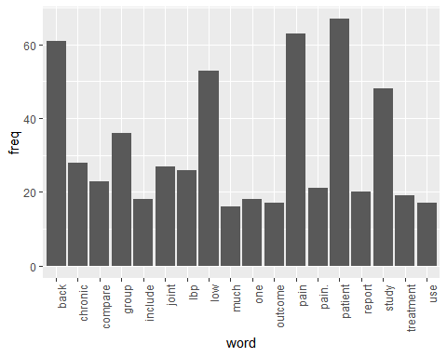

wordcloud(names(freq), freq, min.freq=10,colors=brewer.pal(3,'Dark2'))

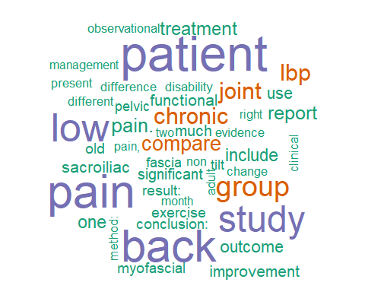

wordcloud(names(freq), freq, max.words=40,colors=brewer.pal(6,'Dark2'))

## Warning in wordcloud(names(freq), freq, max.words = 40, colors =  
## brewer.pal(6, : patient could not be fit on page. It will not be plotted.

