Migraine PubMed

Janis Corona

12/9/2019

## This script takes twenty articles from the abstracts on Migraine articles from NCBI’s PubMed

This creates a directory to stem the abstracts and preprocess from the csv file into a corpus of 10 files in a folder called Migraines.

Auto <- read.csv('migraines_PubMed_abstracts.csv', sep=',',  
 header=TRUE, na.strings=c('',' '))  
colnames(Auto)

## [1] "abstract" "source"

auto <- Auto[complete.cases(Auto$abstract),]  
  
  
dir.create('./Migraines')  
  
ea <- as.character(auto$abstract)  
setwd('./Migraines')  
  
for (j in 1:length(ea)){  
 write(ea[j], paste(paste('EA',j, sep='.'), '.txt', sep=''))  
}  
setwd('../')

This code preprocesses and stems the corpus

library(tm)  
library(SnowballC)  
library(wordcloud)  
library(ggplot2)  
  
migraine <- Corpus(DirSource("Migraines"))  
  
  
migraine

## <<SimpleCorpus>>  
## Metadata: corpus specific: 1, document level (indexed): 0  
## Content: documents: 20

migraine <- tm_map(migraine, removePunctuation)  
migraine <- tm_map(migraine, removeNumbers)  
migraine <- tm_map(migraine, tolower)  
migraine <- tm_map(migraine, removeWords, stopwords("english"))  
migraine <- tm_map(migraine, stripWhitespace)  
migraine <- tm_map(migraine, stemDocument)  
  
dtmmigraine <- DocumentTermMatrix(migraine)  
  
freq <- colSums(as.matrix(dtmmigraine))

This code orders words stemmed by frequency and finds input correlations

FREQ <- data.frame(freq)  
ord <- order(freq, decreasing=TRUE)  
  
freq[head(ord, 25)]

## migrain headach studi treatment preval use disabl   
## 247 159 83 62 61 52 46   
## consult year patient medic diagnosi women report   
## 43 41 41 40 39 36 35   
## criteria particip acut includ among need rate   
## 32 32 30 29 28 28 27   
## sever care health men   
## 26 24 24 22

findAssocs(dtmmigraine, "criteria", corlimit=0.75)

## $criteria  
## onset acetaminophen   
## 0.87 0.81   
## acetaminophencaffeinebutalbit acetylsalicyl   
## 0.81 0.81   
## acidcaffeinebutalbit codein   
## 0.81 0.81   
## consent cycl   
## 0.81 0.81   
## document earli   
## 0.81 0.81   
## enrol formal   
## 0.81 0.81   
## fulfil goal   
## 0.81 0.81   
## head inclusionexclus   
## 0.81 0.81   
## instruct ketorolac   
## 0.81 0.81   
## local mens   
## 0.81 0.81   
## menstrual mrm   
## 0.81 0.81   
## newli newspap   
## 0.81 0.81   
## painfle phase   
## 0.81 0.81   
## plus preliminari   
## 0.81 0.81   
## pretreat protocol   
## 0.81 0.81   
## rag relief   
## 0.81 0.81   
## satisfi seventyf   
## 0.81 0.81   
## sumatriptan thirtynin   
## 0.81 0.81   
## took undiagnos   
## 0.81 0.81   
## via withdrew   
## 0.81 0.81   
## satisfact hour   
## 0.80 0.80   
## respons pain   
## 0.80 0.76   
## advertis versus   
## 0.76 0.76

findAssocs(dtmmigraine, "disabl", corlimit=0.63)

## $disabl  
## model monitor size scale   
## 0.76 0.74 0.74 0.66   
## function measur combin amongst   
## 0.65 0.65 0.65 0.64   
## accept add allianc allow   
## 0.63 0.63 0.63 0.63   
## alon belief dali dimens   
## 0.63 0.63 0.63 0.63   
## disabilityadjust diseaserel ehf environ   
## 0.63 0.63 0.63 0.63   
## european feder full gain   
## 0.63 0.63 0.63 0.63   
## healthi highlight human icf   
## 0.63 0.63 0.63 0.63   
## incomplet joint knowledg launch   
## 0.63 0.63 0.63 0.63   
## lift mortal nonfat organ   
## 0.63 0.63 0.63 0.63   
## overview paramet publichealth relev   
## 0.63 0.63 0.63 0.63   
## role top undertaken wha   
## 0.63 0.63 0.63 0.63   
## whilst whos work ylds   
## 0.63 0.63 0.63 0.63

findAssocs(dtmmigraine, "women", corlimit=0.7)

## $women  
## slight calcul canadian   
## 0.93 0.71 0.71   
## less nineti nonspecif   
## 0.71 0.71 0.71   
## perhap psychosoci seven   
## 0.71 0.71 0.71   
## somewhat standard static   
## 0.71 0.71 0.71   
## substanti triptansdihydroergotamin   
## 0.71 0.71

wf <- data.frame(word=names(freq), freq=freq)  
p <- ggplot(subset(wf, freq>30), aes(word, freq))  
p <- p + geom_bar(stat= 'identity')   
p <- p + theme(axis.text.x=element_text(angle=90, hjust=1))   
p

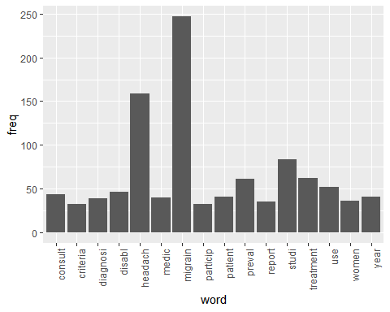

wordcloud(names(freq), freq, min.freq=25,colors=brewer.pal(3,'Dark2'))

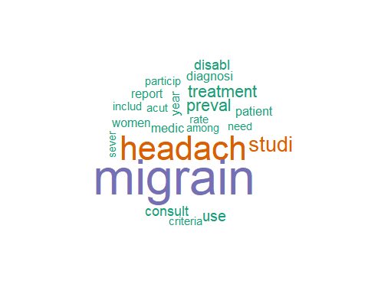

wordcloud(names(freq), freq, max.words=40,colors=brewer.pal(6,'Dark2'))

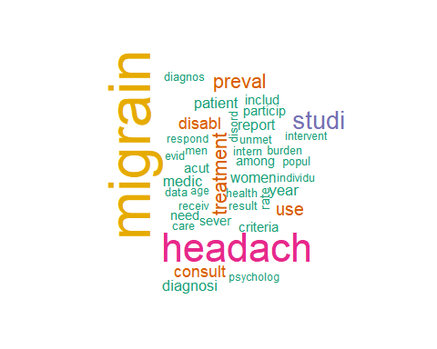

### The above stemmed the corpus, this will lemmatize the original csv file

and add the field to the table and write out to csv, followed by plot the word count frequencies that were lemmatized and the word clouds

library(textstem)  
  
lemma <- lemmatize_strings(auto$abstract, dictionary=lexicon::hash_lemmas)  
  
Lemma <- as.data.frame(lemma)  
Lemma <- cbind(Lemma, auto)  
  
colnames(Lemma) <- c('lemmatizedAbstract','abstract', 'source')  
  
write.csv(Lemma, 'Lemmatizedmigraine.csv', row.names=FALSE)

dir.create('./migraine-Lemma')  
  
ea <- as.character(Lemma$lemmatizedAbstract)  
setwd('./migraine-Lemma')  
  
for (j in 1:length(ea)){  
 write(ea[j], paste(paste('EAL',j, sep='.'), '.txt', sep=''))  
}  
setwd('../')

library(tm)  
library(SnowballC)  
library(wordcloud)  
library(ggplot2)

migraine <- Corpus(DirSource("migraine-Lemma"))  
  
migraine

## <<SimpleCorpus>>  
## Metadata: corpus specific: 1, document level (indexed): 0  
## Content: documents: 20

# this is an NCBI file so there are dashes and numbers in gene names at times  
# that I would like to show, if they are frequent  
# migraine <- tm_map(migraine, removePunctuation)  
# migraine <- tm_map(migraine, removeNumbers)  
  
migraine <- tm_map(migraine, tolower)  
migraine <- tm_map(migraine, removeWords, stopwords("english"))  
migraine <- tm_map(migraine, stripWhitespace)  
  
dtmmigraine <- DocumentTermMatrix(migraine)  
dtmmigraine

## <<DocumentTermMatrix (documents: 20, terms: 1507)>>  
## Non-/sparse entries: 2971/27169  
## Sparsity : 90%  
## Maximal term length: 17  
## Weighting : term frequency (tf)

freq <- colSums(as.matrix(dtmmigraine))  
  
FREQ <- data.frame(freq)  
ord <- order(freq, decreasing=TRUE)  
  
freq[head(ord, 25)]

## migraine headache study prevalence use treatment   
## 209 153 63 56 49 44   
## patient report year much woman disability   
## 39 35 35 32 32 30   
## acute among diagnosis population participant health   
## 30 28 28 27 27 27   
## high relate rate criterion migraine, base   
## 26 26 25 24 24 23   
## consult   
## 23

health <- as.data.frame(findAssocs(dtmmigraine, "health", corlimit=0.6))  
  
criteria <- as.data.frame(findAssocs(dtmmigraine, "criteria", corlimit=0.55))  
  
  
treatment <- as.data.frame(findAssocs(dtmmigraine, "treatment", corlimit=0.55))  
  
health

## health  
## increasingly 0.78  
## model 0.78  
## ie, 0.75  
## necessary 0.74  
## public 0.73  
## care 0.72  
## non 0.70  
## global 0.66  
## barrier 0.65  
## demographic, 0.65  
## socioeconomic, 0.65  
## step 0.65  
## attributable 0.64  
## quarter 0.64  
## state 0.64  
## publish 0.64  
## 1.14 0.64  
## care. 0.64  
## consult, 0.64  
## consult. 0.64  
## insurance 0.64  
## rate, 0.64  
## successfully 0.64  
## appropriate 0.63  
## currently 0.63  
## cause 0.61

criteria

## [1] criteria  
## <0 rows> (or 0-length row.names)

treatment

## treatment  
## acute 0.81  
## relate 0.78  
## assessment 0.77  
## moderate 0.75  
## background: 0.71  
## identify 0.70  
## less 0.70  
## current 0.69  
## american 0.68  
## prevention 0.68  
## use 0.67  
## opioid 0.66  
## 2009 0.62  
## respondent 0.62  
## treatment, 0.62  
## medication 0.61  
## per 0.61  
## therapy. 0.60  
## meet 0.59  
## frequency 0.59  
## sample 0.59  
## conclusion: 0.58  
## result: 0.58  
## episodic 0.58  
## objective: 0.58  
## method: 0.57  
## much 0.57  
## category 0.57  
## opportunity 0.57  
## anti 0.57  
## inflammatory 0.57  
## recruit 0.57  
## 38. 0.57  
## beta 0.57  
## contrast 0.57  
## drug 0.57  
## longitudinal, 0.57  
## management, 0.57

wf <- data.frame(word=names(freq), freq=freq)  
p <- ggplot(subset(wf, freq>25), aes(word, freq))  
p <- p + geom_bar(stat= 'identity')   
p <- p + theme(axis.text.x=element_text(angle=90, hjust=1))   
p

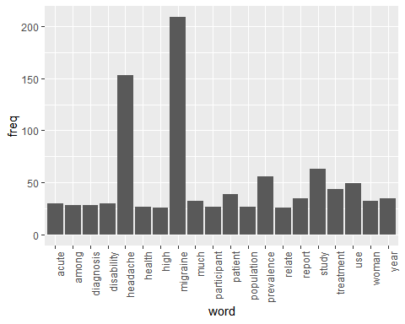

wordcloud(names(freq), freq, min.freq=25,colors=brewer.pal(3,'Dark2'))

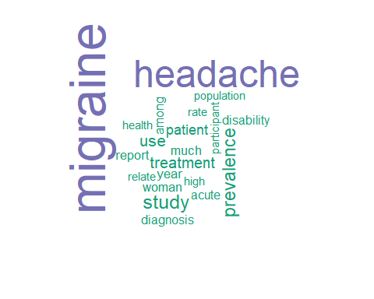

wordcloud(names(freq), freq, max.words=40,colors=brewer.pal(6,'Dark2'))

