|  |  |  |  |  |  |
| --- | --- | --- | --- | --- | --- |
| CONSUMER INFORMATION INDICATOR, CII | | | | | |
| Ch7  petition | **A** | CH 7  DISCHARGED | **E** | CH 7  DISMISSED | **I** |
| Ch11 petition | **B** | CH 11  DISCHARGED | **F** | CH 11  DISMISSED | **J** |
| Ch12 petition | **C** | CH 12  DISCHARGED | **G** | CH 12  DISMISSED | **K** |
| Ch13 petition | **D** | CH 13  DISCHARGED | **H** | CH 13  DISMISSED | **L** |
| **1A** | PERSONAL  RECEIVERSHIP  DEBT  REPAYMENT,WI | **R** | REAFFIRMATION OF  DEBT | **V** | RESCIND  REAFFIRMATION  OF  DEBT |
| **2A** | LEASE  ASSUMPTION  USE OF (AUTO)  PROPERTY  MAKES PAYMENTS | **T** | CANNOT FIND CONSUMER, THE CREDIT GRANTOR CAN’T | **U** | CONSUMER NOW LOCATED |

|  |  |
| --- | --- |
| CONSUMER INFORMATION INDICATOR REMOVAL CODES | |
| **Q** | REMOVES BANKRUPTCY CODES A-P, Z, 1A |
| **S** | REMOVES … R, V, 2A |
| **U** | REMOVES … T, CONSUMER LOCATED |

ECOA Codes:

|  |  |  |  |
| --- | --- | --- | --- |
| **1** | INDIVIDUAL | **T** | TERMINATED |
| **2** | JOINT CONTRACT | **X** | DECEASED |
| **3** | AUTHORIZED USER | **W** | BUSINESS/COMMERCIAL |
| **5** | COMAKER/GUARANTOR | **Z** | DELETE CONSUMER FROM ACCOUNT  (INACCURACIES) |
| **7** | MAKER |  | |

|  |  |
| --- | --- |
| ACCOUNT STATUS CODES | |
| **05** | ACCOUNT TRANSFERRED, REPORT LAST ACCOUNT STATUS W/ CO. |
| **11** | Current account |
| **13** | Paid or closed account zero balance |
| **61** | Paid in full, voluntary surrender |
| **62** | Paid in full, collection account |
| **63** | Paid in full, repossession |
| **64** | Paid in full, charge-off |
| **65** | Paid in full, foreclosure |
| **71** | 30-59 days past due, dpd |
| **78** | 60-89 dpd |
| **80** | 90-119 dpd |
| **82** | 120-149 dpd |
| **83** | 150-179 dpd |
| **84** | 180 dpd |
| **88** | Claim filed with gov for insurance portion of balance on defaulted loan |
| **93** | Assigned to internal or external collections |
| **94** | Foreclosure completed, may have a balance due |
| **95** | Voluntary surrender, may have a balance due |
| **96** | Merchandise repossessed |
| **97** | Unpaid balance reported |
| **DA** | Delete entire account, not fraud |
| **DF** | Delete entire account, investigated and confirmed fraud |

|  |  |
| --- | --- |
| Type of Account | |
| **O** | Open (30, 60, 90 dpd) |
| **R** | Revolving |
| **I** | Installment |
| **M** | Mortgage |
| **C** | Line of Credit |

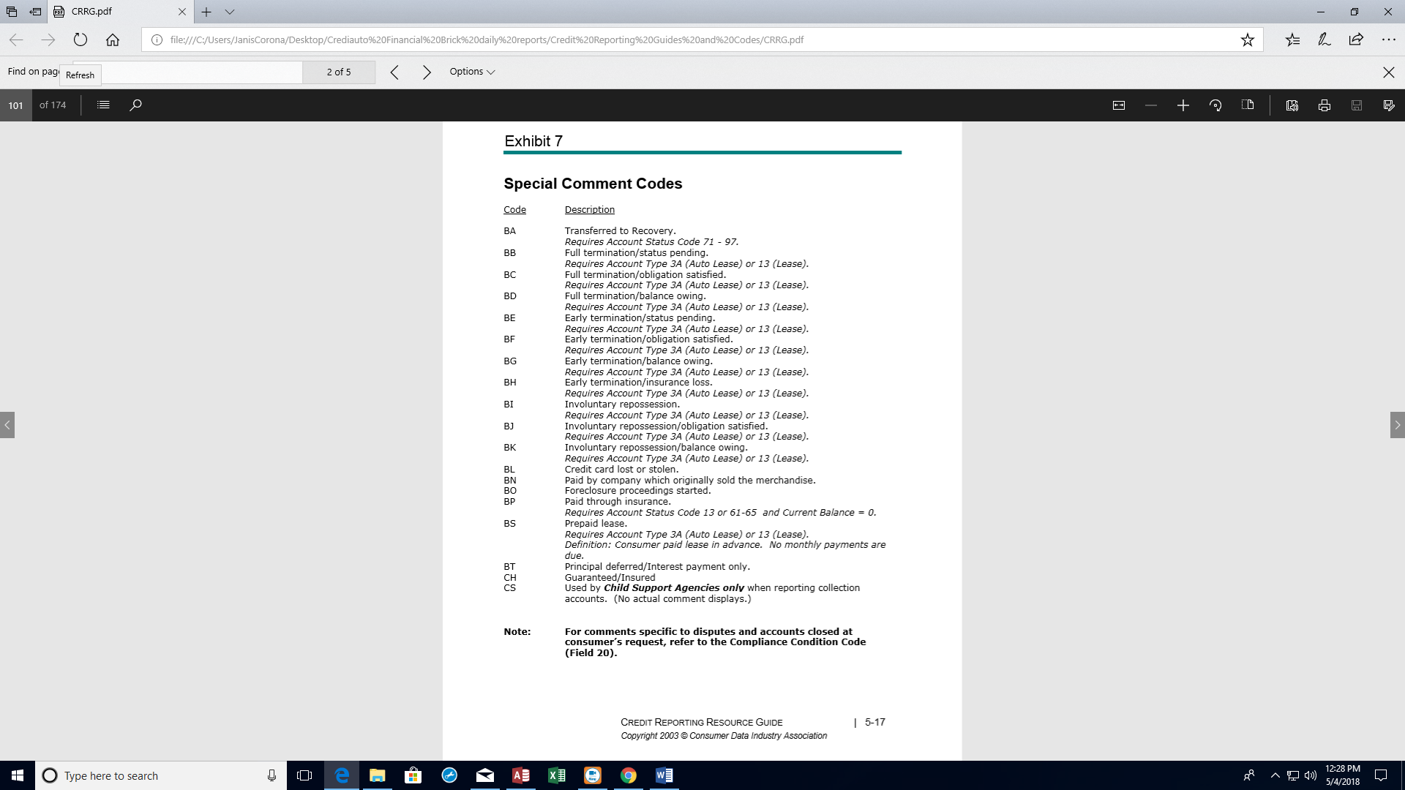

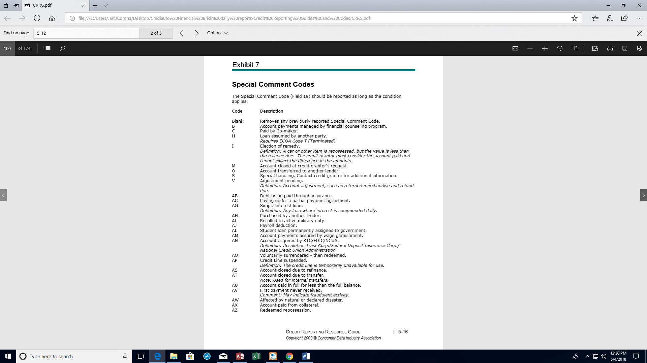

|  |  |
| --- | --- |
| Payment History Profile Rating, PHP | |
| **B** | No payment history |
| **D** | None available for history |
| **G** | Collection |
| **0** | Current |
| **1** | 30-59 dpd (days past due) |
| **2** | 60-89 dpd |
| **3** | 90-119 dpd |
| **4** | 120-149 dpd |
| **5** | 150-179 dpd |
| **6** | 180+ dpd |
| **L** | Charge-Off |

|  |  |
| --- | --- |
| Compliance Condition Codes (CCCs) | |
| **XA**, ie: credit card closed by consumer | Consumer Requested Closed Out |
| **XB**, remove once investigation complete | Consumer dispute to Data Furnisher who is still investigating the dispute, FCRA/FDCPA |
| **XF**, remove once investigation complete | FCBA version of XB |
| **XC** | FCRA, investigation completed with consumer in disagreement |
| **XH** | FCRA, FCBA, FDCPA investigation completed by data furnisher |
| **XD** | Account closed by consumer who disagrees with data furnisher’s investigation of dispute, FCRA investigating |
| **XE** | Same as XD, but for FCRA and FCBA |
| **XJ** | Same as XD, but for FCBA |
| **XR** | CCC removal code of previous CCC |
| Report CCC one time only if applicable as subsequent months retain previous CCC  Do not use XR as default CCC, if not applicable then blank fill | |

|  |  |  |  |
| --- | --- | --- | --- |
| Address Indicators | | | |
| **C** | Confirmed, only report one time the month confirmed | **Y** | Known as consumers address |
| **N** | Not confirmed | **M** | Military address |
| **S** | Secondary Address | **B** | Business address |
| **U** | Non-deliverable address, returned mail | **D** | Data reporter’s default address |
| **P** | Bill Payer Service, not consumer’s residence | | |

Variable Fields **or** Fixed Fields

Report segment name with blank filled

Ignore fields that don’t apply

Header (**Field 2**)

HEADER – Identifies the record

Cycle Identifier (**Field 3**)

Contains the cycle number for the information being reported

Header Program Identifiers

Unique ID assigned each CRA (Consumer Reporting Agency)

Header Dates

Activity Date **(Field 8**)

Date of most recent update to account, ex: 01292017

Date Created (**Field 9)**

Date file was created, ex: 01302017

Program Date (**Field 10**)

Date your reporting format was developed, ex:11232001

Program Revision Date (**Field 11**)

Last date your reporting format was revised, ex.: 10152008

Reporter Information

Reporter Name (**Field 12**)

Name of Company or data process sending CRA the file

Reporter Address (**Field 13**)

Complete mailing address of reporter

Reporter Telephone number (**Field 14)**

The reporter’s phone number

Header Software Information

Software Vendor Name (**Field 15**)

Used to identify the software vendor if you have purchased your credit reporting software from another source

Software Version Number (**Field 16**)

The version number of the software purchased

**Trailer Record**

Record Identifier (**Field 2**)

A constant of the TRAILER used to identify the record

Counters for:

Base records and block count

Status codes

ECOA code Z (delete borrower)

Appendage segments

Social Security Numbers

Dates of Birth

Telephone Numbers

**Base Segment Account-level fields**

Date of Account Information (**Field 24**)

As of the date being reported, with all other information reported for the account the same

Report the date transferred for Account Status 05

Report the date paid for Account Status codes 13 or 61-65, unless closed due to inactivity

Bankruptcy(BK) should contain a date in this month’s billing cycle, not filing date

Identification Number **(Field 5)**

Unique ID of data furnisher

ID each branch office where information verified

Remains the same month to month

At least 5 digits long without embedded blanks or special characters

Cycle Identifier (**Field 6**)

Required if reporting by cycles

Contains the internal cycle for this account

Blank fill if not applicable

Consumer Account Number (**Field 7**)

The consumers complete and unique account number

Do not have the SSN of consumer in any account number

Portfolio Type (**Field 8**)

The one-character abbreviation for type of portfolio values available

I – Installment (auto, education loans)

R – Revolving (credit, debit, flexible credit card)

M – Mortgage (FHA, VA)

O – Open (credit card, collection)

C – Line of Credit (Home equity, debit)

Account Type (**Field 9)**

Identifies account classification

Use only the account type codes of Metro 2 format

Date Opened (**Field 10)**

Date account originally opened, remains constant over time

If reporting returned checks with FCRA(Fair Credit Reporting Agency)

Report date of the check in this field

Credit Limit (**Field 11)**

Credit limit assigned to

Line of Credit (C) accounts

Revolving (R ) accounts

Open (O) when applicable

For closed accounts, report last assigned credit limit

Highest Credit Limit or Original Loan Amount (**Field 12**)

For Line of Credit, Open, and Revolving accounts:

Highest amount of credit utilized by consumer

For installment and mortgage accounts:

Original amount of loan, don’t include interest

For FCRA reporting of returned checks

Report amount of the check in whole without fees

Report both credit limit and highest credit for the following accounts:

Revolving

Line of Credit

Open (if applicable)

Terms Duration (**Field 13**)

Duration of credit extended

Installment (months)

Mortgage (years)

Revolving (REV)

Line of Credit (LOC)

Open (001)

**Terms Frequency** (**Field 14**)

Contains the frequency of payments due with the following values:

|  |  |  |  |
| --- | --- | --- | --- |
| **D** | Deferred payment start date | **W** | Weekly |
| **E** | Semi-monthly | **L** | Bi-monthly |
| **T** | Tri-annually | **Y** | Annually |
| **P** | Single Payment loan | **B** | Bi-weekly |
| **M** | Monthly | **Q** | Quarterly |
| **S** | Semi-annually |  | |

Scheduled monthly Payment Amount **(Field 15**)

Report dollar amount of the scheduled monthly payment due for the current reporting period

Zero fill when account paid in full

Regardless of terms frequency value, the Terms Duration is months for a loan, and the

Scheduled monthly payment amount is the monthly amount

Scheduled Monthly Payment Amount:

|  |  |
| --- | --- |
| I | Requires monthly payment amount |
| R |  |
| C | Minimum amount due based on balance, don’t include past due amounts |
| M | Principal, interest, and escrow for current reporting period |
| O | Zero fill because entire amount due upon demand |

Actual Payment Amount (**Field 16)**

The dollar amount of the monthly payment received for this reporting period

If multiple payments received, then report the total of all payments for the month

**Account Status Codes** (**Field 17A**)

The current condition of account as of the current date of account information

If account has a balance with payments made, report balance as declining with

Payments received

When paid in full, report with appropriate status code, i.e.: 61,62,63,64, and 65

Don’t stop reporting balance until the account is paid in full, 13 or 61-65

Transferred Account, status code 05, report status at time of transfer or sold with

The special comment code associated with the transferred account

Deleted accounts, DF and DA status codes

These codes delete the account and all associated borrowers

DF-due to fraud

DA-reasons other than fraud

Paid collections report as PAID, not deleted

Only inaccurately reported accounts can be deleted

**Payment Rating** **(Field 17B**)

Used with Account Status Code to identify whether an account is current, past due, in collections, or charged-off prior to the status and in the activity period being reported

Required for status codes 05, 13, 65, 88, 89, 94, and 95

Blank fill all payment rating fields for other account status codes

If payment rating unknown, then blank fill

Note: Do not report payment rating, if it is not applicable.

Don’t use zero as a default value

**Payment History Profile (PHP**) (**Field 18)**

Up to 24-month consecutive payment activity with 1st leading entry the current reporting month

Values available:

Current (0)

30-180 dpd (1:6)

Collection (G)

Foreclosure

Voluntary Surrender

Repossession

Charge-Off (L)

PHP, B vs. D reporting

B – No payment history this month, not embedded in between other values

Ex: GG654321000BBBBBBBBBBBBB

D - …, ok to embed in-between other values

Ex: GGDDD43210000BBBBBBBBBBB

**Special comment Field** (**Field 19**)

Fully defines status of the account used with account status and payment rating

Report each month as long as it applies

Blank fill if not applicable

If >1, then use the most important special comment code

See exhibits 6 and 7 of CRRG (Credit Reporting Resource Guide)

**Compliance Condition Codes (CCC)**

Allows for reporting of condition required for your legal compliance

Accounts closed at consumer’s request

Accounts in dispute under FCBA, Fair Credit Billing Act

Accounts in dispute with FDCPA, Fair Debt Collection Practices Act

Accounts in dispute with direct dispute provisions of the FCRA, Fair Credit Reporting Act

Codes:

XB

XF

XC

XG

XH

XD

XE

XJ

Codes replaced with other codes when complete

Removal Codes

XR

Don’t use XR as default

Report one time only as condition applies, CCC retained until a new one occurs

Note: Special Comment and Compliance Condition Code

Two comments may be reported the same reporting period

Ex.: Special Comment Code M ( acct closed by consumer) and CCC=XB

Reporting the account, the following accounts are used together to clearly

Describe the status of the account:

Account Status

Payment Rating

Payment History Profile

Special Comment

Compliance Condition Code

Current Balance (**Field 21)**

Contains the total current balance owed on the account as of the Date of Account Information

Include:

Principal balance, including balloon payment amount

Other amounts:

Interest

Late charges

Fees

Insurance Payments

Escrow

Mortgages

Current balance reported in whole dollars, not rounded but truncated

Credit balances reported as zero

Do not include

Future interest

Escrow fees

Insurance payments

Amount Past Due (**Field 22)**

The total amount in whole dollars that is 30 days or more past due

Includes late charges and fees

Zero when account is current (status code 11)

Original Charge-Off Amount (**Field 23**)

Original amount charged to loss regardless of declining balance

Reported for Account Status codes:

64 – Account paid in full (Charge-Off)

97 – Unpaid balance reported as loss by credit grantor (Charge-Off)

FCRA Compliance/**Date of First Delinquency (DOFD)**

Used to ensure compliance with FCRA

The date of the first delinquency leading to the status being reported

Heirarchy of DOFD:

DOFD determined by hierarchy

If none in hierarchy apply, then zero fill but not required

Three parts of the Heirarchy for DOFD:

1. Account Status Code (if none, go to 2.)

71,78,80,82,83,84 (delinquent)

88,89,93,94,95,96,97 (derogatory)

61-65 (paid, was derogatory)

1. Payment Ratings (if none, go to 3.)

1-6 (delinquency)

G (collection)

L (Charge-Off)

1. Current Account with Bankruptcy or Reaffirmation Indicator

Date of BK or personal receivership petition if account current and not 1. Or 2.

Payment rating 0 with account status 11,05,13

If none of 1., 2., or 3. Apply, then zero fill-in DOFD field.

Note: if sold or transferred, then DOFD at time of delinquency for FCRA compliance must be provided to that Company who bought the account

Date Closed (**Field 26**)

Date account closed, paid in full, or sold

For open or revolving accounts there may be a balance due

Date of Last Payment **(Field 27**)

Contains the date the most recent payment was received, whether full or partial payment is made

Include Date payment received

Directly from consumer

Or other sources, ie: sale or insurance payment

Interest Type Indicator (**Field 28)**

Designates the interest type:

F = Fixed

V = Variable/adjustable

Report indicator ‘V’ for loans where the interest rate will be variable at some point,

Even if the interest rate starts as fixed

Blank fill if not available

Consumer Identification

Consumer Name Fields

Surname (hyphenate two last names)

First Name (hyphenate two first names)

Middle Name

Generation Code (J,S,2,3,4,…)

Do not report

Special characters

Title

Suffixes

Internal messages

Estates / trusts

Messages, such as

‘parent of’ or ‘baby’

Social Security Number (SSN)

Consumer SSN

If unavailable, zero or 9 fill-in all entries, **and** report the DOB(Date of Birth)

No foreign numbers

No tax IDs

No territory IDs

No duplicate SSNs for couples

No fictitious SSNs

Do not report minors’ SSNs

Date of Birth (DOB)

DOB of consumer

If unavailable, zero or 9 fill-in entire field

If no DOB, then SSN must be reported

Do not report minors’ SSNs

Telephone Number

Area Code and 7 digits

**ECOA Code**

Equal Credit Opportunity Act

Defines relationship of consumer to the account

Metro 2 has separate ECOA codes for each consumer on account in:

Base field

J1 and J2 fields

If ECOA code changes, report new ECOA code

Ex:

1:base,

2:base/J1/j2,

3:J1/J2,

5: J1/J2,

7:Base (J1/J2 if >1 maker on account)

Note: Full DOB (MMDDYYYY) must be reported for all new adds of authorized users on all pre-existing and newly opened accounts

ECOA = T (Terminated)

Consumer no longer associated with account

Payment history prior to termination still applies

Do not report this consumer on subsequent updates

ECOA = X (Deceased)

Consumer deceased

Report only on consumer who is deceased

Do not report on consumer on subsequent updates

X helps deter fraudulent activity

ECOA = Z (Delete Consumer)

The entire account is deleted for this consumer

Only report ECOA Z if the consumer was reported in error

Do not stop reporting the consumer, report for consumers

Sent in error

Deleting Inaccurate Information

Z – deletes associated borrower from account

DA – deletes entire account and its associated borrowers

ECOA T, X, Z

Each has a specific purpose, not interchangeable

ECOA W (business/commercial)

Base segment: Consumer name with ECOA code (personally liable)

J2 Segment: Business name with W

**Consumer Information Indicator (CII)**

Contains a value indicating a special condition that applies only to the consumer

Being reported

Separate CII field for each consumer reported on an account (primary and associated borrower)

Three categories:

1. Bankruptcy
   1. Petition A,B,C,D
   2. Discharged E,F,G,H
   3. Dismissed I,J,K,L
   4. Personal Receivership 1A (WI ch128)
2. Reaffirmation of Debt
   1. Consumer reaffirms debt via BK court, R (makes payments)
   2. Reaffirmation of debt rescinded, V
   3. Leases Assumption (keeps property w/ payments), 2A
3. Cannot locate consumer
   1. Credit Grantor cannot locate consumer, T
   2. Consumer now located, U

Report each ECOA code for each borrower in appropriate field as each applies separately to each borrower

Removal Codes for CII:

Each category has its own removal code:

Q – Removes BK A-P, Z, or 1A

S – Removes Reaffirmation of debt R, reaffirmation rescinded V, or lease assumption 2A

U – Consumer now located (Removes indicator T)

Note: if a CII doesn’t apply, then blank fill the field, don’t use a removal code as default report the code only one time as it applies, retaining the previous code each month

CIIs can be reported every month as an option only when it applies

Country Code

Standard two character country code abbreviation

If consumer has two addresses, then use the US address if used, otherwise use the foreign address

Address Guidelines:

Report the complete address on all records

May prevent processing by CRA if not given accurately

First Line of Address

The consumer’s first line of billing/mailing address, ie: 111 Main St.

Second Line of Address

Additional if needed, ie: suite #102, apt#100

Do not report messages, ie: ‘Do not mail,’ attorney, charge-off, chapter 13, fraud, C/O,…

City Field

City name of consumer

State field

USPS standard abbreviation for consumer state address

Postal/Zip Code

Consumer’s zip code

Address Indicator

Choose one of the following for consumers address or blank fill the field if unknown

C – confirmed

Y – known as consumer’s address

N – Not confirmed

M – Military address

S – Secondary address

B – Business address

U – non-deliverable address, returned mail

D – data reporter’s default address

P – bill payer service, not consumer’s residence

Note: The Fact Act for data furnishers 2010 requires that if a substantial address discrepancy exists between the address of inquiry and the address on file that the requestor of the credit report be notified

Final rules require that users develop and implement reasonable policies and procedures for furnishing an address for the consumer that the user has reasonably confirmed as accurate

Residence Code

The one-character residence code of consumer’s address

0 = owns

R = Rents