Wisconsin Breast Cancer - Data Mining a Malignant Classification

Janis Corona
Corona, USA janislcorona@lewisu.edu
Shirley Vu
Santa Clara, USA
shirleyvu@lewisu.edu

Abstract— In this report, the supervised machine learning algorithms explored in week 5 of CPSC 51000, 70510, were used to classify the diagnosis of a breast cancer needle biopsy from the 30 digital image characteristics of the nuclei as either malignant or benign. The use of Random Forests, decision tree, Naïve Bayes, and Ada Boost algorithms in the widgets of Orange data mining software as well as the J48, Random Forest and Random Tree packages of Weka data mining software gave high accuracy results in correctly classifying the biopsy instances.

Objective
This report explores the efficacy of multiple supervised machine learning algorithms in classifying the breast cancer biopsies as malignant or benign. The software used for this analysis is Orange Canvas Data Mining software version 3.6 and Weka software for Random Forests and decision tree classifications.

the data

The Original UCI Dataset
The dataset on which this report is based is originally from [1] the University of Irvine Machine Learning Repository: https://archive.ics.uci.edu/ml/machine-learning-databases/breast-cancer-wisconsin/breast-cancer-wisconsin.data
This dataset was produced by Dr. William H. Wolberg from January 1989 through November 1991 while working at the University of Wisconsin Hospitals, Madison, Wisconsin USA. The data is comma delimited for 699 biopsies or instances, each with values for the following 11 attributes:
- ID number
- Clump Thickness (1-10)
- Uniformity of Cell Size (1-10)
- Uniformity of Cell Shape (1-10)
- Marginal Adhesion (1-10)
- Single Epithelial Cell Size (1-10)
- Bare Nuclei (1-10)
- Bland Chromatin (1-10)
- Normal Nucleoli (1-10)
- Mitoses (1-10)
- Class (2 for benign, 4 for malignant)

The Kaggle Dataset
[2] The Kaggle version of the dataset of 11 original attributes retains two of the attributes, ID number and Class, however the Class attribute has been renamed to “Diagnosis” and the label has been changed from 4 to “M” for Malignant, and from 2 to “B” for benign. In addition, the digital images of the fine needle aspirates of the breast mass biopsies were used to calculate the following 10 features for each instance:
- Radius
- Texture
- Perimeter
- Area
- Smoothness
- Compactness
- Concavity
- Concave Points
- Symmetry
- Fractal Dimension
The standard error and worst value (the mean of the three largest values in each category) were also calculated for each feature, which produced 30 total attributes for each instance. In total, the final dataset contains 569 instances with 32 attributes, with 357 benign and 212 malignant diagnoses. The numeric real values of the 30 attributes other than ID and class are most likely in digital pixels per inch, however this is not disclosed. There is no missing data, as the original data was cleaned by Kaggle and made available for members to download. See Figure 1 for a sample of the dataset.
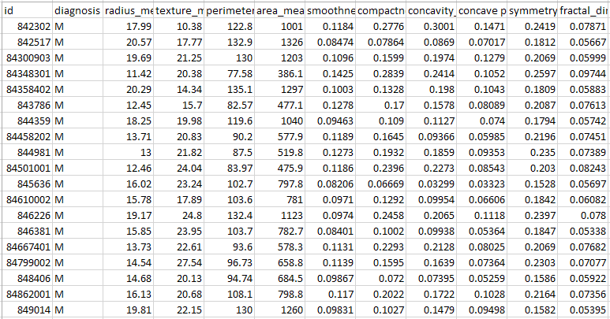
Figure 1: A screenshot of the dataset viewed in Excel.

Data mining preparation

Data Preparation
The data set in comma separated file format was first uploaded into [3] Orange and [4] Weka. The target attribute was set to diagnosis. See Figure 2a and Figure 2b for screen shots of data loaded into each program.
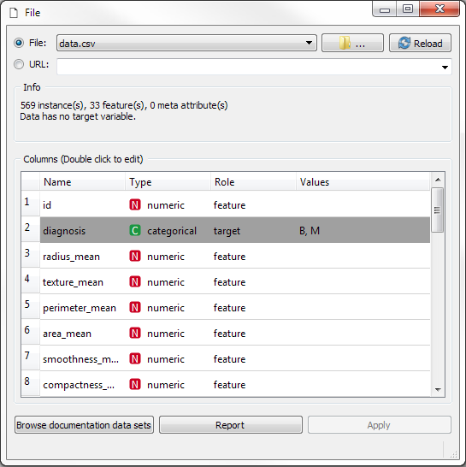
Figure 2a: The file upload window in Orange data mining software in which diagnosis is set as target.

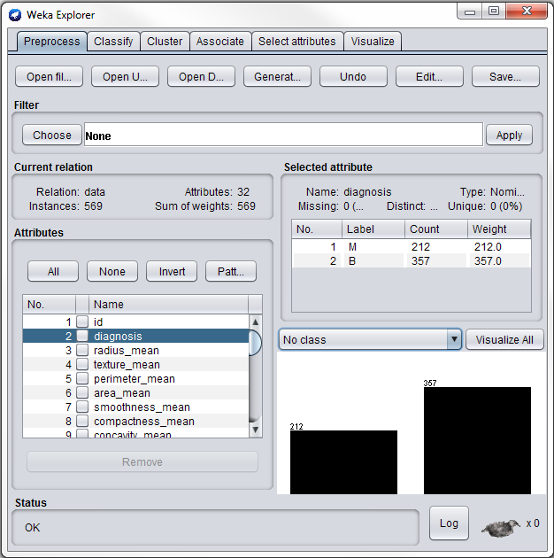
Figure 2b: The file upload window in Weka showing data summary.

Orange data mining for decision trees, random forests, AdaBoost, and Naïve Bayes
In Orange data mining software, the data file was linked to the widgets for Tree, Random Forest, AdaBoost, and Naïve Bayes. Each were then linked, in addition to the original dataset, to the Test & Score widget to calculate each predictive model’s performance using 10-fold cross validation stratified and averaged over classes. See Figure 3a for a screen shot of the Orange data mining workflow.

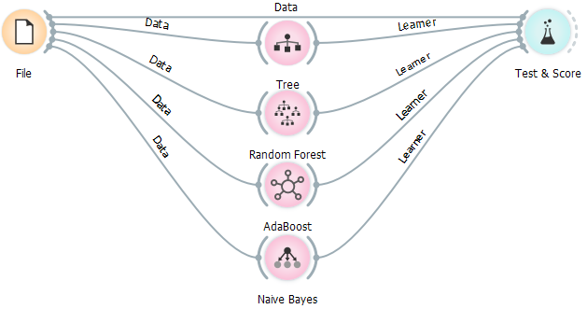
Figure 3a. Decision Tree, Random Forest, AdaBoost, and Naïve Bayes fed into the Test & Score widget in Orange data mining software.

Weka data mining for J48 Decision Tree, RandomTree and RandomForest
In Weka, the same file was uploaded and run through J48, RandomTree, and RandomForest with cross validation of 10 folds. There was also a tree view for the J48 decision tree model and the RandomTree model, but not for the Random Forest model.
The [5] J48 Decision Tree is a classifier that is created by J. Ross Quinlan and written in a document that Weka cited in the parameter setting box when choosing the ‘more’ option, authored by Steven S. Salzberg. This classifier uses the C4.5 classifier algorithm, that will classify each tree branch by attribute, and prune according to rules that satisfy each result for a node of a branch, until the prediction for the target attribute is attained, in our case for biopsy diagnosis as M for malignant or B for Benign.
The [6] Random Tree decision tree classifier is used in Weka, and is described as a decision tree classifier that uses no pruning but k randomly chosen attributes at each node, and a set of estimated probabilities for each classified attribute based on back-fitting, or a hold-out set.
The [7] Random Forest algorithm is from a document written by Leo Brieman, and explains in 33 pages of a pdf format how Random Forest works. This algorithm is based on the Law of Large Numbers, does not overfit, and citing the abstract section of Brieman’s paper is an algorithm with little noise when comparing its robustness to other algorithms like Ada Boost. “Random forests are a combination of tree predictors such that each tree depends on the values of a random vector sampled independently and with the same distribution for all trees in the forest. The generalization error for forests converges as. to a limit as the number of trees in the forest becomes large. The generalization error of a forest of tree classifiers depends on the strength of the individual trees in the forest and the correlation between them.”

results
After the text edit has been completed, the paper is ready for the template. Duplicate the template file by using the Save As command, and use the naming convention prescribed by your conference for the name of your paper. In this newly created file, highlight all of the contents and import your prepared text file. You are now ready to style your paper; use the scroll down window on the left of the MS Word Formatting toolbar.

Orange to Test and Score the Tree, Random Forest, AdaBoost, and Naïve Bayes
The Test and Score widget with cross validation of 10 folds, stratified and averaged over classes calculated high accuracy of over 92%, as well as high precision and recall values both above 90% for all algorithms. The RandomForest algorithm was most successful with a classification accuracy of 96%. See Figure 3b for a screen shot of the results.
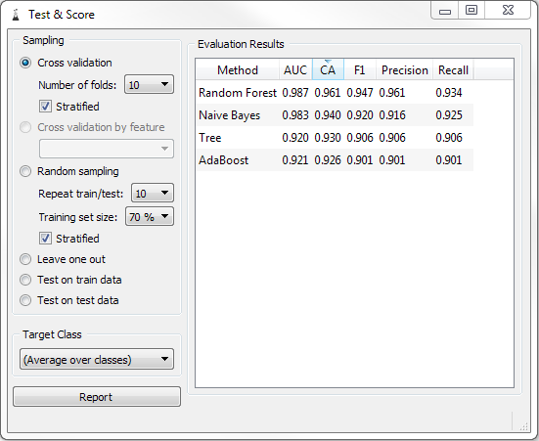

Figure 3b: Results of the Test and Score analysis of the Tree, Random Forest, AdaBoost, and Naïve Bayes algorithms in Orange data mining software.

Weka results on J48, Random Tree and Random Forest Trees
The J48 package in the Trees classifier of Weka produced a listed tree view of the J48 Decision Tree, as well as an accuracy of 92.97% using cross validation with 10 folds. See Figure 4a, Figure 4b, and Figure 4c for a screen shot of the decision tree in results, the Decision Tree view diagram, and the accuracy results.

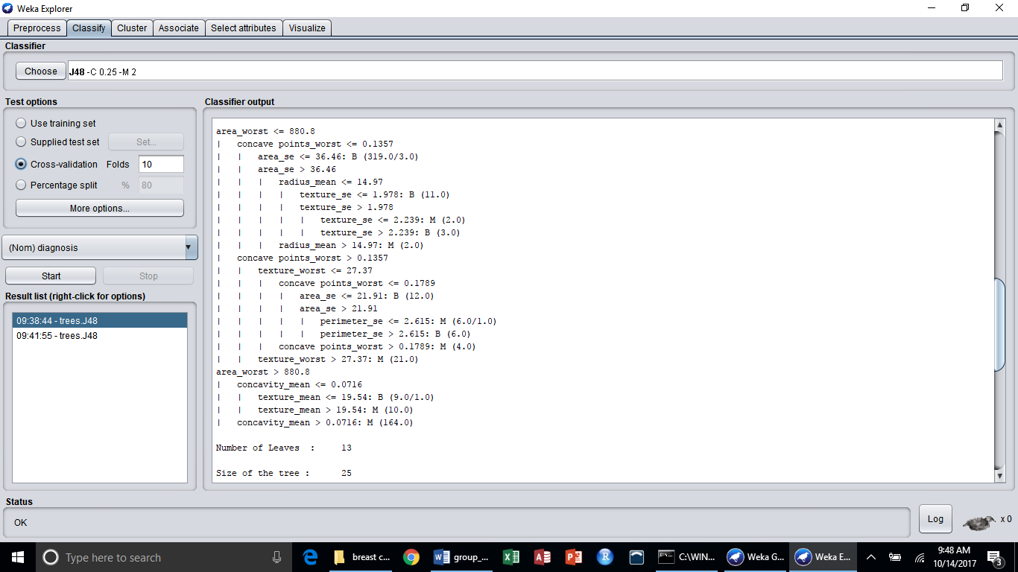
Figure 4a: J48 Decision Tree with 13 leaves and tree size of 25.

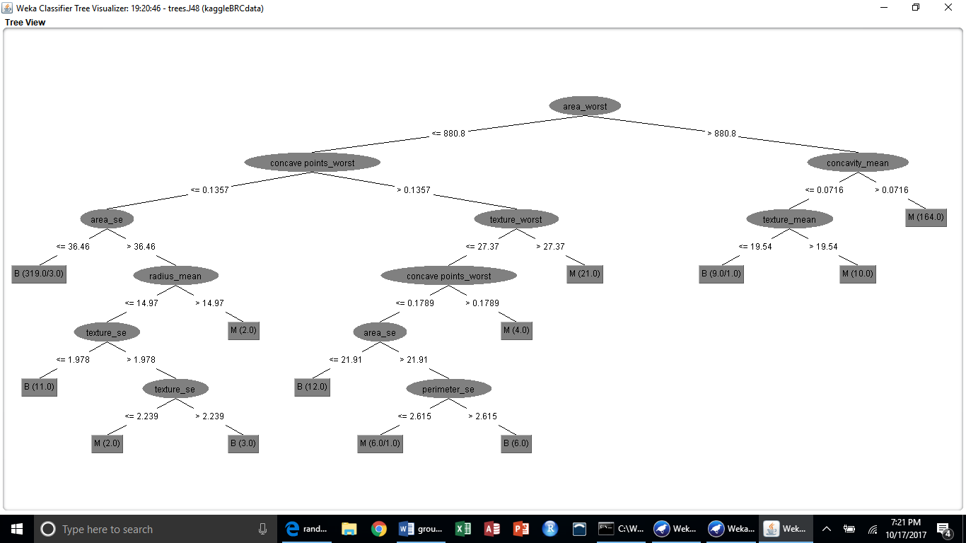
Figure 4b. J48 Decision Tree view in Weka using the visualize tree option when right clicking the result list for J48 in lower left corner window, as seen in Figure 4c below.

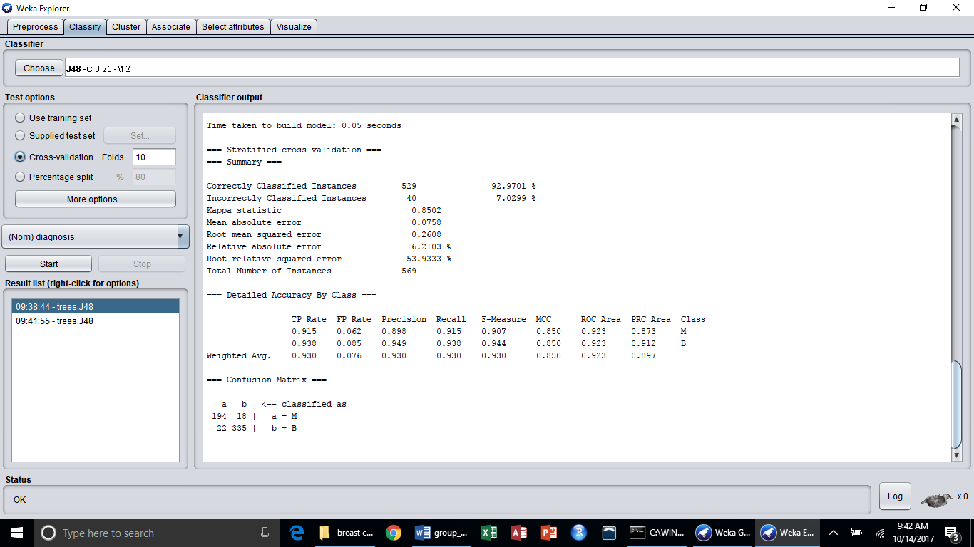
Figure 4c: J48 Decision Tree results in Weka data mining software.
The RandomTree algorithm correctly classified 91.74%, and incorrectly classified 8.26% of the biopsy diagnoses. See Figure 5 for the screen shot of the results with the RandomTree tree classifier.

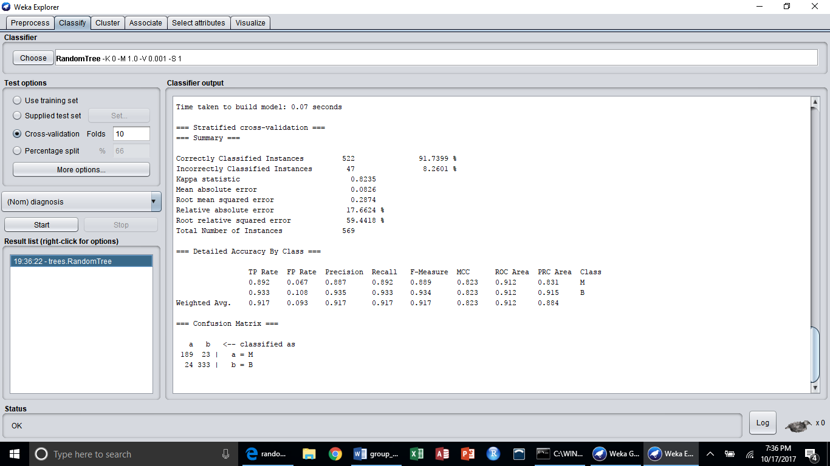
Figure 5: Results from the “RandomTree” classifier in Weka data mining software

The RandomForest classifier correctly classified 95.96% of the instances with 4.04% incorrectly classified. See Figure 6 for the screen shot of the results in Weka with the RandomForest tree classifier.

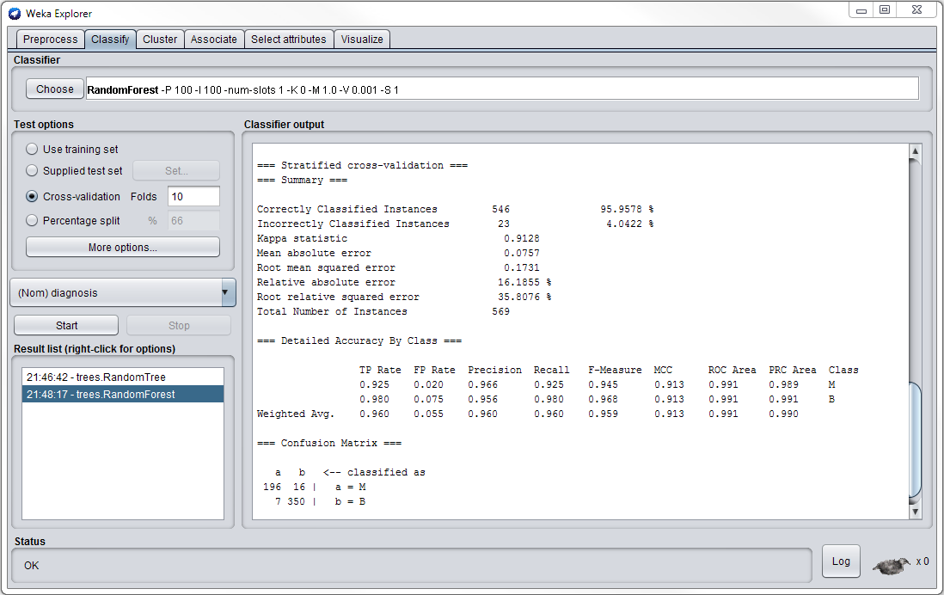
Figure 6: Results from the RandomForest tree classifier in Weka data mining software.

Conclusion
This report utilized data mining techniques and machine learning algorithms to analyze 569 data instances of breast cancer data, providing support for and displaying the utility of supervised machine learning methods and their potential to classify breast cancer biopsies as malignant or benign. This project as a group effort was helpful for practicing data mining techniques and understanding multiple supervised machine learning decision tree classifier algorithms

References

- University of Wisconsin Hospitals, Madison from Dr. William H. Wolberg, 15 July 1992. https://archive.ics.uci.edu/ml/machine-learning-databases/breast-cancer-wisconsin/breast-cancer-wisconsin.data
- K. P. Bennett and O. L. Mangasarian: "Robust Linear Programming Discrimination of Two Linearly Inseparable Sets", Optimization Methods and Software1, 1992, 23-34 https://www.kaggle.com/uciml/breast-cancer-wisconsin-data
- Orange data mining software for running classification algorithms, 12 October 2017, https://orange.biolab.si/download/files/Orange3-3.6.0-Python34-win32.exe
- Weka software for running classification algorithms, 12 October 2017, http://prdownloads.sourceforge.net/weka/weka-3-8-1jre-x64.exe.
- Salzberg, S.L. Mach Learn (1994) 16: 235. https://doi.org/10.1007/BF00993309
- Weka, information, Synopsis on Weka.classifiers.trees.RandomTree
- Leo Brieman, University of California Berkeley Statistics Department, Random Forests, Jan 2001, https://www.stat.berkeley.edu/~breiman/randomforest2001.pdf

