Market Basket of Hand Picked Stocks

Janis Corona

2/15/2020

I used yahoo finance at finance.yahoo.com to grab a list of stocks I wanted to examine over time.

This is a youtube tutorial on quant finance from ’Quant Finance with R Part 1 intro and Data": [This tutorial link](https://www.youtube.com/watch?v=uwuPQUa2TjI).

The [github repository](https://github.com/fdupuis659/Quant-Finance-with-R) for these tutorials are at: <https://github.com/fdupuis659/Quant-Finance-with-R>

library(quantmod)  
library(PerformanceAnalytics)

HandStocks <- read.csv('yahooStockBasket.csv', header=TRUE, sep=',',   
 na.strings=c('',' '))  
allStocks <- as.character(HandStocks$stock)

tickers <- allStocks  
  
weights <- rep(1/length(tickers), length(tickers))  
  
All_portfolioPrices <- NULL  
  
for (ticker in tickers){  
 All_portfolioPrices <- cbind(All_portfolioPrices, getSymbols.yahoo(ticker,  
 from = '2007-01-03',   
 periodicity='daily', auto.assign=FALSE)[,4:5])  
   
}  
  
write.csv(All_portfolioPrices,'all_portfolio_prices.csv', row.names=TRUE)

Create the NYSE subset and the Nasdaq subset. There are also a few that are ‘other OTC’ labeled that I will exclude.

NYSE <- subset(HandStocks, HandStocks$stockExchange=='NYSE')  
NASDAQ <- subset(HandStocks, HandStocks$stockExchange=='Nasdaq')

The changes made are that the NYSE and NASDAQ stocks read in above will be used.

nyse <- as.character(NYSE$stock)  
nasdaq <- as.character(NASDAQ$stock)

tickers <- nyse  
  
weights <- rep(1/length(tickers), length(tickers))  
  
NYSE_portfolioPrices <- NULL  
  
for (ticker in tickers){  
 NYSE_portfolioPrices <- cbind(NYSE_portfolioPrices, getSymbols.yahoo(ticker,  
 from = '2007-01-03',   
 periodicity='daily', auto.assign=FALSE)[,4])  
   
}

Check NAs not in data.

colSums(is.na(NYSE_portfolioPrices))

## TGT.Close HD.Close JPM.Close XOM.Close CVX.Close MGM.Close   
## 0 0 0 0 0 0   
## TEVA.Close HST.Close FCAU.Close WFC.Close WWE.Close QSR.Close   
## 0 0 864 0 0 2000   
## SCE.PB.Close WM.Close S.Close GM.Close F.Close JWN.Close   
## 1195 0 0 978 0 0   
## NUS.Close AMC.Close KSS.Close LUV.Close HMC.Close PCG.Close   
## 0 1753 0 0 0 0   
## NKE.Close WMT.Close TJX.Close TM.Close T.Close JNJ.Close   
## 0 0 0 0 0 0   
## C.Close EPD.Close VZ.Close HRB.Close AAP.Close SIG.Close   
## 0 0 0 0 0 0   
## M.Close YELP.Close   
## 0 1301

There are some stocks with missing values and this is probably due to so far back the dates are pulled from 2007. Lets make a separate data set for those and remove them from this one. FCAU, QSR, SCE.PB, GM, AMC, and Yelp have many NAs.

NYSE_portfolioPrices_2007 <- NYSE_portfolioPrices[,-c(9,12,13,16,20,38)]  
colSums(is.na(NYSE_portfolioPrices_2007))

## TGT.Close HD.Close JPM.Close XOM.Close CVX.Close MGM.Close TEVA.Close   
## 0 0 0 0 0 0 0   
## HST.Close WFC.Close WWE.Close WM.Close S.Close F.Close JWN.Close   
## 0 0 0 0 0 0 0   
## NUS.Close KSS.Close LUV.Close HMC.Close PCG.Close NKE.Close WMT.Close   
## 0 0 0 0 0 0 0   
## TJX.Close TM.Close T.Close JNJ.Close C.Close EPD.Close VZ.Close   
## 0 0 0 0 0 0 0   
## HRB.Close AAP.Close SIG.Close M.Close   
## 0 0 0 0

NYSE_portfolioPrices_2015 <- NYSE_portfolioPrices[complete.cases(NYSE_portfolioPrices),]

So we have all data for NYSE portfolio prices since 2007 that excluded some stock not available in our list, and data on all the stocks in the list since December 2014.Lets do the same for the NASDAQ stocks.

tickers2 <- nasdaq  
  
weights <- rep(1/length(tickers2), length(tickers2))  
  
NASDAQ_portfolioPrices <- NULL  
  
for (ticker in tickers2){  
 NASDAQ_portfolioPrices <- cbind(NASDAQ_portfolioPrices, getSymbols.yahoo(ticker,  
 from = '2007-01-03', periodicity='daily', auto.assign=FALSE)[,4])  
   
}

Check NAs not in data.

colSums(is.na(NASDAQ_portfolioPrices))

## FTR.Close UBSI.Close INO.Close GRPN.Close FFIN.Close GOOG.Close   
## 0 0 0 1221 0 0   
## ONCY.Close ARWR.Close COST.Close AAL.Close CSSEP.Close MSFT.Close   
## 0 0 0 0 2891 0   
## DLTR.Close KGJI.Close AMZN.Close ROST.Close TMUS.Close PBYI.Close   
## 0 0 0 0 73 1337   
## NFLX.Close HOFT.Close SDC.Close RRGB.Close JBLU.Close   
## 0 0 3195 0 0

There are also some stocks with missing values for NASDAQ pulled from 2007. Lets make a separate data set for those and remove them from this one. GRPN, CSSEP, TMUS, PBYI, and SDC are the stock with many NA values.

NASDAQ_portfolioPrices_2007 <- NASDAQ_portfolioPrices[,-c(4,11,17,18,21)]  
colSums(is.na(NASDAQ_portfolioPrices_2007))

## FTR.Close UBSI.Close INO.Close FFIN.Close GOOG.Close ONCY.Close ARWR.Close   
## 0 0 0 0 0 0 0   
## COST.Close AAL.Close MSFT.Close DLTR.Close KGJI.Close AMZN.Close ROST.Close   
## 0 0 0 0 0 0 0   
## NFLX.Close HOFT.Close RRGB.Close JBLU.Close   
## 0 0 0 0

NASDAQ_portfolioPrices_2019 <- NASDAQ_portfolioPrices[complete.cases(NASDAQ_portfolioPrices),]

So we have all data for NYSE portfolio prices since 2007 that excluded some stock not available in our list, and data on all the stocks in the list since September 2019 as that was the earliest date that all stocks had available data.

S&P benchmark

benchmarkPrices <- getSymbols.yahoo('^GSPC', from='2007-01-03', periodicity='daily', auto.assign=FALSE)[,4]

Calculate daily change in each column.

benchmarkReturns <- na.omit(ROC(benchmarkPrices))  
colSums(is.na(benchmarkReturns))

## GSPC.Close   
## 0

NYSE_2007_portfolioReturns <- na.omit(ROC(NYSE_portfolioPrices_2007))  
colSums(is.na(NYSE_2007_portfolioReturns))

## TGT.Close HD.Close JPM.Close XOM.Close CVX.Close MGM.Close TEVA.Close   
## 0 0 0 0 0 0 0   
## HST.Close WFC.Close WWE.Close WM.Close S.Close F.Close JWN.Close   
## 0 0 0 0 0 0 0   
## NUS.Close KSS.Close LUV.Close HMC.Close PCG.Close NKE.Close WMT.Close   
## 0 0 0 0 0 0 0   
## TJX.Close TM.Close T.Close JNJ.Close C.Close EPD.Close VZ.Close   
## 0 0 0 0 0 0 0   
## HRB.Close AAP.Close SIG.Close M.Close   
## 0 0 0 0

NYSE_2015_portfolioReturns <- na.omit(ROC(NYSE_portfolioPrices_2015))  
colSums(is.na(NYSE_2015_portfolioReturns))

## TGT.Close HD.Close JPM.Close XOM.Close CVX.Close MGM.Close   
## 0 0 0 0 0 0   
## TEVA.Close HST.Close FCAU.Close WFC.Close WWE.Close QSR.Close   
## 0 0 0 0 0 0   
## SCE.PB.Close WM.Close S.Close GM.Close F.Close JWN.Close   
## 0 0 0 0 0 0   
## NUS.Close AMC.Close KSS.Close LUV.Close HMC.Close PCG.Close   
## 0 0 0 0 0 0   
## NKE.Close WMT.Close TJX.Close TM.Close T.Close JNJ.Close   
## 0 0 0 0 0 0   
## C.Close EPD.Close VZ.Close HRB.Close AAP.Close SIG.Close   
## 0 0 0 0 0 0   
## M.Close YELP.Close   
## 0 0

NASDAQ_2007_portfolioReturns <- na.omit(ROC(NASDAQ_portfolioPrices_2007))  
colSums(is.na(NASDAQ_2007_portfolioReturns))

## FTR.Close UBSI.Close INO.Close FFIN.Close GOOG.Close ONCY.Close ARWR.Close   
## 0 0 0 0 0 0 0   
## COST.Close AAL.Close MSFT.Close DLTR.Close KGJI.Close AMZN.Close ROST.Close   
## 0 0 0 0 0 0 0   
## NFLX.Close HOFT.Close RRGB.Close JBLU.Close   
## 0 0 0 0

NASDAQ_2019_portfolioReturns <- na.omit(ROC(NASDAQ_portfolioPrices_2019))  
colSums(is.na(NASDAQ_2019_portfolioReturns))

## FTR.Close UBSI.Close INO.Close GRPN.Close FFIN.Close GOOG.Close   
## 0 0 0 0 0 0   
## ONCY.Close ARWR.Close COST.Close AAL.Close CSSEP.Close MSFT.Close   
## 0 0 0 0 0 0   
## DLTR.Close KGJI.Close AMZN.Close ROST.Close TMUS.Close PBYI.Close   
## 0 0 0 0 0 0   
## NFLX.Close HOFT.Close SDC.Close RRGB.Close JBLU.Close   
## 0 0 0 0 0

NYSE_2007_portfolioReturn <- Return.portfolio(NYSE_2007_portfolioReturns)  
NYSE_2015_portfolioReturn <- Return.portfolio(NYSE_2015_portfolioReturns)  
NASDAQ_2007_portfolioReturn <- Return.portfolio(NASDAQ_2007_portfolioReturns)  
NASDAQ_2019_portfolioReturn <- Return.portfolio(NASDAQ_2019_portfolioReturns)

To find out more on the Return.portfolio function, use: $?Return.portfolio$

*

Some side information about a few financial algorithms:

* **CAPM**: formula for expected return with calculated risk on an asset or stock.
* **ALPHA**: risk adjustment metric for performances compares to an index and shows how much better that index is beat by your benchmark.
* **BETA**: measure of volatility with <1 => less risky and >1 => more risky.
* **SHARPE RATIO**: risk metric for every standard deviation unit, how much return is achieved, gives risk & reward, and most widely used metric with finance managers.

This section shows portfolio returns on the NYSE since 2007 stocks.

The number of trading days is 252 days a year.

CAPM.beta(NYSE_2007_portfolioReturn, benchmarkReturns, 0.035/252)

## [1] 0.8787609

CAPM.jensenAlpha(NYSE_2007_portfolioReturn, benchmarkReturns, 0.035/252)

## [1] -0.03233876

SharpeRatio(NYSE_2007_portfolioReturn, 0.035/252)

## portfolio.returns  
## StdDev Sharpe (Rf=0%, p=95%): -0.002775803  
## VaR Sharpe (Rf=0%, p=95%): -0.001834287  
## ES Sharpe (Rf=0%, p=95%): -0.001057602

table.AnnualizedReturns(NYSE_2007_portfolioReturn)

## portfolio.returns  
## Annualized Return 0.0105  
## Annualized Std Dev 0.1815  
## Annualized Sharpe (Rf=0%) 0.0581

table.CalendarReturns(NYSE_2007_portfolioReturn)

## Jan Feb Mar Apr May Jun Jul Aug Sep Oct Nov Dec  
## 2007 0.6 -0.4 0.1 0.3 0.6 0.0 0.5 1.4 1.4 -2.9 1.4 -0.4  
## 2008 1.2 -2.6 3.5 1.3 -0.1 0.1 -0.1 -0.5 -0.6 1.9 -8.8 2.2  
## 2009 -1.9 -1.0 1.8 -0.3 3.0 0.5 0.0 -1.7 -2.2 -2.4 1.2 -0.8  
## 2010 1.1 1.1 0.7 -1.8 -1.4 0.4 0.5 2.6 0.4 -0.3 1.1 0.0  
## 2011 1.1 -1.1 0.5 -0.4 -1.9 1.4 -0.6 -1.1 -1.6 -2.2 -0.3 -0.4  
## 2012 0.9 0.6 0.4 -0.5 -2.3 1.3 -0.9 0.3 0.5 2.2 0.1 1.5  
## 2013 0.4 0.3 -0.2 -0.8 -1.0 0.5 1.5 -0.7 0.8 0.2 -0.2 0.2  
## 2014 -0.4 0.4 0.7 0.3 0.4 0.5 -0.3 0.1 -1.2 0.6 -1.0 -0.4  
## 2015 -1.9 -0.1 -1.0 1.5 0.2 0.7 -0.2 -2.4 0.5 0.4 0.7 -0.7  
## 2016 1.0 1.8 -0.1 -0.4 0.1 0.4 -0.5 0.3 1.0 -1.1 0.0 -0.4  
## 2017 -0.4 0.6 -0.4 -0.5 1.0 1.4 0.5 0.5 -0.2 0.1 -0.2 -0.3  
## 2018 0.0 -0.7 1.3 -0.3 0.7 1.0 -0.6 0.3 0.1 1.0 1.1 1.2  
## 2019 -0.2 0.4 1.0 -0.8 -1.5 0.6 -1.9 -0.1 -0.7 0.6 -0.5 0.3  
## 2020 -2.8 0.1 NA NA NA NA NA NA NA NA NA NA  
## portfolio.returns  
## 2007 2.5  
## 2008 -3.0  
## 2009 -3.8  
## 2010 4.6  
## 2011 -6.6  
## 2012 4.2  
## 2013 1.2  
## 2014 -0.3  
## 2015 -2.4  
## 2016 2.1  
## 2017 2.1  
## 2018 5.1  
## 2019 -3.0  
## 2020 -2.7

This section shows the NYSE 2015 stock portfolio return.

CAPM.beta(NYSE_2015_portfolioReturn, benchmarkReturns, 0.035/252)

## [1] 0.9089286

CAPM.jensenAlpha(NYSE_2015_portfolioReturn, benchmarkReturns, 0.035/252)

## [1] -0.05055032

SharpeRatio(NYSE_2015_portfolioReturn, 0.035/252)

## portfolio.returns  
## StdDev Sharpe (Rf=0%, p=95%): -0.012065988  
## VaR Sharpe (Rf=0%, p=95%): -0.006999366  
## ES Sharpe (Rf=0%, p=95%): -0.004045242

table.AnnualizedReturns(NYSE_2015_portfolioReturn)

## portfolio.returns  
## Annualized Return -0.0062  
## Annualized Std Dev 0.1535  
## Annualized Sharpe (Rf=0%) -0.0404

table.CalendarReturns(NYSE_2015_portfolioReturn)

## Jan Feb Mar Apr May Jun Jul Aug Sep Oct Nov Dec  
## 2014 NA NA NA NA NA NA NA NA NA NA NA -0.4  
## 2015 -1.7 0.1 -0.8 1.2 0.0 0.4 0.0 -2.9 2.6 -0.5 0.0 -0.7  
## 2016 0.6 1.8 -0.6 -0.7 0.5 0.4 -0.6 -0.6 1.0 0.2 -0.5 -0.5  
## 2017 0.2 NA 0.0 -0.1 1.4 0.3 -0.1 0.9 0.1 0.1 -0.2 -0.5  
## 2018 0.2 -1.3 1.2 -0.4 0.4 0.1 -1.1 0.1 -0.2 0.7 0.7 1.0  
## 2019 -0.2 0.5 1.2 -0.7 0.4 NA NA NA NA NA NA NA  
## 2020 NA -4.0 NA NA NA NA NA NA NA NA NA NA  
## portfolio.returns  
## 2014 -0.4  
## 2015 -2.5  
## 2016 0.8  
## 2017 2.1  
## 2018 1.4  
## 2019 1.2  
## 2020 -4.0

The next section shows the NASDAQ portfolio return for 2007.

CAPM.beta(NASDAQ_2007_portfolioReturn, benchmarkReturns, 0.035/252)

## [1] 0.9353663

CAPM.jensenAlpha(NASDAQ_2007_portfolioReturn, benchmarkReturns, 0.035/252)

## [1] 0.06146454

SharpeRatio(NASDAQ_2007_portfolioReturn, 0.035/252)

## portfolio.returns  
## StdDev Sharpe (Rf=0%, p=95%): 0.02579675  
## VaR Sharpe (Rf=0%, p=95%): 0.01619773  
## ES Sharpe (Rf=0%, p=95%): 0.00964793

table.AnnualizedReturns(NASDAQ_2007_portfolioReturn)

## portfolio.returns  
## Annualized Return 0.1071  
## Annualized Std Dev 0.2249  
## Annualized Sharpe (Rf=0%) 0.4761

table.CalendarReturns(NASDAQ_2007_portfolioReturn)

## Jan Feb Mar Apr May Jun Jul Aug Sep Oct Nov Dec  
## 2007 0.3 -0.3 0.3 0.0 -0.3 -0.5 -0.5 1.6 2.3 -2.7 -0.3 -0.7  
## 2008 -0.9 -3.0 4.5 1.5 -0.7 1.0 -0.6 -1.4 -0.8 2.4 -9.0 1.7  
## 2009 -0.2 0.9 0.8 -1.8 3.3 0.0 -0.3 -2.2 -2.2 -2.3 0.9 -1.1  
## 2010 -0.8 2.0 -0.1 -2.5 -1.4 1.0 1.2 4.2 -1.3 -0.8 0.5 -1.3  
## 2011 0.7 -1.3 0.9 -0.2 -1.8 1.6 -0.4 -1.0 -1.3 -1.6 1.4 -0.9  
## 2012 0.0 1.2 -0.4 0.3 -2.6 2.3 -1.0 0.0 0.4 -1.1 0.3 2.0  
## 2013 0.4 0.7 -1.5 -1.4 -0.4 1.7 1.5 -1.1 2.1 -0.1 0.4 0.5  
## 2014 -2.5 0.0 1.8 0.7 0.3 2.2 -0.4 0.1 -1.6 1.7 -1.4 -0.4  
## 2015 1.7 0.6 -0.6 1.0 0.5 0.8 0.7 -5.0 1.0 0.4 1.5 -1.5  
## 2016 0.4 3.2 1.2 1.7 0.0 1.0 0.8 -0.1 1.5 -0.8 -0.4 -1.1  
## 2017 -0.2 0.4 -0.1 0.8 0.6 -0.3 0.5 0.3 0.5 0.1 -0.6 -0.8  
## 2018 -2.0 -0.6 2.0 0.4 1.3 -0.5 0.2 0.1 0.5 2.6 0.3 2.2  
## 2019 -1.9 0.6 1.6 -0.4 -1.3 1.3 -1.3 -0.3 -0.4 0.6 -0.7 0.0  
## 2020 1.3 -0.2 NA NA NA NA NA NA NA NA NA NA  
## portfolio.returns  
## 2007 -0.9  
## 2008 -5.8  
## 2009 -4.2  
## 2010 0.5  
## 2011 -3.8  
## 2012 1.4  
## 2013 2.8  
## 2014 0.5  
## 2015 1.1  
## 2016 7.4  
## 2017 1.0  
## 2018 6.6  
## 2019 -2.1  
## 2020 1.1

The next section shows the NASDAQ portfolio return for 2019.

CAPM.beta(NASDAQ_2019_portfolioReturn, benchmarkReturns, 0.035/252)

## [1] 0.8379404

CAPM.jensenAlpha(NASDAQ_2019_portfolioReturn, benchmarkReturns, 0.035/252)

## [1] 0.1472888

SharpeRatio(NASDAQ_2019_portfolioReturn, 0.035/252)

## portfolio.returns  
## StdDev Sharpe (Rf=0%, p=95%): 0.04272244  
## VaR Sharpe (Rf=0%, p=95%): 0.03789039  
## ES Sharpe (Rf=0%, p=95%): 0.03073317

table.AnnualizedReturns(NASDAQ_2019_portfolioReturn)

## portfolio.returns  
## Annualized Return 0.1882  
## Annualized Std Dev 0.2466  
## Annualized Sharpe (Rf=0%) 0.7633

table.CalendarReturns(NASDAQ_2019_portfolioReturn)

## Jan Feb Mar Apr May Jun Jul Aug Sep Oct Nov Dec portfolio.returns  
## 2019 NA NA NA NA NA NA NA NA -1.7 0.2 0.5 3.1 2.0  
## 2020 -1.3 -0.7 NA NA NA NA NA NA NA NA NA NA -1.9

library(dplyr)  
library(quantmod)  
library(PerformanceAnalytics)  
library(imputeTS)  
library(PortfolioAnalytics)  
library(ROI)  
library(ROI.plugin.quadprog)  
library(ROI.plugin.glpk)

Calculate daily change in each column.

benchmarkReturns <- na.omit(ROC(benchmarkPrices))

* NYSE_2007_portfolioReturn
* NYSE_2015_portfolioReturn
* NASDAQ_2007_portfolioReturn
* NASDAQ_2019_portfolioReturn

NYSE_2007_portfolioReturn:

portNYSE_2007 <- portfolio.spec(colnames(NYSE_2007_portfolioReturns))  
  
portNYSE_2007 <- add.constraint(portNYSE_2007, type="weight_sum", min_sum=0.99, max_sum=1.01)  
portNYSE_2007 <- add.constraint(portNYSE_2007, type="box") #, min=.10, max=.40)  
portNYSE_2007 <- add.objective(portNYSE_2007, type="return", name="mean")  
portNYSE_2007 <- add.objective(portNYSE_2007, type="risk", name="StdDev")

optPort <- optimize.portfolio(NYSE_2007_portfolioReturns, portNYSE_2007,  
 optimize_method = "ROI", trace=TRUE)

chart.Weights(optPort)

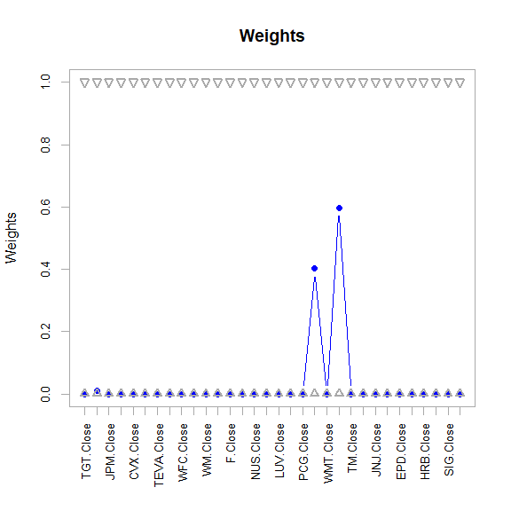

ef <- extractEfficientFrontier(optPort, match.col = "StdDev", n.portfolios = 25,  
 risk_aversion = NULL)

## Warning: executing %dopar% sequentially: no parallel backend registered

chart.EfficientFrontier(ef,  
 match.col = "StdDev", n.portfolios = 25, xlim = NULL, ylim = NULL,  
 cex.axis = 0.8, element.color = "darkgray", main = "Efficient Frontier",  
 RAR.text = "SR", rf = 0, tangent.line = TRUE, cex.legend = 0.8,  
 chart.assets = TRUE, labels.assets = TRUE, pch.assets = 21,  
 cex.assets = 0.8)

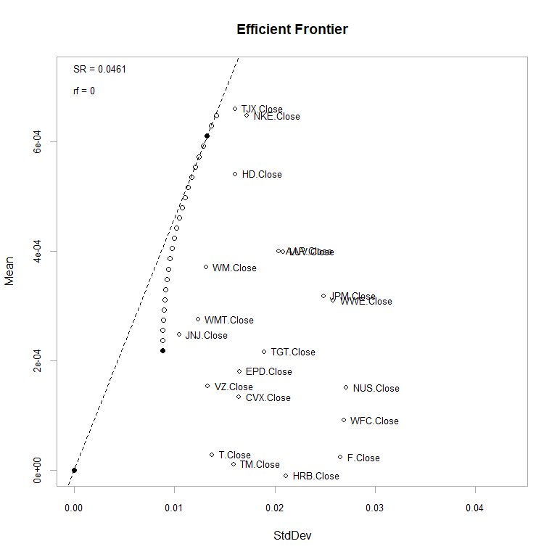

rp <- random_portfolios(portNYSE_2007, 10000, "sample")

opt_rebal <- optimize.portfolio.rebalancing(NYSE_2007_portfolioReturns,  
 portNYSE_2007,  
 optimize_method="random",  
 rp=rp,  
 rebalance_on="months",  
 training_period=1,  
 rolling_window=10)

equal_weight <- rep(1 / ncol(NYSE_2007_portfolioReturns),  
 ncol(NYSE_2007_portfolioReturns))  
  
benchmark <- Return.portfolio(NYSE_2007_portfolioReturns,   
 weights = equal_weight)  
  
colnames(benchmark) <- "Benchmark Portfolio"

sp500prices <- getSymbols.yahoo("SPY", from='2007-01-03', periodicity = 'daily', auto.assign=FALSE)[,4]  
sp500Rets <- na.omit(ROC(sp500prices))  
sp500Rets <- as.xts(sp500Rets)

chart.Weights(opt_rebal, main="Rebalanced Weights Over Time")

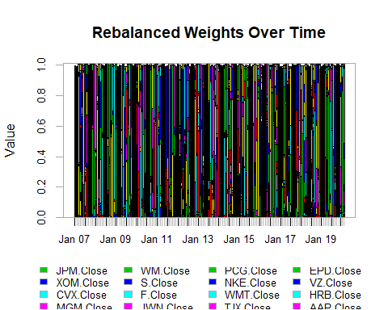

rebal_weights <-extractWeights(opt_rebal)  
  
rebal_returns <- Return.portfolio(NYSE_2007_portfolioReturns,   
 weights=rebal_weights)

## Warning in Return.portfolio.geometric(R = R, weights = weights, wealth.index =  
## wealth.index, : The weights for one or more periods do not sum up to 1: assuming  
## a return of 0 for the residual weights

rets_df <- cbind(rebal_returns, benchmark, sp500Rets)  
  
charts.PerformanceSummary(rets_df, main="NYSE* Profit & Loss Over Time")

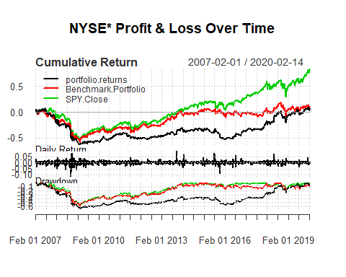

As you can see above for the NYSE hand selected stocks analyzed with this tutorial, that the benchmark portfolio was better than this portfolio but not as good as the S&P 500 stocks. We will see how the NASDAQ stock compare. Because these NYSE stocks were below zero for cumulative returns from 2007 until 2020 where they just broke even or had a slight positive cumulative return.

NASDAQ_2007_portfolioReturn

portNASDAQ_2007 <- portfolio.spec(colnames(NASDAQ_2007_portfolioReturns))  
  
portNASDAQ_2007 <- add.constraint(portNASDAQ_2007, type="weight_sum", min_sum=0.99, max_sum=1.01)  
portNASDAQ_2007 <- add.constraint(portNASDAQ_2007, type="box") #, min=.10, max=.40)  
portNASDAQ_2007 <- add.objective(portNASDAQ_2007, type="return", name="mean")  
portNASDAQ_2007 <- add.objective(portNASDAQ_2007, type="risk", name="StdDev")

optPort <- optimize.portfolio(NASDAQ_2007_portfolioReturns, portNASDAQ_2007,  
 optimize_method = "ROI", trace=TRUE)

chart.Weights(optPort)

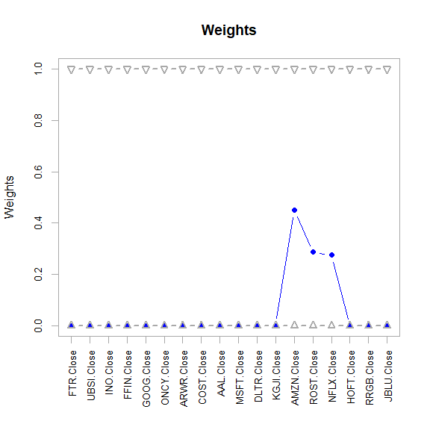

ef <- extractEfficientFrontier(optPort, match.col = "StdDev", n.portfolios = 25,  
 risk_aversion = NULL)

chart.EfficientFrontier(ef,  
 match.col = "StdDev", n.portfolios = 25, xlim = NULL, ylim = NULL,  
 cex.axis = 0.8, element.color = "darkgray", main = "Efficient Frontier",  
 RAR.text = "SR", rf = 0, tangent.line = TRUE, cex.legend = 0.8,  
 chart.assets = TRUE, labels.assets = TRUE, pch.assets = 21,  
 cex.assets = 0.8)

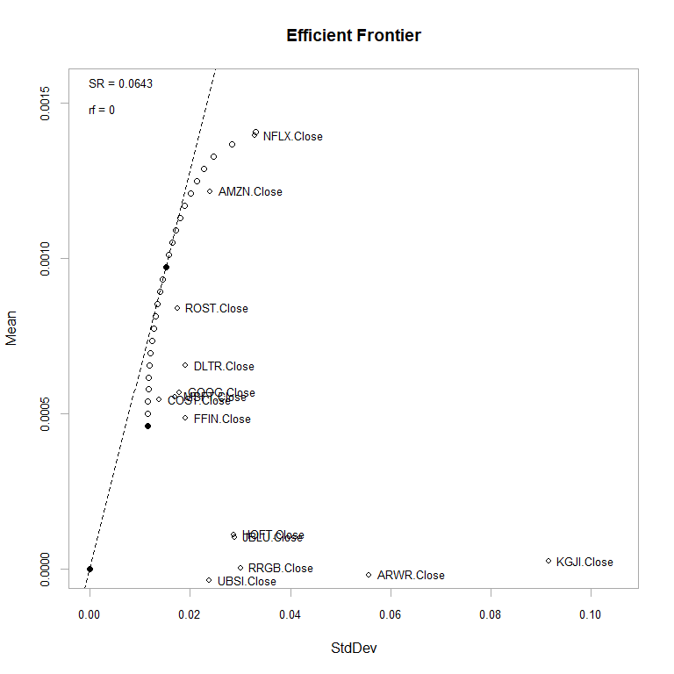

rp <- random_portfolios(portNASDAQ_2007, 10000, "sample")

opt_rebal <- optimize.portfolio.rebalancing(NASDAQ_2007_portfolioReturns,  
 portNASDAQ_2007,  
 optimize_method="random",  
 rp=rp,  
 rebalance_on="months",  
 training_period=1,  
 rolling_window=10)

equal_weight <- rep(1 / ncol(NASDAQ_2007_portfolioReturns),  
 ncol(NASDAQ_2007_portfolioReturns))  
  
benchmark <- Return.portfolio(NASDAQ_2007_portfolioReturns,   
 weights = equal_weight)  
  
colnames(benchmark) <- "Benchmark Portfolio"

sp500prices <- getSymbols.yahoo("SPY", from='2007-01-03', periodicity = 'daily', auto.assign=FALSE)[,4]  
sp500Rets <- na.omit(ROC(sp500prices))  
sp500Rets <- as.xts(sp500Rets)

chart.Weights(opt_rebal, main="Rebalanced Weights Over Time")

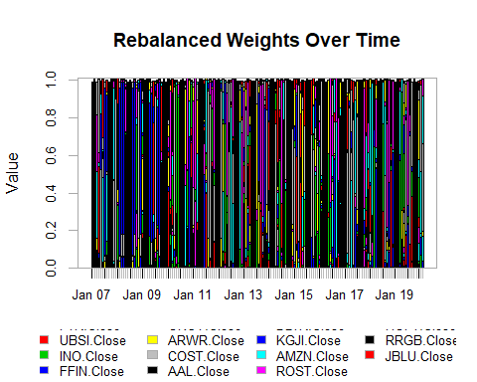

rebal_weights <-extractWeights(opt_rebal)  
  
rebal_returns <- Return.portfolio(NASDAQ_2007_portfolioReturns,   
 weights=rebal_weights)

## Warning in Return.portfolio.geometric(R = R, weights = weights, wealth.index =  
## wealth.index, : The weights for one or more periods do not sum up to 1: assuming  
## a return of 0 for the residual weights

rets_df <- cbind(rebal_returns, benchmark, sp500Rets)  
  
charts.PerformanceSummary(rets_df, main="Profit & Loss Over Time")

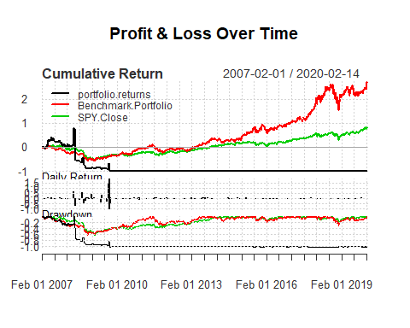

Looking at the above, the portfolio returns for the NASDAQ hand selected stock were far below the benchmark portfolio and the S&P 500 close as well as below zero cumulative return from 2009 to 2019. This makes it a terrible portfolio of stocks, but could be modified later by analyzing individual stocks, and points in time, and returns on investment (ROI) for different historical time frames of importance.

The NYSE portfolio was better than the NASDAQ stocks by just breaking even since the start at 2007 to 2020.

For more information, please visit this [link](https://www.youtube.com/watch?v=m5h2pYs4_m8), then email me your comments at [janis@themassagenegotiator.com](mailto:janis@themassagenegotiator.com).

What and who wrote that information at the link above. It is one of those references where so many questions come up, like what time period was it, what is the story behind the song, was it originally to mock somebody, but turned snazzy so that this main them could keep supplying the source’s needs. Well, these thoughts and questions are unlimited, as are the reasons that people invest in the stocks they do. But it can be said with certainty, that when people invest in stocks they believe these companies are going to last a long time and generate a nice return on investment for them, unless some unforseeable event occurs, like a law suit, a settlement, a big company bulldozing the playing field and all those smaller businesses out of the way, recessions, stagantion, depressions, memorabilia when celebrities die, and so on.

Email your thoughts to me at the above email. Here is the motivation for this data science project on finances. You just saw it above, as well as many other questions.

We will be going over the data that we have pulled from finance.yahoo.com via the above script for various stocks that were picked by me and while driving and seeing businesses around my metropolis.

This is just another data science problem to wrap up some questions with some answers pulled from available resources, all_portfolio_prices.csv.

* 1.) Tally up the ROI on each of these 65 stocks. make 65 ROI per day, and with the initial value of the stock.
* 2.) This data of 65 stocks now has the volume of trades per day and the closing price from 01-03-2007 through 02-15-2020. Of course some stock are missing, and these are a mix of NYSE and NASDAQ. With this information we should look for daily changes and the volume of the stock being traded. Examine whether there is a pattern in the number of trades per day, per stock, and the daily change per stock, and pin point those stocks that pass a certain threshold of their previous day closing price, like 10% of their value as an increase of decrease.
* 3.) Pull data from the unemployment/employment rates of data from the Bureau of Labor Statistics or BLS and find out if this points to any clues in the date range of certain stocks being strong with little change and others being more volatile.
* 4.) Get the top Yahoo trending stories in the finance department and run some text mining on the articles and the comments if available to compare to the changes that could be dramatic in the stock market on that day or week.

**updated 2/16/2020**