Quandmod-Quantitative Finance R tutorial Youtube

Janis Corona

1/20/2020

This is a youtube tutorial on quant finance from ’Quant Finance with R Part 1 intro and Data": [This tutorial link](https://www.youtube.com/watch?v=uwuPQUa2TjI).

The [github repository](https://github.com/fdupuis659/Quant-Finance-with-R) for these tutorials are at: <https://github.com/fdupuis659/Quant-Finance-with-R>

The above package, quantmod, is used for quantitative finance in R. The PerformanceAnalytics package is used to analyze the data using quantmod in R.

library(quantmod)  
library(PerformanceAnalytics)

$?quantmod$

$?getSymbols$

This sets a minimum date to grab out of the AAPL finance data so that all dates will be after Feb 1, 2017.

dt <- '2017-2-1'  
  
aapl <- getSymbols.yahoo('AAPL', from = dt, auto.assign=F)

The above object is an ‘xts’ object or extensible time series object used in financial markets.

head(aapl)

## AAPL.Open AAPL.High AAPL.Low AAPL.Close AAPL.Volume AAPL.Adjusted  
## 2017-02-01 127.03 130.49 127.01 128.75 111985000 122.9902  
## 2017-02-02 127.98 129.39 127.78 128.53 33710400 122.7800  
## 2017-02-03 128.31 129.19 128.16 129.08 24507300 123.3054  
## 2017-02-06 129.13 130.50 128.90 130.29 26845900 124.4613  
## 2017-02-07 130.54 132.09 130.45 131.53 38183800 125.6458  
## 2017-02-08 131.35 132.22 131.22 132.04 23004100 126.1330

dim(aapl)

## [1] 746 6

row.names(aapl)[1:20]

## NULL

colnames(aapl)

## [1] "AAPL.Open" "AAPL.High" "AAPL.Low" "AAPL.Close"   
## [5] "AAPL.Volume" "AAPL.Adjusted"

The following are also xts objects.

aaplClose <- aapl[,6]  
  
  
# use of the PerformanceAnalytics library loaded earlier  
appleReturns <- dailyReturn(aaplClose, type='log')  
  
appleReturns1 <- na.omit(dailyReturn(aaplClose, type='log'))

head(appleReturns)

## daily.returns  
## 2017-02-01 0.000000000  
## 2017-02-02 -0.001710085  
## 2017-02-03 0.004269986  
## 2017-02-06 0.009330424  
## 2017-02-07 0.009471964  
## 2017-02-08 0.003870171

head(appleReturns1)

## daily.returns  
## 2017-02-01 0.000000000  
## 2017-02-02 -0.001710085  
## 2017-02-03 0.004269986  
## 2017-02-06 0.009330424  
## 2017-02-07 0.009471964  
## 2017-02-08 0.003870171

The NAs should have been removed but are being read in as zeros, from quantmod when getting the ‘AAPL’ xts object from the web.

The following will chart a graph of the xts object, aapl.

chartSeries(aapl)

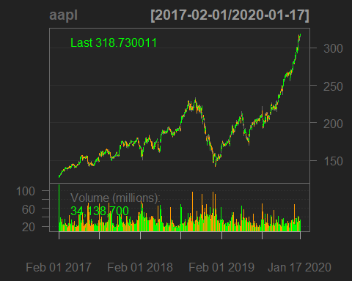

[Quant Finance with R Part 2: Portfolio Analysis](https://www.youtube.com/watch?v=2Y4HX0UUcrA): (<https://www.youtube.com/watch?v=2Y4HX0UUcrA>) of 4 parts for this Quantitative Finance tutorial on Youtube from December 2018.

library(quantmod)  
library(PerformanceAnalytics)

Function that uses the closing price column to add the prices since a set date.

tickers <- c('FB', 'AAPL','NFLX')  
  
weights <- c(0.25, 0.25, 0.25)  
  
portfolioPrices <- NULL  
  
for (ticker in tickers){  
 portfolioPrices <- cbind(portfolioPrices, getSymbols.yahoo(ticker,  
 from = '2016-01-03', periodicity='daily', auto.assign=FALSE)[,4])  
   
}

Check NAs not in data.

colSums(is.na(portfolioPrices))

## FB.Close AAPL.Close NFLX.Close   
## 0 0 0

S&P benchmark

benchmarkPrices <- getSymbols.yahoo('^GSPC', from='2016-01-03', periodicity='daily', auto.assign=FALSE)[,4]

Calculate daily change in each column.

benchmarkReturns <- na.omit(ROC(benchmarkPrices))  
colSums(is.na(benchmarkReturns))

## GSPC.Close   
## 0

portfolioReturns <- na.omit(ROC(portfolioPrices))  
colSums(is.na(portfolioReturns))

## FB.Close AAPL.Close NFLX.Close   
## 0 0 0

portfolioReturn <- Return.portfolio(portfolioReturns)

To find out more on the Return.portfolio function, use: $?Return.portfolio$

*

Some side information about a few financial algorithms:

* **CAPM**: formula for expected return with calculated risk on an asset or stock.
* **ALPHA**: risk adjustment metric for performances compares to an index and shows how much better that index is beat by your benchmark.
* **BETA**: measure of volatility with <1 => less risky and >1 => more risky.
* **SHARPE RATIO**: risk metric for every standard deviation unit, how much return is achieved, gives risk & reward, and most widely used metric with finance managers.

The number of trading days is 252 days a year.

CAPM.beta(portfolioReturn, benchmarkReturns, 0.035/252)

## [1] 1.391641

CAPM.jensenAlpha(portfolioReturn, benchmarkReturns, 0.035/252)

## [1] 0.0524188

SharpeRatio(portfolioReturn, 0.035/252)

## portfolio.returns  
## StdDev Sharpe (Rf=0%, p=95%): 0.05044925  
## VaR Sharpe (Rf=0%, p=95%): 0.03085222  
## ES Sharpe (Rf=0%, p=95%): 0.01879745

table.AnnualizedReturns(portfolioReturn)

## portfolio.returns  
## Annualized Return 0.2242  
## Annualized Std Dev 0.2473  
## Annualized Sharpe (Rf=0%) 0.9067

table.CalendarReturns(portfolioReturn)

## Jan Feb Mar Apr May Jun Jul Aug Sep Oct Nov Dec  
## 2016 1.4 3.8 1.9 -0.2 -0.8 1.6 1.6 0.2 0.8 -1.4 -1.3 -1.0  
## 2017 2.7 1.3 -0.2 1.8 0.1 -0.1 0.5 0.0 0.7 0.4 -0.7 -0.8  
## 2018 0.3 -1.1 2.8 1.1 1.8 -0.8 1.7 -0.3 0.8 2.6 -0.2 1.7  
## 2019 -0.1 0.3 1.8 2.3 -2.5 1.4 -1.4 -0.4 0.0 1.3 -0.3 0.4  
## 2020 0.6 NA NA NA NA NA NA NA NA NA NA NA  
## portfolio.returns  
## 2016 6.8  
## 2017 5.8  
## 2018 10.9  
## 2019 2.8  
## 2020 0.6

[Quant Finance Part 3: Portfolio Optimization](https://www.youtube.com/watch?v=6Pi0fjARtUI): <https://www.youtube.com/watch?v=6Pi0fjARtUI>

Same libraries and code above used, but add in more tickers.

tickers <- c('FB', 'AAPL','NFLX','AMZN','GOOGL','SQ','NVDA')  
  
weights <- c(0.25, 0.25, 0.25)  
  
portfolioPrices <- NULL  
  
for (ticker in tickers){  
 portfolioPrices <- cbind(portfolioPrices, getSymbols.yahoo(ticker,  
 from = '2016-01-03', periodicity='daily', auto.assign=FALSE)[,4])  
   
}

S&P benchmark

benchmarkPrices <- getSymbols.yahoo('^GSPC', from='2016-01-03', periodicity='daily', auto.assign=FALSE)[,4]

Calculate daily change in each column.

benchmarkReturns <- na.omit(ROC(benchmarkPrices))  
portfolioReturns <- na.omit(ROC(portfolioPrices))  
portfolioReturn <- Return.portfolio(portfolioReturns)

$install.packages(′imputeTS′)$ $install.packages(′PortfolioAnalytics′)$

library(dplyr)

##   
## Attaching package: 'dplyr'

## The following objects are masked from 'package:xts':  
##   
## first, last

## The following objects are masked from 'package:stats':  
##   
## filter, lag

## The following objects are masked from 'package:base':  
##   
## intersect, setdiff, setequal, union

library(quantmod)  
library(PerformanceAnalytics)  
library(imputeTS)

## Registered S3 methods overwritten by 'forecast':  
## method from   
## fitted.fracdiff fracdiff  
## residuals.fracdiff fracdiff

##   
## Attaching package: 'imputeTS'

## The following object is masked from 'package:zoo':  
##   
## na.locf

library(PortfolioAnalytics)

## Loading required package: foreach

portf <- portfolio.spec(colnames(portfolioReturns))  
  
portf <- add.constraint(portf, type="weight_sum", min_sum=1, max_sum=1)  
portf <- add.constraint(portf, type="box", min=.10, max=.40)  
portf <- add.objective(portf, type="return", name="mean")  
portf <- add.objective(portf, type="risk", name="StdDev")

Need to install some more libraries to run the optimize.portfolio().

$install.packages(′ROI′)$

$install.packages(′ROI.plugin.quadprog′)$

$install.packages(′ROI.plugin.glpk′)$

library(ROI)

## Registered S3 method overwritten by 'ROI':  
## method from   
## print.constraint PortfolioAnalytics

## ROI: R Optimization Infrastructure

## Registered solver plugins: nlminb, glpk, quadprog.

## Default solver: auto.

##   
## Attaching package: 'ROI'

## The following objects are masked from 'package:PortfolioAnalytics':  
##   
## is.constraint, objective

library(ROI.plugin.quadprog)  
library(ROI.plugin.glpk)

optPort <- optimize.portfolio(portfolioReturns, portf, optimize_method = "ROI", trace=TRUE)

chart.Weights(optPort)

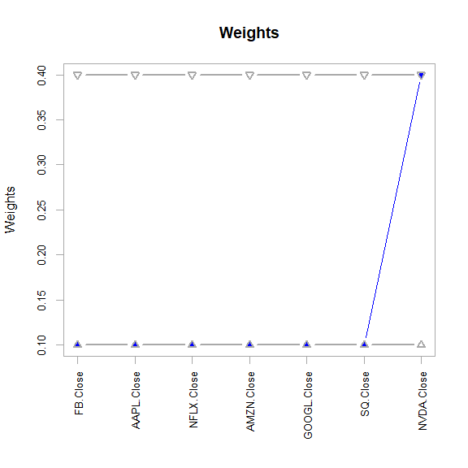

ef <- extractEfficientFrontier(optPort, match.col = "StdDev", n.portfolios = 25,  
 risk_aversion = NULL)

## Warning: executing %dopar% sequentially: no parallel backend registered

chart.EfficientFrontier(ef,  
 match.col = "StdDev", n.portfolios = 25, xlim = NULL, ylim = NULL,  
 cex.axis = 0.8, element.color = "darkgray", main = "Efficient Frontier",  
 RAR.text = "SR", rf = 0, tangent.line = TRUE, cex.legend = 0.8,  
 chart.assets = TRUE, labels.assets = TRUE, pch.assets = 21,  
 cex.assets = 0.8)

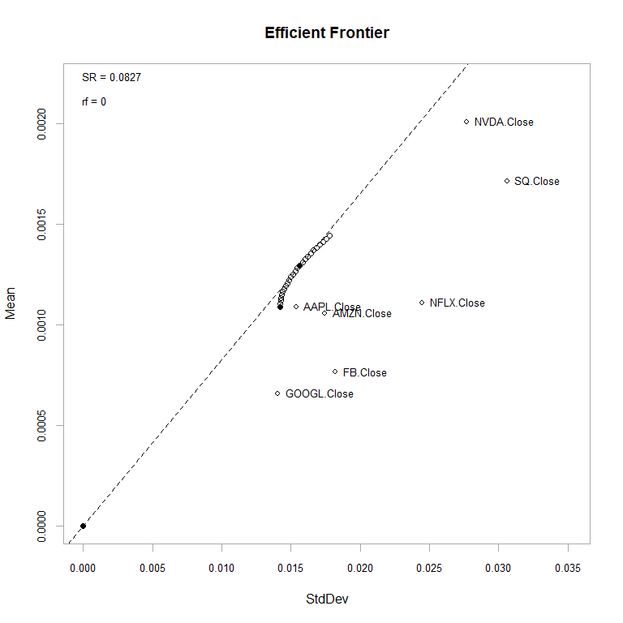

[Quant Finance Part 4: Portfolio Optimization Backtest](https://www.youtube.com/watch?v=mBjdkAVdhgM): <https://www.youtube.com/watch?v=mBjdkAVdhgM>

library(quantmod)  
library(PerformanceAnalytics)  
library(PortfolioAnalytics)

tickers <- c("FB", "AAPL", "AMZN", "NFLX", "GOOGL", "SQ", "NVDA")  
  
portfolioPrices <- NULL  
for(ticker in tickers) {  
 portfolioPrices <- cbind(portfolioPrices,  
 getSymbols.yahoo(ticker, from='2016-01-03', periodicity = 'daily', auto.assign=FALSE)[,4])  
}  
  
portfolioReturns <- na.omit(ROC(portfolioPrices))  
  
portf <- portfolio.spec(colnames(portfolioReturns))  
  
portf <- add.constraint(portf, type="weight_sum", min_sum=0.99, max_sum=1.01)  
portf <- add.constraint(portf, type="transaction_cost", ptc = 0.001)  
portf <- add.constraint(portf, type="box", min=.10, max=.40)  
portf <- add.objective(portf, type="return", name="mean")  
portf <- add.objective(portf, type="risk", name="StdDev", target=0.005)

rp <- random_portfolios(portf, 10000, "sample")

opt_rebal <- optimize.portfolio.rebalancing(portfolioReturns,  
 portf,  
 optimize_method="random",  
 rp=rp,  
 rebalance_on="months",  
 training_period=1,  
 rolling_window=10)

equal_weight <- rep(1 / ncol(portfolioReturns), ncol(portfolioReturns))  
benchmark <- Return.portfolio(portfolioReturns, weights = equal_weight)  
colnames(benchmark) <- "Benchmark Portfolio"

sp500prices <- getSymbols.yahoo("SPY", from='2016-01-03', periodicity = 'daily', auto.assign=FALSE)[,4]  
sp500Rets <- na.omit(ROC(sp500prices))  
sp500Rets <- as.xts(sp500Rets)

chart.Weights(opt_rebal, main="Rebalanced Weights Over Time")

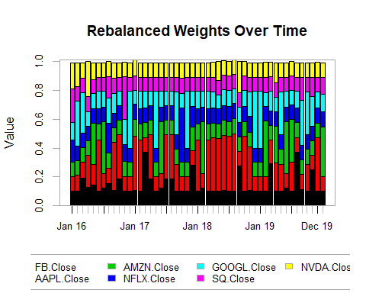

rebal_weights <-extractWeights(opt_rebal)  
rebal_returns <- Return.portfolio(portfolioReturns, weights=rebal_weights)

## Warning in Return.portfolio.geometric(R = R, weights = weights, wealth.index =  
## wealth.index, : The weights for one or more periods do not sum up to 1: assuming  
## a return of 0 for the residual weights

rets_df <- cbind(rebal_returns, benchmark, sp500Rets)  
  
charts.PerformanceSummary(rets_df, main="P/L Over Time")

