This blog is more study and visualization analysis if those genes that are related to the body systems of our life on a regular maintenance scheme for why our gene expression is driven to express a certain amount every day in maintaining and regulation, compared to states when the body is under three different grades of COVID-19. There are some bar and scatter plots that give more minute details on the demographics of each sample for the age, sample ID, and gender.

The files, supplemental files, scripts, images, etc can be found at my Github repository: <https://github.com/JanJanJan2018/RA-simulating-COVID-study-analysis> and the Rpubs documented html version of the coded R script is available in that repository as an R markdown .Rmd file or at my Rpubs address: <https://www.rpubs.com/janisharris/monotonicIncreasingDecreasingCOVID19_ML_RF_LDA> .

Also note that this data was obtained from the donated (National Center for Bioinformatics-NCBI gene expression omnibus data repository-GEO, series ID: GSE152418 published July/August 2020-fairly new) data on 34 convalescent patients aged 23-91 with 18 females and 16 males for all three grades of COVID-19: moderate (least severe), severe (mid-level severe), and ICU (most severe) as grades. Also, all of the moderate samples are females, so males can't be compared in that grade of COVID-19. Much of this data could be skewed to a normal citizen's data because it is common knowledge that nursing homes administer vitamins and pharmaceuticals to their nursing home patients. Some patients that are young could be in there due to epilepsy, paralysis, or another health condition that their families or the state cannot watch them in a safe environment for. Also, the rank of the genes associated with each body system such as 'vitamin D' could have a top ranked gene that overlaps with another body system like 'vitamin C' because that gene is involved in their network of vitamin D and vitamin C absorption. VDR happens to be that gene. The rank is from the genes listed on genecards.org when typing in automated script to return those top ranked genes and selecting only the top three.

Let me explain the motive for, ohps, excuse me? I mean motivation for this blog. I in no way look at people as them being motivated to do something for narcissistic goals unlike some people shaped by theri professions and married more than twice. But I will do this by copy and pasting the motivation from the R script I made earlier so that I can have more time to analyze my findings and go on random tangents about little somethings relevant but not so relevant about each finding.

"... as a massage therapist of more than 14 years of experience and having recently studied for and taken and passed my MBLEx or Massage and Bodywork Licensing Examination, I can tell you there are many fascinating items of the body systems and mineral as well as vitamin dependencies that lead to disease in some people. But when relearning the endocrine system and the hormones related to the pineal, hypothalamus, pituitary, adrenals, thyroid, and pancreas many other vitamins, steroids, and hormones should be looked at in studying these different cases of COVID-19.

We will look at the Vitamin C which helps the body absorb Vitamin D and make calcium in the bone blood, the glucagon that turn glucose into sugar and insulin that lowers glucose in the blood having to do with the pancreas hormones, dopamine that relates to parkinsons disease when the hypothalamus doesn't produce enough, melatonin that regulates sleep and produced by the pineal gland near the pituitary and hypothalamus in the brain that regulates sleep, estrogen, prolactin, and progesterone regulated by the pituitary gland in the brain in females, testosterone regulated by the males in their testes, and corticosteroids and adrenaline regulated by the adrenals when in sympathetic response of danger in the body. Also, the vitamins that people are commonly told to take in addition to Vitamin C and Vitamin D, such as fish oil or omega 3s, vitamin B12 or zinc, and magnesium mineral.Also, calcitonin, a thyroid hormone that breaks down calcium so that the kidneys don't get kidney stones nor other healthy problems.

Lets use our data we created earlier with our fold change modified values for Inf, NaN, and 0 when z/0, 0/0,0/z where z is any rational number and the alternate value was replaced in respective case with disease mean, 1, or healthy mean." --me about 8 hours ago. (8/18/2020)

<https://public.tableau.com/profile/janis5126#!/vizhome/vitMinSterAllGenesBarchart/vitMinSterAllGenesBarchart?publish=yes>

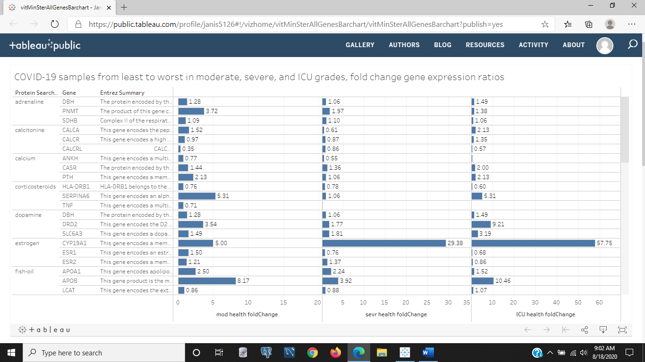

Figure 1: All of our genes' fold change values in moderate (least severe), severe (mid level severe), and ICU (most severe) grades of COVID-19. Some genes within a body system or element don't have a noticeable increase of decrease between grades like the corticosteroids and one dopamine body system element. Some genes also increase or decrease monotonically like two of the dopamine. And some body systems have genes in their three top ranked that increase with severity while some decreasing with severity such as Estrogen.

<https://public.tableau.com/profile/janis5126#!/vizhome/vitaminCovidScatterAgeGender/vitaminCovidScatterAgeGender?publish=yes>

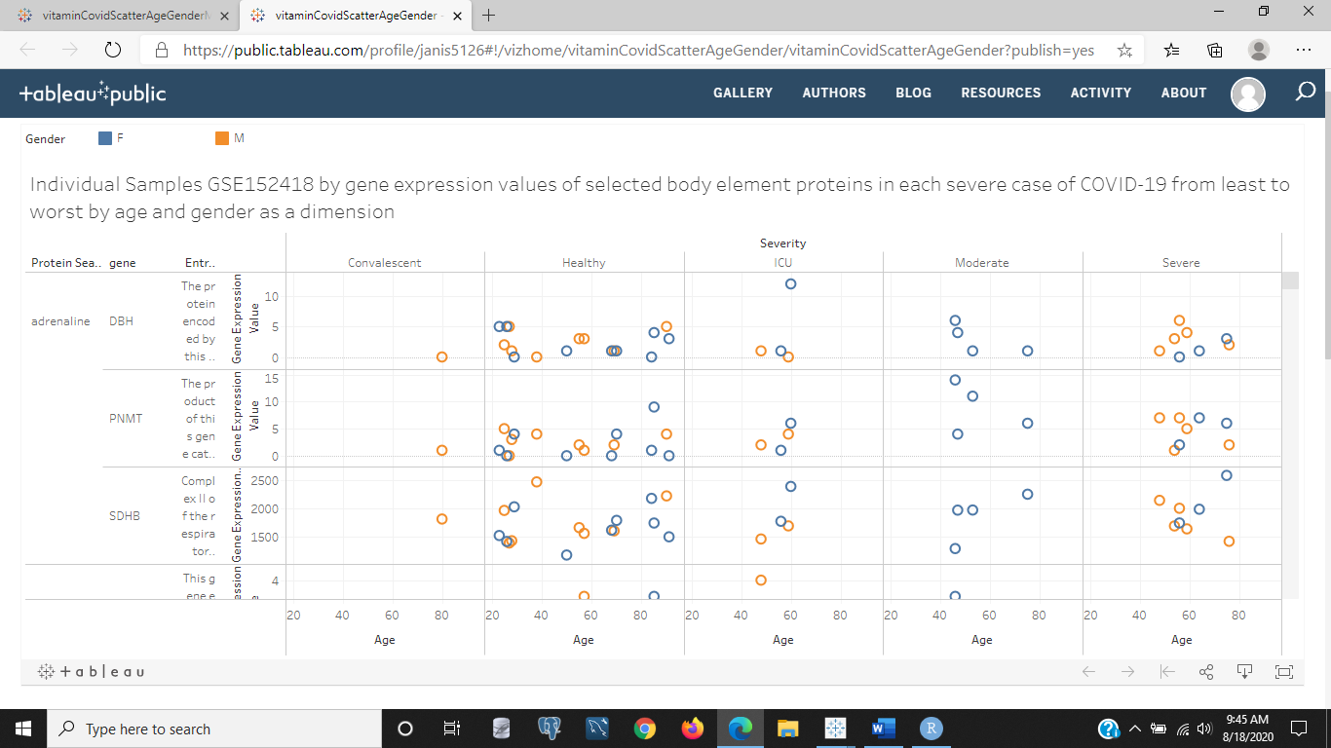

Figure 2: The above image is the scatter plot of all the body system's top three ranked genes for genders and age within each grade of COVID-19. We can see adrenaline for the most part has no pattern in healthy cases, but in females goes up with age in the severe and ICU grades, while down in the moderate cases. The reverse seems to be true for adrenaline in males for two of those three genes in the severe grade only.

<https://public.tableau.com/profile/janis5126#!/vizhome/vitMinSterMonDecrAllGenesBarchart/vitMinSterMonDecrGenesBarchart?publish=yes>

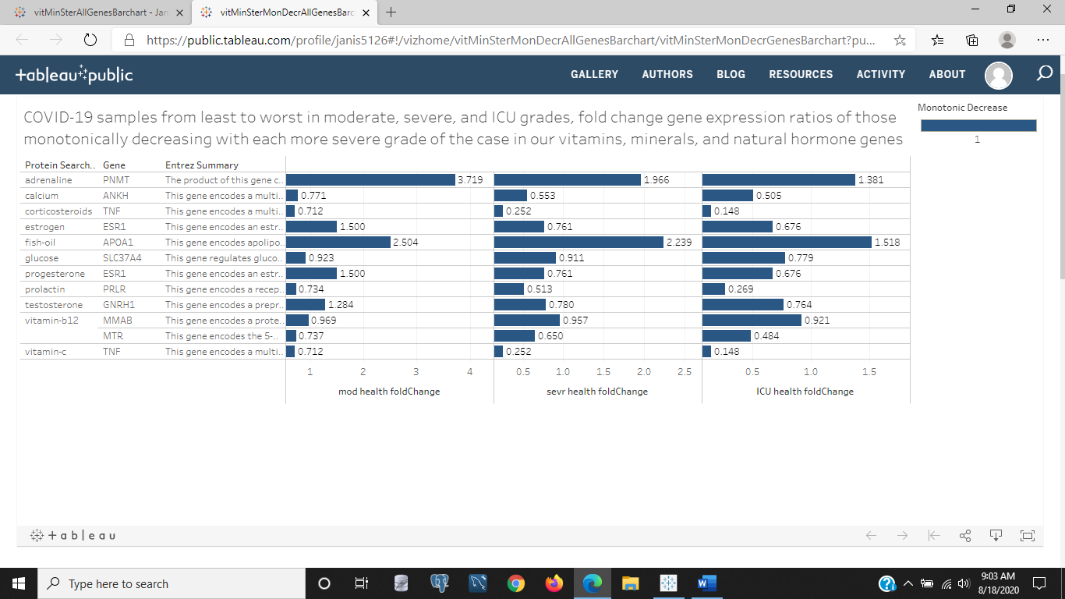

Figure 3: This bar chart is a bit more interesting because it takes those genes in our body system genes that are decreasing from least to worst severe in both genders and by age. The labels are the respective fold change within their grade of COVID-19. We notice one out of the top three ranked genes by genecards.org for adrenaline, corticosteroids, calcium, estrogen, fish oil, glucose, progesterone, prolactin, testosterone, and vitamin C, but two genes out of three genes are monotonically decreasing in the vitamin b12 genes from least to worst severe COVID-19. This chart gives the fold change values, but what can we assume about this data? If more severe cases have less of these vitamins and minerals, shouldn't we be consuming more in our diets to avoid getting the more severe forms of COVID-19? Possibly, but that requires a hypothesis and procedure to test the results over time and exposure to the disease.

<https://public.tableau.com/profile/janis5126#!/vizhome/vitaminCovidScatterAgeGenderMonDecr/vitaminCovidScatterAgeGenderMonDecr?publish=yes>

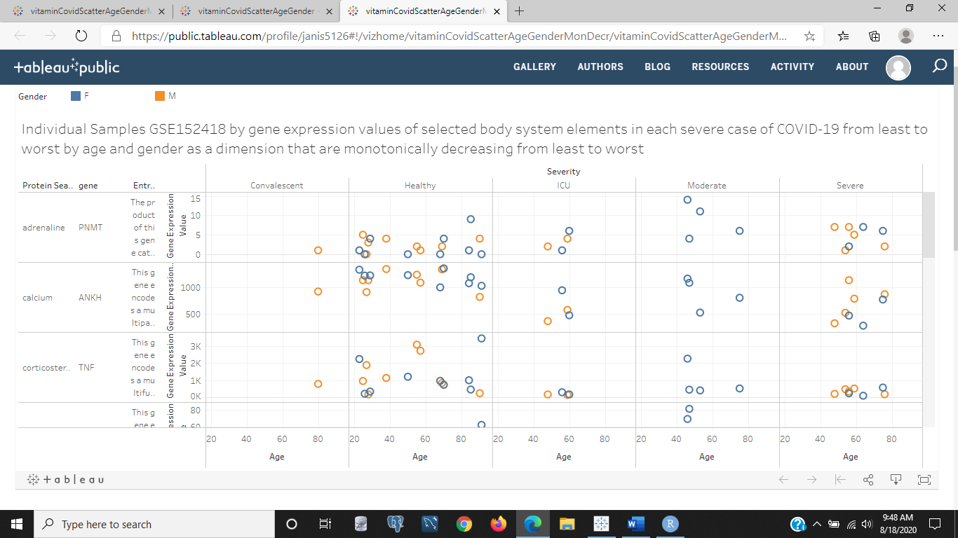

Figure 4: This is the same monotonically decreasing genes in Figure 3 but by raw values and using the sample specific ID alias name, age, and gender of each sample in their respective grade of moderate (least), severe (mid-level severe), and ICU (most severe) grades of COVID-19. Do we see any trends that are specific to gender, age, and/or grade of disease? Vitamin C seems to be much higher in healthy cases but dip down low on all grades of COVID-19, with the females in the moderate group (the moderate group is all females) having a normal range close to healthy. Calcium and estrogen seem to increase with age in both genders in the severe and ICU grades, but this could be that these samples are all convalescent patients who are under the daily routine of taking vitamins and hormone therapy to help with aging and improve their health. Estrogen is a bone strengthener that osteo blasts rely on to build and repair bone. With age, elderly women are more prone to fragile bones and fractures subsequently unless their estrogen levels aren't monitored. Some of the young males actually have more estrogen than older males and females, probably due to the underlying condition that keeps them in a convalescent home.

<https://public.tableau.com/profile/janis5126#!/vizhome/vitMinSterMonIncrAllGenesBarchart/vitMinSterMonIncrGenesBarchart?publish=yes>

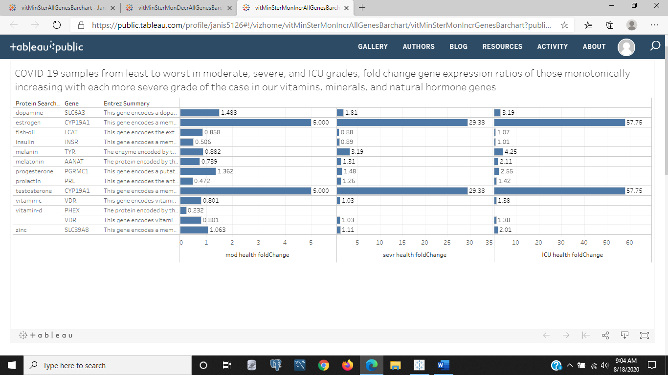

Figure 5: The above image is those genes that are monotonically increasing in gene expression from least to worst severe grades of COVID-19. We see that dopamine, estrogen, fish oil, insulin, melanin, melatonin, progesterone, prolactin, testosterone, vitamin C, and zinc all have one gene that monotonically decreases, but vitamin D has two genes that decrease monotonically from least to most severe COVID-19 diagnosis.

<https://public.tableau.com/profile/janis5126#!/vizhome/vitaminCovidScatterAgeGenderMonIncr/vitaminCovidScatterAgeGenderMonIncr?publish=yes>

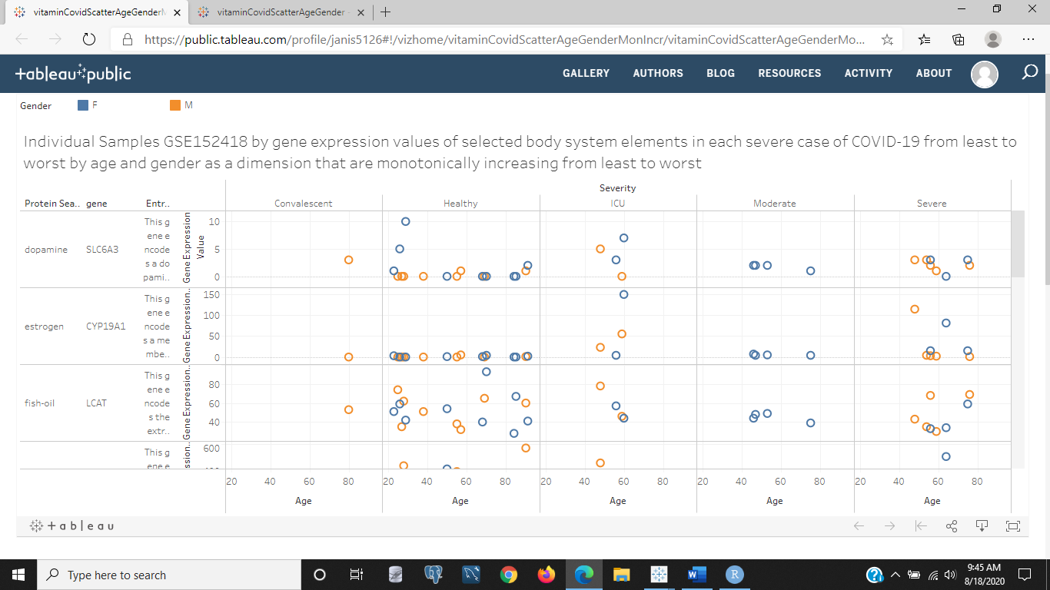

Figure 6: The above image shows the scatter plot of the sample alias IDs, age, and gender of raw values within each grade of COVID-19 for each gene in our body system genes that is monotonically increasing from least to worst grades. There are some patterns and relationships noticed. Zinc is slightly elevated in a few of the severe and ICU grades of COVID-19 compared to healthy samples in a couple females and one male, but otherwise no real shift in gene expression. One vitamin D gene stays within healthy levels for both genders and also each grade of COVID-19 but declines with age in both genders and each grade of COVID-19. Testosterone is outside its healthy range of gene expression for males and females in the severe and ICU grades of COVID-19. One of the prolactin genes is surprisingly elevated for males in the severe grade of this disease. Melatonin is in the normal range for all ages and genders except for one ICU grade COVID-19 male. Melanin is elevated in a few males and females spread between the severe and ICU grades and only one male in the healthy samples. That could be due to pigmentation of natural skin color. Insulin is in the normal ranges for the most part in all three grades but noticeably lower in the moderate group of females. One 90 year old male in the healthy samples and one 64 year old female in the severe samples has elevated insulin levels possibly because they are being treated for diabetes Type I or Type II. Fish oil is in the normal range of the healthy samples for all three grades, but estrogen is slightly elevated in both males and females in the severe and ICU grades with not enough samples to show if it decreases or increases with age, but given the samples shown in the severe grade decreases with age and increases with age in the ICU grade of COVID-19. The dopamine levels are slightly elevated compared to the majority of healthy samples for all grades of COVID-19. There are two healthy samples from a 26 and 29 year old with much more elevated dopamine levels than the other 15 healthy samples. This could be due to their medicine if they are taking pain killers, as dopamine is a happy drug than blocks pain.

I hope you enjoyed looking at these samples and data and making some hypothesis and life choices about the minerals and vitamins you want to take. I would take those minerals and vitamins that are low in the more severe COVID-19 cases as this probably indicates that those patients had low levels to begin with and thus suffered the more severe COVID-19 grade of the disease symptomatically. But also, there were those genes that were low in healthy cases and elevated in the more severe grades of COVID-19. Lets recap what those vitamins and minerals were (that are lower than a healthy level in ICU patients.

-genes higher in the severe or ICU grades of COVID-19 compared to healthy samples:

- dopamine (SLCGA3, increased in severe and ICU grades)

- estrogen (CYP19A1, increased in severe and ICU grades)

- melanin (TYR, increased in severe grades)

- testosterone (CYP19A1, overlap with estrogen)

- zinc (SLC39A8, increased in severe and ICU grades)

- fish oil (APOA1, increases with age both genders in moderate and severe)

- adrenaline (PNMT, increased in moderate grade only)

- progesterone (ESR1, increased in the moderate females, overlap with estrogen)

-genes lower in the more severe or ICU grades of COVID-19 compared to healthy samples:

- vitamin C (TNF, decreased in all grades of COVID-19)

- calcium (ANKH, decreased in all grades of COVID-19, increase with age in both genders)

- estrogen (ESR1, lower in severe and ICU grades, increased in all female

moderate grade)

- corticosteroid (TNF, decreased in all grades of COVID-19, overlap with Vitamin C)

- glucose (SLC37A4, decreased in ICU and severe grades of COVID-19)

- prolactin (PRLR, decreased in all grades of COVID-19)

- testosterone (GNRH1, decreased in severe grades of COVID-19)

- vitamin B12 (MTR, decreased in ICU and severe grades of COVID-19)

Keep in mind this data is based entirely on medicated and vitamin supplied convalescent patients aged 21-93 years of age. But from our data, you have seen what type of gene expression is more common in each grade of COVID-19 severity, the outliers, relationships if any by gender or age, and more. This is useful to how you want to incorporate your diet and cleanliness standards. Notice how there aren't any observations on Vitamin D because all grades of the disease fell within the healthy range of vitamin D gene expression levels, but vitamin C had a gene that was elevated in the more severe grades of this disease.

I went ahead and added iron to our mix of body system genes and analyzed the changes of the top three ranked iron genes in our healthy, moderate, severe, and ICU grades of severity of COVID-19. Let me share some images with you from that.

<https://public.tableau.com/profile/janis5126#!/vizhome/ironCovid19AgeGenderSeverityScatter/ironCovid19AgeGenderSeverityScatter?publish=yes>

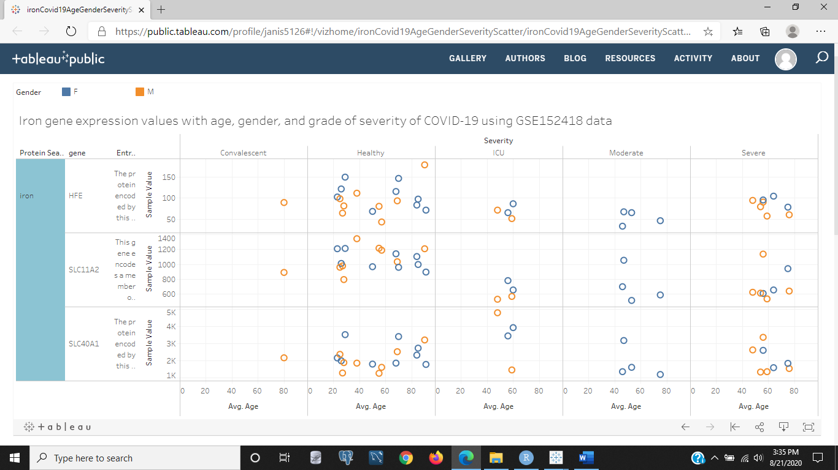

Figure 7: The image above is the chart of genes in Tableau that has only the iron actual raw values for its top 3 ranked genes in our samples. We can see that the first gene is much higher over all in expression in healthy samples, and that in all three grades of severity of COVID-19 the iron levels are on the smaller range decreasing with age in both genders and all cases excep the ICU grade for females where it increased with age. The 2nd iron gene is similar except that iron increases with age in females. The last iron gene shows that it is lower in healthy samples and than the other two iron genes, but in ICU grades of COVID-19 it is increased.

<https://public.tableau.com/profile/janis5126#!/vizhome/notMonIncOrDecr/notMonIncOrDecr?publish=yes>

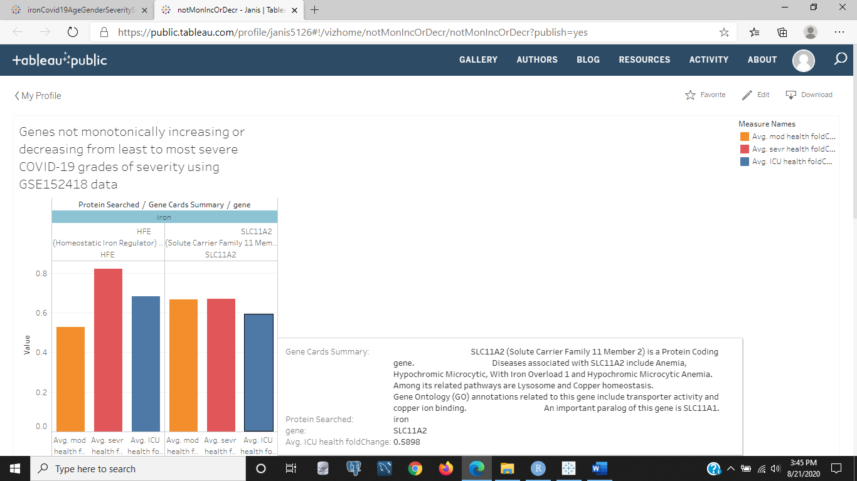

Figure 8: This image is of those iron genes that aren't monotonically increasing or decreasing. There fold change values are shown for each gene and all are under expressed in the disease state compared to the healthy state. We created the rules for these fold change values so that if the disease state mean was 0 and the healthy mean was not 0, the fold change would be 1-healthy mean, and if both the disease state and the healthy state means were 0 then the fold change value would be 1, and finally if the healthy mean was 0 but the disease mean was not 0 the value would be the disease state. And if the fold change was not 0, Inf, or NaN, then the value would stay as is from the disease state/healthy state ratio of mean values. We can see from the image of the Tableau chart, that the iron gene was clicked on and selected to 'keep only' so that only the iron genes are displayed among those nonmonotonic. HFE and SLC11A2 are shown, and the ICU grade of COVID-19 severity is lower than the severe grade of COVID-19, but the moderate grade is lower than the ICU grade in the HFE gene and higher in the SLC11A2 gene. SLC11A2 is involved in transporter activity and copper ion binding and associated with anemia (not enough red blood cells). While HFE is associated with hemochromatosis (too many red blood cells) and signaling receptor binding as well as peptide antigen binding.

<https://public.tableau.com/profile/janis5126#!/vizhome/monIncBarChart/monIncBarChart?publish=yes>

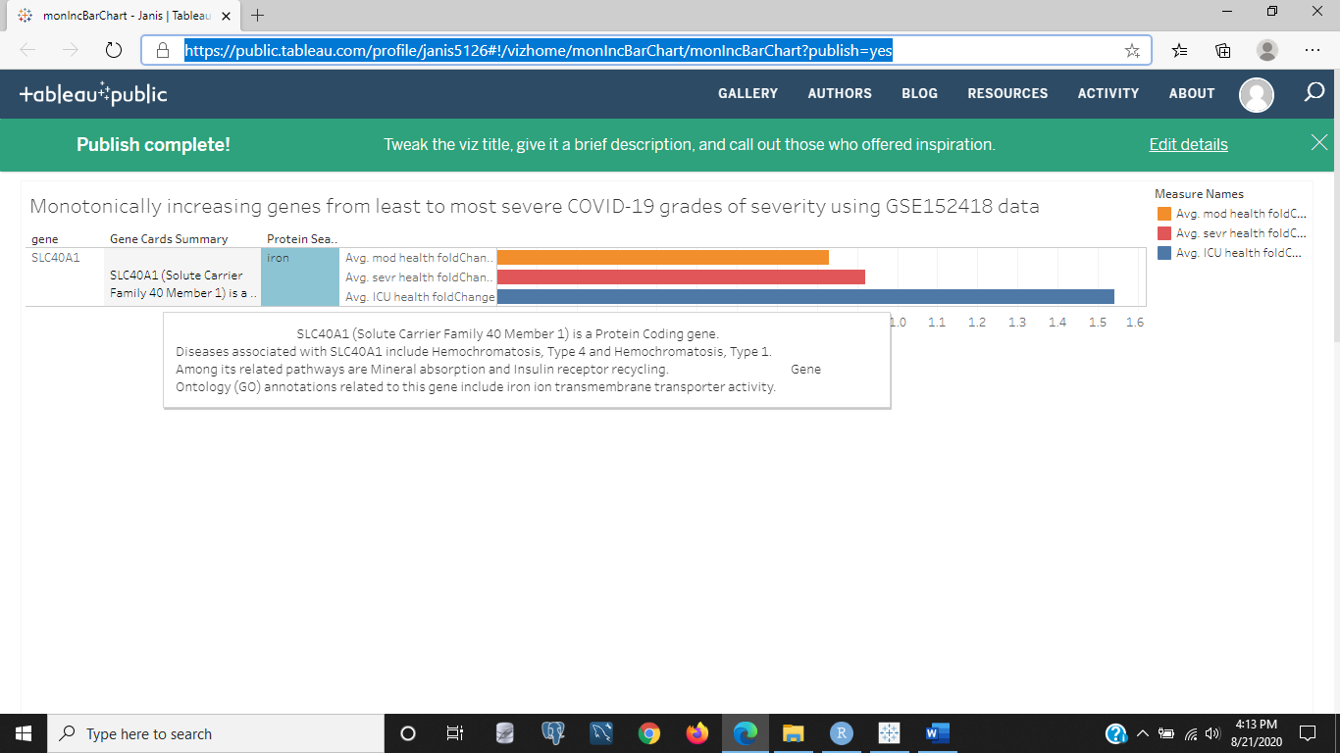

Figure 9: The image above is of those genes monotonically increasing but with iron selected as the 'keep only' gene to be displayed. We can see the description of this gene that is one of the top three ranked iron genes, SLC40A1, as associated with hemochromatosis Type I and Type 4, iron ion transmembrane transporter activity, and its related pathways include mineral absorption and insulin receptor recycling.

<https://public.tableau.com/profile/janis5126#!/vizhome/monDecBarChart/monDecBarChart?publish=yes>

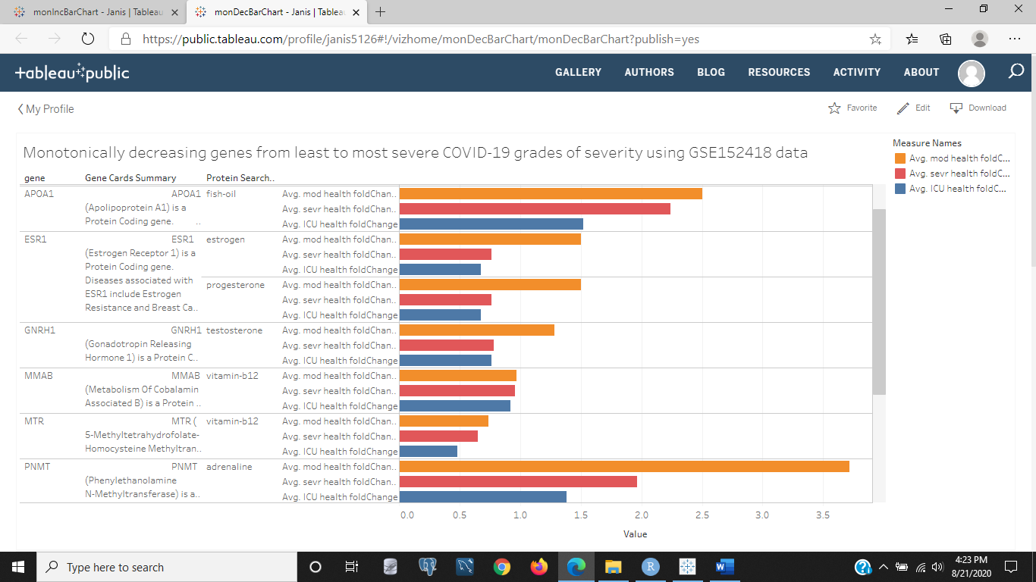

Figure 10: We already have this chart, because it is the monotonically increasing genes from least to most severe grades of COVID-19, except that iron was added to the data set and coincidentally not in this chart because its three genes are split between the monotonically decreasing and the genes nonmonotonic. Look at the genes that are higher in the least severe case and dramatically lower in the most severe case. Most are hormones, but one is a fish oil gene and a couple of vitamin B12 genes that aren't dramatically higher in the moderate compared to the ICU grade of COVID-19. Estrogen, progesterone, and testosterone are gender related hormones. The testosterone gene GNRH1 is produced in the hypothalamus which lies in front of the pituitary gland that produces estrogen and progesterone. Synthetic progesterone is consumed when eating legumes and yams. Adrenaline is the sympathetic hormone produced by the adrenal glands and released in times of extreme stress or fight or flight threats to personal safety. If you explore the chart further you will see that TNF is a corticosteroid and vitamin C gene that is dramatically higher in moderate cases than in ICU cases of COVID-19.

Thank you for reading this blog, if you have any questions leave a comment on the blog or message me. If you want me to research any data available for significant findings or a safety boundary of diet or healthy you can feel more secure at getting around in the world, or compare your healthy condition to survival statistics for people who have had or been exposed to any disease and the data is available, message me or email me at janis@themassagenegotiator.com.

Have a great rest of your week.