<https://public.tableau.com/profile/janis5126#!/vizhome/monotonicDecreaseCOVID19casesBarchart/monotonicDecrease?publish=yes>

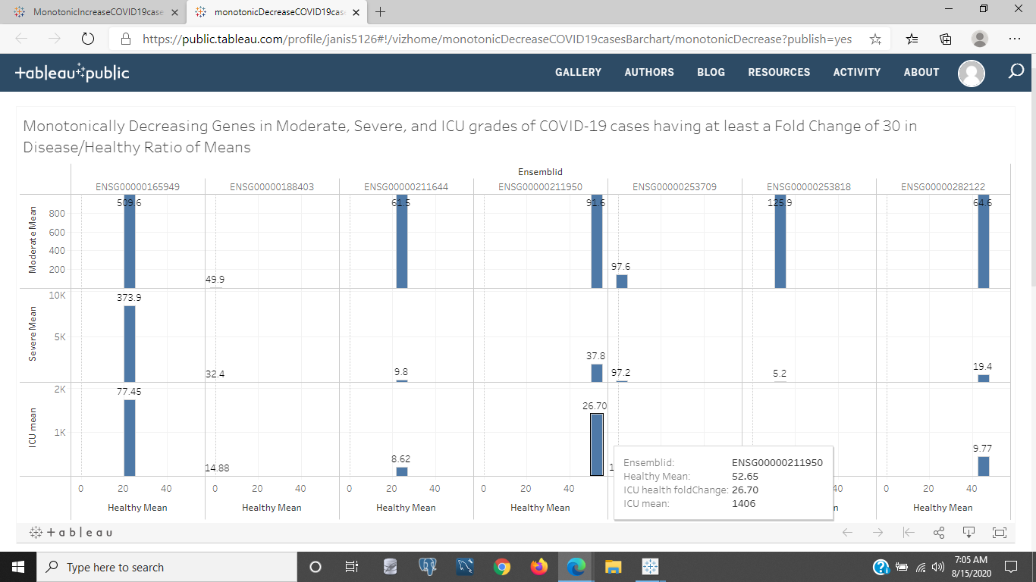

<https://public.tableau.com/profile/janis5126#!/vizhome/MonotonicIncreaseCOVID19casesBarchart/monotonicIncrease?publish=yes>

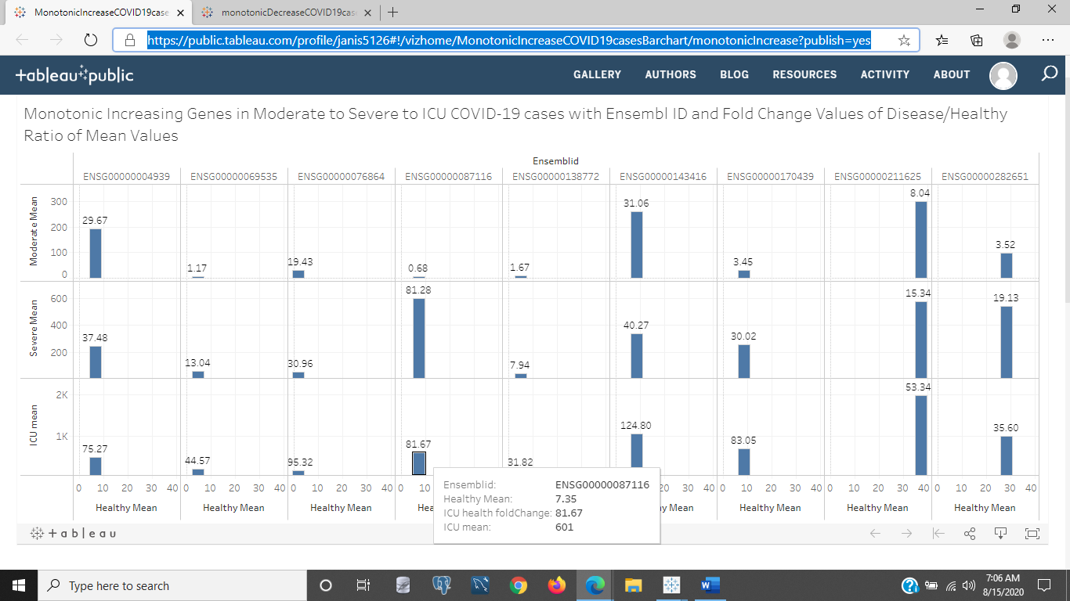

<https://public.tableau.com/profile/janis5126#!/vizhome/monotonicDecreaseFCgrtr20summs/monotonicDecrease2?publish=yes>

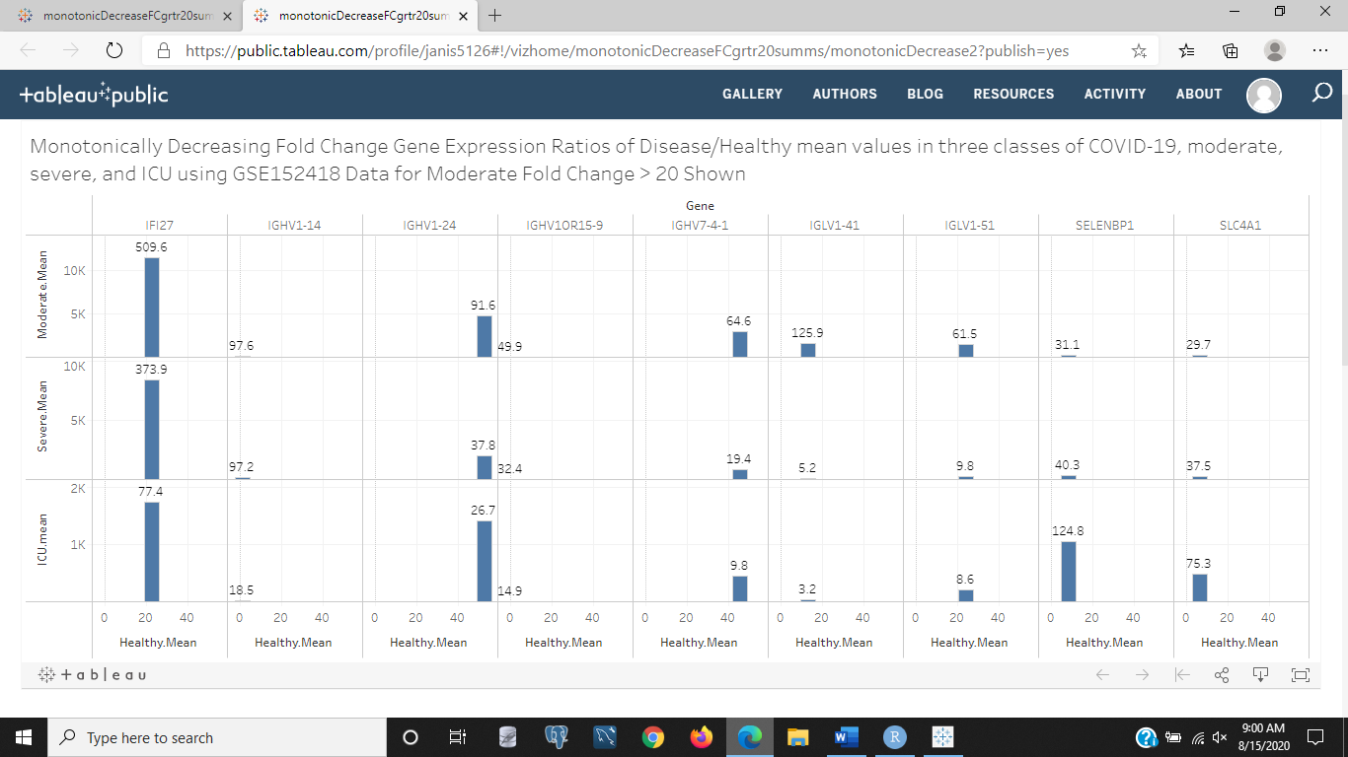

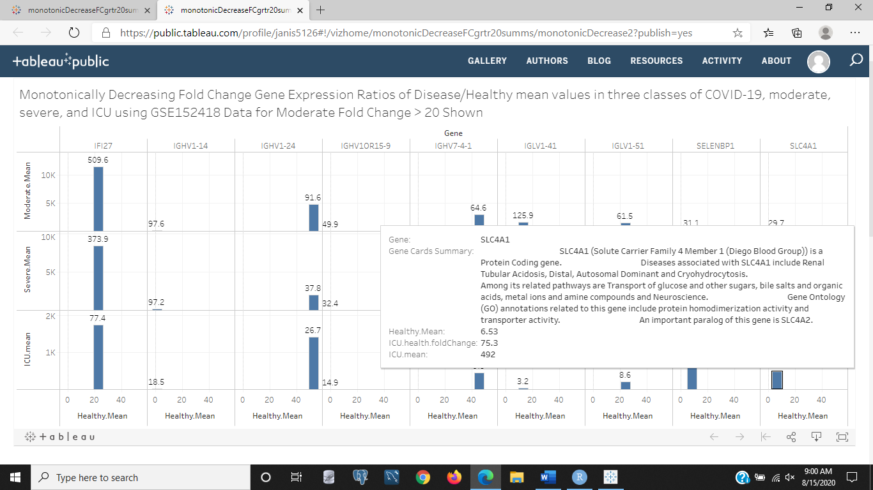

<https://public.tableau.com/profile/janis5126#!/vizhome/monotonicIncreaseFCgrtr30summs/monotonicIncrease2?publish=yes>

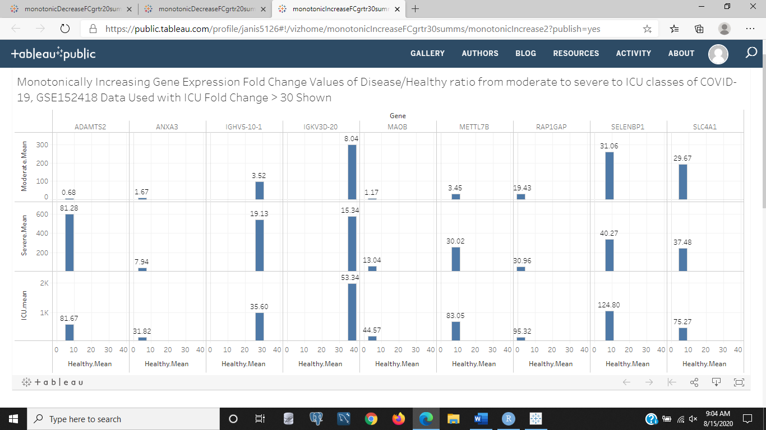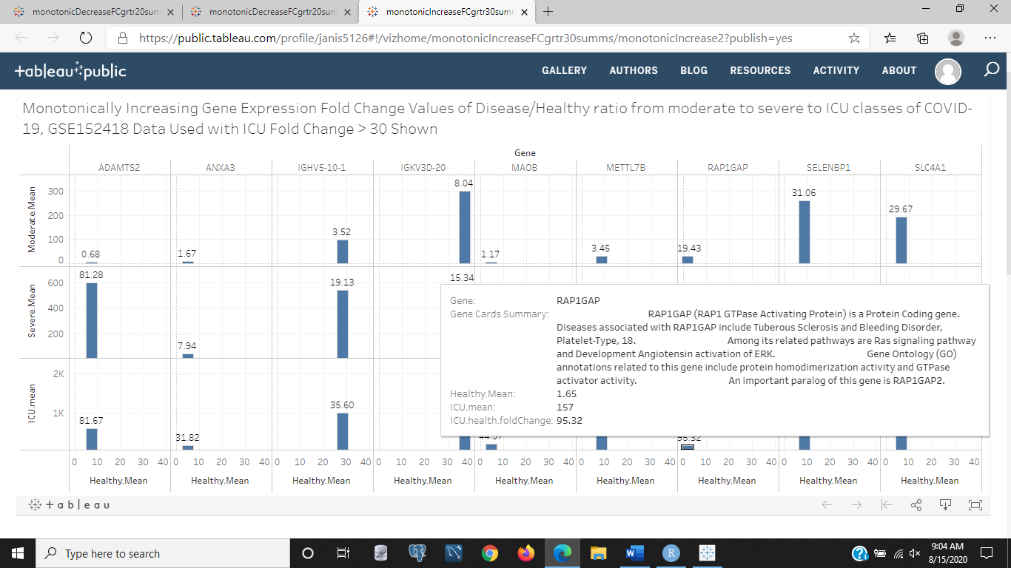

<https://public.tableau.com/profile/janis5126#!/vizhome/sunGenesCOVID19/vdrSunGenesCOVID19?publish=yes>

