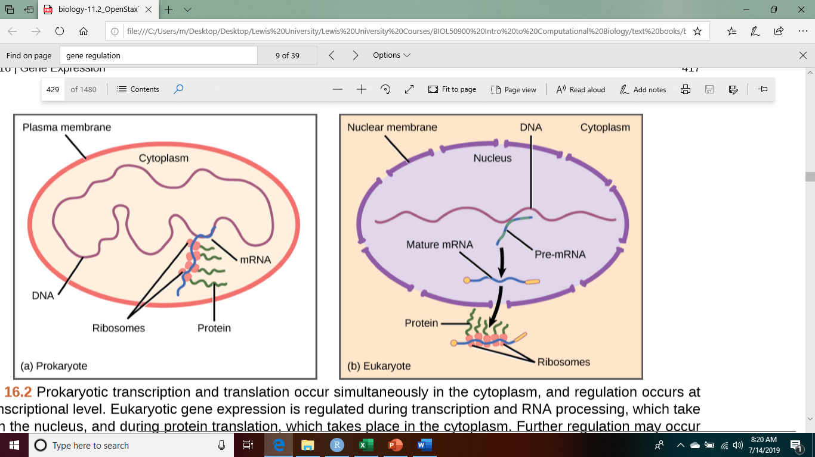

Biology. 2017. Houston, TX. OpenStax, ch.16, p417, Rye,C., Wise, R., Jurukovski, V., DeSai, J., Choi, J., & Avissair, Y. (2017). Biology. OpenStax.

