Top of Form

[Messages](https://api.turnitin.com/announcements.asp?r=27.9285801136407&svr=341&lang=en_us&) English [Help](https://help.turnitin.com/feedback-studio/integrations.htm)

Bottom of Form

**Turnitin**

* [Assignment Inbox](https://api.turnitin.com/s_class_portfolio.asp?r=27.9285801136407&svr=341&lang=en_us&aid=40198&cid=21077164&assignid=79531828&sub_assignid=&nav=0)

* [preferences](https://api.turnitin.com/integration_user_info.asp?r=27.9285801136407&svr=341&lang=en_us&)

Top of Form

STEP

Submit: Single File Upload

Congratulations - your submission is complete! This is your digital receipt. You can print a copy of this receipt from within the Document Viewer.

**Author:**

Janis Corona

**Assignment title:**

Week 1 Turnitin Written Assignment - Revised Proposal, Prospectus and Annotated Bibliography

**Submission title:**

Revised Proposal, Prospectus, and Annotated Bibliography_Janis

**File name:**

Week1_Proposal_Prospectus_AnnotatedBibliography.docx

**File size:**

50.39K

**Page count:**

29

**Word count:**

8902

**Character count:**

45924

**Submission date:**

07-Jun-2019 12:07PM (UTC-0500)

**Submission ID:**

1141128460

[«](https://api.turnitin.com/t_submit.asp?r=20.0799220601144&svr=333&lang=en_us&aid=79531828) Page 1 [»](https://api.turnitin.com/t_submit.asp?r=20.0799220601144&svr=333&lang=en_us&aid=79531828)

[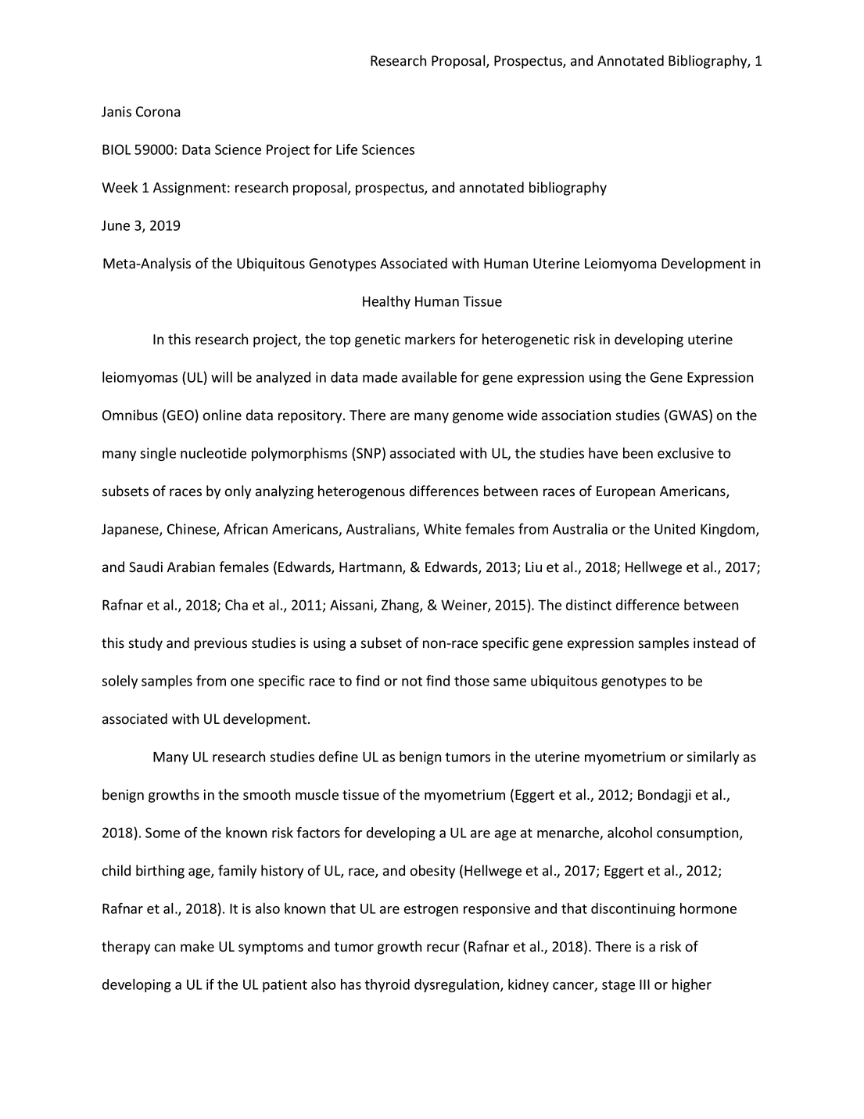](https://api.turnitin.com/panda/get_page_image.asp?m=6953af3b22b9874e3cf2d82811e95603&session-id=686a1fd928c0fcadb841e0e0c278cb17&submission_id=oid:1:1567117881&page=1)

We take your privacy very seriously. We do not share your details for marketing purposes with any external companies. Your information may only be shared with our third party partners so that we may offer our service.

Return to assignment list

Bottom of Form

Copyright © 1998 – 2019 [Turnitin, LLC](http://www.turnitin.com/). All rights reserved.

* [Privacy Policy](https://help.turnitin.com/Privacy_and_Security/Privacy_and_Security.htm#Privacy_Policy)

* [Privacy Pledge](https://help.turnitin.com/Privacy_and_Security/Privacy_and_Security.htm#Privacy_Pledge)

* [Terms of Service](https://help.turnitin.com/Privacy_and_Security/Privacy_and_Security.htm#Terms_of_Service)

* [EU Data Protection Compliance](https://help.turnitin.com/Privacy_and_Security/Privacy_and_Security.htm#EU_Data_Protection_and_GDPR_Compliance)

* [Copyright Protection](https://help.turnitin.com/Privacy_and_Security/Privacy_and_Security.htm#Copyright_Protection)

* [Legal FAQs](https://help.turnitin.com/Privacy_and_Security/Privacy_and_Security.htm#Legal_FAQs)

* [Helpdesk](https://api.turnitin.com/help/helpdesk.asp?r=27.9285801136407&svr=341&lang=en_us&)

* [Research Resources](http://www.plagiarism.org/)