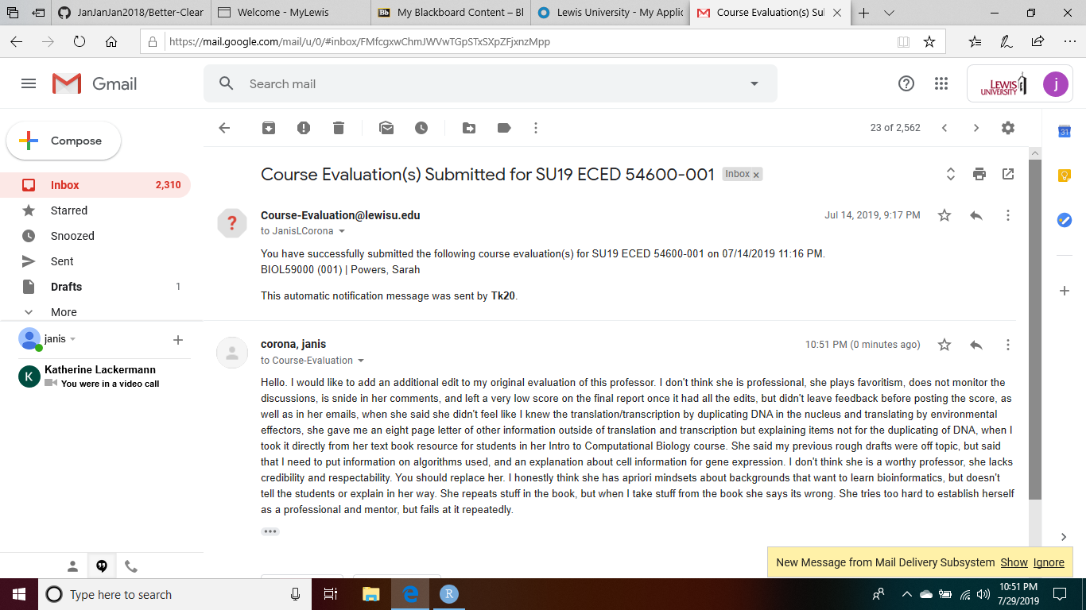

Hello. I would like to add an additional edit to my original evaluation of this professor. I don't think she is professional, she plays favoritism, does not monitor the discussions, is snide in her comments, and left a very low score on the final report once it had all the edits, but didn't leave feedback before posting the score, as well as in her emails, when she said she didn't feel like I knew the translation/transcription by duplicating DNA in the nucleus and translating by environmental effectors, she gave me an eight page letter of other information outside of translation and transcription but explaining items not for the duplicating of DNA, when I took it directly from her text book resource for students in her Intro to Computational Biology course. She said my previous rough drafts were off topic, but said that I need to put information on algorithms used, and an explanation about cell information for gene expression. I don't think she is a worthy professor, she lacks credibility and respectability. You should replace her. I honestly think she has apriori mindsets about backgrounds that want to learn bioinformatics, but doesn't tell the students or explain in her way. She repeats stuff in the book, but when I take stuff from the book she says its wrong. She tries too hard to establish herself as a professional and mentor, but fails at it repeatedly.