Go back to the BLS HighLowWages.csv file we created for 2017 earlier in Tableau open it up as a text file. We need to hide the Year for the State field added earlier so do that now if you didn’t do it earlier. Then we also need to create a WageGap field between the state middle income earners and the low pay workers by Metro. This calculated field will be one field, not multiple fields like the average wage fields calculated earlier for each of the 14 metro regions.

For this select all the fields except the Year field, right click and scroll down to select ‘pivot’, this will make the fields pivot rows:

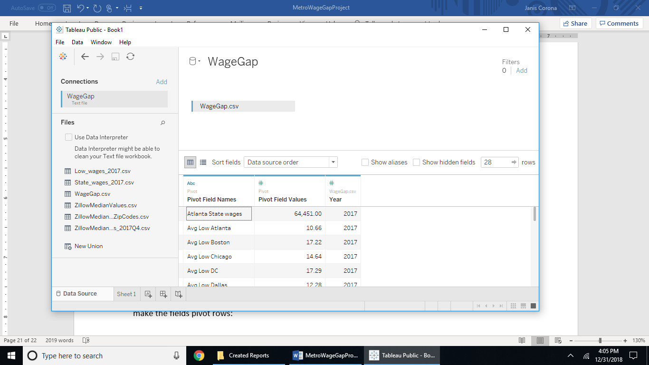

This calculation for a new field called AnnualWages can be copied and pasted into Tableau, sometimes the font throws it off, but it should work:

If [Region] == 'Atlanta State wages' then [Wages]

ELSEIF [Region] =='Boston State wages' then [Wages]

ELSEIF [Region] =='Chicago State wages' then [Wages]

ELSEIF [Region] =='DC State wages' then [Wages]

ELSEIF [Region] =='Dallas State wages' then [Wages]

ELSEIF [Region] =='Detroit State wages' then [Wages]

ELSEIF [Region] =='LA State wages' then [Wages]

ELSEIF [Region] =='Manhattan state wages' then [Wages]

ELSEIF [Region] =='Miami State wages' then [Wages]

ELSEIF [Region] =='Philly State wages' then [Wages]

ELSEIF [Region] =='Phoenix State wages' then [Wages]

ELSEIF [Region] =='Riv State wages' then [Wages]

ELSEIF [Region] =='SF State wages' then [Wages]

ELSEIF [Region] =='Houston State wages' then [Wages]

ELSE [Wages]*8*5*52 end

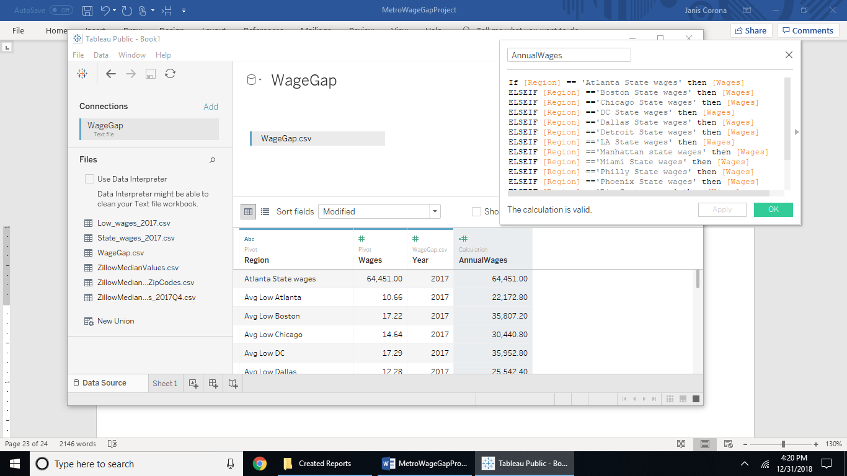

Then filter out the year value by Region, select all then uncheck the year value.

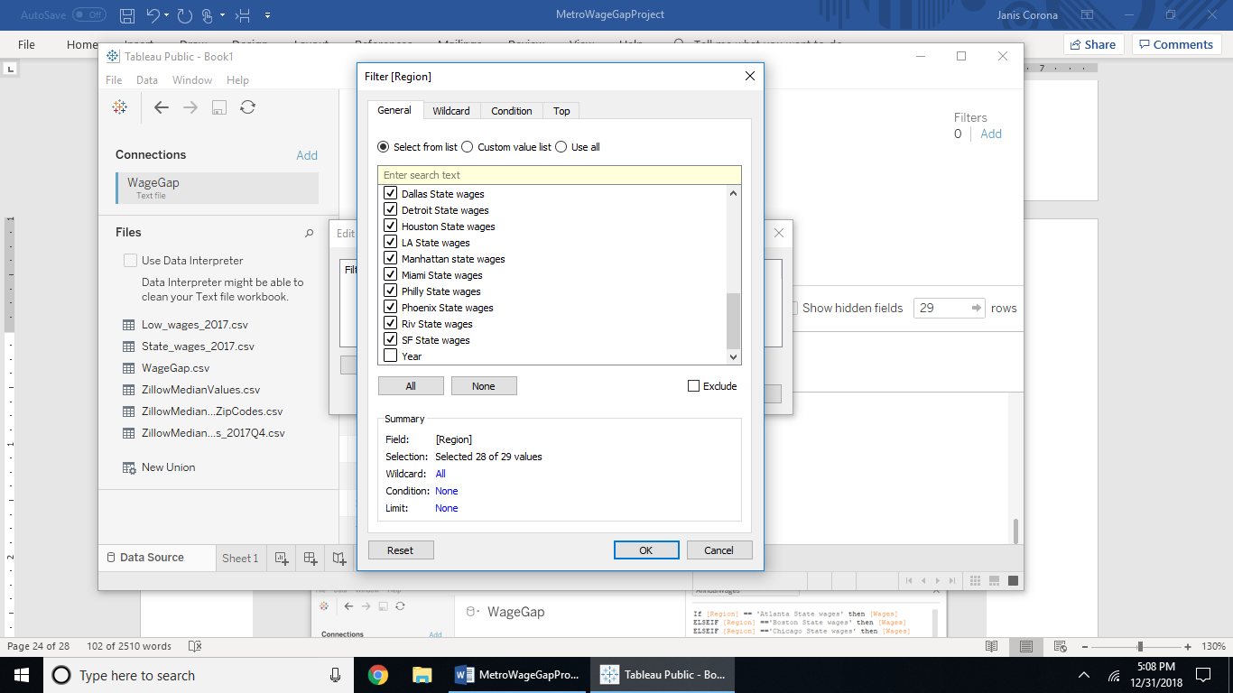

Another calculated field is to input strings of metro by low or high wages.

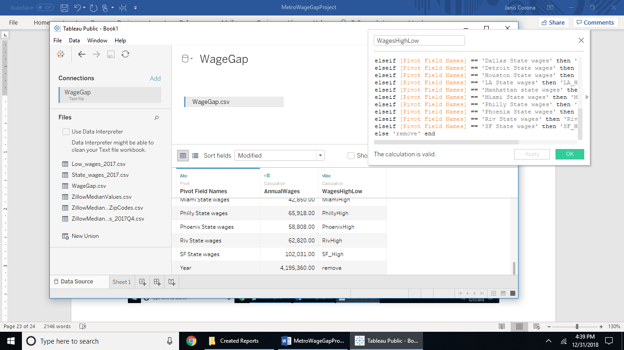

This calculated field is to be named WagesHighLow. The calculation to copy and paste is:

if [Region] == 'Atlanta State wages' then 'AtlantaHigh'

ELSEIF [Region] == 'Avg Low Atlanta' then 'AtlantaLow'

elseif [Region] == 'Avg Low Boston' then 'BostonLow'

ELSEIF [Region] == 'Avg Low Chicago' then 'ChicagoLow'

elseif [Region] == 'Avg Low DC' then 'DC_Low'

elseif [Region] == 'Avg Low Dallas' then 'DallasLow'

elseif [Region] == 'Avg Low Detroit' then 'DetroitLow'

elseif [Region] == 'Avg Low Houston' then 'HoustonLow'

elseif [Region] == 'Avg Low LA' then 'LA_Low'

elseif [Region] == 'Avg Low Miami' then 'MiamiLow'

elseif [Region] == 'Avg Low NY' then 'NY_Low'

ELSEIF [Region] == 'Avg Low Philly' then 'PhillyLow'

elseif [Region] == 'Avg Low Phoenix' then 'PhoenixLow'

elseif [Region] == 'Avg Low Riv' then 'RivLow'

elseif [Region] == 'Avg Low SF' then 'SF_Low'

elseif [Region] == 'Boston State wages' then 'BostonHigh'

elseif [Region] == 'Chicago State wages' then 'ChicagoHigh'

elseif [Region] == 'DC State wages' then 'DC_High'

elseif [Region] == 'Dallas State wages' then 'DallasHigh'

elseif [Region] == 'Detroit State wages' then 'DetroitHight'

elseif [Region] == 'Houston State wages' then 'HoustonHigh'

elseif [Region] == 'LA State wages' then 'LA_High'

elseif [Region] == 'Manhattan state wages' then ' NY_High'

elseif [Region] == 'Miami State wages' then 'MiamiHigh'

elseif [Region] == 'Philly State wages' then 'PhillyHigh'

elseif [Region] == 'Phoenix State wages' then 'PhoenixHigh'

elseif [Region] == 'Riv State wages' then 'RivHigh'

elseif [Region] == 'SF State wages' then 'SF_High'

else '' end

Now to make the wage gap field with another calculated field. Hide all the columns except for the AnnualWages and the WagesHighLow fields.

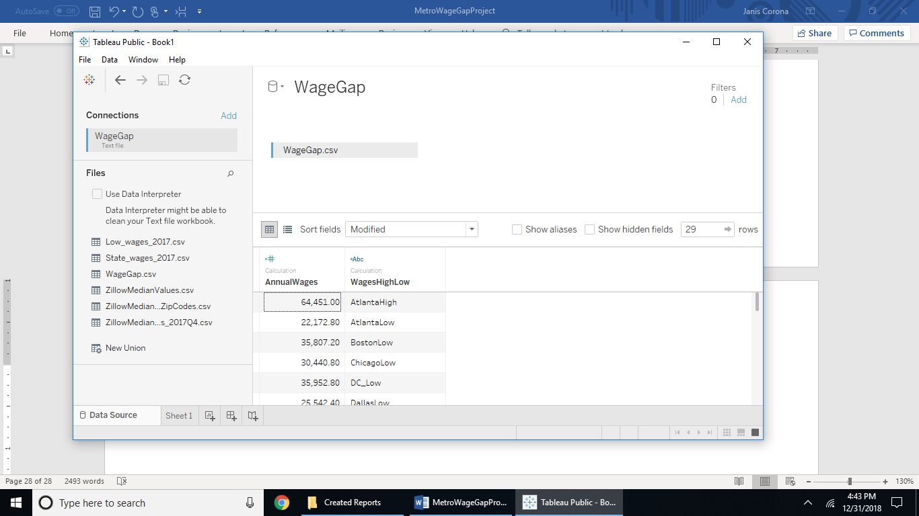

Remove the pivot of the Region field by right clicking and selecting to remove the pivot, then select all fields except the calculated fields and right click to choose pivot again. This way you can hide all the fields except the calculated fields and export to csv from the Data tab and save this file as WageGap.csv

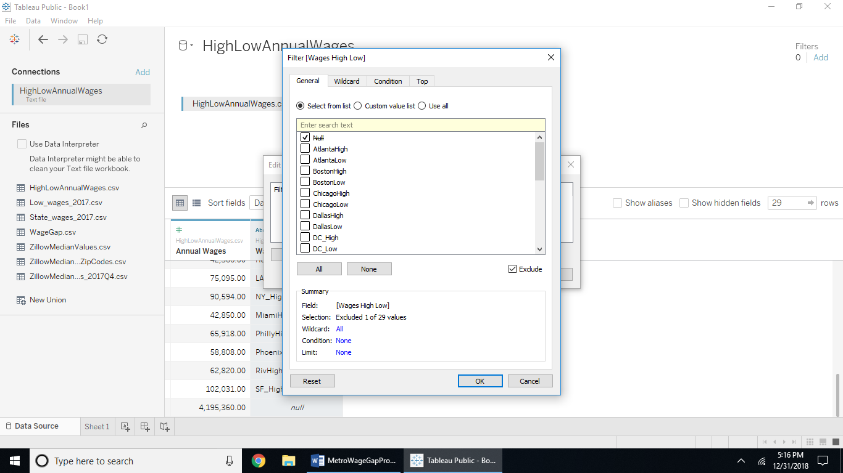Reopen the newest file WageGap.csv and filter out the null value by selecting it and the Exclude option for the Wages High Low field.

There is no calculations that can be done on this file, go back to the HighLowWages.csv and perform annual and wageGap calculations manually.