<https://www.bls.gov/data/>

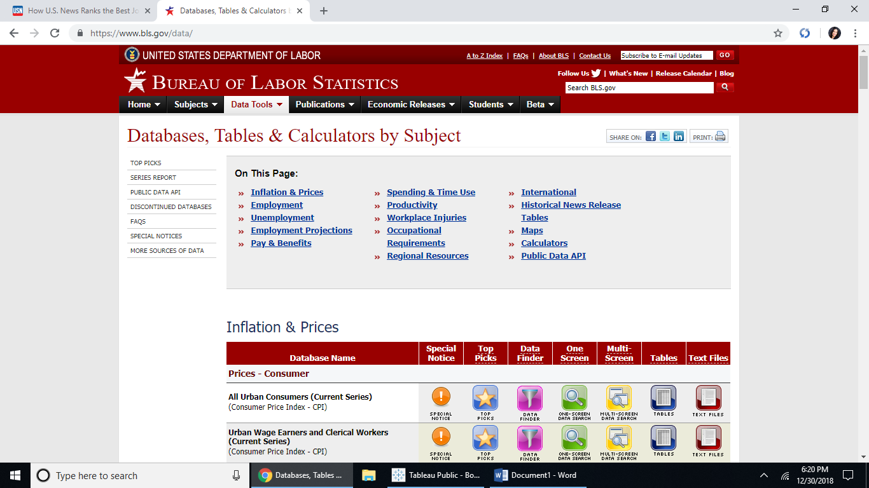

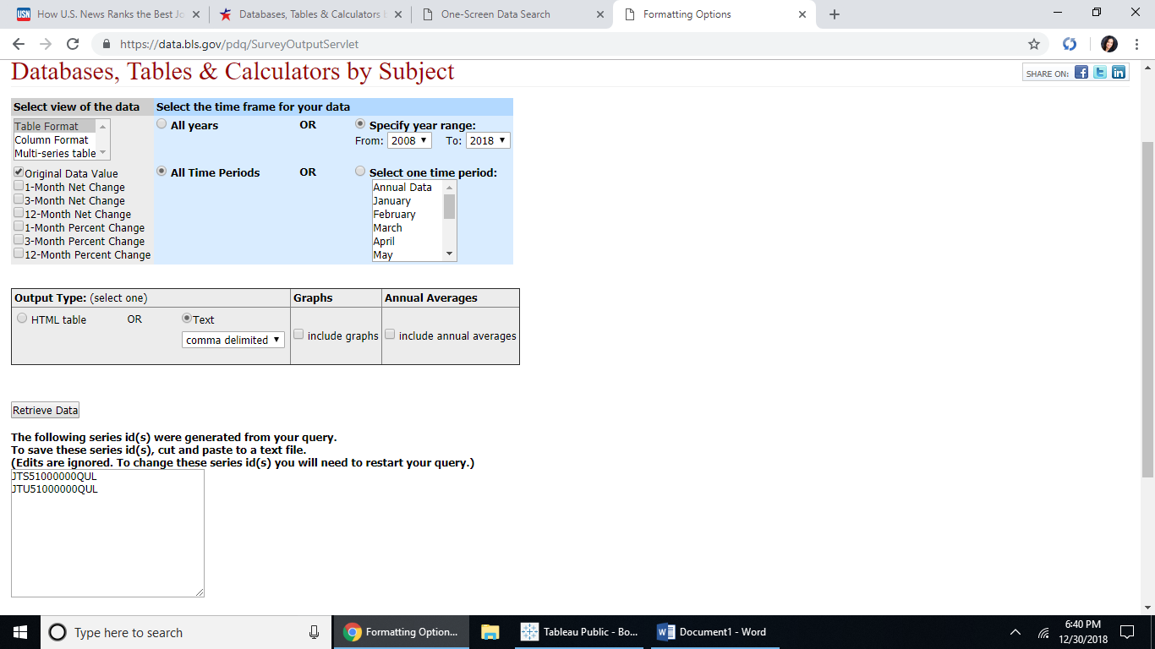JTS51000000QUL

JTU51000000QUL

Data extracted on: December 30, 2018 (9:42:08 PM)

**Job Openings and Labor Turnover Survey**

Series Id:     JTS51000000QUL

Seasonally adjusted

Industry:      Information

Region:        Total US

Data Element:  Quits

Rate/Level:    Level - In Thousands

Year,Jan,Feb,Mar,Apr,May,Jun,Jul,Aug,Sep,Oct,Nov,Dec

2008,43,46,38,41,39,35,39,39,33,37,20,29

2009,34,29,36,32,43,30,40,27,26,26,32,29

2010,16,26,46,24,22,27,27,26,28,35,37,46

2011,26,33,30,40,35,33,31,38,40,32,33,31

2012,37,33,34,27,35,41,31,44,40,36,34,45

2013,39,29,30,37,37,41,39,54,30,28,29,36

2014,38,42,44,42,42,39,37,36,35,50,43,37

2015,37,45,49,42,41,43,45,41,44,45,41,32

2016,40,39,39,42,40,37,42,34,54,41,36,45

2017,40,47,39,38,34,42,52,49,51,44,46,50

2018,50,49,43,48,56,51,49,49,47,48(P), ,

P : preliminary

Series Id:     JTU51000000QUL

Not seasonally adjusted

Industry:      Information

Region:        Total US

Data Element:  Quits

Rate/Level:    Level - In Thousands

Year,Jan,Feb,Mar,Apr,May,Jun,Jul,Aug,Sep,Oct,Nov,Dec

2008,53,37,31,45,38,33,45,49,33,40,19,22

2009,42,23,29,34,41,28,45,34,26,28,32,23

2010,19,20,38,25,21,26,30,34,28,37,36,38

2011,32,25,25,41,33,33,34,51,41,33,32,26

2012,44,27,30,28,33,40,35,56,39,38,30,39

2013,47,21,24,37,35,39,43,65,32,28,24,33

2014,46,35,39,42,40,37,42,49,38,50,36,34

2015,44,38,44,41,39,42,50,53,47,44,32,29

2016,47,33,34,41,37,35,47,46,58,40,27,42

2017,48,42,34,37,31,40,58,61,55,43,37,48

2018,57,44,38,47,54,48,56,60,50,47(P), ,

P : preliminary

Data extracted on: December 30, 2018 (9:46:38 PM)

#### Job Openings and Labor Turnover Survey

Series Id:     JTS51000000HIL

Seasonally adjusted

Industry:      Information

Region:        Total US

Data Element:  Hires

Rate/Level:    Level - In Thousands

Year,Jan,Feb,Mar,Apr,May,Jun,Jul,Aug,Sep,Oct,Nov,Dec

2008,76,64,69,66,58,67,56,49,66,67,54,55

2009,63,54,55,53,55,55,59,43,53,53,59,65

2010,57,48,49,45,46,52,55,54,53,59,62,67

2011,58,47,63,72,63,64,52,67,65,59,61,60

2012,53,67,61,62,63,54,55,83,57,63,70,66

2013,58,77,46,67,83,81,77,68,81,66,63,75

2014,77,59,89,76,67,71,80,75,62,80,83,75

2015,77,77,78,78,85,78,80,81,80,90,75,71

2016,83,82,75,95,73,85,77,76,81,76,78,80

2017,79,79,80,69,77,71,80,81,82,82,79,83

2018,79,82,84,84,89,78,76,77,78,80(P), ,

P : preliminary

Series Id:     JTU51000000HIL

Not seasonally adjusted

Industry:      Information

Region:        Total US

Data Element:  Hires

Rate/Level:    Level - In Thousands

Year,Jan,Feb,Mar,Apr,May,Jun,Jul,Aug,Sep,Oct,Nov,Dec

2008,91,51,62,71,57,76,58,53,65,72,53,45

2009,75,43,49,57,53,64,60,46,51,57,60,55

2010,66,38,42,47,46,61,55,58,50,63,65,59

2011,65,38,54,75,64,75,52,71,61,63,65,53

2012,57,55,53,63,66,64,57,85,54,66,73,57

2013,62,66,40,68,88,96,80,69,76,72,63,62

2014,84,51,77,77,71,84,85,75,59,90,80,61

2015,88,66,68,79,87,92,86,81,76,103,71,57

2016,96,70,65,96,73,99,83,76,77,88,74,64

2017,94,67,70,69,77,83,85,81,79,96,75,67

2018,92,70,74,84,92,88,79,77,75,94(P), ,

P : preliminary

Data extracted on: December 30, 2018 (9:47:15 PM)

#### Job Openings and Labor Turnover Survey

Series Id:     JTS51000000LDL

Seasonally adjusted

Industry:      Information

Region:        Total US

Data Element:  Layoffs and discharges

Rate/Level:    Level - In Thousands

Year,Jan,Feb,Mar,Apr,May,Jun,Jul,Aug,Sep,Oct,Nov,Dec

2008,21,21,35,23,20,33,19,21,43,40,42,36

2009,33,37,37,49,29,30,30,23,18,25,27,38

2010,30,23,23,19,29,25,24,26,21,21,23,28

2011,21,20,36,19,23,21,26,20,20,23,25,23

2012,21,26,23,25,22,18,17,33,18,19,20,18

2013,20,21,13,26,25,38,25,40,33,18,20,27

2014,23,25,38,27,22,23,37,22,25,25,19,24

2015,26,24,25,21,24,28,25,25,25,29,32,19

2016,26,21,23,29,28,26,28,24,13,19,27,25

2017,26,26,27,26,36,25,24,28,37,33,21,29

2018,31,26,27,29,25,22,24,27,28,16(P), ,

P : preliminary

Series Id:     JTU51000000LDL

Not seasonally adjusted

Industry:      Information

Region:        Total US

Data Element:  Layoffs and discharges

Rate/Level:    Level - In Thousands

Year,Jan,Feb,Mar,Apr,May,Jun,Jul,Aug,Sep,Oct,Nov,Dec

2008,40,20,31,19,16,30,21,18,36,41,42,40

2009,60,35,33,40,24,28,32,19,15,25,28,44

2010,51,21,21,16,25,22,25,22,18,20,24,33

2011,35,18,34,17,21,18,26,18,18,22,25,27

2012,33,22,22,24,21,17,18,30,16,18,19,20

2013,30,17,12,27,23,36,24,38,32,17,19,27

2014,34,20,36,28,20,22,35,20,26,24,19,23

2015,41,18,23,23,23,28,24,23,25,28,31,18

2016,42,15,22,32,27,26,27,22,13,19,27,23

2017,42,19,25,28,36,24,24,26,34,33,21,27

2018,52,17,25,32,24,20,22,25,29,14(P), ,

P : preliminary

Data extracted on: December 30, 2018 (9:47:48 PM)

#### Job Openings and Labor Turnover Survey

Series Id:     JTS51000000OSL

Seasonally adjusted

Industry:      Information

Region:        Total US

Data Element:  Other separations

Rate/Level:    Level - In Thousands

Year,Jan,Feb,Mar,Apr,May,Jun,Jul,Aug,Sep,Oct,Nov,Dec

2008,6,6,3,8,4,5,8,2,6,4,6,12

2009,4,2,6,6,8,7,3,7,4,11,6,6

2010,10,4,8,3,3,6,3,5,8,5,5,4

2011,11,4,3,6,3,3,5,2,5,3,1,6

2012,3,1,5,3,4,7,1,13,7,6,6,6

2013,10,2,9,4,8,7,4,5,6,7,6,7

2014,16,3,5,6,8,5,8,5,10,9,4,10

2015,10,8,11,7,13,8,12,13,11,9,6,11

2016,16,10,5,15,10,8,12,12,11,12,9,13

2017,13,7,12,12,11,5,12,6,12,3,6,8

2018,11,9,4,8,10,8,5,7,6,4(P), ,

P : preliminary

Series Id:     JTU51000000OSL

Not seasonally adjusted

Industry:      Information

Region:        Total US

Data Element:  Other separations

Rate/Level:    Level - In Thousands

Year,Jan,Feb,Mar,Apr,May,Jun,Jul,Aug,Sep,Oct,Nov,Dec

2008,6,6,3,8,4,5,8,2,6,4,6,12

2009,4,2,6,6,8,7,3,7,4,11,6,6

2010,10,4,8,3,3,6,3,5,8,5,5,4

2011,11,4,3,6,3,3,5,2,5,3,1,6

2012,3,1,5,3,4,7,1,13,7,6,6,6

2013,10,2,9,4,8,7,4,5,6,7,6,7

2014,16,3,5,6,8,5,8,5,10,9,4,10

2015,10,8,11,7,13,8,12,13,11,9,6,11

2016,16,10,5,15,10,8,12,12,11,12,9,13

2017,13,7,12,12,11,5,12,6,12,3,6,8

2018,11,9,4,8,10,8,5,7,6,4(P), ,

P : preliminary

<https://data.bls.gov/pdq/SurveyOutputServlet>

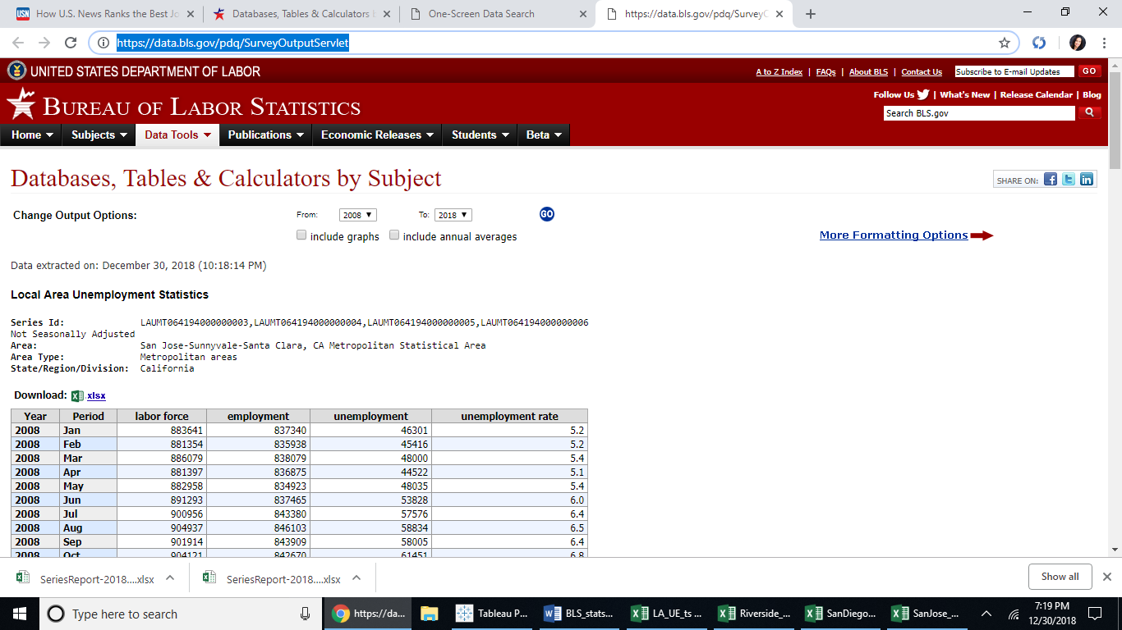

<https://www.bjs.gov/index.cfm?ty=tp&tid=31>

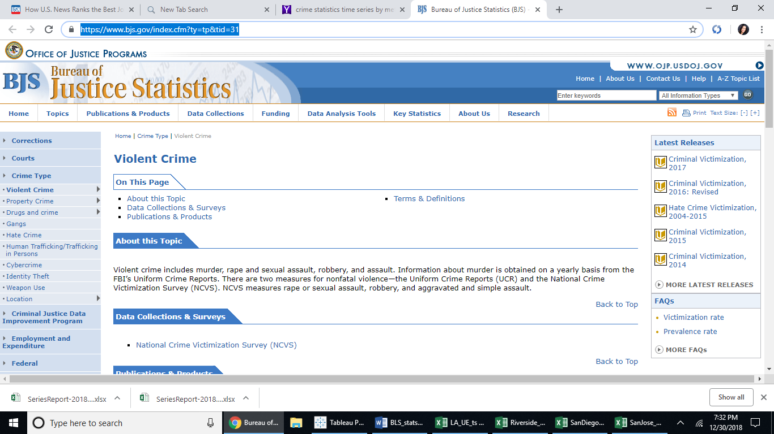

<https://www.cdc.gov/nchs/data_access/Vitalstatsonline.htm>

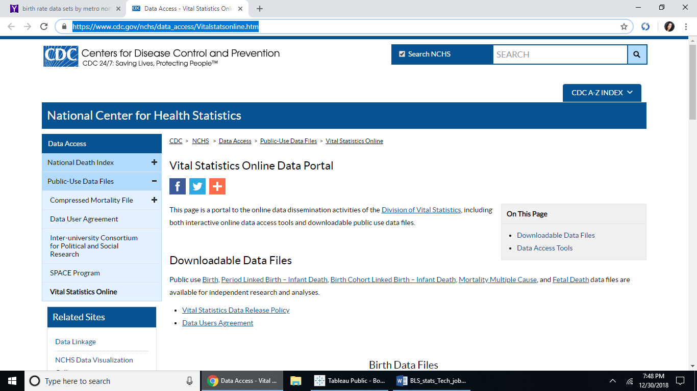

<https://www.bls.gov/oes/current/oes_31080.htm>

