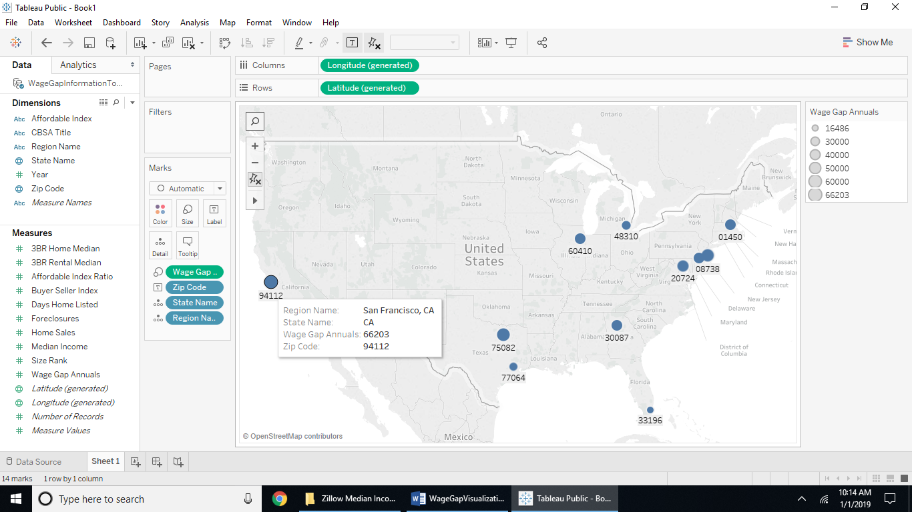

The above screenshot shows the US map of the top 14 metro regions with wage gap annual values shown larger if the value is larger as a blue dot. Hovering over the dots will bring up the state name, zip code and the wage gap annual value for that metro. San Francisco, CA is shown to have a wage gap of $66,203 per year.

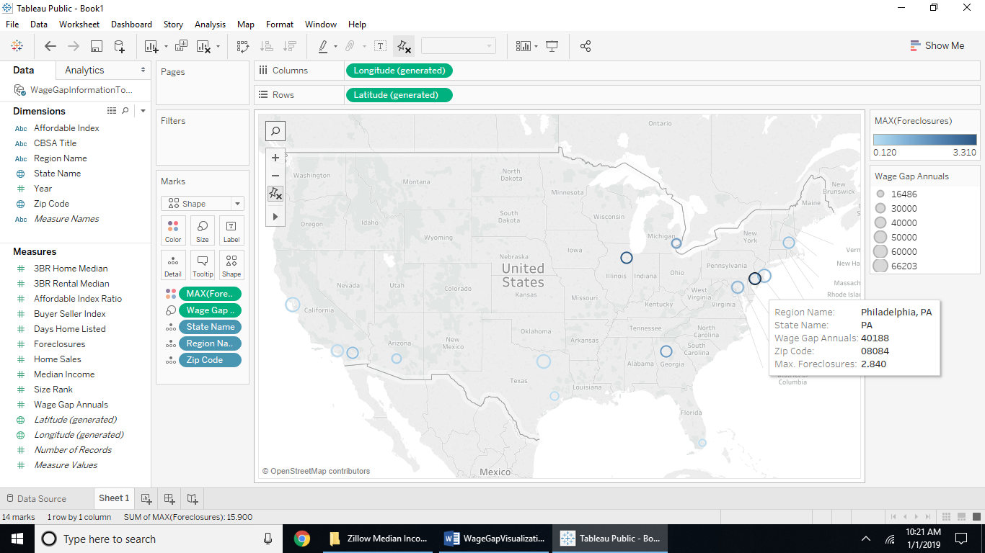

The above screenshot shows the top 14 metros by location along a US map by zip code with the darker open circles as maximum of foreclosures as a valuer per 10,000 homes in that metro. Using max() is irrelevant to the data, since the values are one aggregate value per region, it is already the max() and the min() of each regional metro location. The lighter and almost invisible open circles indicate less foreclosures than the competing regions. The darker areas are chicago and Philladelphia of the top 14 metro populations with foreclosures. The size of the open circles indicates the regions with larger wage gaps between high paying state jobs like teacher, law enforcement, health departments, versus the low paying wages of food preparers, cashiers, food servers, and security guards. The larger open circles are seen as San Francisco, Dallas, and New York metros.

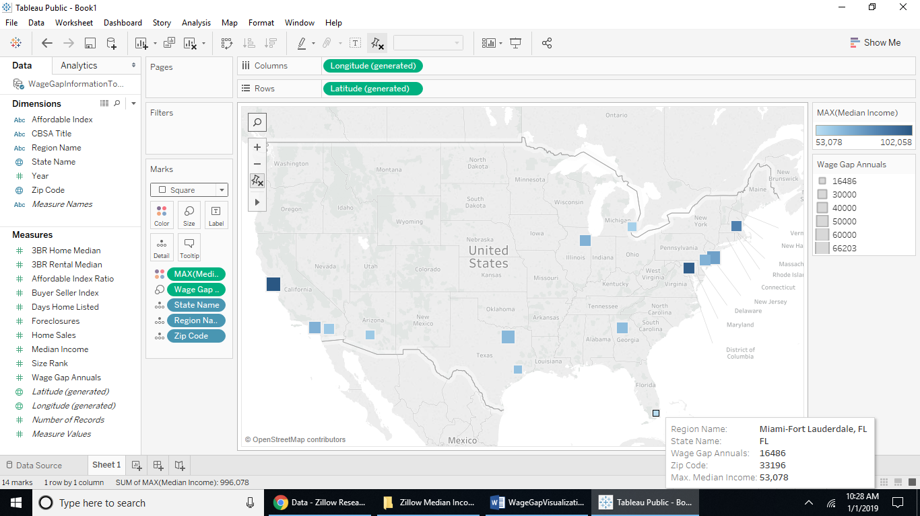

From the above screenshot the visualization shows square map markers with the larger squares representing higher wage gaps and the darker squares representing the higher median incomes. You can see the two run together, with the higher median values also having higher wage gaps, and the lower median incomes also having lower wage gap values. Such as Miami which is shown to have a wage gap of $16,000 but a median income of $53,000.

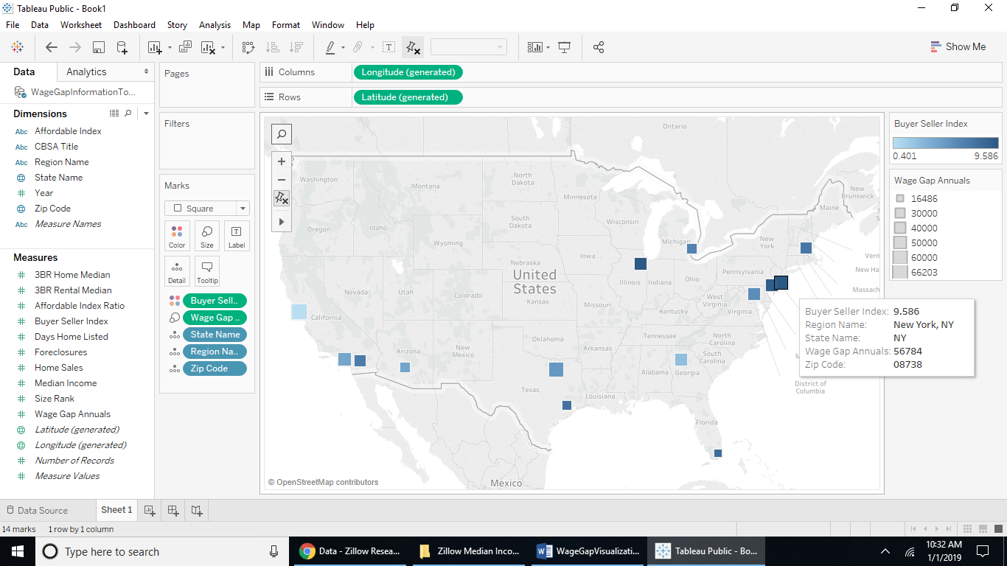

The above screenshot shows regions of darker square markers being a buyer’s market and the regions of lighter square markets as closer to a seller’s market using the buyer-seller index value where below 5 is a seller’s market and above 5 is a buyer’s market. When using the wage gap as the size of the sqare mapped marker you can tell that median values for wage gaps are more a buyer’s market when examining New York. Also, when looking at San Francisco, they also are in a seller’s market with a lower buyer-seller index than it’s competitors in the top 14 metro populations but also being one of the largest square marker’s indicating a higher wage gap than competitors by region.

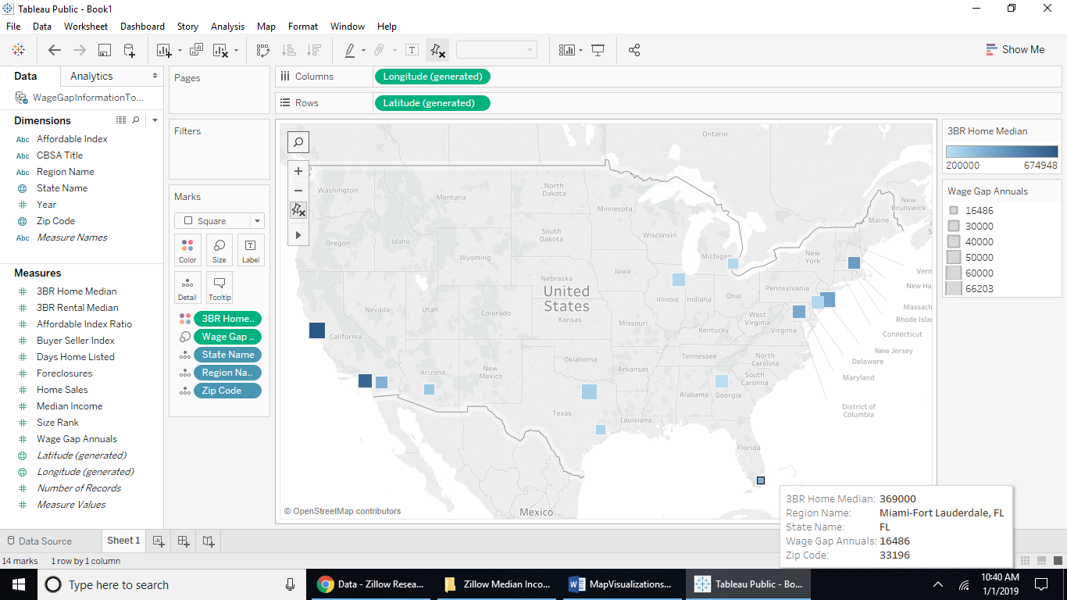The above screenshot shows the relationship to median three bedroom home values and the wage gap. The darker markers are the regions with higher home values while the larger markers are the ones with the higher wage gaps. San Francisco has a higher wage gap and a higher home value and Miami has a smaller wage gap but middle range home values. Take a look at Houston, it has a smaller wage gap by its size and a lower home value by its color indicator being lighter. Houston is almost equivalent to Detroit in terms of home values and wage gap. Houston is known to have had two major floods with home devastation in the last five years but be a hustel and bustle tech industry, while Detroit is known to be a declining automotive industry region with financial troubles and super cold weather. Would you rather live in Houston or Detroit?

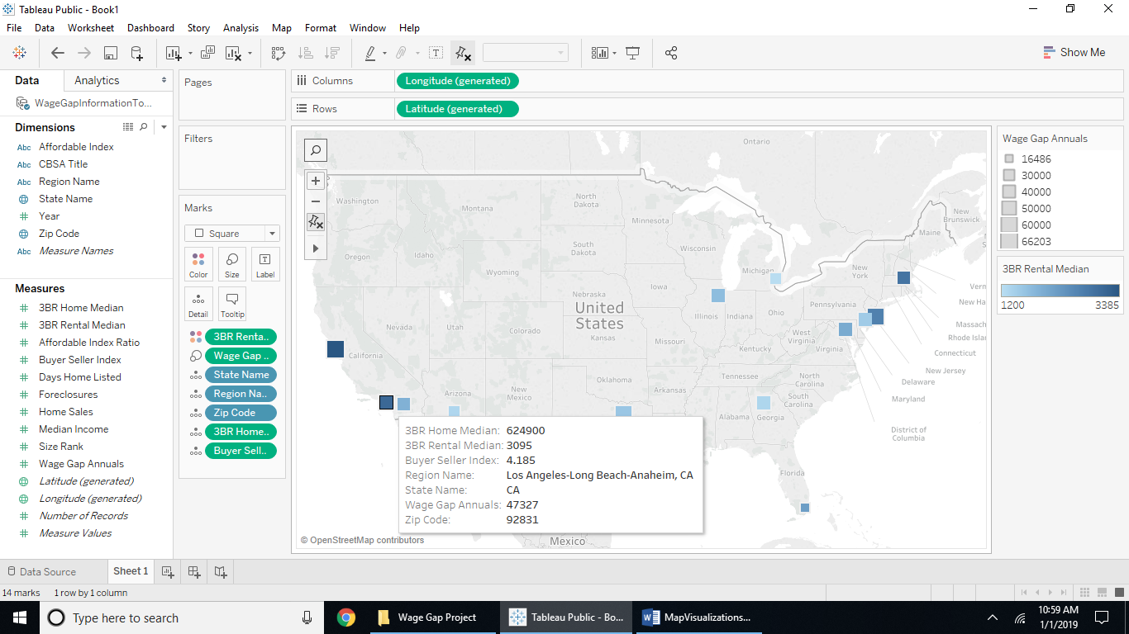

When looking at the rental price and wage gap by metro median values for 2017 as all values are from the end of 2017 values, the map is almost identical to the map showing median home values in relation to wage gaps by regional metro. The 3-bedroom rental price is $3,095 as a median value for the LA and Orange County regions. When hovering over the markers to get the details the home median value for the same rental is $624,000. When you recall the buyer-seller map, LA was right in the middle of the median values for it’s color indicator meaning the market is neither a buyer’s nor a seller’s market. But the value of 4.185 indicates it is closer to a seller’s market as it is below 5 on a scale of 1 to 10.