This blog is about the genes that are found to be associated with serous fluid found in the body's peritoneum or heart cavity, the pleural cavity that holds the lungs, and the peritoneum cavity that holds the abdominal and pelvis organs. I used the same genecards.org to gather the 25 most associated genes with serous fluid, then compared the ten most associated genes in our tables of uterine leiomyoma (UL) and non-uterine leiomyoma tissue samples and our samples of flu immunized blood samples after 1 and 7 days with the healthy and non-immunized blood samples as the control group.

I uploaded the results then made some tables on the samples means for each type of tissue and the fold change values of the diseased to healthy or treated to healthy samples. This document is at <https://www.rpubs.com/janisharris/fluAndUL-foldChange-serousFluidCavities> .

Note that every image links to the Tableau Public Server online interactive chart to explore the various details by hovering and scrolling each chart.

<https://public.tableau.com/profile/janis5126#!/vizhome/fluUnderULanySerousGenesFC/fluUnderULanySerousGenesFC?publish=yes>

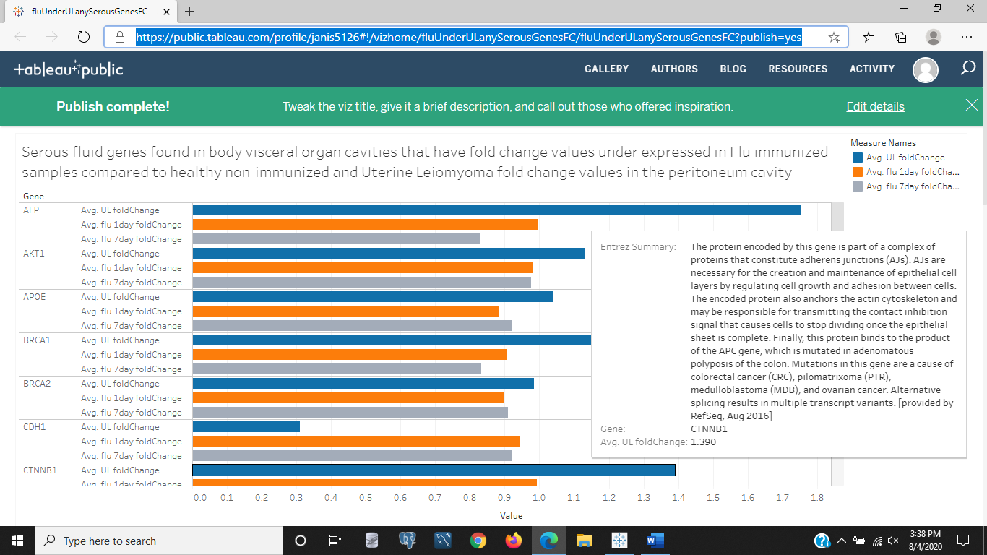

Figure 1: Fold change values between Uterine Leiomyoma (UL) compared to non-UL and flu immunized samples over 1 day compared to healthy and non-immunized samples, as well as flu immunized samples over 7 days compared to healthy and non-immunized samples. The genes are the gene that are associated with serous fluid in the body cavities that protect the organs but in this image also have under expressed gene values compared to healthy samples for both time periods of flu samples of 1 or 7 days after inocculation.

<https://public.tableau.com/profile/janis5126#!/vizhome/fluOverULanySerousGenesFC/fluOverULanySerousGenesFC?publish=yes>

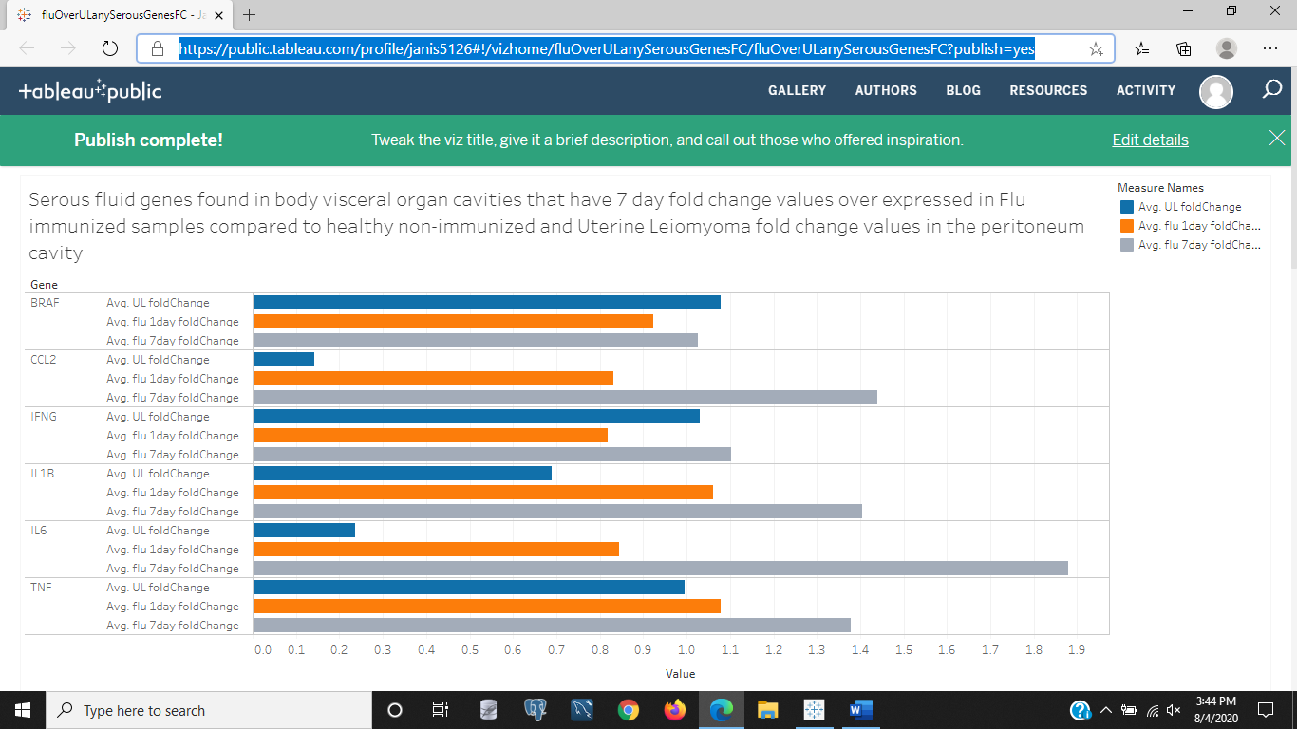

Figure 2: The above figure is also an interactive chart of the fold change values in genes associated with serous fluid in UL and flu immunized samples, but for those flu immunized samples after 7 days of being inocculated that have over expresssion in these genes compared to non-immunized and healthy samples. The gene summary for each gene and what diseases are associated with each gene is given when each bar is hovered over.

<https://public.tableau.com/profile/janis5126#!/vizhome/UL_overExpressedAndFluFCs/UL_overExpressedAndFluFCs?publish=yes>

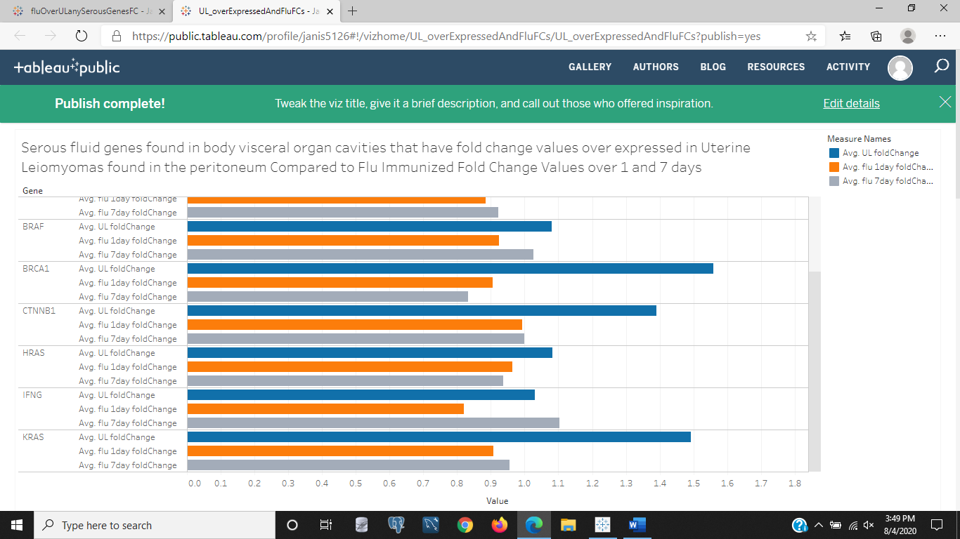

Figure 3: The serous genes that are over expressed in UL samples compared to non-UL samples, and comparatively charted next to the flu immunized fold change values for 1 and 7 days compared to healthy and non-immunized samples. It shows gene behavior, as well as gives a summary of each gene and their function and diseases associated with the gene when mutations of it arise and other details.

<https://public.tableau.com/profile/janis5126#!/vizhome/UL_underExpressedAndFluFCs/UL_underExpressedAndFluFCs?publish=yes>

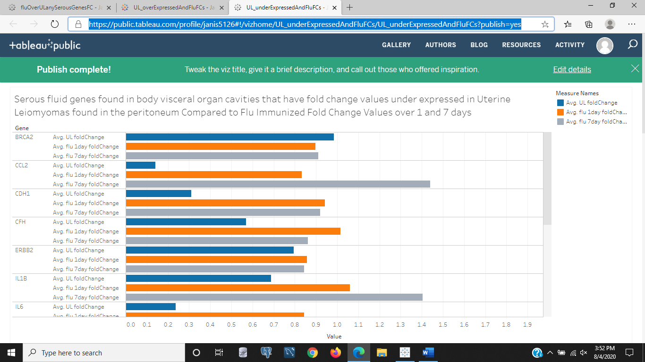

Figure 4: The genes associated with serous fluid of the body cavities and how the fold changes in UL are under expressed compared to non-UL samples, and next to flu immunized samples after 1 and 7 days of being immunized compared to their healthy and non-immunized samples in fold change values of gene expression. Gene summaries with each gene's function and other details is displayed when each bar is hovered over in the Tableau desktop site.

<https://public.tableau.com/profile/janis5126#!/vizhome/flu1_FC/flu1_FC?publish=yes>

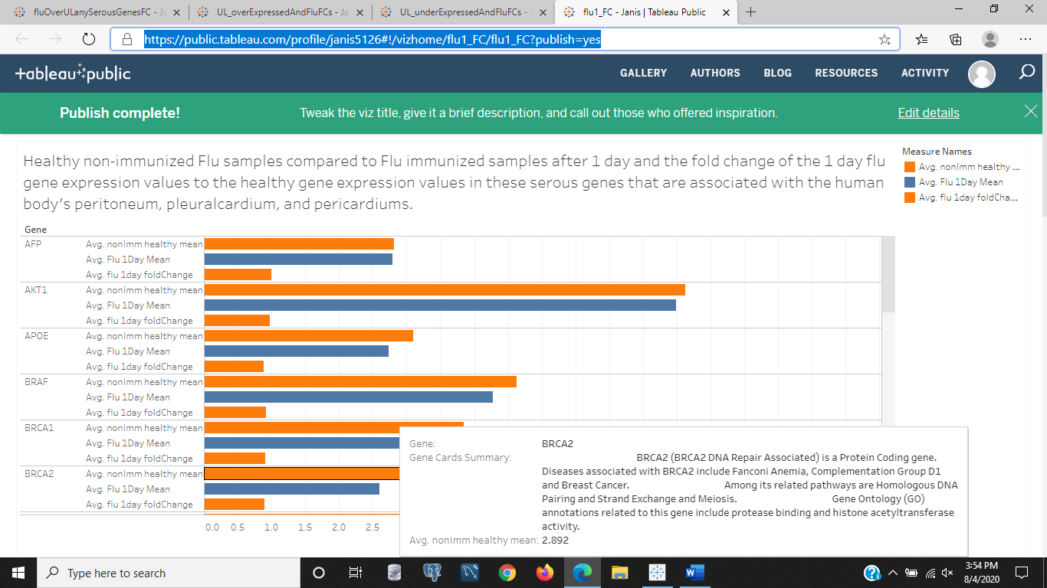

Figure 5: The above image is of the chart on Tableau Public Server that compares the flu immunized samples after 1 day of immunizations to that of the healthy, non-immunized samples by mean values across all samples and with the fold change of the treated/non-treated ratio. The details of each gene are displayed with the Gene Cards summary when each bar is hovered over.

<https://public.tableau.com/profile/janis5126#!/vizhome/flu7_FC/flu7_FC?publish=yes>

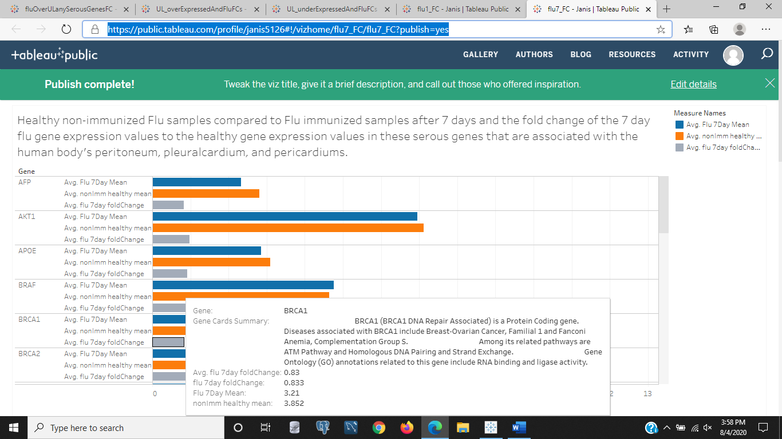

Figure 6: The serous genes' fold change and mean values in the flu immunized samples after 7 days of being inocculated and for the healthy, non-immunized samples. The gene summaries are displayed when hovering over each bar in the chart at the Tableau Public Server site.

<https://public.tableau.com/profile/janis5126#!/vizhome/UL_FC_over/UL_FC_over?publish=yes>

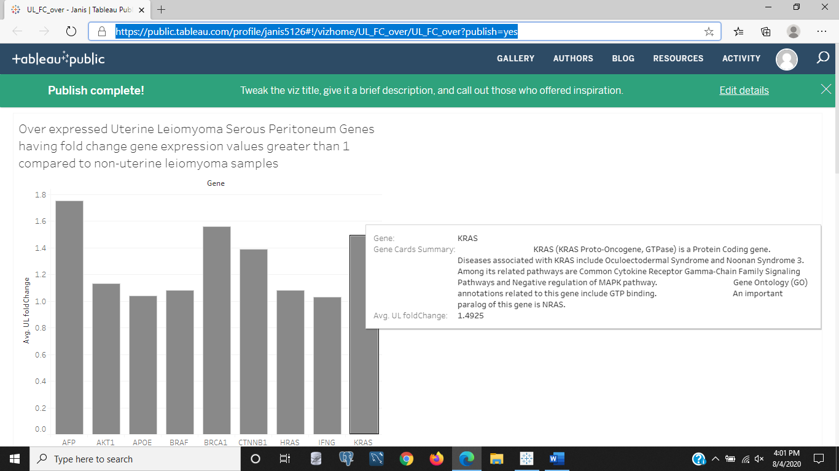

Figure 7: The UL fold change values of those serous genes over expressed in UL compared to non-UL tissue. The gene summaries are given when hovering over each bar in the bar chart at the Tableau Public Server Site hosting this chart.

<https://public.tableau.com/profile/janis5126#!/vizhome/UL_FC_under/UL_FC_under?publish=yes>

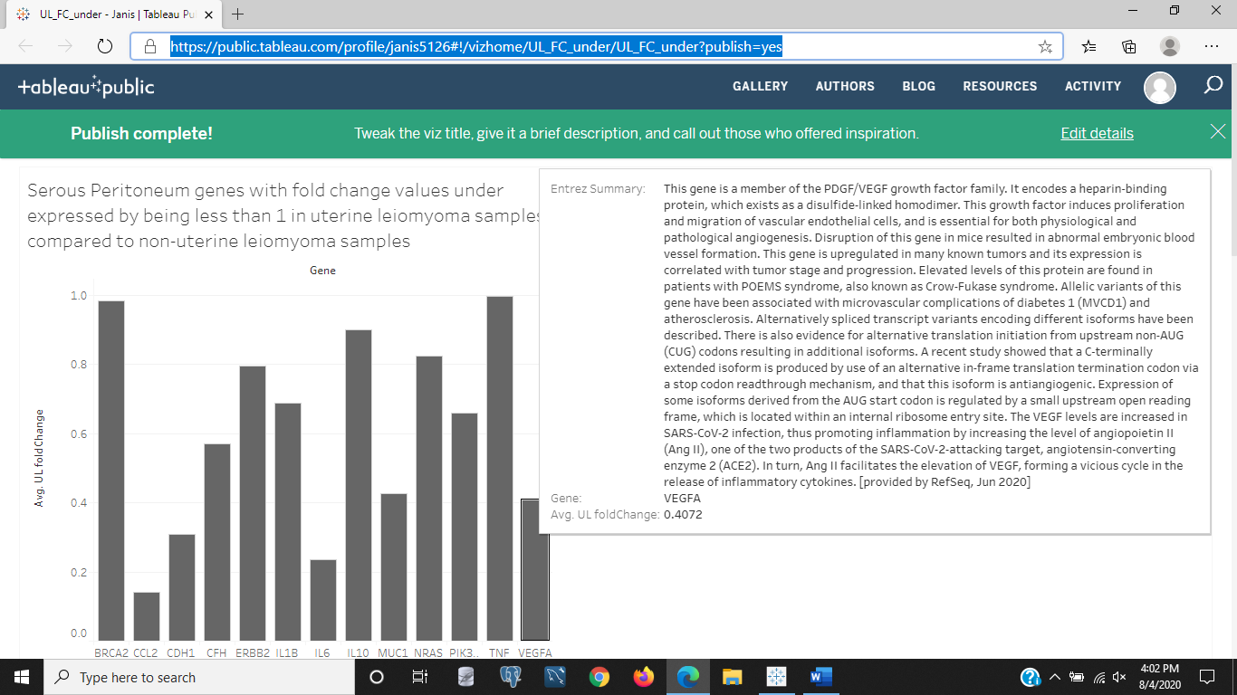

Figure 8: Those UL serous genes that are under expressed in UL compared to non-UL gene expression samples. The gene summaries are displayed when hovering on each gene bar at the Tableau site host for this bar chart of gene expression fold change values.

Some notes on the above data on serous genes as shown in UL and Flu immunized samples follows.

The 25 genes that genecards.org returned with our search for serous fluid genes are:

"TP53" "TNF" "IL10" "BRCA1" "IL1B" "PIK3CA" "BRCA2" "KRAS"

"IFNG" "ERBB2" "PTEN" "IL6" "CCL2" "AKT1" "CTNNB1" "BRAF"

"MUC1" "CDH1" "APOE" "HRAS" "VEGFA" "CFH" "NRAS" "AFP"

"CXCL8"

It seems the interleukin antibody, IL1B, is a pain hypersensitivity gene for inflammation, likely responsible for inflammation and to prevent movement of strains, sprains, and other injuries immediately after they occur. Lets see the gene expression of this gene in UL then flu immunized samples.

This gene IL1B is almost under expressed by 15-33% in UL compared to non-UL samples. Makes sense, as ULs aren't painful but cause painful menstruations in some females.

This gene is elevated 6-10 % more in flu immunized samples compared to non-immunized healthy samples after 1 day. This makes sense as it is early in the infection of an antigen and flu is normally associated with body aches and headaches.

After 7 days, the pain hypersensitivity inflammatory interleukin, IL1B is elevated approximately 40% more in flu immunized samples after 7 days compared to non-immunized and healthy samples.

BRCA1, is a cancer gene associated with estrogen and breast cancer. But lets look up the gene summary. We can see that this gene is a tumor suppressor. Not necessarily that it is a cancer marker, but is used in breast cancer detection when looking at the gene summary for BRCA1

BRCA1 is highly expressed to approximately double the non-UL gene expression values. This could mean it is acting greatly on suppressing the tumor along with other network genes sending its production to an increase in the benign UL tumor.

BRCA1 is included in the flu 1 day immunized samples, and it is under expressed approximately 10% compared to healthy non-immunized samples.

In the 7 day flu immunized samples the BRCA1 gene is underexpressed by almost 20%. That is interesting, hope there is no link to increased risk of breast cancer from flu shots.

The gene cards gene summary for Entrez' version says that PIK3CA is a cervical cancer associated oncogene. Lets see this gene expression in UL then flu immunized samples.

Thats reassuring that, PIK3CA is expressed approximately 32-34% less in UL compared to non-UL samples as it is an oncogene that signals cervical cancer as the gene summary says.

In 1 day flu immunized samples PIK3CA is expressed 10-13% less than in healthy non-immunized samples.

The cervical cancer gene is also 10-13% less expressed in 7 day flu immunized samples compared to healthy non-immunized.

BRCA2 gene has important exons and the copy mutations of this gene that make it an ovarian and breast cancer oncogene. It is a tumor suppressor gene like BRCA1. The Entrez gene summary says BRCA2 where the exon 11 is located is a primary culprit in breast cancer for its gene host. Exons and introns both make up the DNA in replication but the introns are dropped. The amino acid build is of adenosine with 70 replicates of aa in the motif in this specific exon. It is a mutation. Tumors are an abundance of mutations that grow fast and in one location, cancerous or malignant if they spread and mutate other neighboring tissue, benign if they stay local and don't spread.

BRCA2, a tumor suppressor, is working in a range of 14% under expressed to 133% over expressed in our UL samples compared to non-UL samples from the above output. There were two of these genes in the array data extracted, with no genotype information attached, but these genes do have different genotypes, hence there being two of these genes in the data. A lot of the genes in this data have more than one genotype the reason for the mean and median fold change values instead of just the fold change value on a one-to-one basis.

The BRCA2 gene is approximately 10% underexpressed in the 1 day flu immunized samples much like the BRCA1 gene was underexpressed the same approximate value.

This gene, BRCA2, is also approximately 10% under expressed in 7 day flu immunized samples thats the same as the 1 day flu immunized and more than the BRCA1 7 day immunized samples that saw a decrease in gene expression of approximately 20%.

In UL samples the KRAS gene has a range of expression from 5% under to 65% over expressed, with most samples over expressed. That isn't great news, but the Kirsten Ras gene is from the Kirsten Rat Sarcoma Virus studies that found the information on how this protein, KRAS, could turn on and off signaling pathways inside the nucleus for cell differentiation and proliferation. You can read more about this gene at https://en.wikipedia.org/wiki/KRAS.

KRAS is underexpressed approximately 10% in 1 day immunized flu samples compared to non-immunized and healthy samples.

In 7 day immunized samples the KRAS oncogene is under expressed approximately 5%.

Lets discuss the KRAS gene some more. It is under expressed in immunized blood samples and over expressed up to 65% in UL tumor samples. It is one of the top ten genes returned searching genecards.org for genes associated with 'serous fluid' of the body cavities. The uterus is in the pericardium of the abdomen and pelvis with the other visceral organs. In rats, a mammal like humans obviously different, this KRAS gene is associated with pancreatic and colon cancer. This could be significant to study this gene in UL tissue, and as we all know when some networks slow or get backed up in the body, other diseases could occur. There are some comorbidities associated with UL, if a great number of women with ULs also get pancreatic or colon cancer. Otherwise, there is not. It does make this finding a possible gene target to watch out for in other cancer risks or health risks for females with ULs.

The gene IFNG is a cytokine, which is a pain inflammatory interleukin. The above description says those with a gene mutation in this gene will be prone to infections. This gene, IFNG, combats infections, so it makes sense that those with autoimmune disorders and mutations in this gene will be more at risk of viral and bacterial infections.

In the above data, we see that IFNG is over expressed by 5-10% in UL compared to non-UL samples, and that is good, since it fights infections in the body.

IFNG is under expressed up to 20% in 1 day flu immunized samples. This makes sense as it is early in the stage of flu virus infection, even though the flu virus is deactivated it will be treated as an antigen.

After 7 days of flu immunizations, the IFNG interleukin gene is increased approximately 10%, which also makes sense as this is the usual time period that symptoms show after infection as 1-2 weeks after infection from common knowledge on flu symptom internet searches that state such information. But https://www.healthline.com/health/how-long-does-the-flu-last says symptoms can show 1-4 days after infection. And the Center for Disease Control (CDC) says that the symptoms can show 1-7 days after becoming sick. Which could mean after being infected or after showing infection signs. More CDC information on this is available at: https://www.cdc.gov/flu/about/disease/spread.htm

"When Flu Spreads

People with flu are most contagious in the first three to four days after their illness begins. Most healthy adults may be able to infect others beginning 1 day before symptoms develop and up to 5 to 7 days after becoming sick. Children and some people with weakened immune systems may pass the virus for longer than 7 days."-CDC

ERBB2 seems to be another oncogene that indicated increased expression in breast and ovarian tumors. It encodes a member of the epidermal growth factor receptor family. The epidermis is the skin and mucous linings of the body's organs. Lets see how this gene is expressed in ULs and flu immunized samples.

The results for ERBB2 in UL tissue are that this gene is approximately 15-60% under expressed in UL compared to non-UL samples. That is reassuring as the Entrez gene summary for ERBB2 stated that over expression of ERBB2 is associated with ovarian and breast tumors as well as cancer.

ERBB2 is also under expressed in the 1 day flu immunized samples by approximately 10-15%.

ERBB2 is under expressed after 7 days of being immunized with the flu compared to healthy and non-immunized samples. The fold change values are 12-16% less after 7 days of immunizations.

We have seen that some of these 10 genes in UL and flu samples are over expressed or under expressed more than 10%. Lets recall those genes dramatically over and under expressed in the UL samples, then the flu samples.

- UL:

- over expressed genes more than 10%:

- TP53

- BRCA1

- BRCA2

- IFNG

- KRAS

- under expressed genes by more than 10%:

- IL1B

- PIK3CA

- ERBB2

- 1 day flu:

- over expressed by more than 10%:

- TNF

- under expressed by more than 10%:

- IL10

- BRCA1

- IL1B

- PIK3CA

- BRCA2

- KRAS

- IFNG

- ERBB2

- 7 day flu:

- over expressed by more than 10%:

- TNF

- IL1B

- under expressed by more than 10%:

- BRCA1

- PIK3CA

- ERBB2

It is interesting to get a set of genes for different tissue typese and systems in the body to find out if any anomolies stand out in analysis of the disease state compared to healthy state when researching or exploring health ailments. In future blogs, I will explore the genes assoicated with connective tissue in the fascia and blood as well as specifically the clasts that break down damaged cell waste and the blasts that build and repair cellular tissue in the body and see if any gene targets are made obvious. Maybe there is a way to find balance with amino acids and proportions for certain proteins to build and repair or heal faster or mute auto immune disorders. And who knows!? Maybe we can discover those gene routes and proteins to double down on in our diets to heal when we need rest and destress time as well as a massage, exercise regularly, stretching, proper sleep, low fat and low sugar diets, and not being stuck in repetitive or isolated positions like driving, sitting, or standing for too long.

Hope you enjoyed this science blog. If you want to start scraping the web for data and exploring available data sets on gene expression and disease and treatment studies on humans and also use my scripts and functions in R, then visit my rpubs site at https://www.rpubs.com/janisharris.

Thank you.