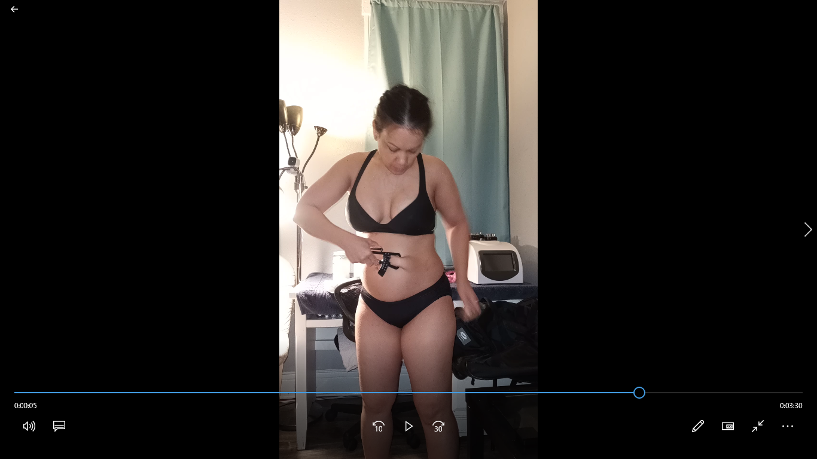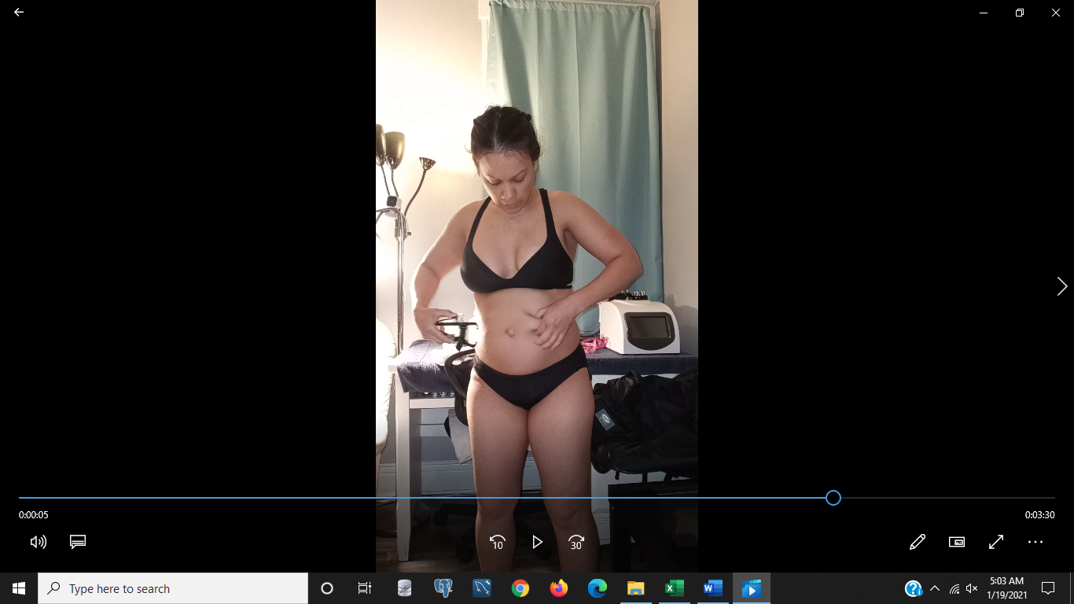

day 1 day 6 day 15

|  |  |  |  |  |  |  |  |  |  |
| --- | --- | --- | --- | --- | --- | --- | --- | --- | --- |
| side turn belly relaxed normal: |  |  |  |  |  |  |  |  |  |
| front view taking waistline measurement: |  |  |  |  |  |  |  |  |  |
| day: | 1 | 3 | 6 | 10 | 13 | 15 | 17 | 20 | 22 |
| weight: | 142 | 142 | 147.6 | 143.8 | 143.8 | 143.8 | 147.6 | 144.2 | 141.6 |
| waistline: | 33 1/2 | 33 1/4 | 32 | 33 1/2 | 33 1/2 | 32 1/2 | 32 1/2 | 32 | 31 1/2 |
| Calories consumed  day prior: | 1827 | 1884 | 1963 | 2961 | 2163 | 2295 | 2688 | 1354 | 1681 |
| time measurements  taken | 5 AM | 6 AM | 6:30 PM | 5:45 AM | 5:45 AM | 7:10 AM | 4:00 AM | 5:15 AM | 2:00 PM |
| minutes of cardio day before: | 0 | 20 | 30 | 20 | 30 | 0 | 28 | 30 | 0 |
| waist trimmer worn day before: | 32 | 32 | 32 | 32 | 32 | 32 | 31 | 31 | 31 |

