Application of large language models (LLM) to synthesize and interpret heterogeneous market data for personalized investment decision support

Motivation
Our goal is to create a system that supports investment decision-making by transforming large volumes of heterogeneous financial data (e.g., reports and market data) into personalized, actionable insights. Existing tools provide access to data but require significant manual interpretation and lack alignment with individual investor strategies. We aim to leverage Large Language Models (LLMs) combined with Retrieval-Augmented Generation (RAG) to synthesize diverse data sources and generate context-aware interpretations tailored to factors such as risk tolerance and investment horizon.

Functional requirements
- System stores user preferences like passive/aggressive investing for each company or group of companies
- System provides for user a sentiment prediction
- System stores historical data for predictions and keeps them based on importance
- System pull email, api data directly from companies and other sources TBD
- Returns list of informations (verbal description that it based his decision on
- Lists crucial sources (chunks) for his decision

Non functional requirements
- Prompt has to execute in less than X minutes
- Model provides at least X% accuracy for request
- System stores previous predictions
- Model provides predictions up to two years period

Won't do
This section describes things that we won’t cover as part of this document and project
- Value based prediction, we only support positive/negative/neutral sentiment predictions
- Model supports historic data up to 3 years

User stories

As a | I want | so that
Investor | get the sentiment prediction | I can improve my investing decision
Investor | characterize my investing strategy for company X | I get personalized suggestions
Admins | Have access to history of investors’ requests | analyze and improve system predictions
Investor | to know based on what inf did the model predicted certain decision | I have possibility of verifying data myself

System components
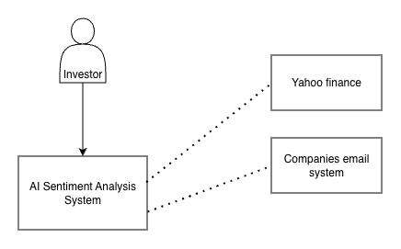
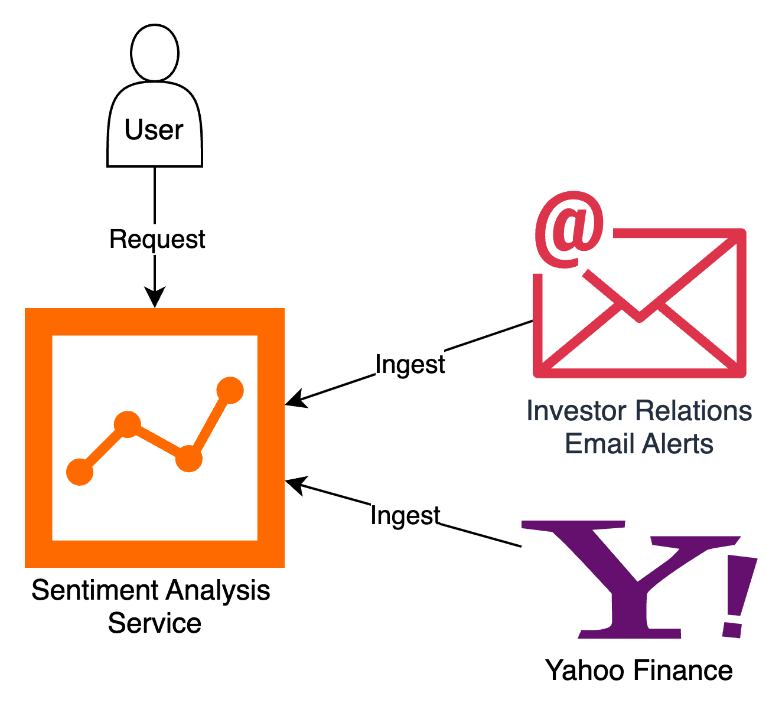

Architecture diagram
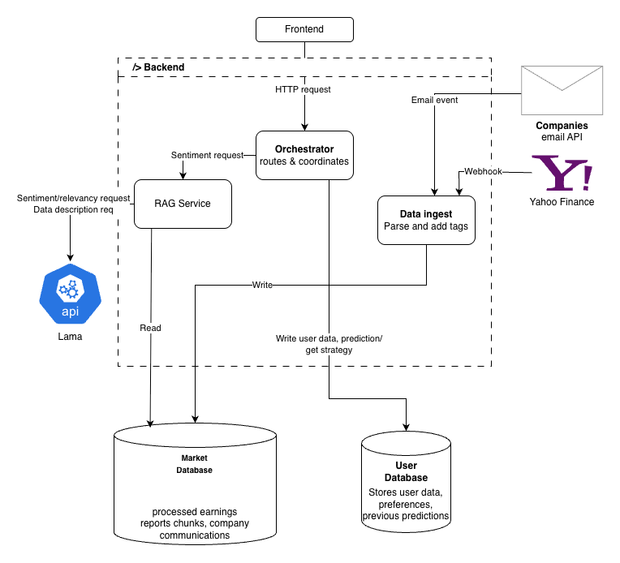

Implementation Considerations

Frontend
- Simple REST based API that is exposed to users. Uses simple functional UI without advanced JS functionalities.

Backend
- Functions as a monolith with 3 main functions: Orchestrator, Rag Service and Data Ingest
- Orchestrator: manages business flow of the application, it coordinates which subsystems should execute in order to deliver functionality to our client. It operates with the assumption that business logic is only known to him and other services (like RAG Service) are available to him on IDL (Interface Definition Language) based cooperation.
- RAG Service: operates on data prepared by Data Ingest component and uses RAG technique to get responses from LLM API. It is responsible for “how” the prompt is created, and what data is provided to LLM. It’s the component that has the most heavy lifting in the whole system
- Data Ingest: has a list of sources that it takes heterogenous data from. It’s responsible for parsing, tagging, enhancing and bringing data to single format so that RAG service can operate on it. For now the supported inputs are “Companies email API” and “Yahoo Finance”

Container diagram architecture

Backend endpoints

Endpoint | Method | URL | Headers | Body | Response
Writes user investing strategy for company X (may be list) | POST | /user/strategy | ? | {  strategy: Enum,  desc: “text desc”,  companies: Enum[]  } | {  "status": "success"  }
User creates account | POST | /user/account |  | {  email: string,  username: string  } | {  "status": "success"  }
Updates user investing strategy for company X (may be list) | PUT | /user/strategy | ? | {  strategy: Enum,  desc: “text desc”,  companies: Enum[]  } | {  "status": "success"  }
User request list of companies he currently is interested in (pre request for below) | GET | /user/strategy |  | None | {  companies: Enum[]  }
User request to see his current investing strategy for company X (may be list) | GET | /user/strategy  {companyID} |  | None | {  strategies: dict{  companyID : dict{  strategy: Enum,  desc: “text desc”  }  }  }
Get prediction for company X | GET | /companies  /{companyID}  /prediction | Authorization | None | {  "companyID": 123,  “sentiment”:  "positive" | "negative",  "confidence": float,  “sources”: int[]  }
Getting user requests history | GET | /user/history  /{userID} | ?Admin? | None | {  userID: 12,  requests: {  request_date: Date,  question: String,  prompt: String,  response: String  }  }
Sending email from webhook | POST | /companies  /{companyId} | ?Admin? | {  email_content: “text”  } | {  "status": "success"  }

LLM Lama endpoints

Endpoint | Method | URL | Headers | Body | Response
Get relevancy assessment | POST | /lama/relevancy | Authorization | {  timeframe: String,  chunks_summaries: str[]  } | {  chosen_chunks: int[]  }
Get sentiment prediction | POST | /lama/prediction | Authorization | {  company: Enum,  timeframe: String,  user_strategy: String,  chunks: str[]  } | {  sentiment: Enum,  confidence: float 0-1,  }

Market database operations

Operation | Description | Input | Output
GetEarningRaportEmbedding | Returns summaries of chunks of earning raptors and emails | companyID | embedding[]
GetEarningRaports | Return chunks of earning reports/ emails | companyID, chunkID[] | chunks[]
SaveMailContent | Saves received email | companyID, string | status

User database operations

Operation | Description | Input | Output
SaveUserStrategy | Saves user strategy | userID, strategy | status
GetUserStrategy | Retrieves user strategy | userID, | strategy
SaveUserPrediction | Saves prediction generated for user | userID, strategy, prediction, date | status
GetUserPredictions | Retrieves all user predictions | userID | prediction[]
SaveUserAccount | Saves user data after account creation | userID, email, username | status

Sequence Diagrams
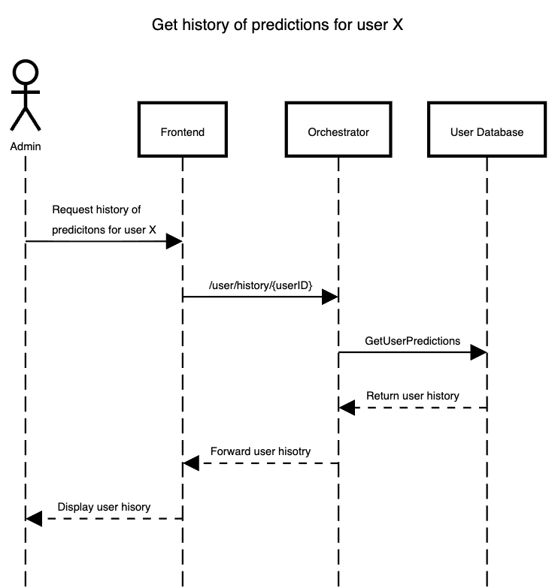
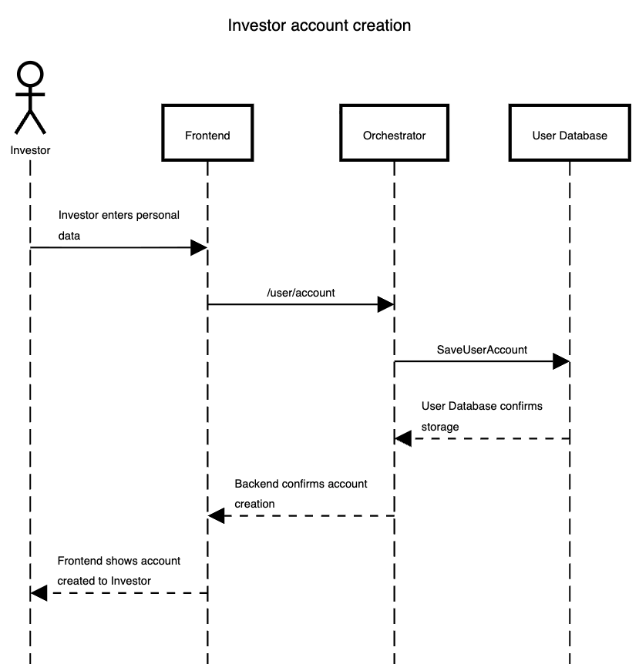
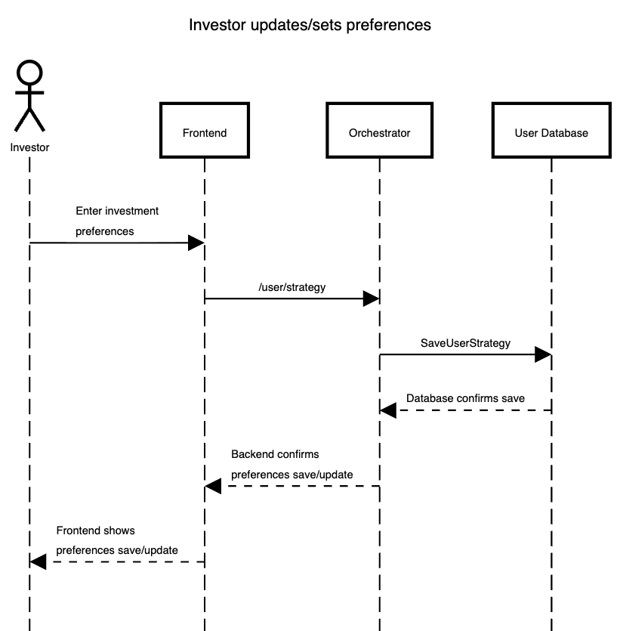
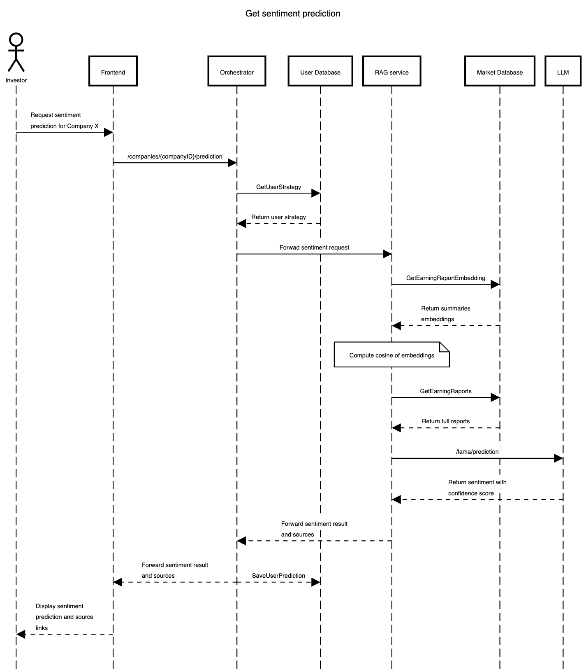
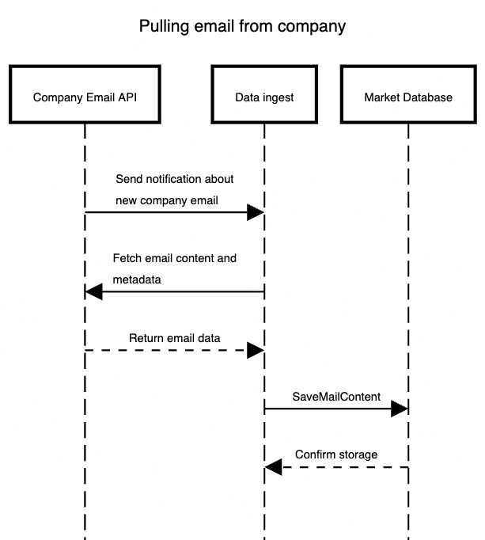

Appendix

