reStructuredText Plugin
This is a little how-to for using the reStructuredText plugin inside gedit.
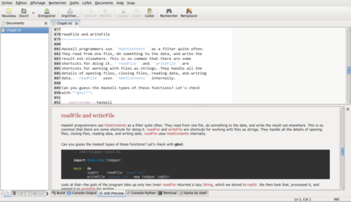
Note: To activate syntax highlighting see syntax/README.rst.

Dependencies
- Python: version >= 3.3 (-> use mcepl/reStPlugin for Python 2.x)
- Pygments: take the latest version
- reStructuredText
- odtwriter: a reStructuredText addon to export in LibreOffice format

Installation
- Put reST.plugin file in gedit's plugins directory. The standard one should be ~/.local/share/gedit/plugins/. Alternatively, the global directory is something like /usr/lib/i386-linux-gnu/gedit/plugins/.
- Copy the whole reST folder into the same directory.
You should then obtain something like this:
.../plugins/
reST.plugin
reST/
__init__.py
makeTable.py
etc.

Usage
Activate the plugin via Edit / Preferences / Plugins and check the checkbox next to reStructuredText Preview.
The plugin is now activated, and you should have a new panel inside the bottom pane named reStructuredText Preview. If you don't see the panel on the bottom of the editor window make it visible via View / Bottom Panel.

Shortcuts
There's only one shortcut for the moment: Ctrl+Shift+R
Ctrl+Shift+R is used to refresh the generated HTML view inside reStructuredText Preview pane. If there's some selected text, the conversion will only process the selected portion of the text. If there's no selection, the entire document is processed. This may be useful for trouble shooting.

Menu
The Tools menu is populated with several options:
- reStructuredText Preview refreshes the preview pane (same as above)
- Create table is useful for creating simple reStructuredText tables
Example: Enter the two folling lines in gedit, select them and activate Create table:
one,two,tree
First,Second,Third
The output will be:
one | two | tree
First | Second | Third
- Paste Code maybe useful to paste some parts of code using Pygments's sourcecode directive. Just invoke Paste Code with something in your clipboard and you're done. You'll have to adjust the language afterwards.
- --> HTML, --> LaTeX, --> LibreOffice: are convenient ways to export your reStructuredText docs to the given formats with custom * stylesheets. If you're not happy with the formatting go ahead and modify the stylesheets!

